[Author name]

[Company name] | [Company address]

**Netflix movie rating vs stock price to see if there is a better indicator vs covid variables**

Group Members

1. Ji Yeol Yang
2. Nimra Wali
3. Hammad AhmedAli
4. Taghipour Heidari
5. Jeremiah Y Sulunteh

**Netflix movie rating vs stock price to see if there is a better indicator vs covid variables**

It is no secret that Netflix, Inc. is the champion in the online streaming revolution. Its streaming platform allows users to watch ad-free content anytime and anywhere over the Internet. Its content library includes television shows, documentaries and feature films covering a wide range of genres and languages. As of now, Netflix has over 208m paid subscribers worldwide, 74m of whom are in the USA. Such unlimited access to digital content has given rise to a growing trend known as “binge-watching”; the consumption of multiple episodes of a show in one sitting. For instance, Nielson has reported that 361,000 Netflix subscribers have seen all nine episodes of Stranger Things season 2 in one sitting within 24 h of its release.

The numbers continue to grow, especially now when people are quarantined in their homes due to the COVID-19 pandemic. Subsequently, has reported that, amidst cinema hall closures and lockdowns, adults are spending a total of 1 h and 11 min on streaming services per day. That is double what they consumed before the pandemic. In addition, Netflix has been the streaming platform of choice for 46% of the UK adults surveyed. But it is unclear as to how much binge-watching they are doing on Netflix and the accompanying effects it has during the COVID-19 lockdown. To shed some light on this, the study has attempted to determine the positive and negative impacts of binge-watching on Netflix during the COVID-19 pandemic. In addition, the time spent behind these marathon viewing sessions has also been investigated.

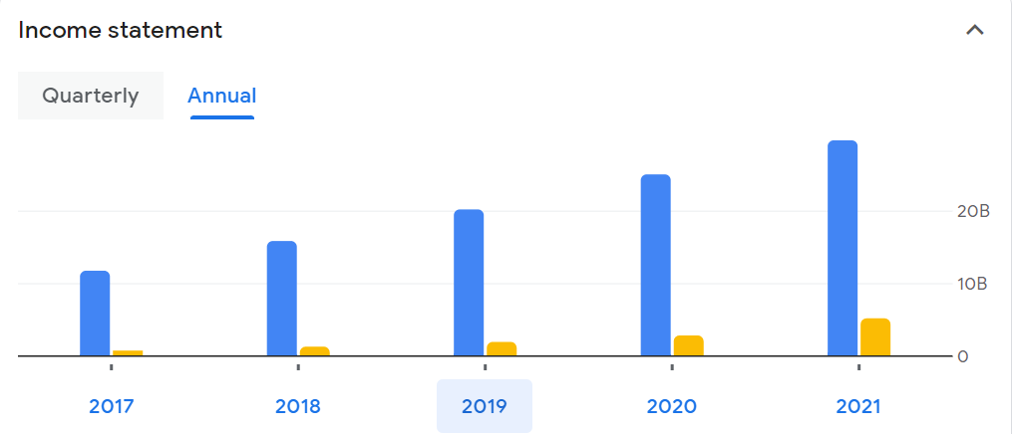

Figure :Income statement

Table :Income statement

|  |  |  |
| --- | --- | --- |
| (USD) | 2019info  FISCAL YEAR ENDED 31/12/2019. | Y/Y CHANGE |
| Revenue  The total amount of income generated by the sale of goods or services related to the company's primary operations | 20.16B | 27.62% |
| Operating expense  Represents the total incurred expenses through normal operations | 5.11B | 21.09% |
| Net income  The company's earnings for a period net of operating costs, taxes and interest | 1.87B | 54.13% |
| Net profit margin  Measures how much net income or profit is generated as a percentage of revenue. | 9.26 | 20.73% |
| Earnings per share  Represents the company's profit divided by the outstanding shares of its common stock. | 4.13 | 54.10% |
| EBITDA  Earnings before interest, taxes, depreciation and amortisation is a measure of a company's overall financial performance and is used as an alternative to net income in some circumstances | 2.71B | 60.38% |
| Effective tax rate  The percentage of their income that a corporation pays in taxes | 9.47% | — |

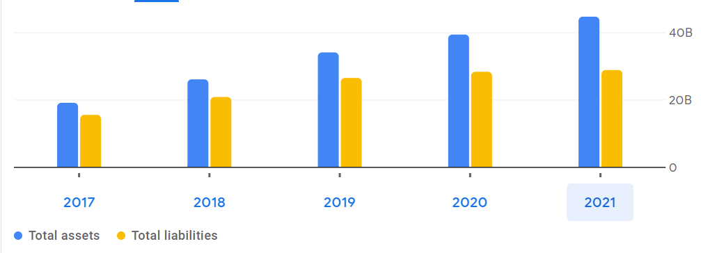

Table :cashflow

Owing to the COVID-19 lockdown and quarantine situation, an online survey constructed on Google Forms had been deployed to the participants, and their responses have been recorded accordingly. For data analysis, Microsoft Excel has been used to determine various aspects such as mean and standard deviation. It has also been used to calculate the total number of hours spent behind binge-watching per month. In the following analysis, the study has presented key insights provided by the target group of respondents.

On Monday, the streaming service’s shares fell more than 2% to around $332 each, a 52-week low. That’s more than 50% down from the company’s 52-week high of $700.99, which it hit in mid-November. The last time shares sold for around $332 a pop was March 20, 2020, just as pandemic lockdowns were being put in place.

Netflix saw significant gains during in 2020 and 2021 as consumers were stuck at home under various restrictions. However, as the mandates dissipate, consumers are gravitating toward out-of-home entertainment like movie theaters, restaurants, and theme parks. In its most recent earnings report, Netflix reported underwhelming subscriber numbers.

Netflix has long been less interested in making money at the box office and more interested in providing content to its subscribers as soon as possible. The streaming service has rebuffed the traditional Hollywood release window, in which a film runs in theaters for about three months before being available in video-on-demand or on a streaming service’s site or app.

Exceptions were made in the past so that Netflix movies could be eligible for Academy Award contention. Netflix’s “The Power of the Dog” is nominated for a field-leading 12 Oscars and is considered a strong contender for several major awards at the March 27 ceremony. However, as the pandemic led studios to shrink the release window from 90 to around 45 days, it seems Netflix is rethinking its strategy.

The economic crisis caused by the global Covid 19 pandemic has hit many industries and individual businesses globally. The media industry is already deep into the transition from the "old" to the "new" media industries, and Netflix is at the forefront of the "new" media industry. New media industries are based on the digitalization of the production system and the convergence of the system of distribution and consumption of content. Netflix is a platform for distributing video content in a streaming model and is a member of a completely new media industry based on high technologies. The technological dimension provides new media industries with less sensitivity to environmental crises, but they are not fully protected from global economic crises. The aim of this paper is to analyze the operations of Netflix Corporation during the Covid 19 pandemic.

# Netflix movie rating vs stock price:

Figure :Netflix movie rating vs stock price

The correlation value is positive, and its value give in below

|  |  |
| --- | --- |
| correlation |  |
| Positive | 0.998679 |

# Compare Netflix stock to Disney:

The streaming market has become an unpredictable battleground in 2022 as multiple companies duke it out for the top spot. Walt Disney (DIS 0.90%) and Netflix (NFLX 3.14%) have sent investors on a roller-coaster ride throughout the year, with the companies seemingly passing the streaming crown back and forth as they one-up each other on subscriber count from quarter to quarter.

These companies have immense potential and have both expanded into new markets over the last few years. Disney dipped its toes into the streaming market with its Hulu service many years ago, but the launch of Disney+ in 2019 saw it enter the market in full force. Meanwhile, Netflix entered the gaming industry with the launch of its Netflix Games in 2021.

Netflix and Disney have been compared countless times in 2022 and will likely continue to be as they strive to dominate the streaming world. Both companies' stocks have dipped considerably since January, prompting investors to wonder if now the best time is to buy. So, let's see whether your money is better off with Disney or Netflix.

# Reference:

1. Tashanova, D., Sekerbay, A., Chen, D., Luo, Y., Zhao, S., & Zhang, T. (2020). Investment opportunities and strategies in an era of Coronavirus pandemic. *Available at SSRN 3567445*.
2. Gultom, M. D., Adlina, H., & Siregar, O. M. (2022). The Influence Of Electronic Word Of Mouth And Brand Image On The Purchase Decision Of Video On Demand Netflix Subscription:(Study on Netflix Users in Medan City). *JOURNAL OF HUMANITIES, SOCIAL SCIENCES AND BUSINESS (JHSSB)*, *2*(1), 122-127.
3. Rahman, K. T., & Arif, M. Z. U. (2021). Impacts of Binge-Watching on Netflix during the COVID-19 pandemic. *South Asian Journal of Marketing*.