MS Word template and guidelines for the manuscript of the contributory papers

- Author¹,* B. Author², C. Author³, and D. Author⁴

¹Nuclear Physics Division, Bhabha Atomic Research Centre, Mumbai - 400085, INDIA

²Deptartment of Nuclear and Atomic Physics,

Tata Institute of Fundamental Research, Mumbai - 400085, INDIA

³Inter University Accelerator Centre, Aruna Asaf Ali Marg, New Delhi - 110067, INDIA

⁴Physics Department, XYZ University
.

Introduction

DAE Symposia on Nuclear Physics covering a wide range of topics [1] are conducted annually. The aim of this series of symposia has been to provide a scientific forum to the nuclear physics community to present their research work and to interact with the researchers in this area.
This is the MS Word template in which the guidelines for preparing the manuscript of the contributory papers are described. The guidelines and format for the submission of contributions and thesis presentations are same. In the format of this template, the details of the sizes and types of the fonts are described. Two-page write up of the work, strictly in the form of this template should be prepared. Only the pdf version of the paper should be uploaded in the website before the deadline. No hardcopy or email submission is acceptable. The bound volume of the symposium proceedings [2] will be distributed during the symposium.

Format of the Template

The various items and their font size and type are as shown in Table 1. Margins of the template are depicted in Fig.1 while the selection of the paper size of the template is shown in Fig.2. The margins from left, right, top and bottom are same and equal to 1.4 inches. The contribution has to be of two pages. One page contribution is not acceptable. The text should be in double columns and single spacing. The spacing between two columns is 0.2 inch. A new heading in the mist of texts should be preceded by a blank line having font size of 10 and followed by a blank line having font size of 4.
______________
*Electronic address: aauthor@barc.gov.in
Figures and Tables

As the proceedings print will be in mono-color, all necessary figures, plots, spectra etc. have to be in black & white or grayscale (see Fig.1) with a good contrast so that good reproduction can be obtained. The size of the figures and tables should not exceed the column width else it can be in two columns width. The axes of the plots should be clearly visible and labeled properly with units etc.

Table 1: Font type and size
For | Font type | Size
Title | Times New Roman – Bold | 14
Author List | Times New Roman – Regular | 12
Institute‘s Address | Times New Roman – Italic(Preferably in not more than two lines) | 9
Text | Times New Roman – Regular (Indent size 0.3 inch) | 10
Reference number | in square bracket | 10
Headings | Times New Roman – Bold (in Title case, 1.5 spacing) | 12
General Guidelines

Once the paper is written as per the format either in MS Word or in Latex, it should be compiled and converted to a pdf file. To convert the Word file into a pdf file, one may i) open the file in MS Word, ii) print the file by selecting Acrobat distiller or pdf writer as printer, iii) and then give a file name ‘a_file.pdf’ when it asks. Only the pdf files of the contributions should be uploaded in the website.
In the authors’ list, in case of a large collaborative experiment it is advised to mention the name of the collaboration and spokesperson’s email address instead of the complete list of authors. For references also, the name of collaboration or only the “first author, et al.” style can be adopted.
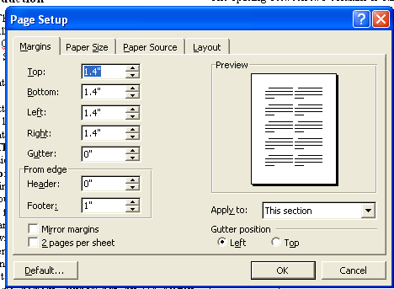

Fig. 1 Margins of the template for page set up

It is not encouraged to have the figures and tables together to occupy more than 50% of available area. Also the content should be sufficient and complete. Authors are also expected not to split their work to submit multiple contributions. Although the contributions are in soft copy form, the symposium organizer will not make any attempt to edit it to conform to the template format.
After screening of the contributions, the acceptance status of the papers shall be made available only on the website.
All the accepted contributions including theses have to be presented as poster during the symposium by any one of the authors. The size of the posters will be about 90 cm width x 100 cm height. Poster presentations could be made impressive using color texts, figures, photographs and table. Three best posters will be chosen for the award on the basis of the work and presentation.
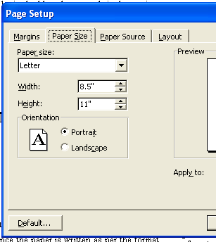

Fig. 2 Paper size selection of the template

References
- Announcement Poster and Website, DAE Symp. on Nucl. Physics.
- DAE Symp. On Nucl.Phys. vv, ppp (yyyy) .

