A short tutorial how to implement a PHREEQC equilibrium and reaction example in ORCHESTRA

Hans Meeussen 14/11/2024

This document describes how implement a simple PHREEQC equilibrium and reaction example in ORCHESTRA. The example was taken from the very useful PHREEQC site by Tony Appelo and can be found here:
https://hydrochemistry.eu/exmpls/ca_f.html
The example demonstrates how to calculate the composition of a solution first in equilibrium with calcite, fluorite and a fixed CO₂ pressure, and subsequently let this solution react with NaAlSi₃O₈ (Na-Feldspar).
The PHREEQC simulation starts with calculating water (SOLUTION 1), with a CO₂ pressure of 0.1 atm, and Ca and F concentrations in equilibrium with calcite and fluorite, respectively. This is the encircled composition in the graph, with (right-click on the chart calculated by PHREEQC, and select 'Show Point Values') 157 mg Ca/L and 2.3 mg F/L.
Next, 7.5 mmol Na-feldspar dissolve in 15 steps (keyword REACTION), while calcite, fluorite, kaolinite and quartz react to equilibrium (keyword EQUILIBRIUM_PHASES).

The graph shows the increase of F (red line) and pH (green line) as a result of the reactions.

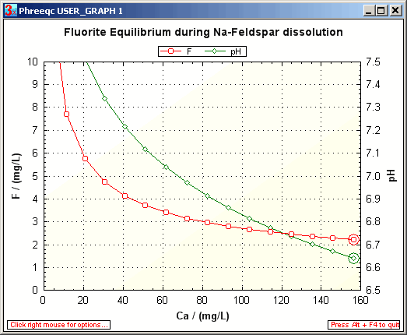

In PHREEQC the complete definition of the simulation is very compact:

SOLUTION 1
pH 7 charge
C 1 CO2(g) -1
Ca 1 Calcite
F 1 Fluorite

REACTION
NaAlSi3O8 1
7.5e-3 in 15

EQUILIBRIUM_PHASES 1
Fluorite
Calcite
Quartz 0 0
Kaolinite 0 0

This is short description is very elegant, but to reproduce it with another code it is necessary to understand what is going on behind the screen!

ORCHESTRA implementation of initial solution calculation
For the ORCHESTRA implementation we need a single cell, that is first equilibrated with the solid phases and fixed CO₂ pressure. Subsequently 7.5e-3 M of NaAlSi₃O₈ is added in 15 steps and equilibrated (and output generated) at each step. A graphical representation of the order of things looks as follows: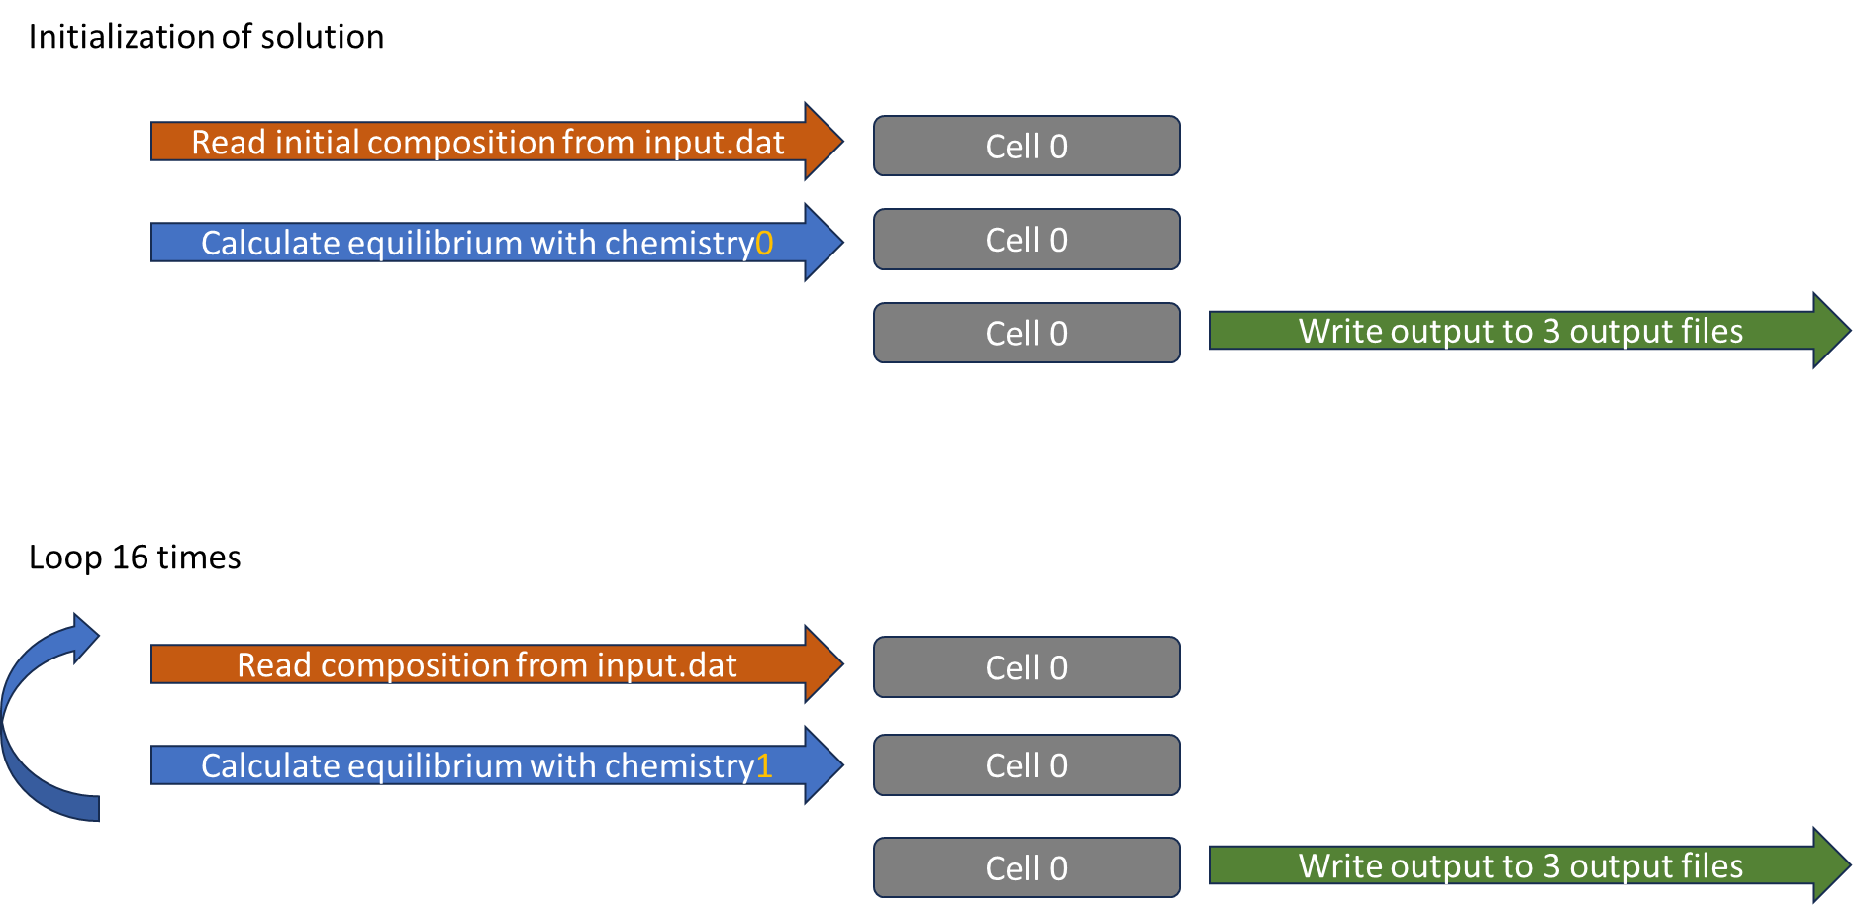
In the ORCHESTRA concert.xml file we can find the definition of a single cell, an input file for this cell, two chemical solvers that operate on this cell and three different output files (to demonstrate different output formats).The order of actions during a run is defined in the “run” task at the bottom of the concert.xml file.
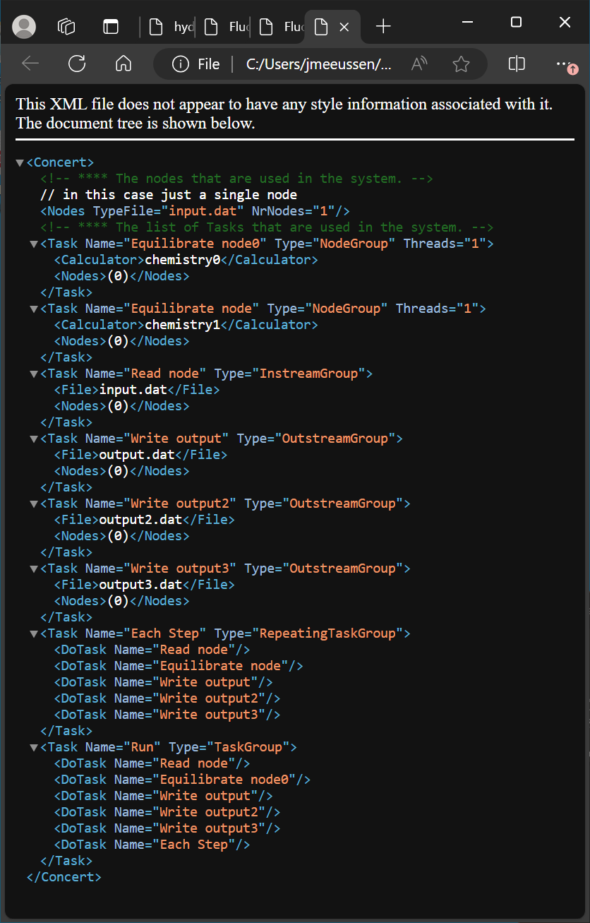
To calculate the composition of a solution in equilibrium with calcite, fluorite and 0.1 atmosphere CO₂[g], we first need to interactively define a chemical system. We do this by selecting CO₂[g], Ca and F as primary entities from the PHREEQC.dat database. The H, O and E primary entities are standard (PHREEQC) entities that together represent water. In PHREEQC these are selected by default, in ORCHESTRA these have to be selected manually as shown in the graph below. For Ca and F we select given amounts in the tot phase (given total amount). For CO₂ we select a given log activity (partial pressure). In case of PHREEQC the primary entities are called master species, and are defined as such in the PHREEQC database.
In case of ORCHESTRA species or entities are made primary or master species at the moment they are selected as such in the user interface, regardless how they are defined in the database.
The user interface automatically rewrites formation reactions in terms of the selected primary entity, and also detects which species / entities are dependent (can be formed out of selected primary entities via reactions). Only independent entities can be selected as primary.
So for example in this case we could select either C (= PHREEQC default) , or e.g. CO₃⁻², or HCO₃⁻ or CO2[g] as primary entity. Selection of any of these entities as primary, will make the other ones dependent, so not available for selection as primary.
For the first calculation we want to use a fixed partial pressure for CO₂[g], which we can define by choosing CO₂[g] as primary entity with a fixed log activity (which is equal to the log of the partial pressure).
(Alternatively it would be possible to use C as primary entity and to define CO₂[g] as a pure phase or “mineral” with given log solubility constant of -1, which is the common PHREEQC approach to obtain the same result. )
We also select given log activities for O, E and H. But the pH is adapted by the charge balancing procedure to reach electroneutrality. (Balance charge on pH).
Note that the default values of 1E-9 given here for the total amounts of Ca and F are overwritten by values in the input file!

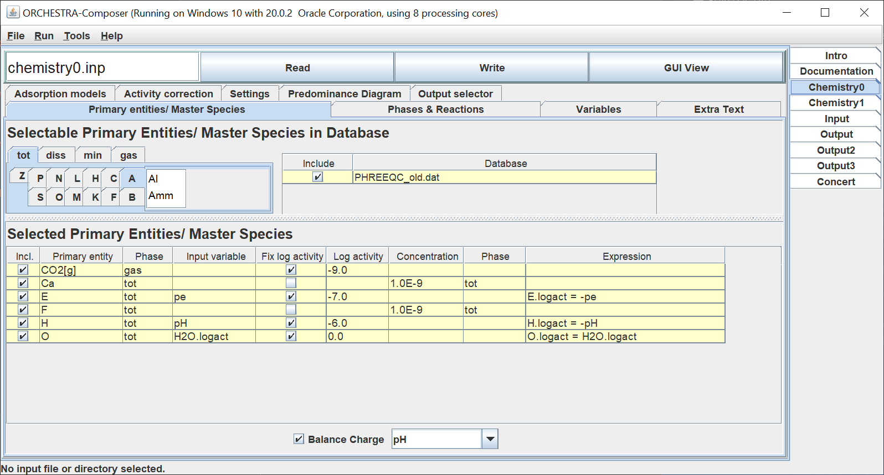

We have the following aqueous ions present (in the diss phase) :

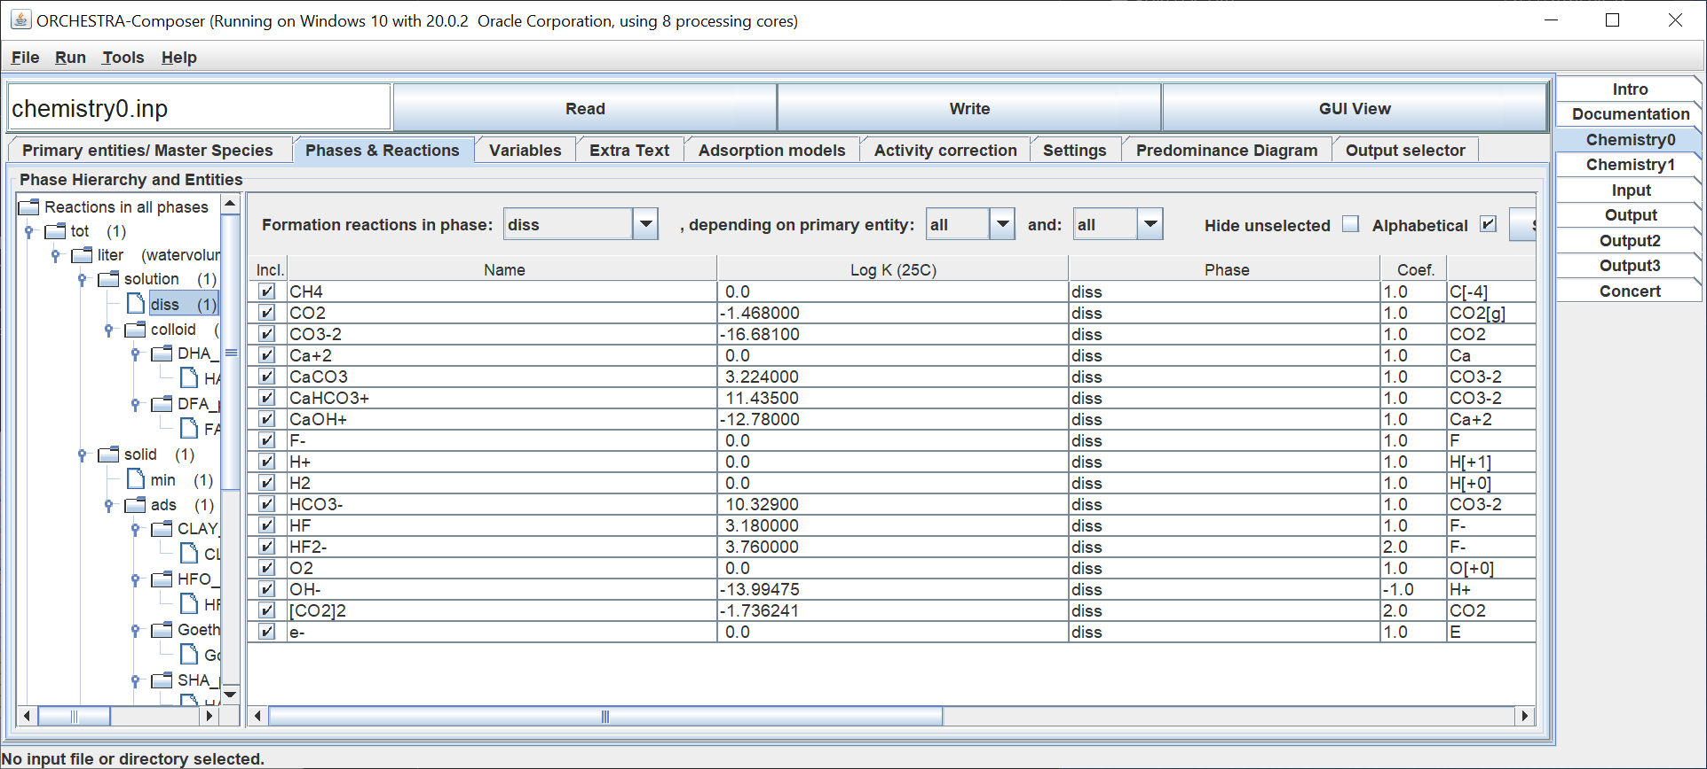

And calcite and fluorite are switched on as potentially precipitating minerals/phases.
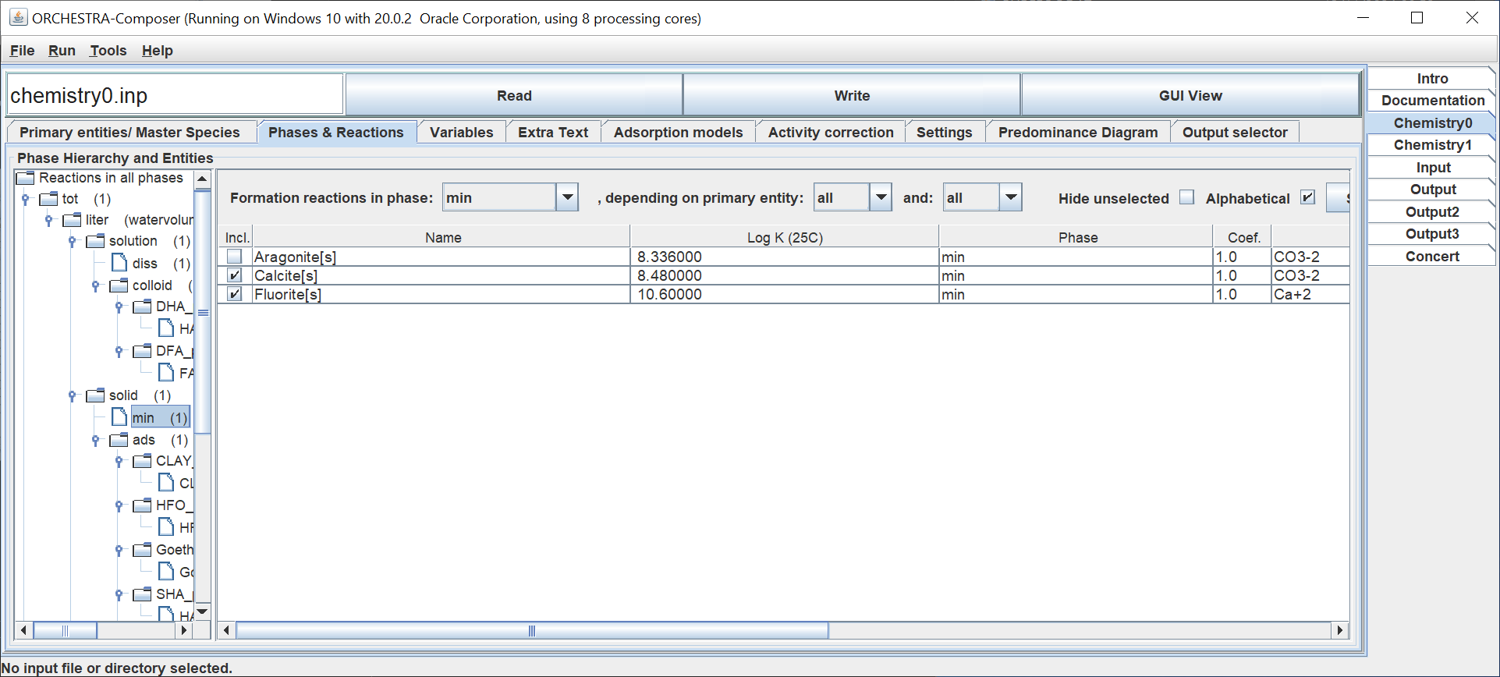

In the input file the molar amounts of the primary entities Ca, F and the (log) partial pressure of CO2[g] is given. The variables for Al, Si and Na are already there, but these are ignored by the calculation with the first solver. Note that values given in the input file overwrite the default values present in the chemistry files!

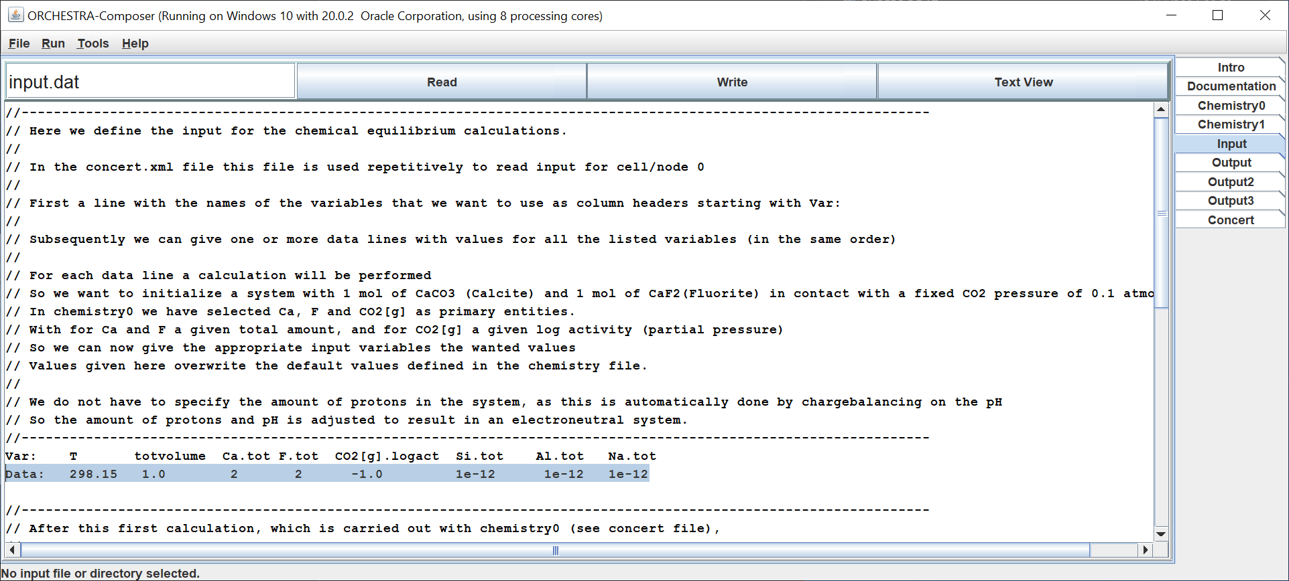

With this we have defined the initial conditions for the simulation.
In the output file we can check the pH and total dissolved F (F.diss) and Ca (Ca.diss)

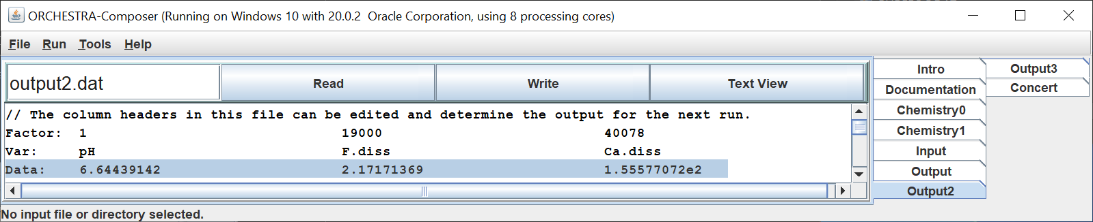

Output 3 shows an automatic full overview of the system composition, very similar to that of PHREEQC.

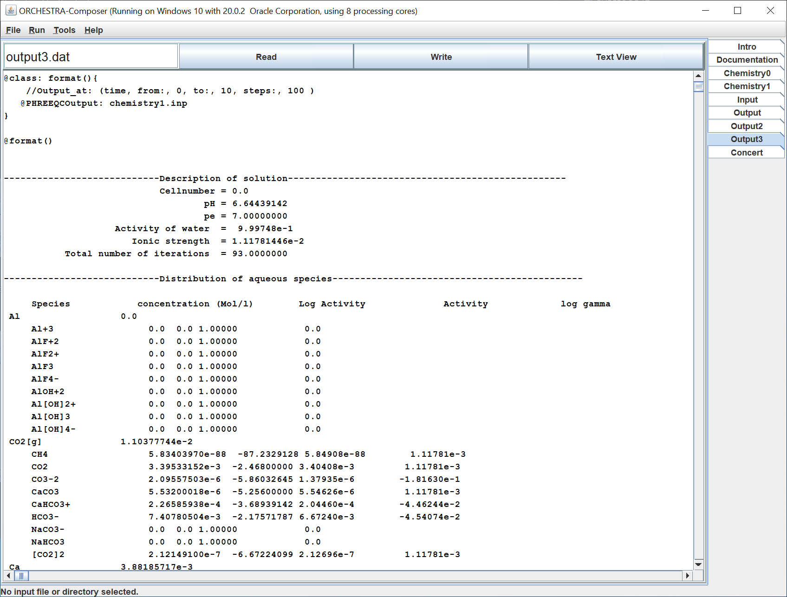

ORCHESTRA implementation of PHREEQC “reaction” simulation

After the first equilibration of a solution, the simulation continues by adding stepwise 7.5 mmol 7.5e-3 M of NaAlSi₃O₈ to the solution. In PHREEQC this is defined as follows:

REACTION
NaAlSi3O8 1
7.5e-3 in 15

For these subsequent calculations the CO2[g] pressure is no longer fixed, but instead the total amount of CO2[g] in the system resulting from the first calculation is kept constant. This requires a change of the chemical equilibrium settings. In ORCHESTRA it is not possible to adapt an existing solver, so we simply create a second one.
We simply copy the first one and change the settings for the CO2[g] primary entity from fixed partial pressure to given total amount (CO2[g].tot). We also add the Na, Al and Si primary entities with given total amounts.

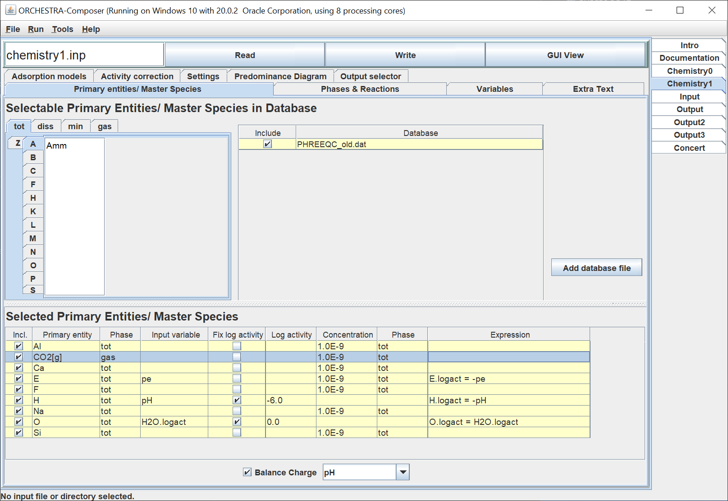
We select the Quartz and Kaolinite as solid phases:
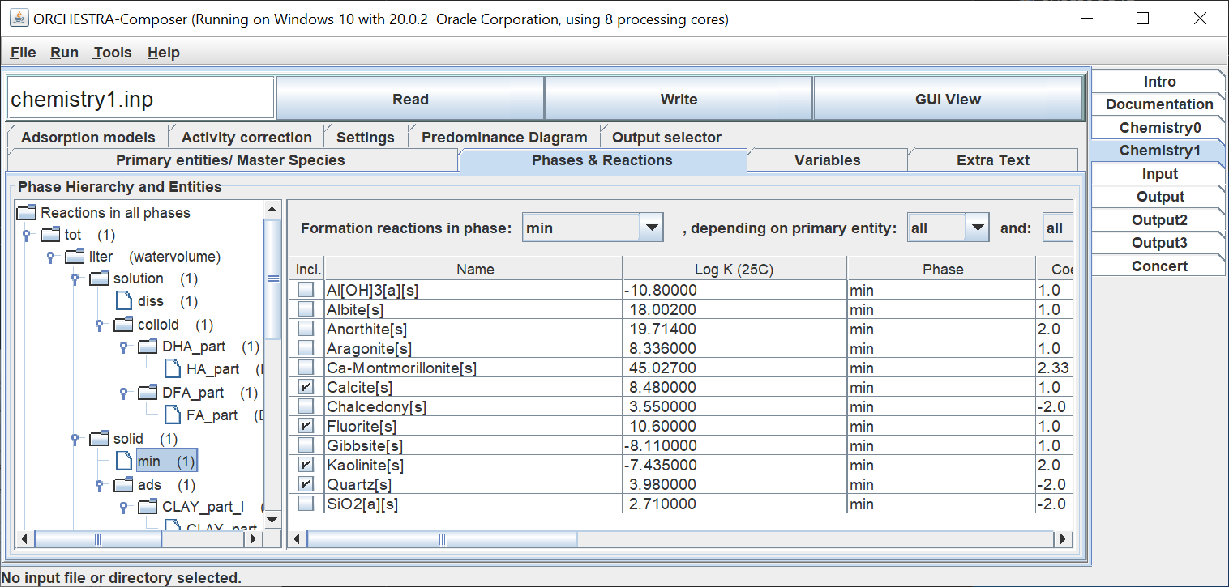

And keep all the automatically selected aqueous ions:
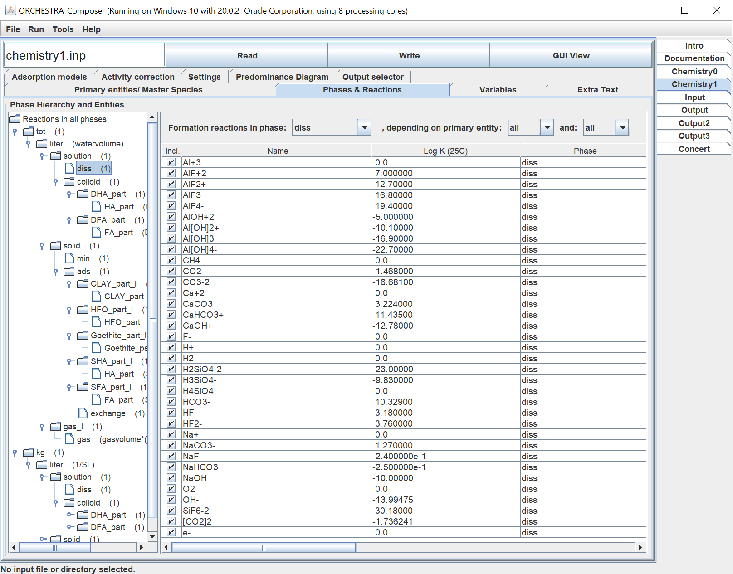

Now we define the addition of NaAlSi3O8 in the input file:
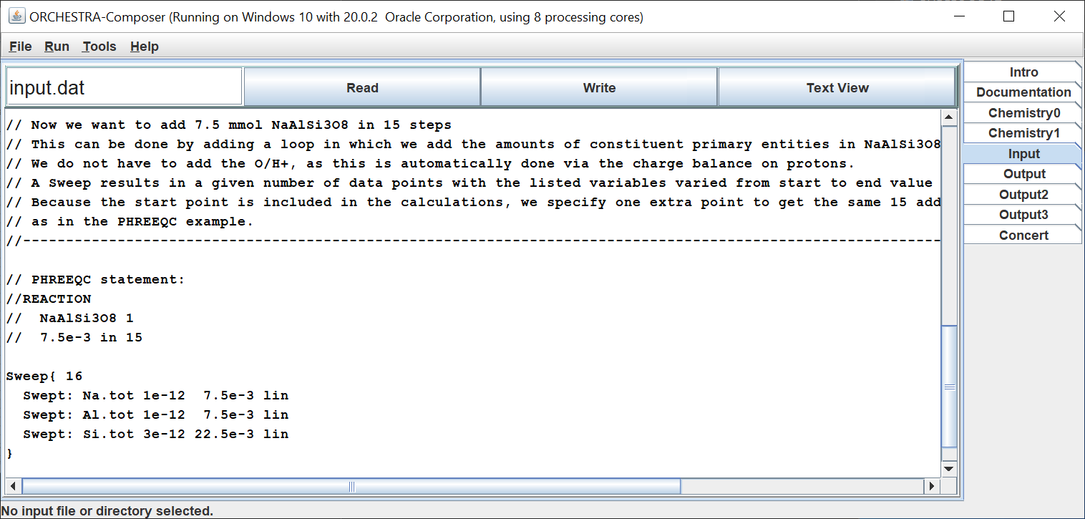

In the concert file we define a first calculation with chemistry0 to initialize the system with fixed CO2 pressure:

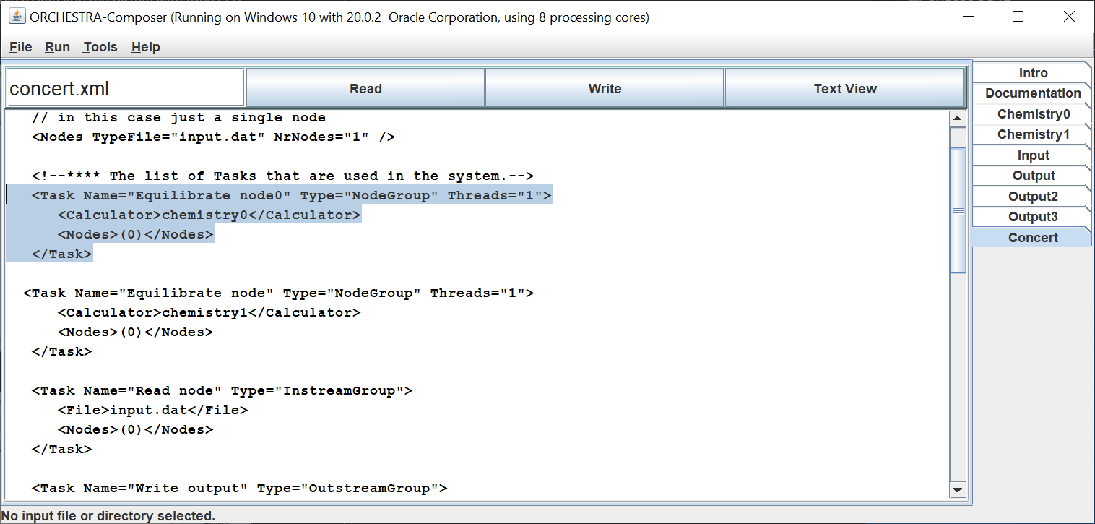
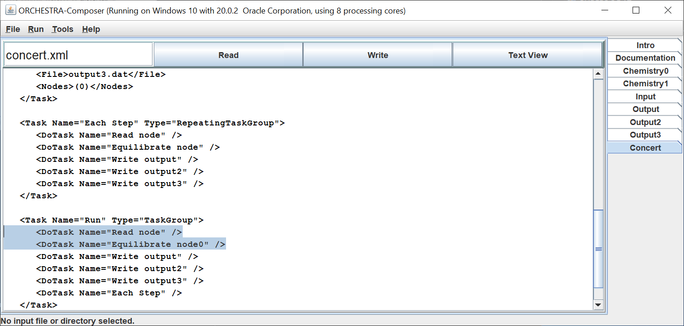

After that the same cell 0 is used in the “Each Step” task to be equilibrated with chemistry1 (given total amount of CO2[g]
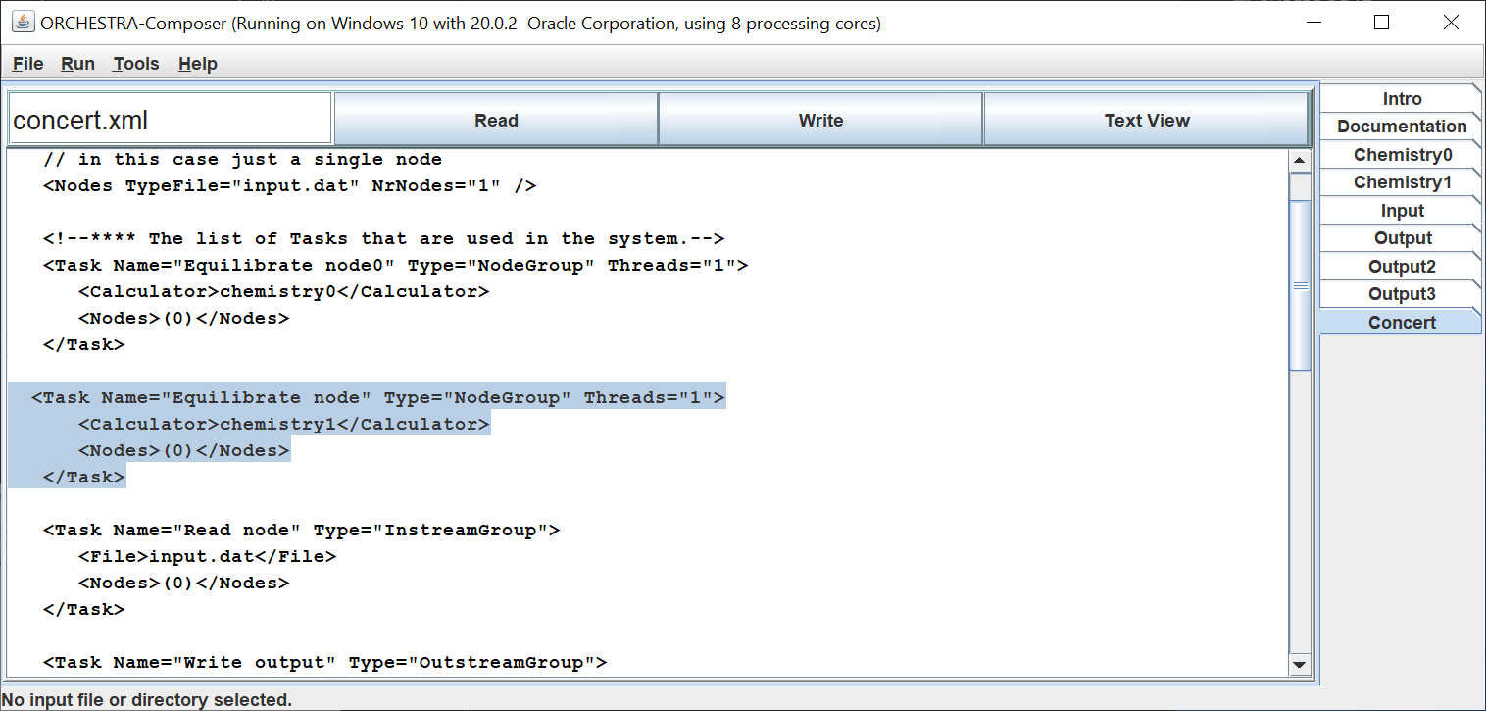
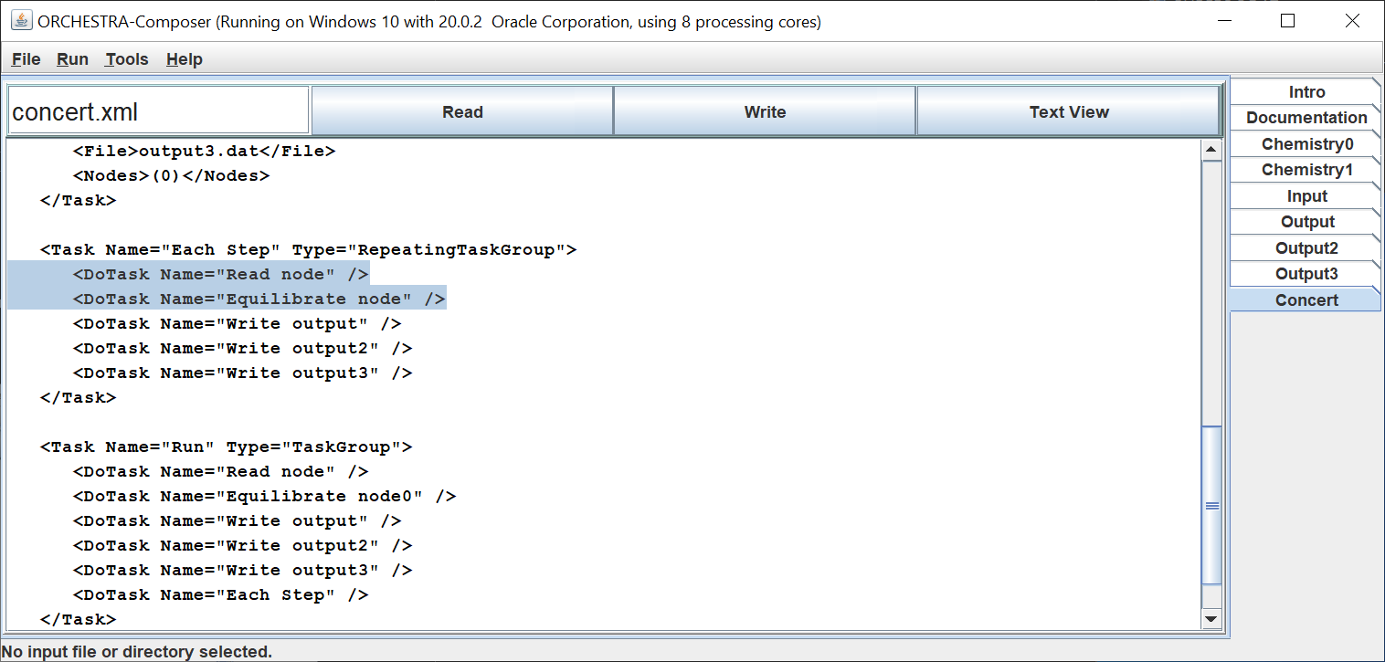

Note that after each calculation, output is written to three different output files.
The output of output2.dat can be directly pasted in Excel to compare the results with PHREEQC.
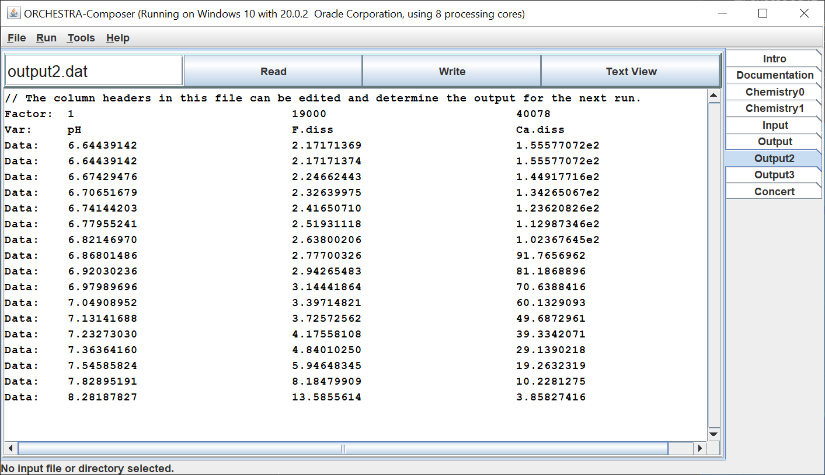

Data and graphs can be found in results.xls in the zipped folder.
The PHREEQC and ORCHESTRA results appear to match very closely.

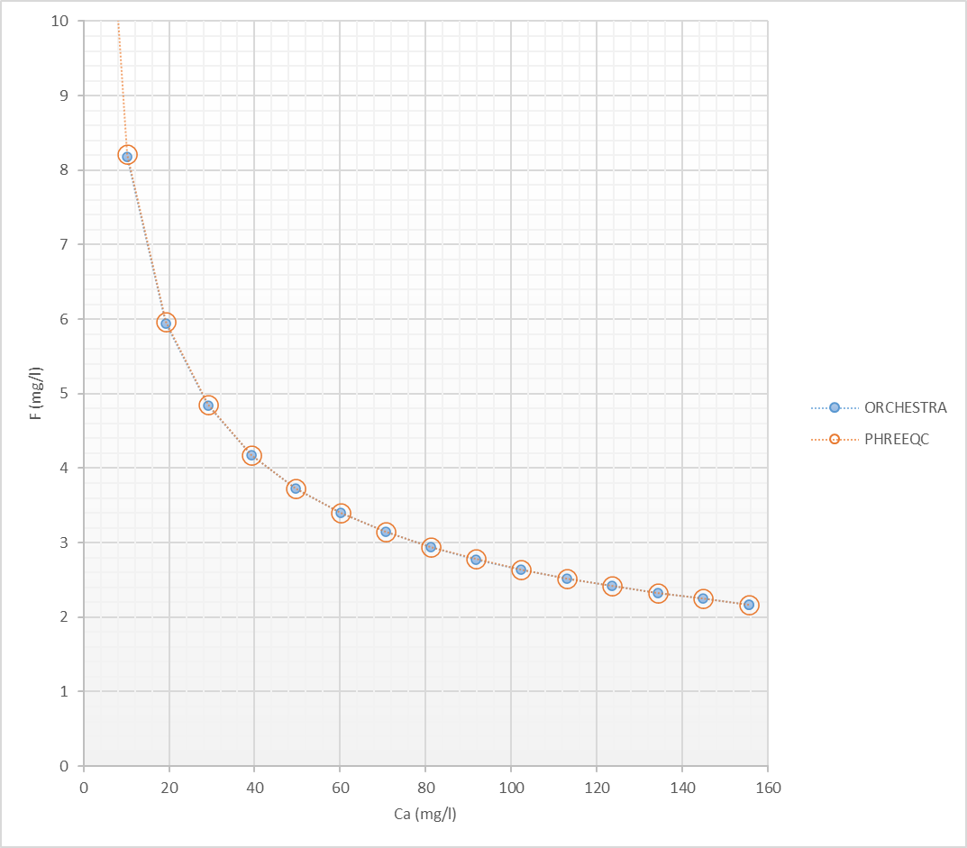

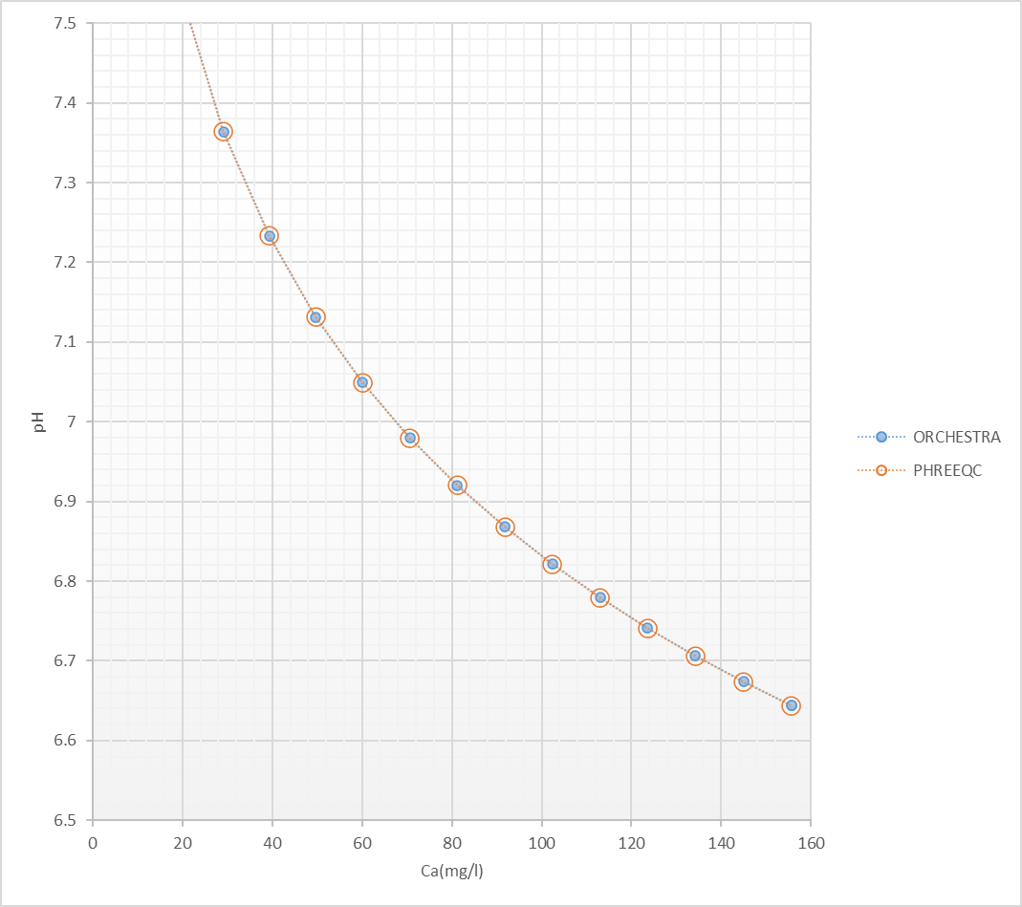

The zipped folder contains all the necessary files (PHREEQC input file, ORCHESTRA complete model and input files) to reproduce the calculations yourself.

