Total number of pages
Total number of questions | @@@
Maximum number of points | @@
Online exam: | Open book, no electronic devices. You are not allowed to work together!
Additional information: | Exam written by hand on paper.

Paper exam
Given the fact that AI models like ChatGPT are now widely used we can no longer do an exam on the computer. This exam will be on paper. Please give your answers together with an explanation.
Please write your answers on one sheet per Assignment. You have been given 3 sheets which should provide you with sufficient space. You do not need to make a report.

1.1 Mass Action Law (10 pts)
In PHREEQC the precipitation/dissolution of Portlandite is given in the data base as follows:

Portlandite
Ca(OH)2 + 2H+ = Ca+2 + 2H2O
log_k 22.804
delta_h -128.62 kJ

Calculate the Gibbs free energy () for this precipitation/dissolution reaction.

Answer 1.1
with R = 8.3145e-03 kJ/(K mol) and T = 298.15 K. Filling in the known parameters gives the answer: 130.17 kJ/mol.

2.1 Lewis Structure of chemical species
You need to give the electron configuration for all the elements in the following list of compounds.
H₂O, H₂CO₃, C₂Cl₄, C₂H₆
You need to write the structure of these compounds as Lewis structures (stick models). Please mark all outer electrons in the structure.
Answer 2.1
H₂O:
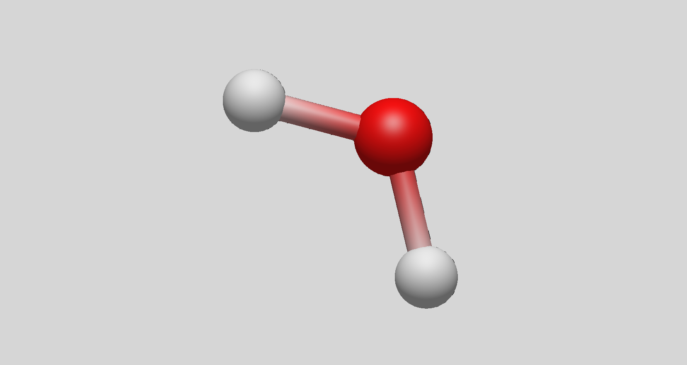

H₂CO₃:
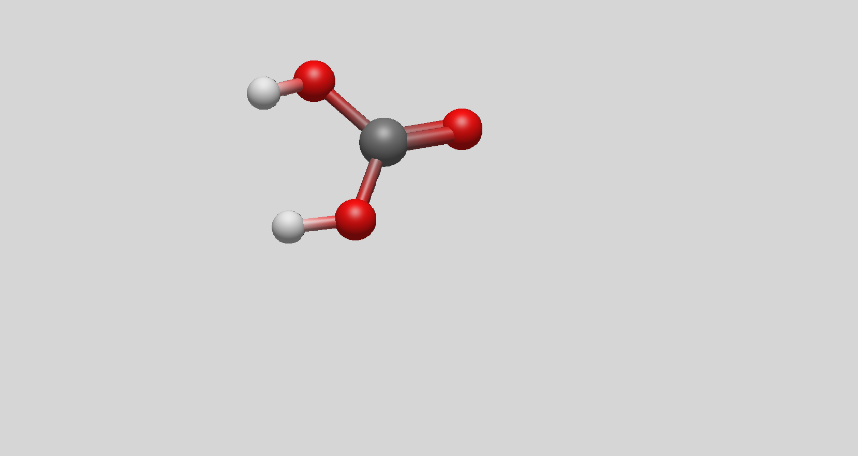

CCl_{4:}
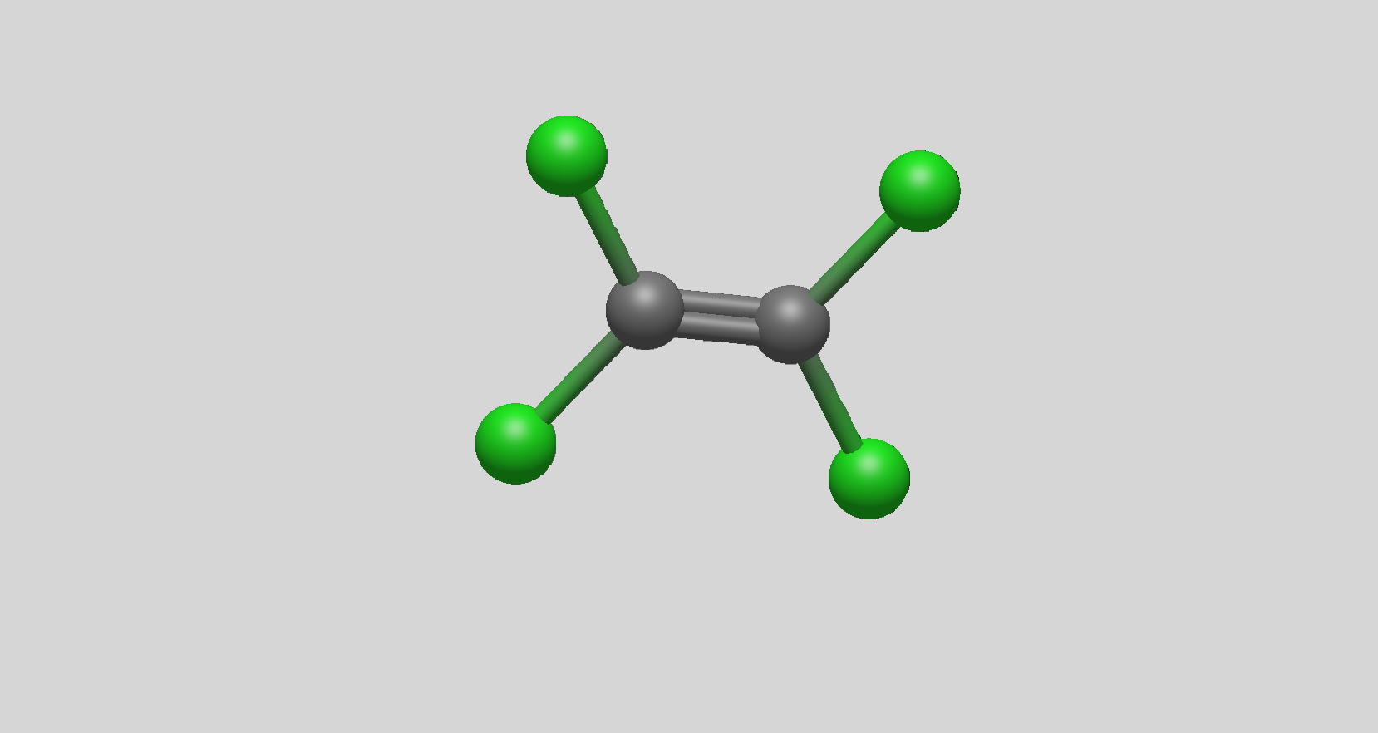
C₂H_{6:}
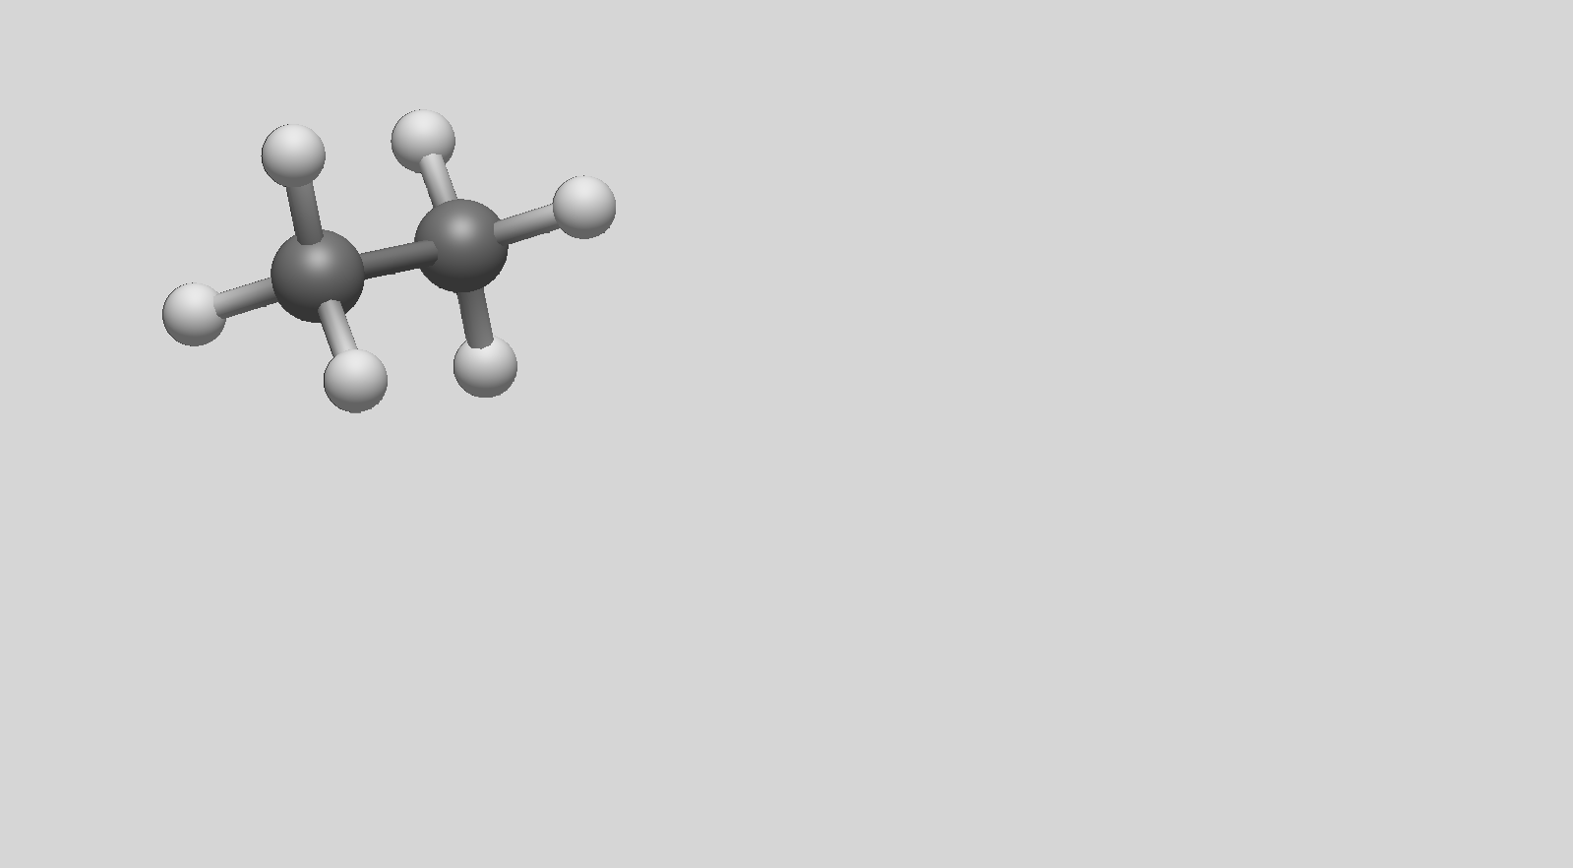

Simulate change due to increase in CO_{2(g)}-pressure due to carbon storage in an aquifer.
In this simulation you calculate what happens in the groundwater when the partial pressure of CO_{2(g)} increases because of the injection of CO₂ in a carbon capture and storage project.
We assume that the rocks in the aquifer are dominated by Calcite and Siderite and that the initial partial CO_{2(g)} pressure is 1 atm. After injection of CO₂ the partial CO_{2(g)} pressure has increased to 4.9 atm. The temperature in the aquifer is 50 ºC.

Assignment 2.1 (15 pts):
Write down the PHREEQC input file you would make for this problem. Please note that you need two simulations:
- The situation before CO₂ injection;
- The situation after CO₂ injection;

Explain what concepts you use and why these concepts are relevant to this problem.

Answer 2.1
First simulation
We need to create a solution where we set the temperature to 50 ºC. This solution is equilibrated with Calcite, Siderite and CO_{2(g)} with with 0 for all saturation indices (mineral equilibrium for the solid phases, SI = log10(1) for the CO2) using and EQUILIBRIUM_ PHASES 1 block. The initial mass is set to 10 moles for all phases.
The result of this simulation is saved in SOLUTION 2.
Key word END closes this simulation

The second simulation uses solution one and a second EQUILIBRIUM_PHASES 2. This one is the same as EQUILIBRIUM_PHASES 1, but the SI value for CO_{2(g)} is set to 0.69 (log10(4.9)).
This simulation saved in SOLUTION 3 and then closed with END.

We use EQUILIBRIUM_PHASES because we may a assume that the gas phase and mineral phases are present in excess.

The input file is:
SOLUTION 1
temp 50
pH 7
pe 4
redox pe
units mmol/kgw
density 1
-water 1 # kg

EQUILIBRIUM_PHASES 1
Calcite 0 10
Siderite 0 10
CO2(g) 0 10

SAVE SOLUTION 2

END
USE SOLUTION 1
EQUILIBRIUM_PHASES 2
CO2(g) 0.69 10
Calcite 0 10
Siderite 0 10

SAVE SOLUTION 3
END

Assignment 2.2 (15 points):
Some excerpts from the PHREEQC output file for the above problem are given in Appendix 1.
Use the results to report on the difference in the dissolved amounts of Siderite and Calcite due to the injection of CO₂.
Give an explanation of the chemical equilibrium reactions causing these changes! Hint: why does the pH change?

Answer 2.2
The first thing we need to check if the simulation results are indeed at equilibrium by checking if all mineral phases potentially present in the system are at 0 or negative Saturation Index. This is indeed the case.

From the output file we see that in the 1 atm case 2.491e-02 moles CO₂ dissolved, 5.511e-03 moles Calcite dissolved and 4.289e-05 moles of Siderite dissolved. And the equilibrium pH was 5.973.

For the 4.9 atm case these numbers are: 1.038e-01 moles dissolved for CO₂, 1.019e-02 moles dissolved for Calcite and 9.366e-05 moles dissolved for Siderite and the pH is 5.536.

Therefore 0.079 moles/kg water more CO₂ dissolves at 4.9 atm, 4.7e-3 moles/kg water more Calcite dissolves and 5e-05 moles/kg water more Rhodochrosite dissolves.

The chemical explanation for this result is that an increase in CO₂ pressure will lead to more CO₂ being dissolved. This binds with water to from H₂CO₃ which then dissociates in to H⁺ and HCO₃⁻ . The increase in acidity moves the equilibrium of HCO₃⁻ ↔ H⁺ + CO₃⁻² to the left, lowering the CO₃⁻² concentration, which then in order to maintain the solubility equilibrium allows more Calcite and Siderite to dissolve.

Change in sample during transport to lab
A water sample is taken from the surface of a spring in the field where we know that the sample is in equilibrium with calcite. The partial pressures of CO_{2(g)} and CH_{4(g)} in the spring water are 0.5 atm and the water temperature is 55 ºC.
A sample of the water is taken in a 1 liter bottle, the bottle is partially filled with 0.85 litres of water and the head-space in the bottle is flushed with nitrogen (Ar_{(g)}) at 1 atm. After flushing the headspace, the bottle is closed and transported to the laboratory where it equilibrates to a temperature of 25 ºC.

Assignment 3.1 (15 pts): Write down a PHREEQC input file you would make to answer the following question: What are the final total and partial pressures in the bottle after equilibration of all gas-phases and and the mineral phases in the laboratory? Please note, the bottle is not opened!
Explain what concepts you use and why these concepts are relevant to this problem.

Answer 3.1
First simulation
We need to create a solution with 0.85 kg water where we set the temperature to 55 ºC. This solution is equilibrated with Calcite where you use SI = 0 and Mass = 10, and CO_{2(g)} and CH_{4(g)} with SI = -0.3 (log10(0.5) and and Mass = 10) with an EQUILIBRIUM_ PHASES 1 block.
The result of this simulation is saved in SOLUTION 2.
Key word END closes this simulation.

The second simulation uses SOLUTION 2, REACTION_TEMPERATURE 1 25, a GAS_PHASE with fixed-volume, initial pressure = 1, volume = 0.25 and initial temperature 55 and CO2(g)= 0 and Ar(g) = 1. Finally we add a second EQUILIBRIUM_PHASES 2 where only Calcite is used with SI = 0 and initial Mass = 0.
This simulation saved in SOLUTION 3 and then closed with END.

In the first simulation we use EQUILIBRIUM_PHASES to equilibrate the water with Calcite and CO2 under in-situ conditions. In the second simulation we use Gas_phase to define the volume of the headspace and the initial conditions (temperature, pressures and composition). We use Reaction_temperature to set the final temperature, we Use Equilibrium_phases 2 to allow calcite to precipitate.

Please note: in order to use Ar(g) we need to change the database. In this case we use the
data in PHREEQC_ThermoddemV1.10_15Dec2020.dat.

The input file is:
DATABASE C:\Program Files (x86)\USGS\Phreeqc Interactive 3.8.6-17100\database\PHREEQC_ThermoddemV1.10_15Dec2020.dat
SOLUTION 1
temp 55
pH 7
pe 4
redox pe
units mmol/kgw
density 1
-water 0.85 # kg

EQUILIBRIUM_PHASES 1
CO2(g) -0.3 10
CH4(g) -0.3 10
Calcite 0 10

SAVE SOLUTION 2
END

USE SOLUTION 2
REACTION_TEMPERATURE 1
25
GAS_PHASE 1
-fixed_volume
-pressure 1
-volume 0.15
-temperature 55
CO2(g) 0
Ar(g) 1
EQUILIBRIUM_Phases 2
Calcite 0 0
END

Assignment 3.2 (15 points): Some excerpts from the PHREEQC output file for the above problem are given in Appendix 2.
- What are the final total pressure and partial pressures?
- How much calcite did precipitate?
- Explain the chemical processes that have taken place in the bottle.

Answer 3.2
In the section of the output where solution 2 is being used we find the following results:
In the Gas phase description we see that the total final pressure in the gas phase is 0.98 atm, the partial pressure of CO2(g) is 0.2181 atm and the partial pressure of Ar(g) is 0.7606 atm.

In the Phase Assemblage and Saturation indices sections we see that the calcite concentration did not change as it remains unsaturated at the lower temperature of 25 degrees C.

When the sample was put in to the bottle and the the headspace was flushed the system was not yet in equilibrium. In the laboratory, the temperature decreased, CO2 degassed and a new equilibrium was found. In degassing the solution, acid (H⁺) was removed from solution.

Exam practice question - Redox chemistry
Materials provided: Table 20.1 from Tro chapter 20
- Consider the following redox reaction occurring in acidic, aqueous solution:
MnO₂ (s) + Cu (s) Cu²⁺ (aq) + Mn²⁺ (aq)
  - Balance this reaction, show the intermediate steps
- Consider the following balanced redox reaction occurring in an electrochemical cell:
Cr (s) + Cd²⁺ (aq) Cr²⁺ (aq) + Cd (s)
  - Calculate E⁰_{cell} (V), K and ΔG_{rxn}⁰ for this reaction.
  - Calculate E_{cell} (V), Q and ΔG_{rxn} if [Cd²⁺] = 1.00 * 10⁻⁵ M and [Cr²⁺] = 1.00 M
- Consider the following Pourbaix diagram (Figure 9.6) and associated redox reactions and log K values (Table 9.4). Derive the equation describing the boundary between NH₄⁺ and N₂, using the information provided in the table and the figure.
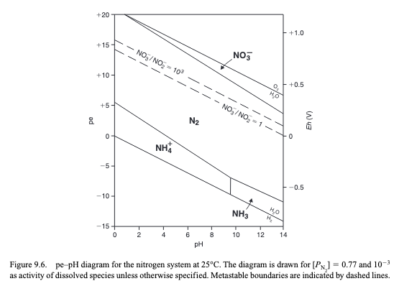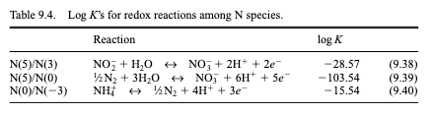
Answers Exam practice question - Redox chemistry
Materials provided: Table 20.1 from Tro chapter 20
- Consider the following redox reaction occurring in acidic, aqueous solution:
MnO₂ (s) + Cu (s) Cu²⁺ (aq) + Mn²⁺ (aq)
  - Balance this reaction, show the intermediate steps
  - Calculate E⁰_{cell} (V) for this reaction
  - Calculate K for this reaction
- Consider the following balanced redox reaction occurring in an electrochemical cell:
Cr (s) + Cd²⁺ (aq) Cr²⁺ (aq) + Cd (s)
  - Calculate E⁰_{cell} (V), K and ΔG_{rxn}⁰ for this reaction.
  - Calculate E_{cell} (V), Q and ΔG_{rxn} if [Cd²⁺] = 1.00 * 10⁻⁵ M and [Cr²⁺] = 1.00 M
- Consider the following Pourbaix diagram (Figure 9.6) and associated redox reactions and log K values (Table 9.4). Derive the equation describing the boundary between NH₄⁺ and N₂, using the information provided in the table and the figure.


Appendix 1: PHREEQC output for assignment 2

…
…
-----------------------------------------
Beginning of batch-reaction calculations.
-----------------------------------------

Reaction step 1.

Using solution 1.
Using pure phase assemblage 1.

-------------------------------Phase assemblage--------------------------------

Moles in assemblage
Phase SI log IAP log K(T, P) Initial Final Delta

CO2(g) -0.00 -1.71 -1.71 1.000e+01 9.975e+00 -2.491e-02
Calcite 0.00 -8.74 -8.74 1.000e+01 9.994e+00 -5.511e-03
Siderite 0.00 -11.03 -11.03 1.000e+01 1.000e+01 -4.289e-05

-----------------------------Solution composition------------------------------

Elements Molality Moles

C 3.046e-02 3.046e-02
Ca 5.512e-03 5.511e-03
Fe 4.289e-05 4.289e-05

----------------------------Description of solution----------------------------

pH = 5.973 Charge balance
pe = -1.678 Adjusted to redox equilibrium
Specific Conductance (uS/cm, 50oC) = 1553
Density (g/cm3) = 0.98886
Volume (L) = 1.01293
Viscosity (mPa s) = 0.56200
Activity of water = 0.999
Ionic strength (mol/kgw) = 1.587e-02
Mass of water (kg) = 9.999e-01
Total alkalinity (eq/kg) = 1.111e-02
Total CO2 (mol/kg) = 3.046e-02
Temperature (oC) = 50.00
Electrical balance (eq) = -4.476e-07
Percent error, 100*(Cat-|An|)/(Cat+|An|) = -0.00
Iterations = 13
Total H = 1.110124e+02
Total O = 5.557269e+01

----------------------------Distribution of species----------------------------
…
…
------------------------------Saturation indices-------------------------------

Phase SI** log IAP log K(323 K, 1 atm)

Aragonite -0.20 -8.74 -8.54 CaCO3
Calcite 0.00 -8.74 -8.74 CaCO3
CH4(g) -11.97 -14.93 -2.96 CH4
CO2(g) -0.00 -1.71 -1.71 CO2 Pressure 1.0 atm, phi 0.996
Fe(OH)3(a) -5.92 -1.03 4.89 Fe(OH)3
Goethite 0.79 -1.03 -1.82 FeOOH
H2(g) -8.70 -11.84 -3.14 H2
H2O(g) -0.92 -0.00 0.92 H2O
Hematite 3.69 -2.07 -5.76 Fe2O3
O2(g) -58.23 -61.26 -3.03 O2
Siderite 0.00 -11.03 -11.03 FeCO3

**For a gas, SI = log10(fugacity). Fugacity = pressure * phi / 1 atm.
For ideal gases, phi = 1.

------------------
End of simulation.
------------------
------------------------------------
Reading input data for simulation 2.
------------------------------------
…
…
-----------------------------------------
Beginning of batch-reaction calculations.
-----------------------------------------

Reaction step 1.

Using solution 1.
Using pure phase assemblage 2.

-------------------------------Phase assemblage--------------------------------

Moles in assemblage
Phase SI log IAP log K(T, P) Initial Final Delta

CO2(g) 0.68 -1.03 -1.71 1.000e+01 9.896e+00 -1.038e-01
Calcite 0.00 -8.74 -8.74 1.000e+01 9.990e+00 -1.019e-02
Siderite 0.00 -11.03 -11.03 1.000e+01 1.000e+01 -9.366e-05

-----------------------------Solution composition------------------------------

Elements Molality Moles

C 1.141e-01 1.141e-01
Ca 1.019e-02 1.019e-02
Fe 9.368e-05 9.366e-05

----------------------------Description of solution----------------------------

pH = 5.536 Charge balance
pe = -1.142 Adjusted to redox equilibrium
Specific Conductance (uS/cm, 50oC) = 2672
Density (g/cm3) = 0.99002
Volume (L) = 1.01573
Viscosity (mPa s) = 0.58084
Activity of water = 0.998
Ionic strength (mol/kgw) = 2.862e-02
Mass of water (kg) = 9.998e-01
Total alkalinity (eq/kg) = 2.056e-02
Total CO2 (mol/kg) = 1.141e-01
Temperature (oC) = 50.00
Electrical balance (eq) = -4.477e-07
Percent error, 100*(Cat-|An|)/(Cat+|An|) = -0.00
Iterations = 13
Total H = 1.110124e+02
Total O = 5.574469e+01

----------------------------Distribution of species----------------------------
…
…

------------------------------Saturation indices-------------------------------

Phase SI** log IAP log K(323 K, 1 atm)

Aragonite -0.20 -8.74 -8.54 CaCO3
Calcite 0.00 -8.74 -8.74 CaCO3
CH4(g) -12.08 -15.03 -2.96 CH4
CO2(g) 0.68 -1.03 -1.71 CO2 Pressure 4.9 atm, phi 0.979
Fe(OH)3(a) -6.51 -1.62 4.89 Fe(OH)3
Goethite 0.20 -1.62 -1.82 FeOOH
H2(g) -8.90 -12.04 -3.14 H2
H2O(g) -0.92 -0.00 0.92 H2O
Hematite 2.52 -3.23 -5.76 Fe2O3
O2(g) -57.83 -60.86 -3.03 O2
Siderite 0.00 -11.03 -11.03 FeCO3

**For a gas, SI = log10(fugacity). Fugacity = pressure * phi / 1 atm.
For ideal gases, phi = 1.

------------------
End of simulation.
------------------

------------------------------------
Reading input data for simulation 3.
------------------------------------

-------------------------------
End of Run after 0.619 Seconds.
-------------------------------
Appendix 2: PHREEQC output for assignment 3

…
…

-----------------------------------------
Beginning of batch-reaction calculations.
-----------------------------------------

Reaction step 1.

Using solution 1.
Using pure phase assemblage 1.

-------------------------------Phase assemblage--------------------------------

Moles in assemblage
Phase SI log IAP log K(T, P) Initial Final Delta

CH4(g) -0.30 -3.31 -3.01 1.000e+01 1.000e+01 -4.130e-04
CO2(g) -0.30 -8.33 -8.03 1.000e+01 9.989e+00 -1.106e-02
Calcite 0.00 1.40 1.40 1.000e+01 9.997e+00 -3.404e-03

-----------------------------Solution composition------------------------------

Elements Molality Moles

C 1.750e-02 1.487e-02
Ca 4.005e-03 3.404e-03

----------------------------Description of solution----------------------------

pH = 6.171 Charge balance
pe = -3.815 Adjusted to redox equilibrium
Activity of water = 1.000
Ionic strength (mol/kgw) = 1.158e-02
Mass of water (kg) = 8.499e-01
Total alkalinity (eq/kg) = 8.011e-03
Total CO2 (mol/kg) = 1.701e-02
Temperature (oC) = 55.00
Electrical balance (eq) = -5.049e-07
Percent error, 100*(Cat-|An|)/(Cat+|An|) = -0.00
Iterations = 13
Total H = 9.436746e+01
Total O = 4.721523e+01

----------------------------Distribution of species----------------------------
…
…
------------------------------Saturation indices-------------------------------

Phase SI** log IAP log K(328 K, 1 atm)

Aragonite -0.17 1.40 1.57 CaCO3
C(element) 1.44 59.25 57.80 C
Ca(element) -83.13 43.52 126.64 Ca
Calcite 0.00 1.40 1.40 CaCO3
CH4(g) -0.30 -3.31 -3.01 CH4
CO(g) -8.56 -11.71 -3.15 CO
CO2(g) -0.30 -8.33 -8.03 CO2
H2(g) -4.72 33.79 38.51 H2
H2O(g) -0.81 -0.00 0.81 H2O
Lime -19.86 9.73 29.59 CaO
Monohydrocalcite -1.00 1.40 2.40 CaCO3:H2O
O2(g) -64.53 -67.58 -3.04 O2
Portlandite -11.00 9.73 20.73 Ca(OH)2
Vaterite -0.53 1.40 1.93 CaCO3

**For a gas, SI = log10(fugacity). Fugacity = pressure * phi / 1 atm.
For ideal gases, phi = 1.

------------------
End of simulation.
------------------

------------------------------------
Reading input data for simulation 2.
------------------------------------
…
…

-----------------------------------------
Beginning of batch-reaction calculations.
-----------------------------------------

Reaction step 1.

Using solution 2. Solution after simulation 1.
Using pure phase assemblage 2.
Using gas phase 1.
Using temperature 1.

-----------------------------------Gas phase-----------------------------------

Total pressure: 0.98 atmospheres
Gas volume: 1.50e-01 liters
Molar volume: 2.50e+01 liters/mole

Moles in gas
----------------------------------
Component log P P Initial Final Delta

Ar(g) -0.12 7.606e-01 5.570e-03 4.663e-03 -9.070e-04
CO2(g) -0.66 2.181e-01 0.000e+00 1.337e-03 1.337e-03

-------------------------------Phase assemblage--------------------------------

Moles in assemblage
Phase SI log IAP log K(T, P) Initial Final Delta

Calcite -0.28 1.56 1.85 0.000e+00 0 0.000e+00

-----------------------------Solution composition------------------------------

Elements Molality Moles

Ar 1.067e-03 9.070e-04
C 1.593e-02 1.354e-02
Ca 4.005e-03 3.404e-03

----------------------------Description of solution----------------------------

pH = 6.325 Charge balance
pe = -3.488 Adjusted to redox equilibrium
Activity of water = 1.000
Ionic strength (mol/kgw) = 1.152e-02
Mass of water (kg) = 8.499e-01
Total alkalinity (eq/kg) = 8.011e-03
Total CO2 (mol/kg) = 1.544e-02
Temperature (oC) = 25.00
Pressure (atm) = 0.98
Electrical balance (eq) = -5.049e-07
Percent error, 100*(Cat-|An|)/(Cat+|An|) = -0.00
Iterations = 9
Total H = 9.436746e+01
Total O = 4.721255e+01

----------------------------Distribution of species----------------------------
…
…

------------------------------Saturation indices-------------------------------

Phase SI** log IAP log K(298 K, 1 atm)

Ar(g) -0.12 -2.97 -2.85 Ar
Aragonite -0.45 1.56 2.01 CaCO3
C(element) 2.00 66.16 64.16 C
Ca(element) -92.48 47.37 139.84 Ca
Calcite -0.28 1.56 1.85 CaCO3
CH4(g) -0.46 -3.31 -2.85 CH4
CO(g) -9.85 -12.88 -3.03 CO
CO2(g) -0.66 -8.48 -7.82 CO2
H2(g) -5.68 37.32 43.00 H2
H2O(g) -1.51 -0.00 1.51 H2O
Lime -22.66 10.04 32.70 CaO
Monohydrocalcite -1.17 1.56 2.73 CaCO3:H2O
O2(g) -71.75 -74.64 -2.89 O2
Portlandite -12.77 10.04 22.81 Ca(OH)2
Vaterite -0.86 1.56 2.43 CaCO3

**For a gas, SI = log10(fugacity). Fugacity = pressure * phi / 1 atm.
For ideal gases, phi = 1.

------------------
End of simulation.
------------------

------------------------------------
Reading input data for simulation 3.
------------------------------------

-------------------------------
End of Run after 0.546 Seconds.
-------------------------------

