

**引查** **TEST**



|  |
| --- |
| **LISTENING TEST**  In the Listening test,you will be asked to demonstrate how well you understand spoken  English.The entire Listening test will last approximately 45 minutes.There are four parts,and directions are given for each part.You must mark your answers on the separate answer sheet. Do not write your answers in your test book  **PART 1**  **Directions:** For each question in this part,you will hear four statements about a picture in your test book.When you hear the statements,you must select the one statement that best  describes what you see in the picture.Then find the number of the question on your answer sheet and mark your answer.The statements will not be printed in your test book and wil be spoken only one time.    Statement (C),“They re sitting at a table,”is the best description of the picture,so you should select answer (C)and mark it on your answer sheet. |

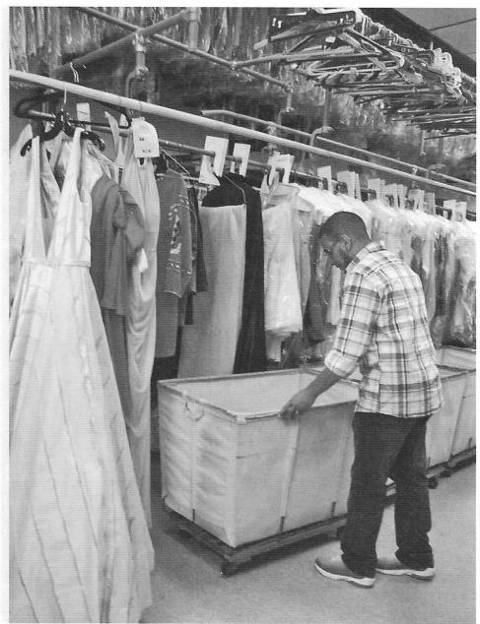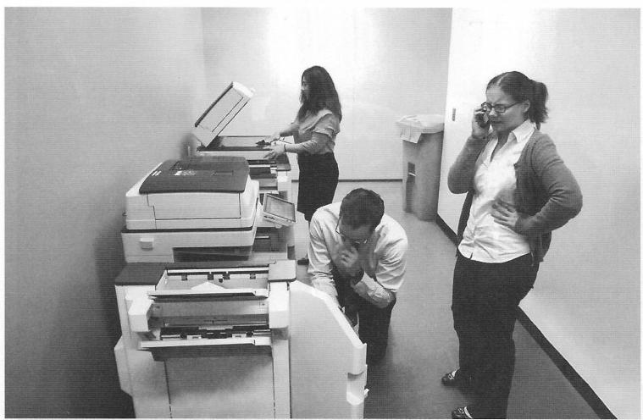

TEST 2

1.



2.

**GO ON TO THF NFXT PAGE**

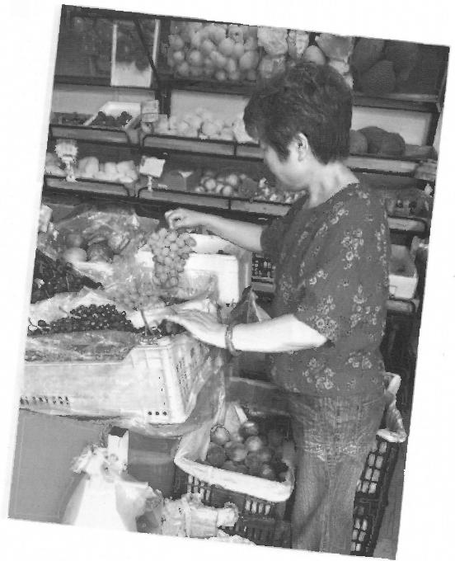3.

**61** **311**

**430100100101000**

4 ie

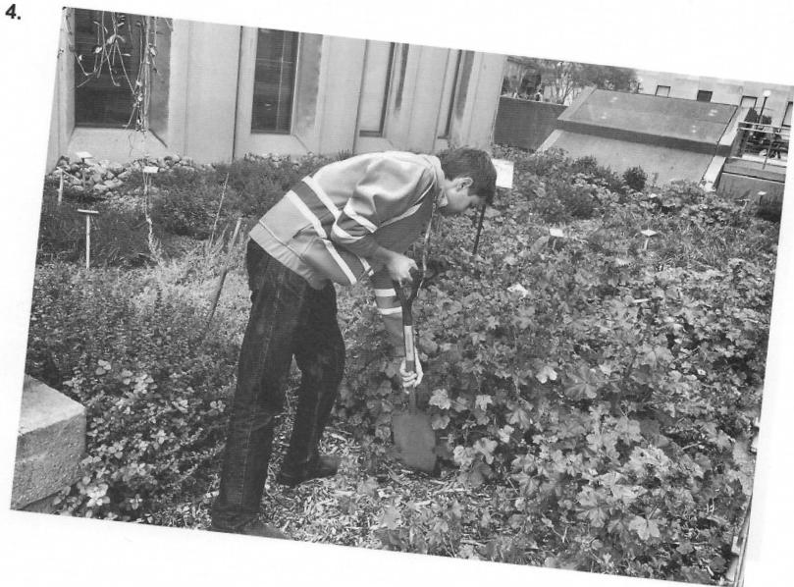

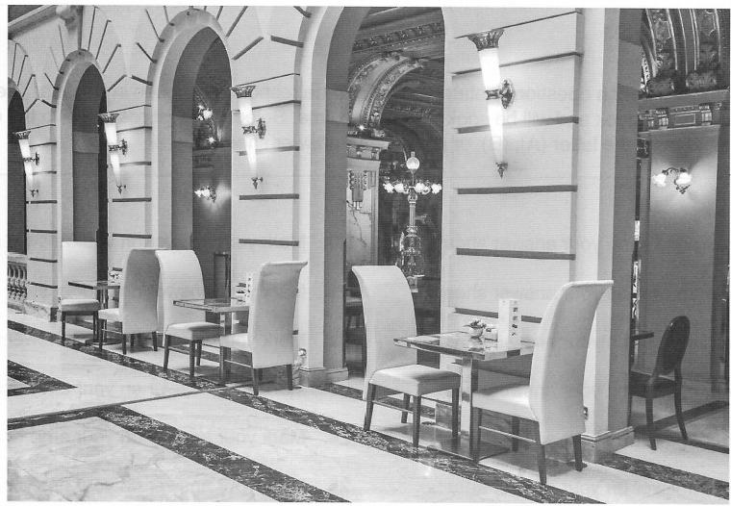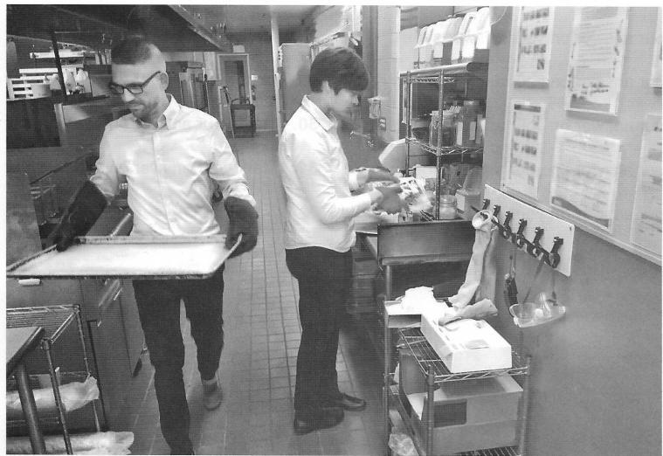

TEST 2

**5.**



**6.**

**GO ON TO THE NEXT PAGE**

|  |
| --- |
| **PART 2**  **Directions:** You will hear a question or statement and three responses spoken in English.They will not be printed in your test book and will bespoken only one time.Select the best response to the question or statement and mark the letter (A),(B),or (C)on your answer sheet. |

**7.** Mark your answer on your answer sheet. **8.** Mark your answer on your answer sheet.  **9.** Mark your answer on your answer sheet. **10.** Mark your answer on your answer sheet. 11.Mark your answer on your answer sheet. 12.Mark your answer on your answer sheet. 13.Mark your answer on your answer sheet. 14.Mark your answer on your answer sheet. 15.Mark your answer on your answer sheet. 16.Mark your answer on your answer sheet. 17.Mark your answer on your answer sheet. 18.Mark your answer on your answer sheet.

19.Mark your answer on your answer sheet.

**20** .Mark your answer on your answer sheet. 21.Mark your answer on your answer sheet. **22.** Mark your answer on your answer sheet. **23.** Mark your answer on your answer sheet. **24.** Mark your answer on your answer sheet. 25.Mark your answer on your answer sheet. 26.Mark your answer on your answer sheet. 27.Mark your answer on your answer sheet. 28.Mark your answer on your answer sheet. 29.Mark your answer on your answer sheet. 30.Mark your answer on your answer sheet.

31.Mark your answer on your answer sheet.



TEST 2

|  |
| --- |
| **PART 3**  **Directions:** You will hear some conversations between two or more people.You will be asked to  answer three questions about what the speakers say in each conversation.Select the best response to each question and mark the letter (A),(B),(C),or (D)on your answer sheet.The conversations will not be printed in your test book and will bespoken only one time. |

**32.** Why does the man want to buy

Ms.Jefferson some flowers?

(A)She was promoted.

(B)She won an award.

(C)She is moving

(D)She is retiring

**33.** According to the woman,where is

Greenwood Flower Shop?

(A)In a shopping mall

(B)In a train station

(C)Next to a café

(D)Across from the library

**34.** What does the man say he will do before he leaves the office?

(A)Fill out a time sheet

(B)Send an e-mail

(C)Finish a budget proposal

(D)Arrange a meeting

**35.** What did the man just do?

(A)He upgraded a flight.

(B)He arranged for a rental car.

(C)He prepared some presentation slides. (D)He made a hotel reservation.

**36.** What does the man remind the woman to do?

(A)Save her receipts

(B)Bring her ID badge

(C)Sign a form

(D)Arrive early

**37.** What does the woman ask the man about?

(A)A bank

(B)A post office

(C)A restaurant

(D)A conference center

**38.** What industry do the speakers most likely

work in?

(A)Television

(B)Fashion

(C)Home furnishings

(D)Advertising

**39.** What does the man suggest doing?

(A)Providing tours of a facility

(B)Opening a branch office

(C)Designing special fabric

(D)Installing brighter lights

**40.** What is the woman concerned about?

(A)A plan would be time-consuming.

(B)A color is too bright.

(C)Some sales figures have declined.

(D)Some supplies will be expensive.

**41.** What problem is being discussed?

(A)A company manual contains some

errors.

(B)A shipment was not delivered on time.

(C)Some materials are missing from a

cabinet.

(D)An e-mail system is not functioning

properly.

**42.** Who most likely is the man?

(A)A computer technician

(B)A security guard

(C)A warehouse manager

(D)A sales representative

**43.** What are the women most likely planning to

do next?

(A)Sign a contract

(B)Attend a training

(C)Go to the airport

(D)Revise a presentation

**GO ON TO THE NEXT PAGE** ,



**44.** Where does the woman work?

(A)At an amusement park

(B)At a fitness center

(C)At a bicycle-tour company

(D)At an automobile dealership

**45.** Why is the man unable to make a

reservation for next Thursday?

(A)A calendar is fully booked.

(B)An employee is on vacation.

(C)Some roads will be closed.

(D)Some equipment will be replaced.

**46.** What will the man most likely do next?

(A)Pick up a brochure

(B)Make a down payment

(C)Provide a membership number

(D)Write a customer review

**47.** Who is the man?

(A)A news reporter

(B)A photographer

(C)A fashion designer

(D)A translator

**48.** Why does the woman say,"The issue is already being printed"?

(A)To apologize for an error

(B)To provide reassurance

(C)To indicate a schedule change

(D)To decline an offer

**49.** What does the woman ask the man to do?

(A)Come in for an interview

(B)Appear in a feature story

(C)Travel for an assignment

(D)Post some information online

**50.** What kind of business do the speakers most likely work for?

(A)An automobile manufacturer

(B)An insurance company

(C)A county hospital

(D)A construction firm

**51.** What problem do the women mention?

(A)A building site did not pass an

inspection.

(B)A vehicle needs to be repaired. (C)Potential clients have not made a

decision.

(D)Some vendors are making late

deliveries.

**52.** What does the man recommend?

(A)Offering a discount

(B)Changing suppliers

(C)Forming a committee

(D)Closing a branch

**53.** What has the woman volunteered to do? (A)Try out some new products

(B)Purchase beverages for a luncheon (C)Lead a workshop session

(D)Organize a hiring event

**54** .What does the man ask the woman to sign?

(A)An employee contract

(B)An attendance sheet

(C)A participant agreement

(D)A service estimate

**55.** What will the woman most likely do next?

(A)Set up her computer

(B)Go to another room

(C)Have some lunch

(D)Make a phone call



TEST 

**56** .Where most likely are the speakers?

(A)At a hair salon

(B)At a catering hall

(C)At a laundry service

(D)At an energy company

**57.** Why does the woman say,"they don't have as many clients,though"?

(A)To express pride in her company's growth

(B)To explain why an expense is so high

(C)To suggest that a strategy should

continue

(D)To question the accuracy of a client list

**58.** What will happen later today?

(A)Some supplies will be delivered.

(B)An inspection will be conducted.

(C)An employee meeting will beheld. (D)An expense report will be submitted.

**59.** Which industry do the speakers most likely work in?

(A)Tourism

(B)Agriculture

(C)Education

(D)Engineering

**60.** What does the man say he is concerned about?

(A)Expenses

(B)Safety

(C)Competition

(D)Space

**61.** What does the man agree to do?

(A)Apply for some funding

(B)Do some research

(C)Organize a business trip

(D)Assemble a work crew

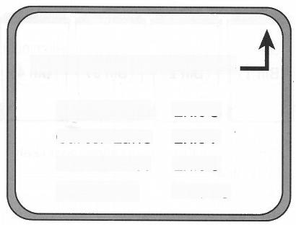

**HARTSVILLE EXITS**

Maple Road Exit 5

Carter Lane Exit 7

Berk Street Exit 8

High Road Exit 10

**62.** What does the woman remind the man

about?

(A)She used to live in the area.

(B)She needs to stop at a store.

(C)She attended a seminar last year.

(D)She has just bought a new car.

**63.** Look at the graphic.Which exit will the

speakers take?

(A)Maple Road

(B)Carter Lane

(C)Berk Street

(D)High Road

**64.** What will the man ask his coworkers to do?

(A)Cancel a reservation

(B)Save some seats

(C)Sign in at an event

(D)Print some materials

***GO ON TO THE NEXT PAGF***





(D)Rescheduling an appointment with a



Aluminum

Plastic Bin 2)

Paper (Bin3)

Glass

Bin 1

Bin4

**65.** Where does the conversation most likely take place?

(A)At a hotel

(B)At an accounting firm

(C)At a doctor's office

(D)At a school

**66.** Look at the graphic.Which bin will the man use?

(A)Bin 1

(B)Bin 2

(C)Bin 3

(D)Bin 4

**67.** What does the woman suggest?

(A)Using a cart

(B)Waiting for a confirmation

(C)Giving an assignment to a colleague

client



nvitation draf+

**Date:** Friday,August 10

**Location:** Davis Botanical Garden

·5:00 PM. Garden Tour

·6:00 PM. Dinner

·7:00 PM. Live Music

·8:00 PM. Speeches

**68** .What type of event are the speakers organizing?

(A)An award ceremony

(B)A grand-opening celebration

(C)A foreign official's reception

(D)A fund-raiser

**69.** Look at the graphic.What time does the

man think the music should begin?

(A)At 5:00 P.M.

(B)At 6:00 P.M

(C)At 7:00 P.M.

(D)At 8:00 P.M.

**70.** What information does the man suggest adding to the invitation?

(A)The name of a sponsor

(B)The location of a concert hall

(C)A Web site address

(D)A list of performers



TEST 2

|  |
| --- |
| **PART 4**  **Directions:** You will hear some talks given by a single speaker.You will be asked to answer three  questions about what the speaker says in each talk.Select the best response to each question and  mark the letter (A),(B),(C),or(D)on your answer sheet.The talks will not be printed in your test book and will bespoken only one time. |

**71.** What did Starbright Corporation recently do?

(A)It changed its company logo.

(B)It opened a new factory.

(C)It conducted a financial audit.

(D)It upgraded a product line.

**72.** What type of product does Starbright

Corporation make?

(A)Footwear

(B)Cosmetics

(C)Housewares

(D)Electronics

**73.** What is available online?

(A)An application

(B)A schedule

(C)A video interview

(D)A virtual tour

**74.** What event is taking place?

(A)An orientation session

(B)A gallery opening

(C)An awards ceremony

(D)A retirement party

**75.** What type of business does Mustafa Perez work for?

(A)An advertising agency

(B)An art gallery

(C)A newspaper publisher

(D)A camera shop

**76.** What has the speaker created for the event?

(A)A slideshow

(B)A T-shirt design

(C)A Web site

(D)A brochure

77.What does the speaker's company produce?

(A)Medications

(B)Textbooks

(C)Exercise clothing

(D)Construction materials

78.What are the listeners reminded to do?

(A)Recruit some staff

(B)Enter some data

(C)Attend some training sessions

(D)Turn on a fan

**79.** What can be found online?

(A)A product database

(B)An employee directory

(C)A handbook

(D)A contract

**80.** What wil the speaker do at a park?

(A)Watch a performance

(B)Sell fruit

(C)Plant trees

(D)Take photographs

**81.** Why does the speaker say,"but it's

supposed to be cloudy all day"?

(A)To ask for help

(B)To express frustration

(C)To reject the listener's suggestion

(D)To reassure the listener

**82.** What does the speaker remind the listener

to do?

(A)Register for a competition

(B)Purchase some supplies

(C)Prepare a shipment

(D)Speak to a customer

***GO ON TO THE NEXT PAGE***



**83.** Where is the announcement being made?

(A)At a technology firm

(B)At a repair shop

(C)At a factory

(D)At a law office

**84.** Where should the listeners go at the end of their shifts?

(A)To the company cafeteria

(B)To the receptionist's desk

(C)To the locker room

(D)To the parking area

**85.** What will happen tomorrow?

(A)Some office furniture will be delivered. (B)New board members will be elected. (C)A city official will conduct an inspection.

(D)Some time-reporting software will be fixed.

**86.** Where do the listeners work?

(A)At an employment agency

(B)At a sports arena

(C)At a conference center

(D)At a medical clinic

**87.** What does the speaker imply when she

says,“Ms.Jenkins has retired”?

(A)A role needs to be filled.

(B)An e-mail will not be answered.

(C)A marketing strategy should be revised. (D)A process will be less efficient.

**88** .What will the listeners most likely do next?

(A)Check a schedule

(B)Complete a registration form

(C)Eat a meal

(D)Brainstorm some ideas

89.What is scheduled for Friday?

(A)A job fair

(B)A wellness workshop

(C)A client meeting

(D)An employee luncheon

90.Why does the speaker say,"the advertising business is very competitive"?

(A)To explain a decision to retire

(B)To justify an employee's promotion

(C)To question the listener's abilities

(D)To express confidence in an approach

**91.** What does the speaker say about Isabel? (A)She has recently joined the company. (B)She can recommend some activities. (C)She will approve expense reports.

(D)She used to work on the NVC Industries account.

**92.** What type of business does the speaker most likely work for?

(A)A television studio

(B)A hardware store

(C)A publishing company

(D)A grocery store

**93.** What is the speaker concerned about? (A)A business has lost customers.

(B)An advertising plan has not been

effective.

(C)A stockroom is overcrowded.

(D)A Web site is not working.

**94.** What does the speaker plan to do?

(A)Transfer to another location

(B)Offer discounts online

(C)Hire more employees

(D)Add videos to a Web site



TEST

|  |  |  |
| --- | --- | --- |
| **List** **of** **Fees** | **Paid** | **Not** **paid** |
| Filing $50.00 |  |  |
| Contract processing: $250.00 |  | √ |
| Vehicle title $125.00 |  | √ |
| Vehicle registration $100.00 |  |  |

**95.** Who most likely is the speaker?

(A)A car salesperson

(B)An auto mechanic

(C)A car rental agent

(D)Avehicle inspector

**96.** Look at the graphic.Which fee must be paid in cash?

(B)Contract processing

(A)Filing

(C)Vehicle title

(D)Vehicle registration

**97.** What service does the speaker remind the listener about?

(A)Shuttle service

(B)Maintenance reminders

(C)Free car washes

(D)Replacement keys

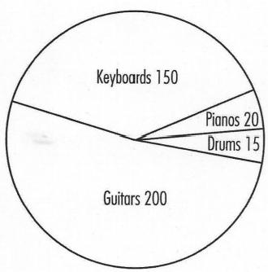

**98.** Who most likely is the speaker?

(A)A jazz singer

(B)A music teacher

(C)A shop manager

(D)A radio host

**99.** What event will take place in September?

(A)A music festival

(B)A press conference

(C)A charity dinner

(D)A talent contest

**100.** Look at the graphic.Which type of

instrument does the speaker focus on?

(A)Keyboards

(B)Pianos

(C)Drums

(D)Guitars

N

**This is the end of the Listening test.**