Lab
Friday, March 1, 2024
10:44 AM

Solution :
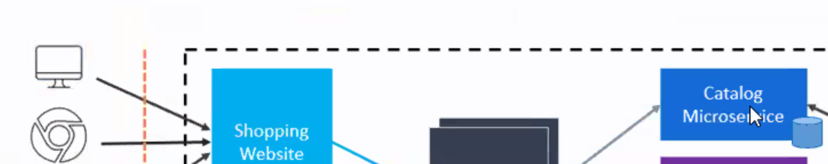
Start integrate one by one all patterns
In early stage , MVC , Web API would be communicating with First created few Microservices

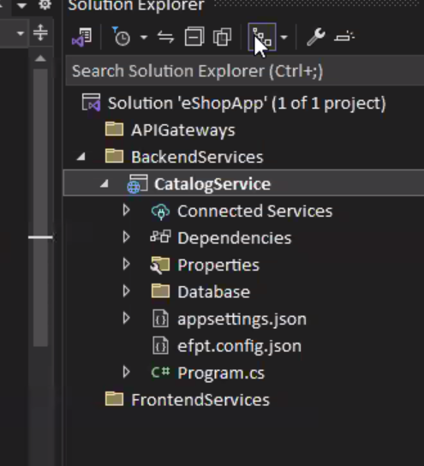
Database and Controllers folders are added in .Net Core project template to make it to act for Database pattern microservice and Web API

Creating API Gateway :
ASP.Net Empty is the template

Configuring OCELOT (as service dependency) :
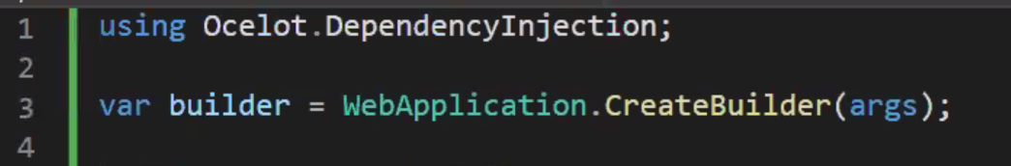

Add ocelot as middleware :


Add Ocelot now :
Integration Pattern
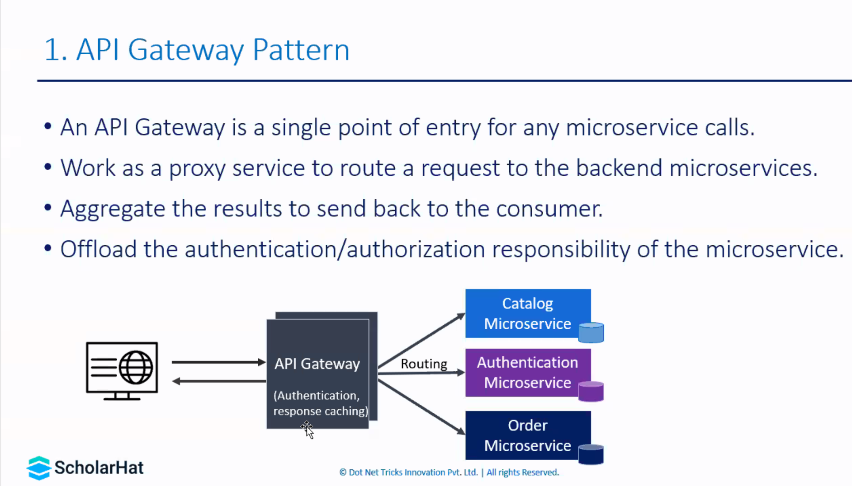

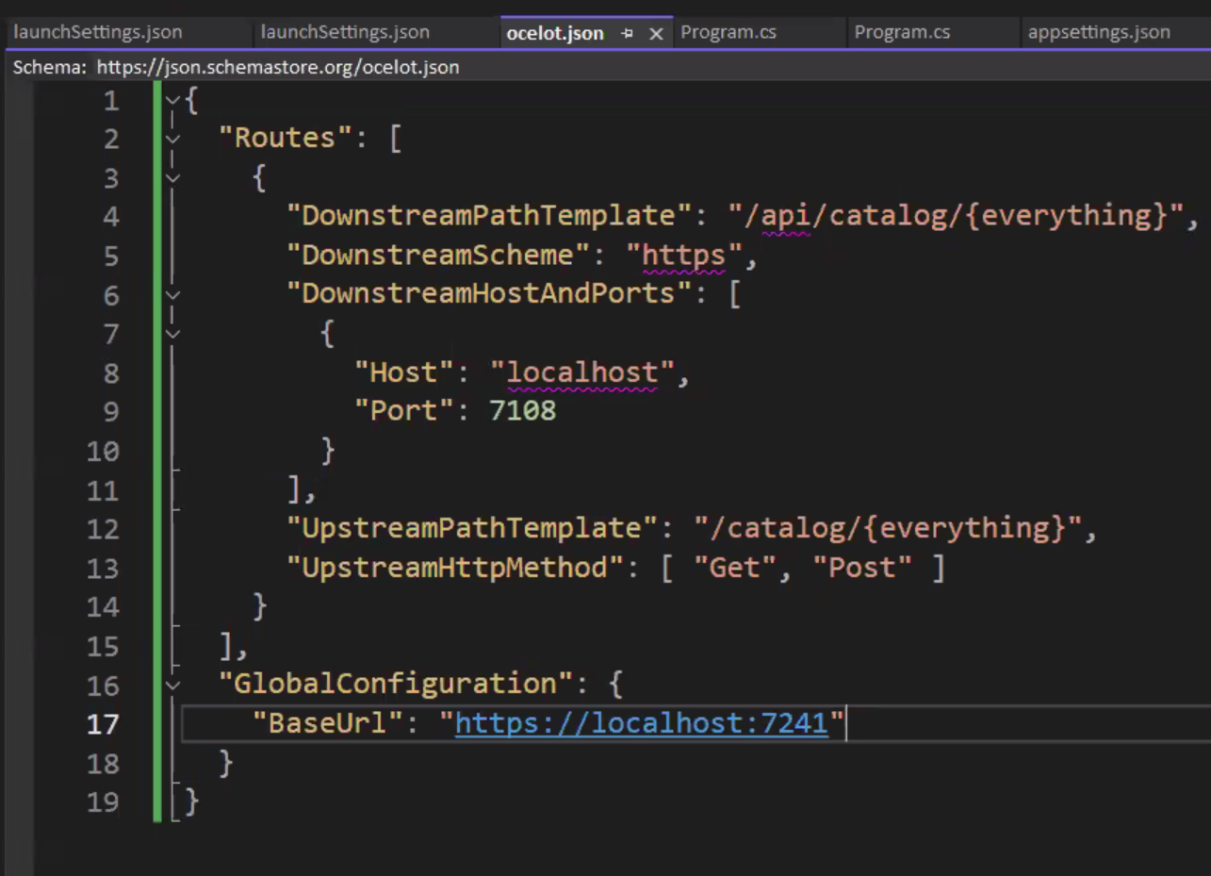
Mention in Program.cs
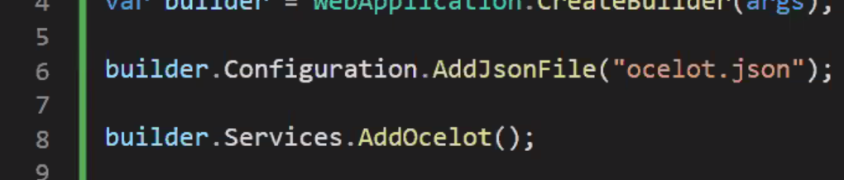

We get API GetAll() end point ::
