When Open Source meets Education

Free, Open and/or Libre software has been a buzz-word in media and technology spheres apart. A lot of heat is surrounding its implementation, specially in developing countries. When there are a lot of confusions concerning how open source can be used to leverage the benefits of ICT and its impact on the areas of implementation, there is one definite sector where open source can be guaranteed to produce magnificent results when properly used.

ICT integrated education systems are widely under adoption by institutions all around the world. There have been mixed outcomes of such implementations, ranging from good indicators to failed one, especially at lower grades. The root cause of such variations in the outcome is embedded deep inside the correlation of the outcomes to various input determinants and the learning context. The determinants, and their correlation has been properly depicted in the following model:

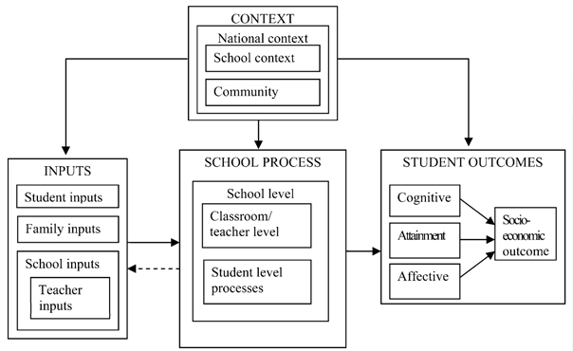
Source: Bhatta (2005)

Only a proper balance in all these determinants is responsible for achieving the desired results. Bhatta quotes it as “Effective use of ICT-based teaching-learning can potentially have a profound impact on the classroom/teacher-level processes and student-level processes.” Also it should be noted that ICT based education system should not be taken as a replacement of the traditional lecture-based teaching/learning approach, the traditional method has its own merits and advantages, which the ICT approach shall not dare or tend to replace. ICT-integration shall rather be applied, in its all strength, to enrich the school process so that a conducive learning environment can be created that can provide students with the opportunities to actively engage with the topic they are learning.

Now having understood the benefits, dimensions and effect of ICT in education, a daunting question of how to effectively use ICT in education, arises. Bhatta maintains, “Effective use of ICT in education means, among other things, creating adequate digital content for schooling purposes and integrating it in the regular teaching learning process.” The digital content, in particular, spans these three types of content – a) Interactive activities (or software modules), b) a digital library, c) creative works from teachers and students themselves. Individual creations from students as well as teachers are of great importance. It needs to be emphasized that one key difference between traditional approaches to educational enhancement and the ICT based approach is that the latter puts special emphasis on the student-level processes. Meanwhile, it is equally important to maintain that by implementing ICT based approach for enhancing education, it is never meant to replace the teacher from the classroom, rather to change his/her role from the deliverer of knowledge to a facilitator who is the pivot of knowledge based synthesis, as well as the one who encourages research, exploration, and creativity among students.

So how does all of these fit with the free software paradigm? Free and Open Source Software (FOSS), from its foundation has all of the necessary feature that involves creativity, sharing and hence helps to leverage the benefits of ICT integration into education. Open Source helps by bringing together numerous collaborators and developers who, by synergy, tend to develop quality tools which in turn attract more users and collaborators. Also the re-usability feature of open source makes sure that “re-inventing the wheels” is not required when some feature that has been previously implemented needs to get its way in the development of a new tool, and hence reducing the developing time so that the developers and users can focus on other innovations. Also that Open Source enables localization and customization so that same tools can be adapted to the socio-cultural aspects of the local region. Meanwhile, making sure that the data/content created using these tools to be licensed under open source, knowledge reusability can be assured. This encourages world-wide sharing of knowledge and artifacts, and hence resulting in a massive repository of knowledge which is open for access to everyone.

Now when we have reached the understanding of how Open Source enriched ICT tools can contribute to the quality of education, it is the right time to suggest the real tools that could help us achieve our goal – an efficient, exploratory and universal education. To host educational frameworks and other tools, GNU/Linux and MeeGo are the best options as the operating system to power various device being used. Moodle, which is based on social constructionist architecture and enable knowledge creation, sharing, grading and a lot of learning activities, is the best tool for Virtual Learning Environment (VLE). A combination of Fedora Commons and Fez helps to maintain digital repository for various types of contents, hence making it useful for managing a digital library. Similarly SchoolTools developed by Shuttleworth foundation, is a great tool for classroom management. This is not to underestimate the other tools available under the Open Source domain, rather more and more tools are available and will be under development to enforce ICT-integration in education. This is also, in fact, the fundamental gist of the One Laptop Per Child (OLPC) model. Through this, I would like to welcome you all to open education!

