WGM SOFTWARE USER MANUAL  
Author: Sami Dhiab  
Revision : 0.0.1  
Log: 19.01.2023

# Download

1. Download the latest version from [here](<https://github.com/theion-batteries/soft_wgm_installer_update>)
   1. Click on Code and Download ZIP

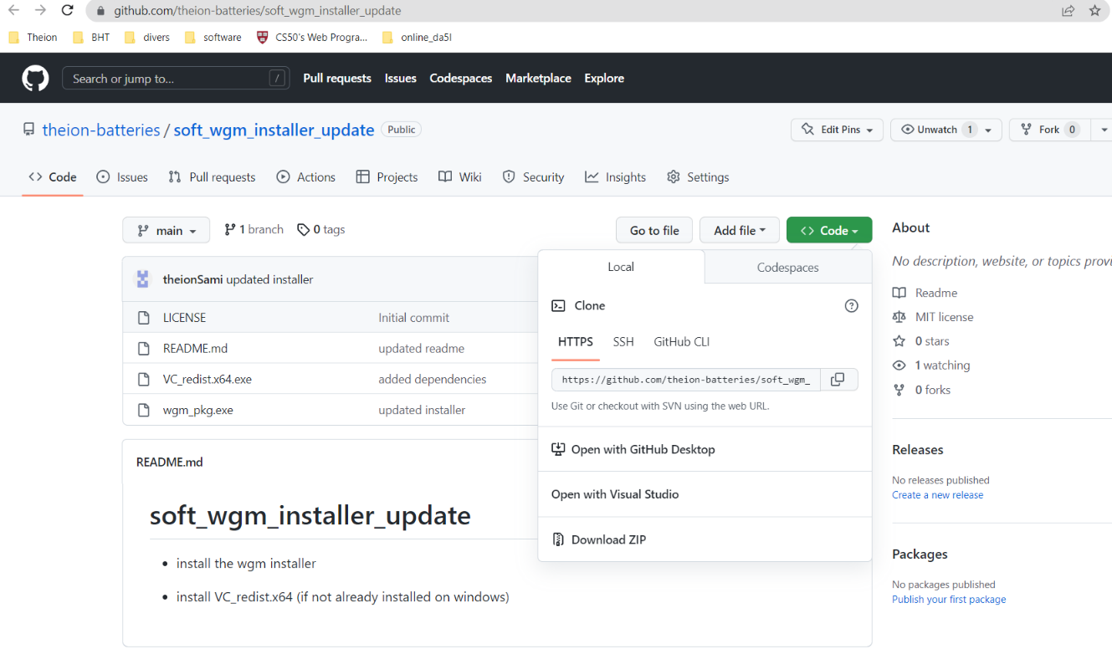

# Install

1. Run the installer wgm_pkg.exe

1. Be sure to install the software under C:/program files/wgm_pkg/ (for path matching)

1. Install VC_redist.x64 (if not already installed on windows) to avoid missing dependencies.

# Run

1. After successful installation, navigate to the installation folder.
2. Run the wgm_app.exe inside C:/program files/wgm_pkg/bin/debug/ as admin the first time.

1. Optional: place a shortcut on the desktop

# User Interface Overview

## Process Tabs

### Main Tab

The Main Tab provides the list of all processes. User can select one process from the list and click on ->execute process to execute that process automatically. The progress bar is updated in real time. Once the process finished or aborted, the time elapsed display is updated with the value in seconds.   
By clicking on ->execute all the processes will run automatically in corresponding order.

### Heating Process Tab

By clicking on ->connect heating dev the application will try to establish connection with heating device and inform the user by changing the variable heating_ready from false to true if the connection is success. After successful connection, the user can send send direct command to the heating device to manually alter settings. By writing the command in the white text field and pressing enter, the cmd_given field is updated and heating_response field will be updated with the device response. By pressing the -> run heating process, the process will start automatically. The process_finished variable will be updated to true once the process finishes. Process time elapsed display is updated upon finishing or abort. Temperature display will notify user with temperature in real time.

### Sinking Process Tab

By clicking on ->connect motion axis the application will try to establish connection with motion axis device and inform the user by changing the variable axis_ready from false to true if the connection is success. Same apply for the ->connect distance senor. After successful connection, the user can send send direct command to the axis motion device to manually interact with it. By writing the command in the white text field and pressing enter, the cmd_given field is updated and axis_response field will be updated with the device response. The displays will notify user about each parameter in real time. The algorithm part is helpful to test certain process step individually. By clicking on   
->move_down_until_sensor_data_valid the algorithm is executed, and the displays are updated on the fly. The algorithms and process steps are explained in different sections.

By pressing the -> run Sinking process, the process will start automatically. The process_finished variable will be updated to true once the process finishes. Process time elapsed display is updated upon finishing or abort.

### CNT Alignment Process Tab

By clicking on ->connect motion axis the application will try to establish connection with motion axis device and inform the user by changing the variable axis_ready from false to true if the connection is success. Same apply for the ->connect cnt dispenser and ->connect high_voltage. After successful connection, the user can send direct command to the choosen device to manually interact with it. By writing the command in the white text field and pressing enter, the cmd_given field is updated and response field will be updated with the device response. The displays will notify user about each parameter in real time. The algorithm part is helpful to test certain process step individually. By clicking on ->move_down_to_center the algorithm is executed, and the displays are updated on the fly. The algorithms and process steps are explained in different sections.  
By pressing the -> run aligning process, the process will start automatically. The process_finished variable will be updated to true once the process finishes. Process time elapsed display is updated upon finishing or abort.

### Cooling Process Tab

By clicking on ->connect motion axis the application will try to establish connection with linear motion axis device and inform the user by changing the variable axis_ready from false to true if the connection is success. Same apply for the ->connect rotation axis  
 and ->connect printhead dev. After successful connection, the user can send direct command to the choosen device to manually interact with it. By writing the command in the white text field and pressing enter, the cmd_given field is updated and response field will be updated with the device response. The displays will notify user about each parameter in real time. The algorithm part is helpful to test certain process step individually. By clicking on   
->linear_move_home the algorithm is executed, and the displays are updated on the fly. The algorithms and process steps are explained in different sections.  
By pressing the -> run cooling process, the process will start automatically. The process_finished variable will be updated to true once the process finishes. Process time elapsed display is updated upon finishing or abort.

### Extracting Process Tab

The extracting process tab is the reverse operation of the sinking process and has a similar tab view. Please refer to the sinking process tab.

## Menu Tabs

### File Menu

User can create an account by providing a username and password. The user data are saved inside a database. After creating account, user can login and start using the application. By clicking on new experiment, the user will create a recording of all parameters for each process. Once finished, user can save the experiment to save data inside the database. By clicking open experiment, user can have access and retrieve previous data of an experiment. By clicking logout the current user is logged out.

### Edit Menu

Each Process has predefined default parameters. User can change these parameters before each process execution.

As example, by clicking on whs_config.yaml, the configuration file for sinking process will be opened.

Details about each parameter are explained in different sections.

### View Menu

Under Construction.

### Build Menu

Under Construction.

### Debug Menu

By clicking on Debug->open debug console, user can get log messages and capture any errors.

For example, by clicking on ->connect motion axis the message connecting controller to axis server is indicated.

### Analyze Menu

Under Construction.

### Tools Menu

Under Construction.

### Window Menu

Under Construction.

### Help Menu

By clicking on Help->documentation, the user manual will be opened as pdf.

By clicking on Help->grbl, the link for grbl manual will be opened inside the browser.

By clicking on Help->update, the software will check for latest update and prompt for install.

