Reality CRM
Feature Guide & Product Overview
A custom Real-Estate CRM for mid-to-large developers
Campaign → Lead → Account → Opportunity → Site Visit → Quotation → Booking → Demand & Receipt

1. Executive Summary
Reality CRM is a purpose-built, non-Salesforce CRM for residential real-estate developers. It manages the entire sales lifecycle — from marketing campaigns and lead capture through site visits, quotations, bookings, and post-sale demand & receipt collection — on top of a multi-tower inventory engine. The platform is multi-project from day one, RERA-aware, and built around strict role-based access, row-level data scoping, and an append-only audit trail.
It is delivered as two applications: an Express/Prisma REST API and a React (Vite) single-page app, backed by PostgreSQL and Redis. A Channel-Partner (broker) portal integrates with the CRM via a secure server-to-server intake API.

2. Platform at a Glance
Sales lifecycle | Campaigns, Leads, Accounts, Opportunities, Site Visits, Quotations, Bookings, Demand & Receipts
Inventory | Projects → Towers → Units with a colour-coded availability grid, holds, and price revisions
Access control | 6 roles, dot-namespaced permissions, row-level scoping, append-only audit log
Money | Stored as BigInt paise (never floats); rupee input converted at the edge; lossless on the client
Multi-project & RERA | Every record carries a project context; RERA fields on Project and Booking
Extensibility | Admin-defined custom fields, 6 UI themes, and a broker-portal integration

3. Key Screens
The following are representative interface mockups that illustrate the layout and visual design of the application. They are illustrative renders, not live screen captures.
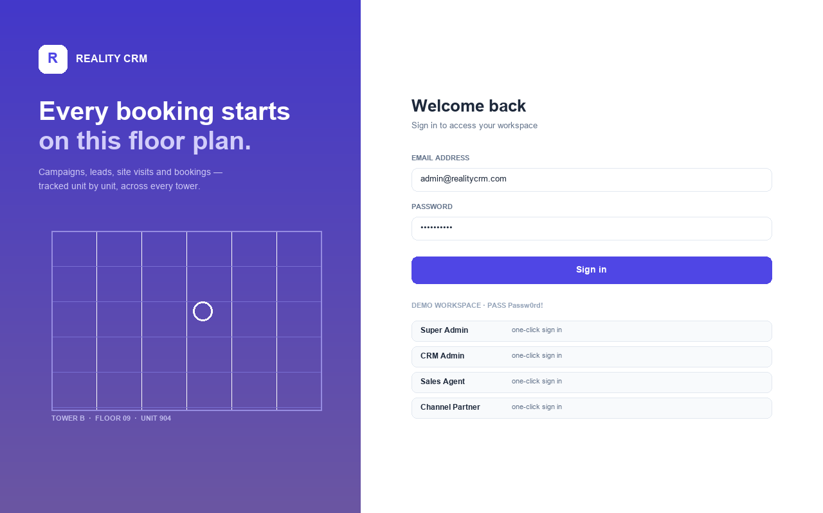
Figure 1 — Sign-in screen with role-based demo accounts and the branded “site plan” panel.
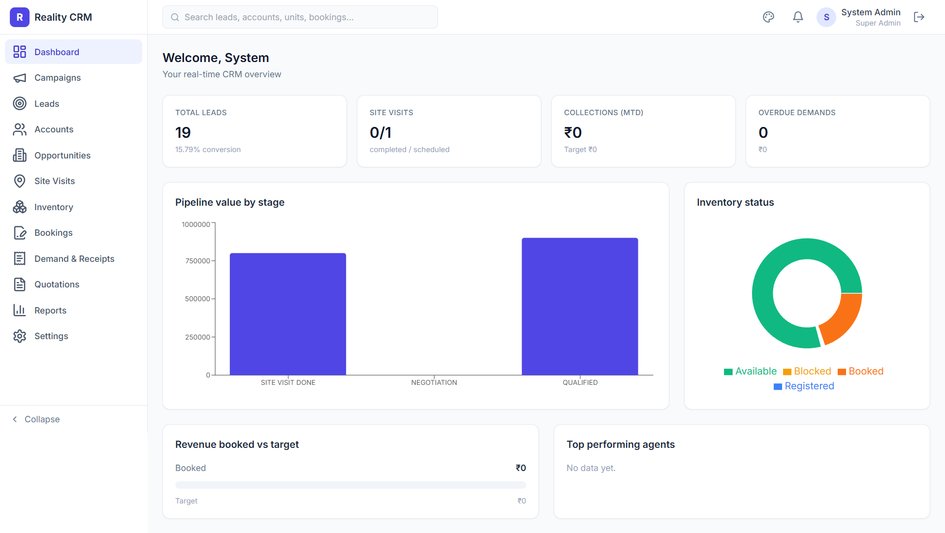
Figure 2 — Dashboard: KPI cards, recent lead activity, pipeline value, and upcoming site visits.
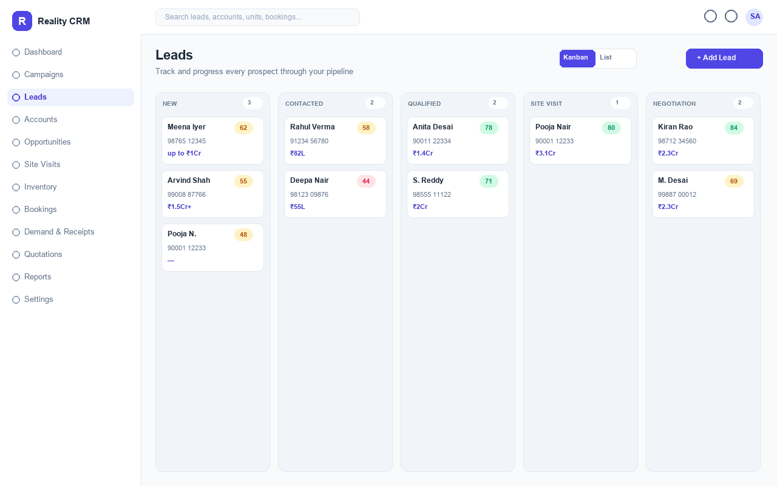
Figure 3 — Leads: drag-and-drop Kanban pipeline with AI lead scores and stage columns.

4. Detailed Feature List

4.1 Authentication, Roles & Security
- JWT authentication — Access/refresh token flow; the SPA silently refreshes on 401 and retries the original request.
- Role-based access control (RBAC) — Six roles — Super Admin, CRM Admin, Sales Agent, Channel Partner, Project Manager, Finance — mapped to dot-namespaced permissions (e.g. leads.read). Super Admin bypasses all checks.
- Row-level scoping — Admins/PM/Finance see everything; agents see only the records they own; channel partners are scoped to their partner account.
- Append-only audit log — Every create/update/delete is written to an immutable AuditLog (never updated or deleted) with old/new values, user, module, and entity.
- Admin console — User management (create, deactivate, reset password), role-to-permission editor, and a searchable, paginated audit log.

4.2 Campaigns & Lead Capture
- Campaigns — Track marketing campaigns by type and status with per-source attribution; every lead can trace back to a campaign source.
- Lead management — Capture name, mobile, email, source channel, interest type, BHK, budget range, and preferred location; automatic round-robin owner assignment for admin-created leads.
- Bulk import — Paste-to-import leads (name, mobile, email) for quick onboarding of lists.
- Drag-and-drop Kanban — Move leads across stages (New → Contacted → Qualified → Site Visit → Negotiation) with optimistic updates and instant feedback; a list view is also available.
- Activity timeline — Log calls, emails, WhatsApp, and notes; every stage change is recorded as a timeline event.
- Lead conversion — Converting a lead spawns an Account + Contact + Opportunity in a single transaction.

4.3 Accounts & Contacts
- Account 360 — Companies, individuals, partners, and investors with PAN/GSTIN, address, and a tabbed view of contacts, leads, opportunities, bookings, and documents.
- KYC workflow — KYC status transitions (Pending → Submitted → Verified / Rejected); a verified KYC is required before a booking can be confirmed.
- Channel-partner accounts — Empanelment status and commission percentage for broker accounts.

4.4 Opportunities
- Pipeline & forecast — Kanban pipeline by stage with deal value, probability, and a forecast/weighted view.
- One open opportunity per unit — Soft block with manager override to prevent double-selling a unit.
- Won locks the unit — Confirming a booking flips the linked opportunity to WON.

4.5 Site Visits
- Scheduling — Schedule visits against a lead and project; visits cannot be scheduled in the past; walk-ins supported.
- Status & feedback — Status flow (Scheduled → Confirmed → Completed / No-show / Cancelled); feedback is required before a visit can be marked Completed.
- Calendar view — A calendar of upcoming and past visits.

4.6 Inventory Engine
- Multi-tower model — Projects → Towers → Units, each unit carrying type, status, and pricing.
- Colour-coded grid — A floor × unit grid that visualises availability (available, blocked, booked, registered).
- Time-limited holds — Only AVAILABLE units can be held; holds expire automatically.
- Price revisions — Versioned price changes that skip BOOKED/REGISTERED units.

4.7 Quotations
- Itemised quotes — Line-item pricing with GST per line; generated, branded, print-ready PDFs.
- Versioning & lock — Accepting a quotation locks its pricing while retaining prior versions.

4.8 Bookings
- Multi-step wizard — Guided booking flow that requires a verified-KYC account and an available unit.
- Sequential numbering — Atomic counter generates gap-free booking/receipt/quote/demand numbers.
- Dual-approval cancellation — Cancelling a booking needs both CRM-Admin and Finance approval.
- Allotment letter — Branded, print-ready allotment letter PDF.

4.9 Finance — Demand & Receipts
- Payment plans — Construction-linked / time-linked / custom plans whose milestones must sum to 100%.
- Demand schedules — GST-itemised demand letters; overdue demands escalate automatically.
- Receipts & reconciliation — Receipts cannot exceed outstanding (with an advance override) and auto-reconcile oldest-first; branded receipt PDFs.

4.10 Reports & Dashboard
- KPI dashboard — At-a-glance leads, site visits, bookings, collections, and pipeline value (fan-out KPI queries).
- Saved reports — Build and save reports; global search across leads, accounts, opportunities, units, and bookings.

5. Configurable & Extensible Capabilities

5.1 Custom Fields — Object Manager
- Admin-defined fields — Super Admins add fields to Account, Opportunity, Lead, and Site Visit at runtime — no database migration required (a metadata-driven design).
- 12 data types — Text, Text Area, Number, Currency, Percent, Checkbox, Date, Date/Time, Email, Phone, URL, and Picklist (with admin-defined options).
- Page-layout ordering — Drag-and-drop (or arrow buttons) to control the display order of custom fields on forms and detail drawers.
- Everywhere it matters — Custom fields render on the create forms and detail drawers of each object, with type validation enforced server-side.

5.2 Theming
- Six UI themes — Indigo (default), Claude (warm clay/cream), Emerald, Ocean, Rose, and a true dark mode (Midnight) — switchable from the top bar and persisted per user.
- Token-driven — Themes are CSS-variable palettes consumed by Tailwind, so a theme switch instantly re-skins the entire application.

5.3 Channel-Partner (Broker) Portal Integration
- Server-to-server intake API — A secure /api/partner endpoint (API-key authenticated) accepts partner submissions without a user login.
- Lead & registration flow — Broker-submitted leads become CRM Leads (source = BROKER, auto-assigned owner, broker credited in the timeline); registrations become CHANNEL_PARTNER accounts with a primary contact.
- Dual-write — The broker portal writes to both its existing system and Reality CRM; the CRM write is authoritative for success while the legacy write is best-effort.
- Status mirroring — Lead status changes in the portal mirror onto the correlated CRM lead's stage, recorded as a synced timeline note.

6. Architecture & Engineering Notes
- Backend — Express + Prisma + PostgreSQL, layered as config / lib / middleware / modules; a permission cache is loaded at boot.
- Frontend — React 18 + Vite + TypeScript, React Query for server state, Zustand for auth/session, Tailwind CSS for styling.
- Money handling — All amounts are BigInt paise end-to-end; JSON emits them as strings and the client parses losslessly.
- Documents — PDFs (allotment letter, quotation, demand, receipt) are rendered as branded print-ready HTML to keep headless browsers out of the API.
- Auditing & numbering — Append-only audit on every mutation; atomic INSERT … ON CONFLICT counters for gap-free document numbers.
- Integrations — Notifications (email/SMS/in-app), S3 signed-URL document storage, and the broker-portal partner API.

Reality CRM — Feature Guide · Generated for internal review

