Date:07.06.2023

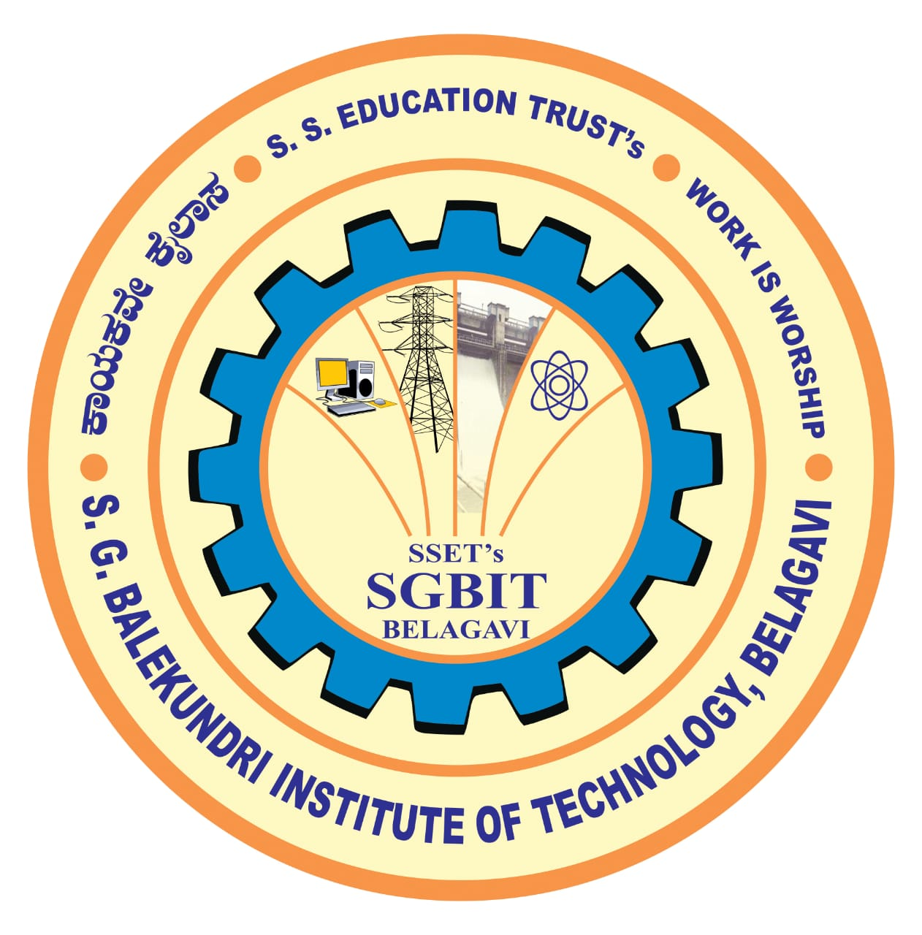  An ISO 21001:2018 Certified Institution | S. S. Education Trust’s CET Code: E-175 (UG)/T-942 (PG)  S. G. BALEKUNDRI INSTITUTE OF TECHNOLOGY  Shivabasavanagar, Belagavi- 590 010, Karnataka- India  Office: 0831-2407172, 2554559 Fax: 0831-2407152 Website: www.sgbit.edu.in  Approved by AICTE New Delhi Recognised by Govt. of Karnataka Affiliated to V T U, Belagavi
 | Department of Mechanical Engineering  Accrediated by NBA | Email: hod-mech@sgbit.edu.in,  Dept. Extn.: 513
SAMVEEKSHANA 2026
Event: Future Ride: “Design Your Dream Machine”
Theme:
Participants create a technical + artistic poster showcasing an aesthetic bike or car.
The design should combine:
- Engineering concepts
- Creative styling
- Innovation & futuristic ideas
Guidelines:
1. Team Size:
- 2 members per team
2. Time Limit:
- 2 hours
3. Materials:
- Chart paper (A2/A3)
- Colors (participants bring their own)
- No pre-printed posters allowed
4. Mandatory Elements:
- Vehicle name
- Key technical features (minimum 4 points)
- Short concept description (50–100 words)
5. Participants may design:
- A futuristic concept vehicle
- A modified existing vehicle
- An eco-friendly or AI-based smart vehicle
6. Entry Fee:
- Rs. 100/- (per team)
Rules and Regulations:
- Prior online registration is compulsory.
- On-spot registration allowed only if slots are available.
- Any form of misconduct will precipitate immediate disqualification from the event.
Punctuality is imperative. Participants need to check in one hour prior to the commencement of the event.
- Participants are mandated to independently arrange all requisite props, materials, and items for the event.
- The verdict of the judging panel shall be deemed final and irrevocable.
- The organizers will not bear liability for loss and damage of any personal belongings during the event.
- The event may be called off due to under participation (less than 10 teams) and the registration amount
would be returned back.
- Each team gets 3 minutes to explain their concept.
Awards:
- First prize: Rs 1000
- Second prize: Rs 500

Mr. Siddharth B. Motari (9945836886) Prof. Angad S.Naik (7411665112)
Student Coordinator Staff Coordinator

Event: Navapravartan : = From Problem to Powerful Solution
Concept:
Participants will be given a real-world problem statement based on current challenges
(technical, social, environmental, industrial, etc.).
Guidelines:
  - Teams must:
- Analyze the problem
- Identify root causes
- Propose an innovative and practical solution
- Present their idea with technical feasibility
  - Team Size:
- 2 members per team
3. Time Limit:
• Preparation: 120 minutes
• Presentation: 5 minutes
• Q&A: 2–3 minutes
Rules and Regulations:
- Prior online registration is compulsory.
- On-spot registration allowed only if slots are available.
- Any form of misconduct will precipitate immediate disqualification from the event.
Punctuality is imperative. Participants need to check in one hour prior to the commencement of the event.
- Participants are mandated to independently arrange all requisite props, materials, and items for the event.
- The verdict of the judging panel shall be deemed final and irrevocable.
- The organizers will not bear liability for loss and damage of any personal belongings during the event.
- The event may be called off due to under participation (less than 10 teams) and the registration amount
would be returned back.
- Each team gets 3 minutes to explain their concept.
Entry Fees: Rs. 50/-
Awards:
- First prize: Rs 1000
- Second prize: Rs 500

Mr. Shriraj V. Patil (7619349912) Prof. Shrinath Ghodake (8904890194)
Student Coordinator Staff Coordinator

