Ex.no:8 | MINI PROJECT – CUSTOMER SHOPPING BEHAVIOR DATA ANALYTICS

Domain and Problem Statement:
Domain: Retail Data Analytics & Consumer Behavior
Problem Statement: A leading retail company faces difficulties adapting to shifting consumer purchasing choices across demographics, product categories, and sales channels. To resolve these issues, this project analyzes behavioral drivers—such as discounts, subscription programs, shipping types, and product reviews—to extract clear trends. By building an end-to-end analytical data pipeline across Python, SQL (PostgreSQL), and Power BI, the management team can make data-driven marketing and product decisions to improve customer engagement and optimize revenue strategies.

Dataset Description:
Dataset Name: Consumer Behavior Dataset.
Granularity: Each row represents a single customer purchase transaction.
Dataset Footprint: 3,900 rows and 18 columns
Key Entities & Attributes:
- Customer Demographics: Customer ID, Age, Gender, Location, Subscription Status.
- Purchase Details: Item Purchased, Category, Purchase Amount (USD), Season, Size, Color.
- Shopping Behavior Metrics: Discount Applied, Promo Code Used, Previous Purchases, Frequency of Purchases, Review Rating, Shipping Type, Payment Method.

Data Source:
Primary Source: Kaggle Open Datasets (Customer Shopping Behaviour ).
Storage Infrastructure: Cleaned transactional records hosted within a local MySQL database instance.

Architecture:
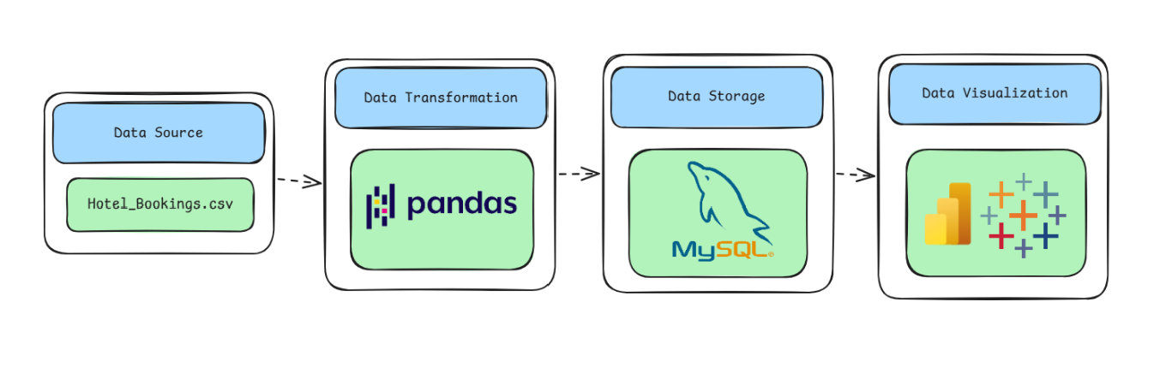

Program:
1. Python – Data Cleaning & Transformation
Got it — you want the same code, just tightly formatted with no comments and no unnecessary blank spaces.
import pandas as pd
import numpy as np
import matplotlib.pyplot as plt

df=pd.read_csv("customer_shopping_behavior.csv")
print(df.head())
print(df.shape)
print(df.info())
print(df.describe())
print(df.isnull().sum())
print(df.duplicated().sum())
df.drop_duplicates(inplace=True)

for c in df.select_dtypes(include=np.number).columns:
df[c]=df[c].fillna(df[c].median())
for c in df.select_dtypes(include="object").columns:
df[c]=df[c].fillna(df[c].mode()[0])

if "Age" in df.columns:
df["Age_Group"]=pd.cut(df["Age"],bins=[0,18,30,45,60,100],labels=["Teen","Young Adult","Adult","Middle Age","Senior"])
if "Purchase Amount (USD)" in df.columns:
df["Spending_Category"]=pd.cut(df["Purchase Amount (USD)"],bins=[-1,50,100,200,np.inf],labels=["Low","Medium","High","Very High"])

df["Gender"].value_counts().plot(kind="bar")
plt.title("Customer Gender Distribution")
plt.show()
df["Category"].value_counts().plot(kind="bar")
plt.title("Product Category Distribution")
plt.show()
df["Payment Method"].value_counts().plot(kind="bar")
plt.title("Payment Method Distribution")
plt.show()
df["Purchase Amount (USD)"].plot(kind="hist",bins=20)
plt.title("Purchase Amount Distribution")
plt.show()

corr=df.select_dtypes(include="number").corr()
plt.figure(figsize=(10,8))
plt.imshow(corr)
plt.colorbar()
plt.xticks(range(len(corr.columns)),corr.columns,rotation=90)
plt.yticks(range(len(corr.columns)),corr.columns)
plt.title("Correlation Heatmap")
plt.show()

print("Customer shopping behavior insights generated successfully.")
print("Insights can be deployed through interactive dashboards.")

df=pd.read_csv("customer_shopping_behavior.csv")
print(df.head())
print(df.info())
print(df.describe())
print(df.isnull().sum())
df.drop_duplicates(inplace=True)

for c in df.select_dtypes(include=np.number).columns:
df[c]=df[c].fillna(df[c].median())
for c in df.select_dtypes(include="object").columns:
df[c]=df[c].fillna(df[c].mode()[0])

df["Category"].value_counts().plot(kind="bar")
plt.show()
df["Gender"].value_counts().plot(kind="bar")
plt.show()
df["Payment Method"].value_counts().plot(kind="bar")
plt.show()
df["Purchase Amount (USD)"].plot(kind="hist",bins=20)
plt.show()

corr=df.select_dtypes(include="number").corr()
plt.figure(figsize=(10,8))
plt.imshow(corr)
plt.colorbar()
plt.xticks(range(len(corr.columns)),corr.columns,rotation=90)
plt.yticks(range(len(corr.columns)),corr.columns)
plt.show()
print("Customer purchasing patterns successfully identified.")

df=pd.read_csv("customer_shopping_behavior.csv")
print(df.info())
print(df.isnull().sum())
print(df.duplicated().sum())
df.drop_duplicates(inplace=True)

for c in df.select_dtypes(include=np.number).columns:
df[c]=df[c].fillna(df[c].median())
for c in df.select_dtypes(include="object").columns:
df[c]=df[c].fillna(df[c].mode()[0])

if "Age" in df.columns:
df["Age_Group"]=pd.cut(df["Age"],bins=[0,18,30,45,60,100],labels=["Teen","Young Adult","Adult","Middle Age","Senior"])
if "Purchase Amount (USD)" in df.columns:
df["Spending_Category"]=pd.cut(df["Purchase Amount (USD)"],bins=[-1,50,100,200,np.inf],labels=["Low","Medium","High","Very High"])

df["Category"].value_counts().plot(kind="bar")
plt.show()
df["Gender"].value_counts().plot(kind="bar")
plt.show()
df["Payment Method"].value_counts().plot(kind="bar")
plt.show()
df["Purchase Amount (USD)"].plot(kind="hist",bins=20)
plt.show()

corr=df.select_dtypes(include="number").corr()
plt.figure(figsize=(10,8))
plt.imshow(corr)
plt.colorbar()
plt.xticks(range(len(corr.columns)),corr.columns,rotation=90)
plt.yticks(range(len(corr.columns)),corr.columns)
plt.show()
print("Knowledge discovered from the customer shopping behavior dataset has been interpreted to support retail business decisions.")

2. MySQL – Database and Data Loading
MySQL Command Prompt:
net start MySQL80
mysql -u root -p
MySQL:
CREATE DATABASE IF NOT EXISTS hotel_analytics;
Python/Jupyter:
username = "root"
password = "YOUR_MYSQL_PASSWORD"
host = "localhost"
port = 3306

# Connect to MySQL database
db_engine = create_engine(
f"mysql+pymysql://{username}:{password}@{host}:{port}/customer _analytics"
)

# Load cleaned data into MySQL
transactions.to_sql(
"customer_analytics ",
con=db_engine,
if_exists="replace",
index=False,
chunksize=5000
)

print("Data loaded successfully into MySQL.")
Verify:
pd.read_sql(
"SELECT COUNT(*) AS total_rows FROM customer_analytics",
db_engine
)
Procedure:

Step 1: Data Preparation & Preprocessing (Python / Pandas)
- Load the raw Kaggle dataset into a Jupyter Notebook / Python script using pandas.read_csv().
- Inspect for null values and handle missing data in country, children, and agent columns.
- Feature engineer total stay length by combining weekend and weeknight stays:
- Filter out invalid rows (e.g., zero total guests or negative ADR entries) and export the cleaned DataFrame to MySQL using sqlalchemy and to_sql().

Step 2: SQL Database Connection & Data Ingestion
- Open Power BI Desktop $→$ Click Get Data $→$ Select MySQL Database.
- Enter the Server (localhost:3306) and Database Name (hotel_analytics).
- Enter authentication credentials, select the cleaned flat table (hotel_bookings / hotel_analytics), and click Transform Data to open Power Query
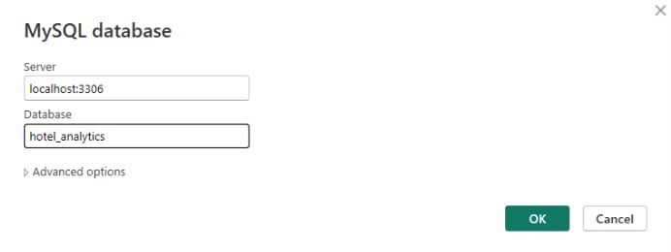

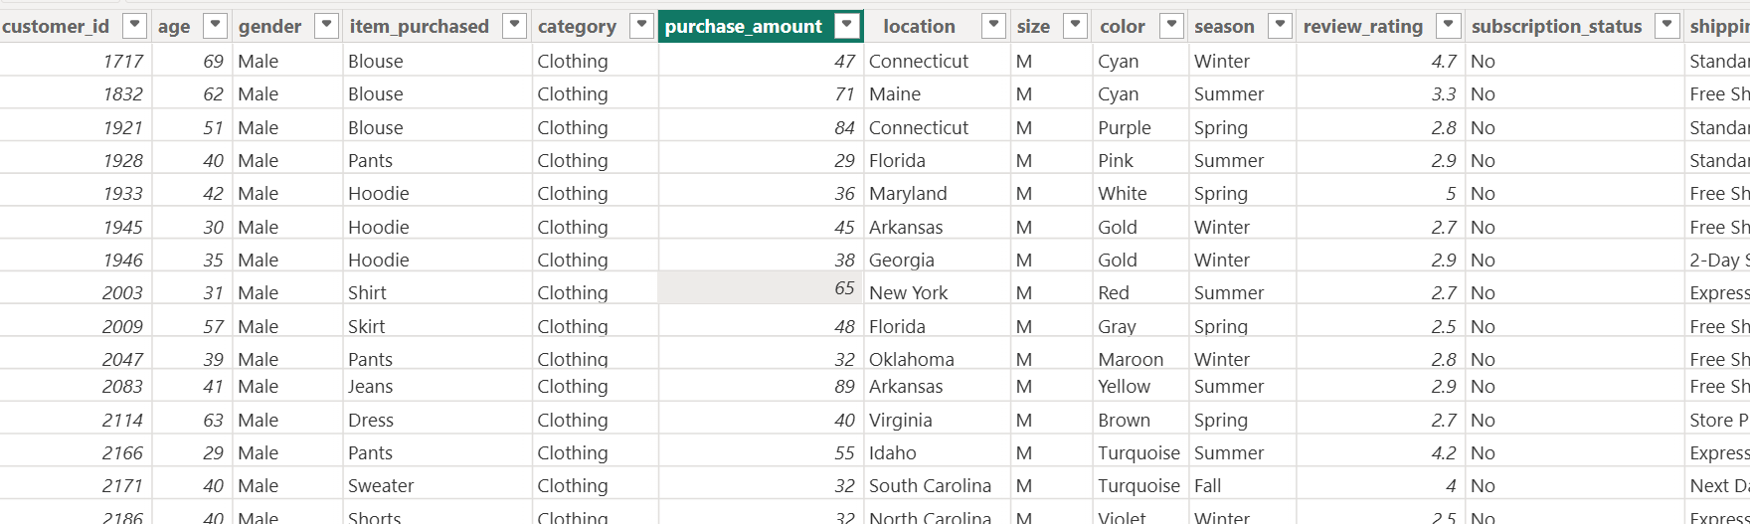

Step 3: Star Schema Data Modeling (Power BI)
- Table Splitting in Power Query:
  - Duplicate the customer table 3 times: Fact_Purchases, Dim_Customer, Dim_Product.
  - In Dim_Customer, keep customer_id, age, gender, location, age_group; remove duplicates; add Index Column as CustomerID.
  - In Dim_Product, keep item_purchased, category; remove duplicates; add Index Column as ProductID.
  - In Fact_Purchases, merge with Dim_Customer and Dim_Product to map CustomerID and ProductID.
  - Remove the raw text columns from Fact_Purchases.
  - Click Close & Apply.
- Establishing Relationships in Model View:
  - Open Model View in Power BI.
  - Connect Dim_Customer[CustomerID] → Fact_Purchases[CustomerID] (1:*).
  - Connect Dim_Product[ProductID] → Fact_Purchases[ProductID] (1:*).
  - Connect Dim_Date[Date] → Fact_Purchases[PurchaseDate] (1:*), if available.
- Hide foreign key columns in Fact_Purchases to organize the Fields pane.

Top 3 Products per Category – Listed the most purchased products within each category.
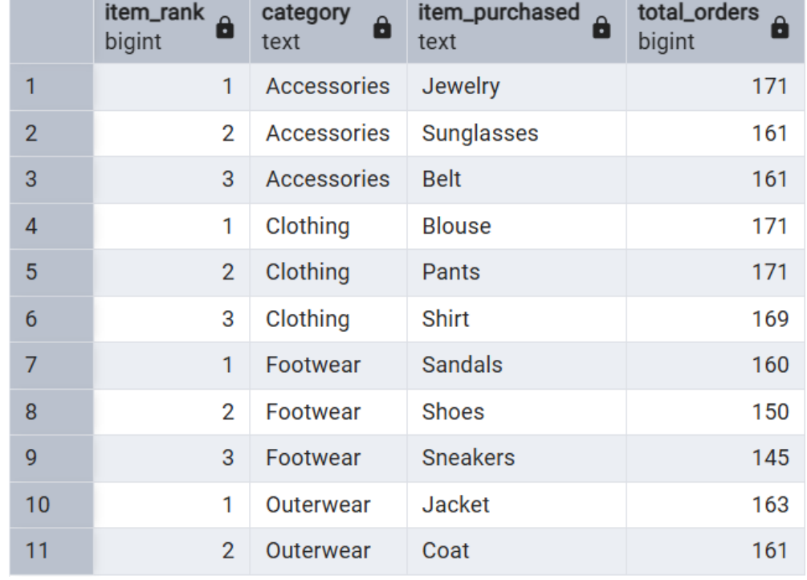
Repeat Buyers & Subscriptions – Checked whether customers with >5 purchases are more likely to subscribe.
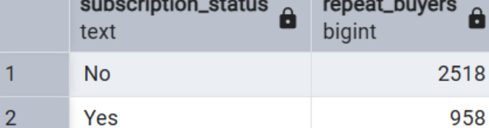

Customer Segmentation – Classified customers into New, Returning, and Loyal segments based on purchase history
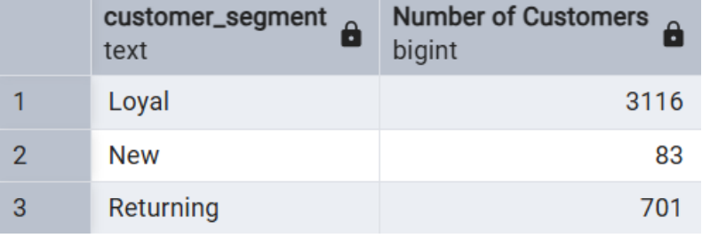
High-Spending Discount Users – Identified customers who used discounts but still spent above the average purchase amount
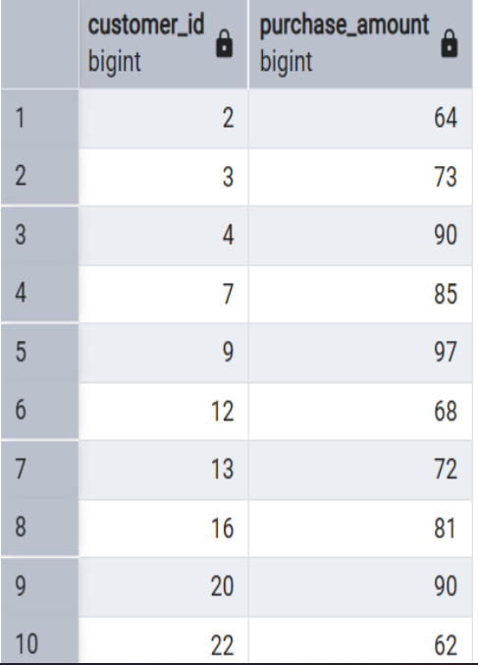
Observed Insights:
- Channel Performance & Shopping Behavior: The dataset tracks shifting consumer purchasing patterns across both online and offline channels, focusing heavily on changes across distinct demographics and product categories.
- Core Conversion Drivers: Customer decision-making and repeat purchases are influenced by key variables, specifically tracking the business impact of discounts, product reviews, seasons, and payment preferences.
• Retention & Loyalty Priorities: The primary analytical focus centers on uncovering long-term customer loyalty trends to help management improve satisfaction and drive sustainable repeat business.
- Technical Pipeline Requirements: The project enforces an end-to-end data stack workflow, requiring Python for data preparation, SQL for transactional analysis, and Power BI for executive dashboards.

