IPC Fundamentals & Memory Models (The “What & Why”)
Focus: Operating System architecture

INTRODUCTION TO IPC.

The Wall Between Processes: Why Isolation Exists
Before asking why processes need to talk, we need to understand why they normally can’t. A process is simply a program in execution. When the operating system runs it, the OS gives it its own private slice of memory, known as its address space. The whole memory of the computer is split into two zones:
- Kernel space: the protected area where the OS core itself lives. Only the kernel can access it directly.
- User space: the area where ordinary programs run. Each process gets its own separate region here.
Every process is also given the illusion that it owns the entire memory starting from address 0. This is called virtual memory. The hardware (the Memory Management Unit, MMU) translates each virtual address into a real physical address using tables set up by the kernel. Two processes can therefore both use “address 1000” and never touch the same physical location. If a process tries to reach an address outside its own region, the hardware raises a fault and the OS terminates it (the familiar “segmentation fault”).
A simple analogy, imagine a large apartment building where every family lives in a locked flat. The kernel is the building’s security manager who holds the master key. Each family (process) can freely rearrange its own furniture, but cannot walk into a neighbour’s flat. This is deliberate: if one family sets its flat on fire (a buggy program crashes), the neighbours and the building itself stay safe. That protection is exactly why a process cannot just write into another’s memory by default.
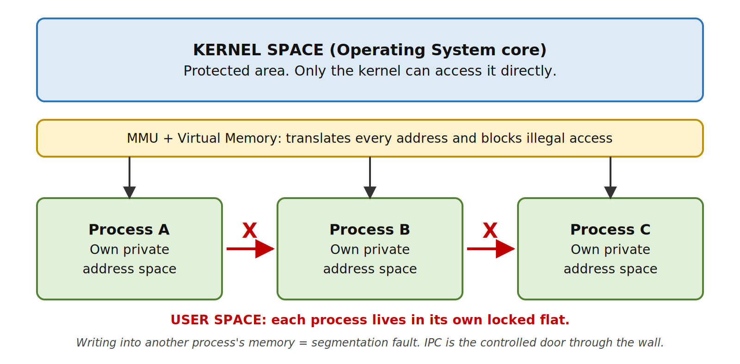
Figure 1: Memory isolation between processes (kernel space vs. user space)
The catch: total isolation is safe, but it also means processes are completely cut off from each other. Real systems need them to cooperate, so the OS provides controlled doors through the walls. These doors are called Inter-Process Communication (IPC).

Why Do Processes Need to Communicate?
IPC is the set of mechanisms an operating system provides so that separate processes can exchange data and coordinate their actions. There are three classic reasons for it:
- Resource sharing: several processes may need the same information at the same time, such as a shared file, a database or a common data structure. Communication is the only safe way to share it.
- Computation speedup: a big task can be split into smaller sub-tasks that run in parallel on multiple CPU cores. The pieces must exchange results to produce the final answer.
- Modularity: a large system can be divided into small, separate processes, each doing one job. If one part crashes, the rest keeps running. A modern web browser is a good example, with separate processes for tabs, the network and the display.
A simple analogy, think of a restaurant kitchen. One chef cutting vegetables, another grilling and a third plating the dish can serve far more customers than one chef doing everything (speedup and modularity). But they must pass ingredients and tell each other “order ready” (communication), and they share the same stove and fridge (resource sharing).

PROCESS TYPES.

Independent vs. Cooperating Processes
Independent processes do not affect, and are not affected by, any other process running in the system. They share no data and never communicate. Their results depend only on their own input.
Cooperating processes can affect, or be affected by, other processes. They share data or exchange information, so they need an IPC mechanism. Any process that shares data with another one is a cooperating process.
A simple analogy, two students writing separate exams in different rooms are independent processes; what one writes has no effect on the other. Now imagine the same two students working together on a group project. One’s section changes what the other must write, so they must keep exchanging information. They are cooperating processes.

THE TWO PRIMARY COMMUNICATION MODELS.
All IPC mechanisms in an operating system are built on one of two fundamental models: Shared Memory or Message Passing.

Shared Memory: The Common Whiteboard
In this model, the OS kernel sets up a region of memory that is mapped into the address space of two or more processes. Once that shared region exists, the processes read and write to it exactly like ordinary memory. The kernel is involved only at the start (to create and attach the region). After that, no system calls are needed for data transfer, so the exchange is very fast.
A simple analogy, imagine a group of friends in a study room with one big whiteboard on the wall. The college (kernel) allots the room once. After that, anybody can walk up, read what is written, or write something new, without asking permission each time. It is very quick. But there is a risk: if two people write in the same spot at the same moment, the text turns into a mess, and nobody can stop them but the friends themselves.
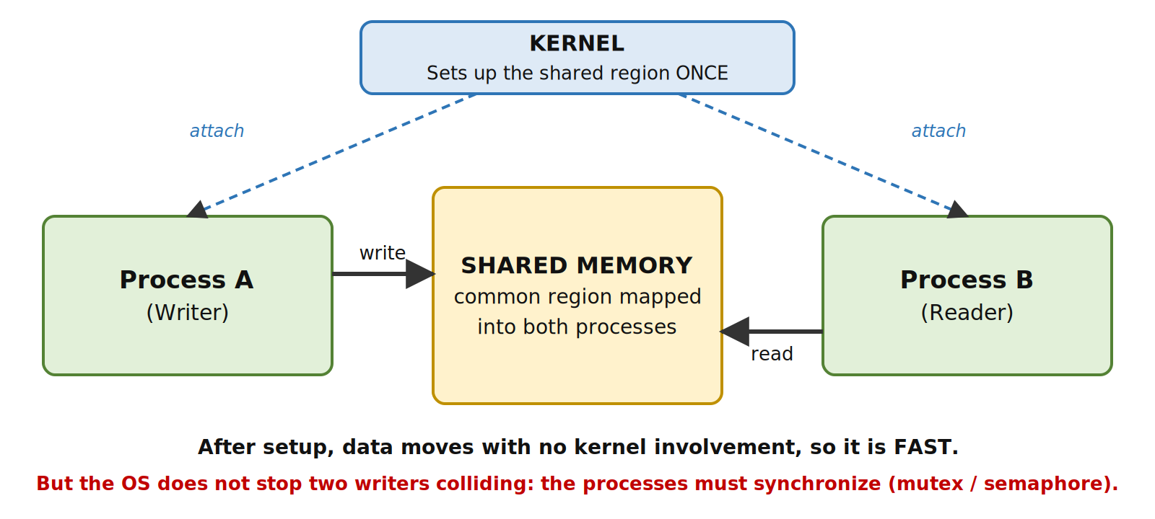
Figure 2: The shared memory model
Key points:
- Fastest form of IPC, since data is not copied through the kernel.
- Works only for processes on the same machine.
- The OS does not protect the shared region from simultaneous access. The processes themselves must synchronize (this is where race conditions appear, and where semaphores and mutexes come in, covered in the Synchronization section).
- Best suited for large amounts of data.

Message Passing: The Postal Service
In this model, processes never touch each other’s memory. Instead, they exchange data as messages, using two basic system calls:
- send(destination, message): hands a message to the kernel to deliver.
- receive(source, message): asks the kernel to hand over a waiting message.
Because every message passes through the kernel, the OS stays in control of the whole exchange. A communication link is set up between the processes, which can be direct (processes name each other) or indirect (messages go to a shared mailbox or port that both use).
A simple analogy, think of WhatsApp or a courier service. You never enter your friend’s house to place a note on their desk. You give the message to the service (kernel), which delivers it, and the friend receives it. Each delivery takes some effort, so it is slower, but there is no chance of two people scribbling over each other’s work.
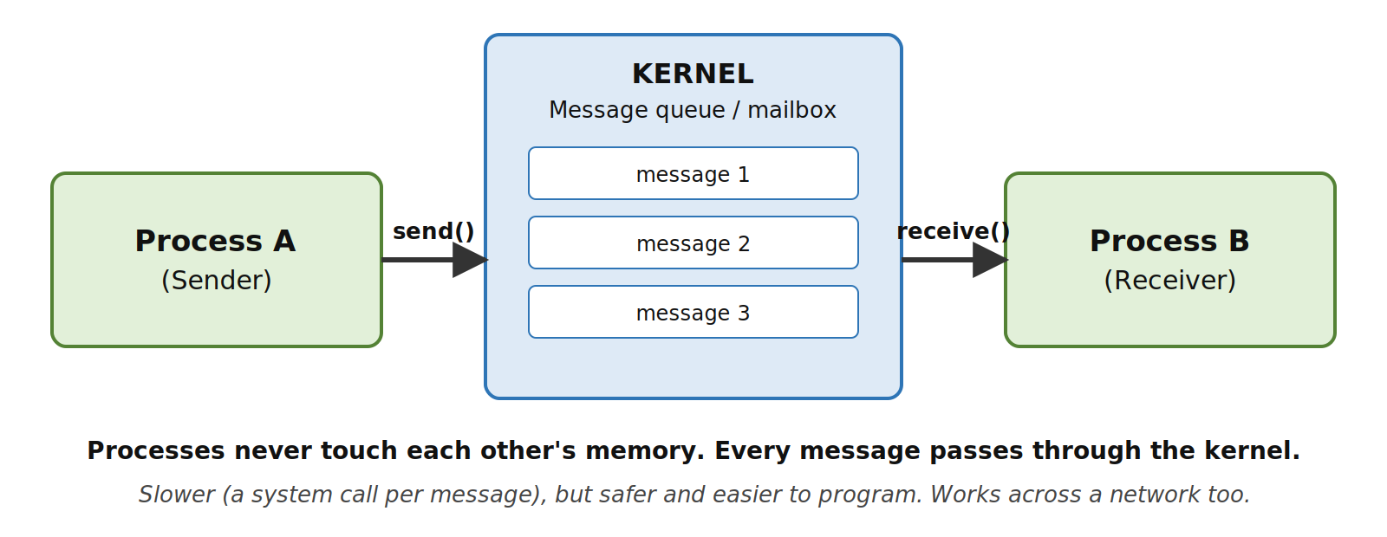
Figure 3: The message passing model
Key points:
- Slower, since every message needs a system call and a copy through the kernel.
- Easier and safer to program, because the OS manages the exchange.
- Works across a network, so it is the foundation of distributed systems.
- Best suited for small amounts of data.

Shared Memory vs. Message Passing
Feature | Shared Memory | Message Passing
Speed | Fast: kernel only sets it up once | Slower: a system call for every message
Kernel involvement | Only at setup | On every send and receive
Synchronization | Programmer must handle it | Handled by the send/receive mechanism
Best for data size | Large amounts of data | Small, structured messages
Works across a network? | No, same machine only | Yes, suits distributed systems
Ease of programming | Harder: race conditions possible | Easier and safer

EXECUTION FLOW.

Synchronous (Blocking) vs. Asynchronous (Non-Blocking) Communication
Message passing can happen in two different styles, depending on whether a process waits for the communication to complete. Each of send and receive can be either blocking or non-blocking.

Synchronous (Blocking) Communication
- Blocking send: the sender is paused until the message is received by the other process (or the mailbox).
- Blocking receive: the receiver is paused until a message actually arrives.
When both sender and receiver are blocking, they meet at the same moment. This is called a rendezvous.
A simple analogy, a phone call. You dial and wait until the other person picks up. Neither of you can do anything else on that call until the conversation happens, but you both know for sure that the message was delivered.

Asynchronous (Non-Blocking) Communication
- Non-blocking send: the sender sends the message and immediately continues its own work without waiting.
- Non-blocking receive: the receiver checks for a message. If one is there it takes it, otherwise it gets “nothing” and carries on with other work.
A simple analogy, sending a text message. You send it and go on with your day. The other person reads it whenever they are free. Nobody is waiting, so more work gets done, but you don’t automatically know when (or whether) it was read.
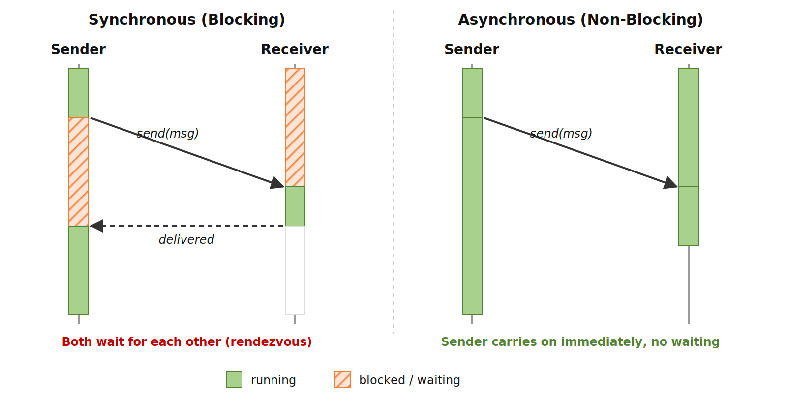
Figure 4: Blocking vs. non-blocking communication
The solution? Choose the style that fits the job. Blocking is simpler and guarantees delivery order, which is useful when a process cannot proceed without the data. Non-blocking keeps the CPU busy and is better for responsive programs. Between the two sits a buffer (a queue of messages held by the kernel), whose capacity can be zero (forces a rendezvous), bounded (sender waits only when full) or unbounded (sender never waits).

CONNECTING THE DOTS.
This section is the foundation for the rest of the project:
- Why: processes are isolated by the kernel/user space split and virtual memory, for protection and stability.
- Pathways: IPC (shared memory or message passing) opens safe channels through that isolation. The specific mechanisms, such as pipes, message queues, sockets and signals, are covered in the Implementation Mechanisms section.
- Guardrails: once processes share data, they can collide. Race conditions, deadlocks and starvation, and the tools to prevent them, are covered in the Synchronization section.

