Synchronization & Classical Problems (The "Algorithms")

THE THREATS.
Race Conditions: The Timing Trap
A race condition happens when two or more processes try to read, modify, and write to the exact same piece of shared data at the exact same time. Because the operating system can pause a process halfway through its execution, the final value depends entirely on the unpredictable timing of who finishes last.

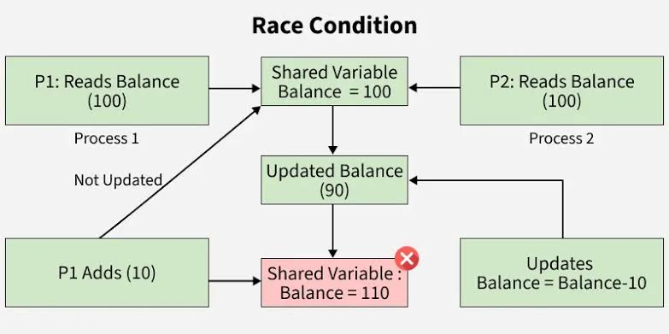
A simple analogy, imagine you and your friend share the same bank account which contains 100$ in it. Imagine the following occurs:
1)you go to the ATM and hit “Withdraw 80$”. The ATM checks the balance, sees 100$ and starts counting out the cash.
2)at the exact same microsecond, your friend uses the banking app to transfer 50$ to another account. The app checks the balance and sees 100$ and approves of the trasnfer.
Because niether of the transactions locked your account during its process, the bank’s internal systems gets confused. It might deduct 80$ and immediately overwrite that trasnactions with ur friend’s 50$ transaction. The bank just lost money because your two transactions “raced” to update the final number.

Deadlocks: The Circular Standstill
A deadlock is a total system freeze. It occurs when two or more processes are each holding onto a resource (like a file or a memory block) while waiting for the other process to release the resource they need. Because neither will let go first, they wait forever.
Suppose Process A and B requires Resource A and B. Process A holds onto resource A and simulatenously Process B holds onto resource B. Now each of the Processes are waiting for the freedom of the other “missing” required resource. Process A is waiting for the freedom of resource B (held by process B) and Process B is waiting for the freedom of resource A (held by procees A). None of the process’s are able to access the required missing resource therefore getting stuck in an infinite waiting game.
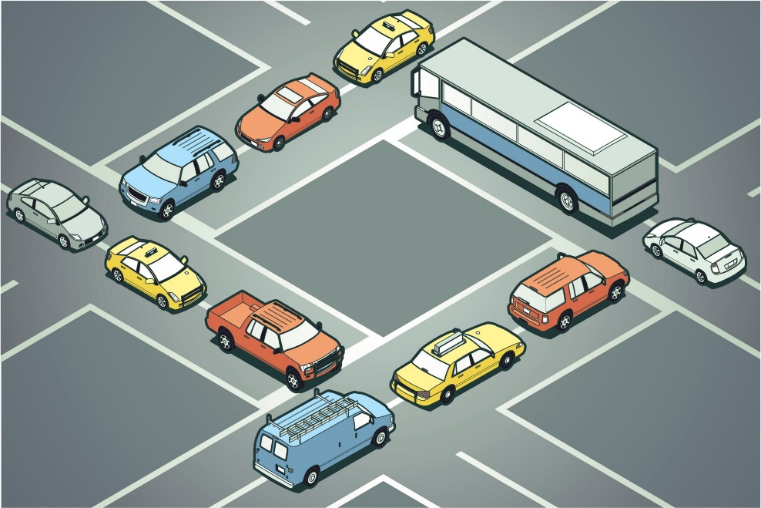
A simple analogy, imagine traffic at nanthoor circle, theres cars coming in from 4 different directions, north, east, west and south. Now picture such a situation where theres a block caused by cars from all directions.
1)the cars coming from the north are blocked by the cars entering from the east.
2)the cars coming from east are blocked by the cars entering from the south.
3)the south cars blocked by the west cars.
4)the west cars blocked by the north cars.
This 4th step loops around back to the 1st step. The block is then considered to be deadlocked as it is waiting for the other cars to move, but in reality, none can.

Starvation: The Endless Wait
Starvation happens when a process is ready to run, but the operating system keeps bypassing it to give CPU time to other processes. The system isn't frozen or broken—it is actively working—but one specific process is being perpetually ignored, usually due to a flawed priority system.
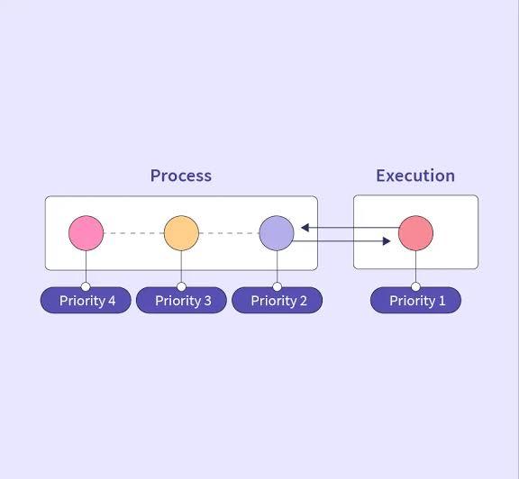
A simple analogy, imagine you are standing at a crosswalk without a pedestrian signal waiting to cross, however theres a steady stream of uneven spaced cars oncoming. Since the cars have the higher priority to cross considering the situation at hand, you are struck there waiting for your chance as processes (cars) with higher priority keep occupying CPU time. You are "starving" for a chance to cross, even though the traffic system as a whole is flowing perfectly fine.

THE TOOLS TO OVERCOME.
To prevent the chaos of race conditions, operating systems enforce Mutual Exclusion—a strict rule that only one process can use a shared resource or execute a sensitive piece of code (called a "Critical Section") at a time.
Mutex Locks: The Washroom Wait
A Mutex (short for Mutual Exclusion) is the simplest synchronization tool. It is a binary switch: it is either locked or unlocked. Crucially, a Mutex has the concept of ownership. The specific process that locks the Mutex is the only one allowed to unlock it.
A simple analogy, Imagine you enter a washroom with only 1 door, obviously you lock the door behind you. Now You (the process) proceed about your business inside the washroom. Now suppose another person B wants to use the washroom. He sees that the door is locked from the inside and waits (OS puts him to sleep) outside the door with the intent of using it after youre done. If another person C also waits for the same, he gets into the line behind B. Once the youre done with your work inside the washroom, the door is unlocked and its key is handed over (by the OS) to the next person B (process) waiting in line. Who also then enters and does his/her business.
Counting Semaphores: The Smart Parking Lot
A Semaphore is an integer variable managed by the OS. Instead of just a single key, a counting semaphore keeps track of a pool of identical resources. Processes interact with it using two atomic (un-interruptible) commands: wait() (which subtracts 1) and signal() (which adds 1).
A simple analogy, think of a parking lot with 50 parking spots and an automated gate. The digital sign at the front says 50 spots available. A car enters and parks at the 50th spot. The sensors detect this and subtract 1 (wait()) from the total spots turning down to 49. 49 more cars come in and the subtraction keeps repeating until the sign hits 0. When the 51st car arrives, the sign says 0 and the gate refuses to open until another car (process) leaves its parking spot and exits the lot (adds 1 to the total spots - signal() ), allowing the 51st car to enter and park up.
Binary Semaphores: The Relay Baton
A Binary Semaphore is simply a counting semaphore that is restricted to only two values: 0 and 1. Functionally, it looks exactly like a Mutex Lock, but the philosophy is different. Because it doesn't have "ownership," it is often used for signaling between two different processes, rather than locking a resource for one.
A simple analogy, imagine a relay race, runner 2 cannot start running, so they wait() until runner 1 reaches upto him/her and hands off the signal(), only then is the runner 2 allowed to run.

Classical Algorithmic Problems - Stress Tests.
These three classical problems are like stress tests for operating systems. If you can solve these without causing a deadlock, race condition, or starvation, your system is rock solid.

The Producer-Consumer Problem (Managing the Assembly Line)
This problem is about managing a shared workspace (a "Bounded Buffer" like an array or queue) where one process makes data and another uses it.
A simple analogy, imagine a bakery with a display case that holds exactly 10 donuts, The Producer is making the donuts and The Consumer is the cashier who is taking the donuts to sell them. The rules are simple:
1) The baker cannot put more donuts in the case if its already full (10/10 donuts).
2)The cashier cannot take a donut if the case is empty (0/10 donuts).
3)The producer and the consumer cannot reach into the case for the exact same donut at the exact time or they might end up smashing it (race conditon).
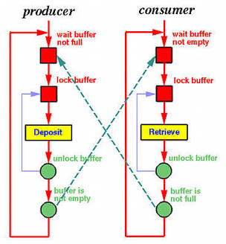
The solution?
We use three tools:
- A Mutex Lock to make sure only one person hands reach into the case at a time.
- An Empty Semaphore (starts at 10) tracking available empty spots. The baker waits on this.
- A Full Semaphore (starts at 0) tracking filled spots. The cashier waits on this.
The Readers-Writers Problem (Sharing the Google Doc)
This problem focuses on a shared database or file where the type of action matters. Reading data doesn't change it, so multiple processes should be able to read at once. But writing does change it, so writers need absolute privacy.
A simple analogy, imagine a timetable billboard in a busy railway station. There are 2 kinds of people:
1)Readers: the passengers who are constantly looking at the timetable. 1000’s of people can look at the timetable at the same time without interfering each others process’s.
2)Writer: The maintainence worker who needs to update the timetable with new information.
The rules are as follow:
- If anyone is reading, a writer cannot start updating.
- if a writer is updating, nobody can read (they would see glitched, half-updated text).
- The Starvation Threat: If readers just keep arriving in a continuous stream, the billboard is never empty. The poor maintenance worker (the Writer) stands there forever, starving for a turn.
The solution?
To prevent writer starvation, we use Mutex locks and queues to flip the priority. The moment a Writer indicates they want to edit, the OS places a "virtual barricade." Current readers can finish, but new readers are blocked and queued up. Once the current readers leave, the Writer gets exclusive access, finishes the job, and then releases the queue of waiting readers.

The Dining Philosophers Problem (Breaking the Circular Standstill)
This is the ultimate test of Deadlock (circular wait). It is a philosophical puzzle created by computer scientist Edsger Dijkstra in 1965.
A simple analogy, five philosopher’s sit at a round table, between each philosopher is exactly one chopstick (5 people, 5 chopsticks).To eat their bowl of noodles, a philosopher needs two chopsticks (the one on their left, and the one on their right).They alternate between thinking (sleeping) and eating (executing).
The Threat: Imagine all 5 philosophers get hungry at the exact same time. They all reach to their left and grab the left chopstick. Now, every single philosopher has one chopstick in their left hand, and is waiting for the chopstick on their right. But the chopstick on their right is held by the person next to them. Nobody can eat. Nobody will put their left chopstick down until they've eaten. The table is permanently Deadlocked.
The solution?
To break a Deadlock, you only have to break one link in the circle. The classic algorithmic solution is Asymmetry. Instead of everyone following the exact same rule (grab left, then grab right), we change the rules for just one person. We tell Philosopher #5 to grab their right chopstick first. Because of this tiny change, the circular wait is broken. Someone will always get two chopsticks, finish eating, and put them down for the next person.

