*High duty-cycle bats in the field do not alter echolocation calls when flying in groups*

Neetash Mysuru Rajagopalachari $​^{*}​^{1}$, Thejasvi Beleyur $​^{*}​^{1}$, Aditya Krishna $​^{1,2}$, Holger R Goerlitz $​^{1}$

1 Acoustic and Functional Ecology, MPI for Ornithology, Seewiesen

2 IISER Mohali (ADRESS)

*joint first authors

Last Updated : 2020-12-28

Groups provide benefits to their members, but also challenge individual sensory systems. Roosting sites and leks for instance are filled with a multitude of signals, of varying relevance to each individual. Studies to date have looked at groups of passive sensing animals that act as receivers of sensory stimuli. Each individual in a passive sensing group detects its surroundings without majorly affecting the sensory systems of their neighbours. Active sensing animals in contrast emit probes of energy to detect their surroundings. Echolocating bats emit intense calls and listen for returning echoes to perceive their environment. When echolocating in groups, bats may not be able to detect their own echoes due to masking by the intense calls of their neighbours. Bats use a variety of sensory strategies to cope with such acoustically challenging conditions. To date however, most studies have been performed on low duty-cycle bats that emit short frequency-modulated calls with long pauses. In contrast, high duty-cycle bats that emit long calls with short pauses are understudied despite their higher chances of call-echo overlap during group echolocation. Studying high duty-cycle bats has also been hindered by a lack of methods to analyse overlapping calls. We developed methods to analyse and extract call parameters of temporally overlapping calls and studied the echolocation of multiple free-flying high-duty cycle bats of the genus Rhinolophus in the field. Our results show that bats did not alter their call parameters even when flying in groups (with up to (at least) X other individuals). This lack of response is in contradiction to a previous flightroom study. Our results highlight the robustness of bat echolocation, and the importance of studying behaviour under natural conditions.

## 1 Introduction

Living in groups provides both costs and benefits to the group members, which Individuals have to balance [@behavecolref]. Advantages of being in a group might be increased foraging success, offspring survival, or thermoregulation, while challenges might include increased parasitism, and competition. An individual’s sensory perception is also challenged in groups, due to the multitude of dynamic sensory information from group members, for example in leks, roosting sites, or even at human gatherings. Only a small fraction of this information is relevant to a receiver [@principlesofanimalcomm], which necessitates various adaptations to filter out irrelevant information, including unique calls (e.g., mate contact calls in penguins) or avoiding signal overlap with neighbours (e.g., in frogs and cricket pairs) [@principlesofanimalcomm].

Many studies to date have focused on sensory filtering in passive sensing animals, i.e., animals that sense their surroundings by receiving external energy (e.g., penguins, frogs, humans)[@ZweifelHartmann2020;@NelsonMacIver]. As each passively-sensing group member receives external information independently, their sensory processes do not affect other individuals around them. In contrast, active sensing animals like electrolocating fish or echolocating bats face a unique sensory challenge when actively sensing in social groups (Ulanovsky and Moss 2008; Gillam et al. 2010;@takadaoriginalJARpaper). Echolocating bats emit intense ultrasonic calls and detect their surroundings by listening for the echoes reflecting off objects around them (Griffin 1958). In groups however, a bat’s returning echoes can be overlapped by the calls and echoes from its neighbours, preventing detection of its surroundings. (Møhl and Surlykke 1989; Ulanovsky and Moss 2008). Active sensing animals thus face the issue that their information of interest is potentially masked by the multitude of surrounding signals in a group. An echolocating bat in a group may thus end up metaphorically flying ‘blind’, as without detecting its own echoes it cannot sense its environment.

A combination of laboratory and field studies have shown the diverse behavioural responses of bats in response to sensory challenge from groups and experimental playbacks. Bats increase call levels, alter temporal features such as call rate, duration and duty cycle (Amichai, Blumrosen, and Yovel 2015; Jarvis, Jackson, and Smotherman 2013; Lu, Zhang, and Luo 2020; Hage et al. 2013; Lin, Abaid, and Müller 2016), and spectral properties such as bandwidth and terminal frequency (Hase et al. 2018; Cvikel et al. 2015; Götze et al. 2016; Fawcett and Ratcliffe 2015). These responses however are not uniform across species, with different species showing seemingly opposite responses to similar situations (Ulanovsky et al. 2004; Amichai, Blumrosen, and Yovel 2015; Jarvis, Jackson, and Smotherman 2013; Adams, Davis, and Smotherman 2017).

There are two broad groups of echolocating bats (Fenton, Faure, and Ratcliffe 2012) characterised by their duty cycle, i.e., the fraction of time spent emitting calls. The first and major group of bats are low-duty cycle bats. They typically emit frequency-modulated (FM) calls. The second group are high-duty cycle bats which typically emit calls with a long constant-frequency (CF) component and one or two flanking short FM components (CF-FM calls). In contrast to low-duty cycle bats, the calls of high-duty cycle bats are longer (10 to $≥$ 50ms) and thus have higher duty cycles of ~30-60% [@ratcliffereview]. Higher duty cycle directly increases the probability of temporal overlap and thus masking of echoes by calls (Beleyur and Goerlitz 2019). High-duty cycle bats such as rhinolophids and hipposiderids are thus likely to be more affected in group echolocation than low-duty cycle bats, making them a unique system to understand the sensory strategies echolocators use in challenging conditions. Most studies on group echolocation so far investigated low-duty cycle bats (Lin, Abaid, and Müller 2016; Fawcett and Ratcliffe 2015; Götze et al. 2016), likely due their speciosity (~87% of all echolocating bats (Fenton, Faure, and Ratcliffe 2012; Database 2020)) and ease of call analysis. A wider variety of species need to be studied, to understand the echolocation responses in context of their ecology and auditory systems.

A typical CF-FM call has of up to three call components: a short initial upwards FM sweep (iFM), a long central CF segment (CF), and a short terminal downward FM sweep (tFM) (*sensu* Tian and Schnitzler (1997)). The CF component is used for the flutter detection of prey wingbeats (Schnitzler and Denzinger 2011) based on high-resolution frequency analysis around the CF frequency in the bat’s auditory fovea (Neuweiler 2000). Different species and even individuals within a species use different CF-frequencies that are matched to the frequency tuning of their acoustic foveas (Schnitzler, Suga, and Simmons 1976). Individual bats also compensate for flight-induced Doppler shifts to keep the CF-frequency of the returning echo within their acoustic fovea (Schnitzler 1973; Schoeppler, Schnitzler, and Denzinger 2018). Despite potential temporal overlap of emitted call and returning echo, Doppler-shift compensation spectrally separates the CF parts of the echo and call when a bat is echolocating alone. In groups however, temporal and spectral overlaps between neighbours’ calls and own incoming echoes is bound to occur. While the CF component is involved in prey detection, the tFM component is thought to be involved in target ranging (Tian and Schnitzler 1997; Neuweiler et al. 1987), and the role of the iFM remains ambiguous. Comparable to call alterations in FM-bats (Biosonar chp2), CF-FM bats show rapid alterations in tFM bandwidth and duration based on the behavioural context, e.g. resting, landing or prey capture (Neuweiler et al. 1987; Schoeppler, Schnitzler, and Denzinger 2018; Tian and Schnitzler 1997).

Previous investigations [@delREFS] of group echolocation in CF-FM bats found no support for changes in CF frequencies to avoid spectral overlap (“jamming avoidance response”; @bullockelectricfish; Jones, Sripathi, and Waters 1994; Jones et al. 1993; Fawcett et al. 2015). Recent studies in low duty cycle FM bats also questioned the efficacy of a jamming avoidance response in groups [@Goetze,@MazarYovel]. In contrast to the CF-component, we are only aware of one study that quantified changes of the FM-component in group flight, reporting an increased tFM duration and bandwidth (Fawcett et al. 2015). Given the tFM’s flexibility and role in ranging, there is a strong need for its explicit quantification in multi-bat contexts. The tFM may show the same kinds of changes in multi-bat contexts as shown in low-duty cycle bats, which also use their FM calls primarily for ranging (Fawcett et al. 2015; Amichai, Blumrosen, and Yovel 2015; Hase et al. 2018).

Studying group echolocation in high-duty cycle bats entails analysing audio with overlapping calls. The analysis of recordings with overlapping calls is a nascent field (but see Izadi, Stevenson, and Kloepper 2019), and acoustic measurements have not been attempted to the best of our knowledge . Even studies with multiple high-duty cycle bats have been limited to 2-3 bats in flightroom conditions (Fawcett et al. 2015; Jones, Sripathi, and Waters 1994; Jones et al. 1993). Here, we developed methods to extract echolocation parameters in the presence of overlapping calls and to investigate the high-duty-cycle echolocation of group-flying horseshoe bats in a natural cave

## 2 Methods

### 2.1 Study species and site

Two species of rhinolophid bats *Rhinolophus mehelyi* and *R. euryale* were recorded in their natural environment. Both species emit CF-FM calls with peak frequencies between 102-112 kHz, and are not acoustically distinguishable due to overlap in their call characteristics (Dietz and Kiefer 2016). For the purposes of this study, we thus treated them as a single group of bats that may face the problem of acoustic jamming due to the similarity in spectro-temporal call structure.

We observed bats that flew in an out of and rested inside a small dome-shaped cave (Figure 1) next to the main entrance of the Orlova Chuka cave system, Bulgaria. The cave had a size of approximately 5 x 3 x 1.6 m3 (l x b x h), one opening where bats flew in and out of throughout the night, and some roosting sites on the inside.

### 2.2 Experimental setup

We placed an experimental audio-video setup inside the cave, consisting of three microphones and two infrared cameras. Two consumer grade CCTV cameras (UV-AHDBP716) with infrared lamps were connected to a digital video recorder (XVR1004) to record the flight of bats as they flew in and out of the cave. The system recorded video mostly at 22 Hz, however there was frame rate variation between 18-27 Hz. Video feeds were time-synchronised (but not frame-synchronised) by common burnt-in time stamps on the frame. The two cameras were placed in approximately the same position on every recording night. The cameras were placed to maximise the total cave volume recorded while also capturing the blinking LED light. Video was recorded continuously through the night. Audio from three CM16 microphones (Avisoft Bioacoustics, Glienicke, Germany) were recorded by a 416H soundcard (Avisoft Bioacoustics, 250 kHz sampling rate, 16 bit resolution). As horseshoe bat calls are directional (Matsuta et al. 2013), the three microphones were placed at different positions in the cave to increase the number of on-axis calls captured (Figure 1). Microphones were placed in the same location with an estimated +/- 10cm error in the cave across multiple nights. Audio was recorded continuously through the night as consecutive multichannel files of 1 minute duration

The audio and video feeds were synchronised using the method described in Laurijssen et al. 2018. In short, ON-OFF signals with variable durations between 0.08-0.5 s were generated by a portable computer (Raspberry Pi 3) and recorded on the audio soundcard and used to drive the blinking of an LED that was recorded by the two cameras. (See Supplementary Information (SI) 0.1 for signal generation script, electronic circuit and associated notes).

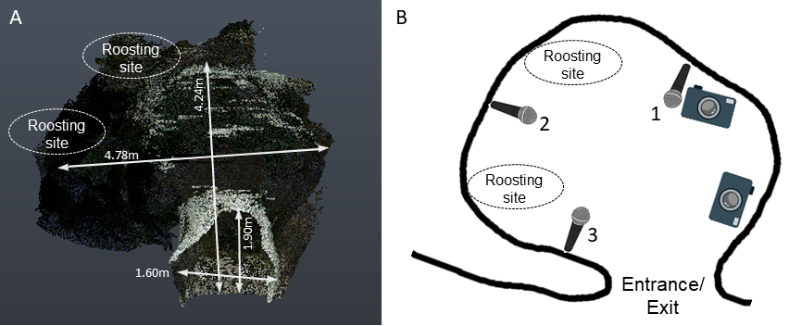

Figure 1: Point cloud scan (A) and schematic of the cave, indicating the entrance/exit, the typical roosting sites inside the cave, and the position of microphones and cameras. (3D scanning by Klaus Hochradel, UMIT Tirol) The numbers next to the microphone correspond to the positions in the main text..

### 2.3 Video analysis to determine group sizes

Bat activity in the cave was recorded for a total of about 12 hours across four nights (16-19 August 2018). After entering the cave, bats typically flew around for a few seconds or flew to the roosting site, where they stayed for several seconds to minutes, and later exited from the cave again. We watched the videos and manually identified bat flight activity, noting its start and end time and the number of visible bats. A bat flight activity is defined as the interval during which the number of visible bats flying inside the cave is constant. Successive bat flight activities were operationally defined as being separated from one another by least 6 frames (~0.3s).  We defined the start of bat activity as the frame a bat was observed to fly in either of the two camera view. Similarly, the end of bat flight activity was when a bat was not observed anymore in either of the camera views. Multi-bat contexts could have dynamic transitions in the number of bats, and we annotated the start and end of the multi-bat activity with the part of the video that had the maximum number of bats (See SI 0.2 for more details).

### 2.4 Synchronsing bat flight activity in video and audio

For each bat flight activity identified in the video, we identified the corresponding region of the recorded audio. The synchronization signal in the video was quantified by quantifying the median intensity of the pixels in the region around the LED. We then cross-correlated the normalized normalized pixel intensity with the recorded ON/OFF voltage signal in the audio. We managed to successfully find audio matches for 1181 video annotations (55% of 2132 video annotations). The low match rate is primarily due to the fluctuating camera frame rates, and because many of the matched audio files originated from non-target bat species, which could not be discriminated from our target speices *R. mehelyi/euryale* while annotating the videos. Observed non-target species were *R. ferrumequinum* and vespertilionid and miniopterid FM bats, all of which occur in the Orlova Chuka cave system (Ivanova 2005). For the acoustic analysis we chose matched audio files that only had *R. euryale* and/or *R. meheyli* calls.

## 2.5 Acoustic parameter analysis

All flight activity matched audio files (henceforth referred to as flight-activity audio) were first forward-backward high-pass filtered at 70 kHz (2nd order Butterworth filter). For the analysis we used recordings from the first microphone, as it appeared to have consistently captured calls with the least reverberance of the three channels. The first microphone was located facing the cave opening, perhaps therefore capturing calls of both entering and exiting bats well.

We quantified frequency, duration and amplitude of the three components of the echolocation call (iFM, CF and tFM) using two complementary acoustic analyses. The first analysis is the ‘individual call’ analysis, where we measured parameters of one individual echolocation call from each flight activity audio file. The second analysis is the ‘window’ analysis. Each flight-activity audio was split into consecutive windows of 50 ms duration. We then measured the acoustic parameters per window of all windows of a flight-activity audio. In recordings with multiple bats, the 50 ms windows could contain overlapping calls.

The advantage of the individual call analysis is that the measurements made on the calls are directly interpretable as call component alterations reveal the sensory decisions of the bats. On the other hand, the disadvantage of the individual call analysis is that especially in multi-bat recordings, it can be difficult to find a non-overlapped call. The window analysis complements individual call analysis by enabling measurements even on audio with overlapping calls. Window analysis also allows a kind of null-hypothesis testing where the observed multi-bat audio can be compared with 1) single bat audio and 2) ‘virtual’ multi-bat audio files created by adding multiple single bat audio files. These ‘virtual’ multi-bat audio files recreate a scenario where two bats echolocate in the same volume without actively responding to each other’s presence. The disadvantage with window analysis is the lack of call-level measurements. Ultimately, using the two approaches simultaneously strengthens the interpretation of our results.

### 2.5.1 Individual call analysis

Per flight activity audio, we chose one call that was not overlapped by other calls and that had a signal-to-noise ratio of at least 20 dB (Figure 2) through a random search protocol (SI 0.3). Briefly, from a randomly determined time point, an experimenter began searching into a randomly determined direction (backward or forward in time) until a suitable call was found. We were able to find 226 individual calls across all the synchronised audio files. Calls were automatically segmented into their corresponding parts iFM, tFM or CF (Tian and Schnitzler 1997) (Figure 2) using the *itsfm* package [Beleyur (2020);*biorxivpaper*]. Most approaches to date focus on segmenting CF-FM calls into their components by high/low pass filtering around the peak frequency of the call (Siemers et al. 2005; Schuchmann, Puechmaille, and Siemers 2012; Tian and Schnitzler 1997; Lu, Zhang, and Luo 2020; Schoeppler, Schnitzler, and Denzinger 2018). For an accurate estimate of the peak frequency, this approach requires a recording of the call with a prominent CF component. While suitable for laboratory studies, filtering around the peak frequency fails in the analysis of CF-FM calls recorded in the field under a variety of conditions eg. calls with loud FM and faint CF components. *itsfm* overcomes these limitations by tracking the *change* in frequency over time to segment it into FM and CF components.

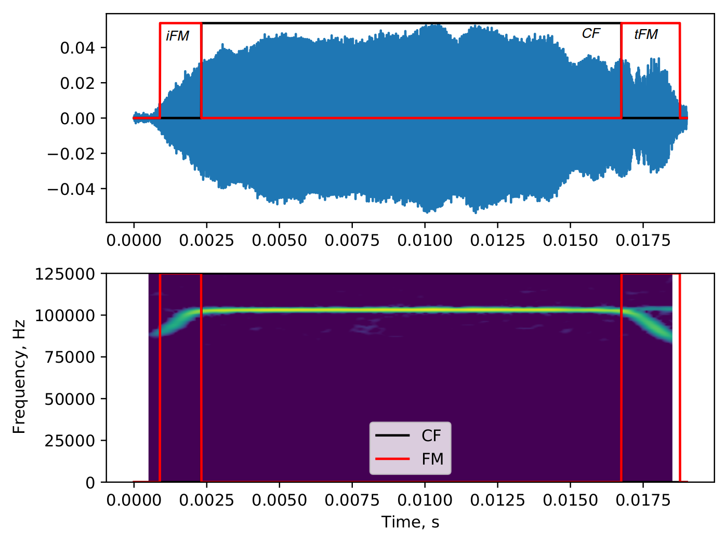

Figure 2: Example of a manually selected single CF-FM call, which was automatically segmented into its initial frequency-modulated (iFM), central constant-frequency (CF) and terminal frequency-modulated (tFM) components based on rate of frequency change over time, using the itsFM package. The itsfm package allows accurate segmentation into call components under challenging recording conditions

From the segmented CF and FM components we measured specific parameters. In the CF component, we measured the peak frequency, RMS level and duration. The CF peak frequency was quantified because bats may shift their CF frequencies in the presence of conspecifics. [RATIONALES for the other measures?] From the FM components, we measured the lower frequency (-10 dB peak frequency of the FM audio segment), bandwidth (defined as difference between the CF peak frequency and the lower frequency of the FM segment), RMS level and duration. We also calculated the iFM/CF and tFM/CF amplitude ratios, i.e., the relative amplitude of the iFM and tFM component relative to the CF component. The relative call component measures were calculated as CF-FM bats are known to independently vary the level of call components in a context specific manner (Tian and Schnitzler 1997; Lu, Zhang, and Luo 2020).

### 2.5.2 Windowed calls analysis

Each flight activity audio was split into consecutive 50 ms windows (See SI 0.4 for details of window splitting). We chose a window duration of 50 ms as it provided high spectral resolution (20 Hz at 250 kHz sampling rate) that allows to distinguish between multiple CF components that may be contained in the window. Initial observations showed that 50 ms was about the longest observed duration of a bat call in our data, and was about twice the length of typical calls. Over the course of a flight activity audio, there may be multiple windows without calls or very faint calls in them. To exclude those windows, we removed all windows whose RMS level were not at least 20 dB above the maximum RMS level of manually annotated audio segments without calls (for details, see SI 0.4.1). From the remaining windows that contained echolocation calls, we measured each window’s received RMS level, dominant frequencies and FM lower frequencies. Dominant frequencies are defined as local frequency peaks in the smoothed power spectrum that are within 14 dB of the window’s peak frequency (i.e., the frequency with highest energy in the spectrum). Dominant frequencies are a measurement of the CF frequencies of multiple calls in the same window (for details of dominant frequency measurement see SI 0.4.2). FM lower frequencies were determined by a spectrogram-based method which identified FM regions and chose the lowest frequency in all FM regions identified in a window (SI 0.4.3). There could be multiple terminal and dominant frequency values for a single window, however only one received RMS level measurement per window. We chose the measurements in the window analysis to be analogous to the measurements in the individual call analyses: the dominant frequencies in the window analysis complements the CF peak frequency measurements in the individual call analysis, while the lower frequencies and RMS measurements of the FM parts are analogous to the bandwidth and RMS level of the FM parts of the individual call analysis.

The advantage of the window analysis is the possibility to make ‘virtual multi-bat’ data (Fawcett et al. 2015; Ratcliffe et al. 2004) by combining recorded single bat call sequences. We created virtual multi-bat audio by combining single bat audio-files that were of similar durations (SI 0.4.4). This represents a ‘null’ dataset of multiple bats that were echolocating, but not responding to each other’s presence. We performed the same window acoustic analysis on the virtual multi-bat audio as described above.

## 2.6 Statistical analysis

We observed up to four bats flying in the cave at the same time. Especially in the individual call dataset the number of recordings of multi-bat ($≥$ 2 bats) calls was low (N=177, 40, 7, 2 for group sizes of 1, 2, 3, 4 respectively,), we thus combined all annotations with $≥$ 2 bats into a multi-bat class and compared ‘single’ and ‘multi’ bat calls in the individual call analysis. To maintain consistency with individual call analysis we also performed comparisons of ‘single-bat’, ‘multi-bat’ and ‘virtual-multi-bat’ flight-activity audio in the window analysis.

### 2.6.1 Individual call analysis

We calculated the median difference between multi-bat and single-bat conditions ($median_{multi}-median_{single}$) for all parameters except CF peak frequency. For CF peak frequencies, we calculated the range difference ($Range_{multi}-Rangesingle$) of CF peak frequencies in multi bat and single calls. The range difference was calculated because the supposed spectral jamming avoidance response, i.e., a shift in the used call frequencies, leads to an increased frequency range (Habersetzer 1981), or, as paradoxically has also been observed, a narrower range (Furusawa et al. 2012). We performed permutation tests to assess the significance of the observed differences between single and multi-bat conditions.

Our dataset consists of calls from a population of resident wild bats of unknown group size. The same bats may have visited the cave site multiple times over the course of a night. Additionally, bat activity was relatively clustered in time, with median time intervals between consecutive flight annotations of 36 s and 54 s, for annotations used in individual call and window analysis, respectively. Thus, our dataset originates from an unknown number of individuals with an unknown amount of pseudo-replication, potentially lowering the variation in the data. To account for this temporal pseudo-replication, we repeated the analysis by creating two independent subsets from our full dataset: The ‘clustered’ subset contained all calls from the flight activities that were separated by $≤$ 1 min from each other. The ‘isolated’ subset contained all calls from flight activities that ≥1 min from each other. One minute was chosen as it was slightly larger than the observed median inter-annotation interval. Broadly speaking, we expect that if the results of our analysis are comparable across the isolated and clustered subsets, there is a common underlying effect that is independent of temporal clustering. However, if the results of the subset analysis do not corroborate each other, it hints at an effect due to temporal clustering/isolation in the dataset.

### 2.6.2 Windowed call analysis

In analogy to CF peak frequency range in the individual call analysis, we first calculated the dominant frequency range ($max_{dominant frequency}-min_{dominant frequency}$) across each flight activity audio. We expect variation in the dominant frequency (and thus a non-zero range of dominant frequency) across a flight activity for two reasons: 1) the combined effect of the bat’s Doppler shift compensation and 2) the Doppler shift due to the bat’s motion relative to the microphone will cause variation in the dominant frequency. These two effects will lead to non-zero dominant frequency range even for single-bat flight activities (SI 0.8). In multi-bat and virtual-multi-bat situations, we expect an increased dominant frequency range due to multiple bats calling at different individual frequencies. We first calculated the median difference in dominant frequency ranges between 1) multi-bat and single-bat and 2) multi-bat and virtual-multi-bat flight activity audio. A permutation test was then performed to assess the significance of the observed median difference.

To understand the theoretically expected dominant frequency range from single and multi bat flights, (and thus the expected range difference) we also performed simulations quantifying Doppler shift and Doppler shift compensation parametrised by the observed data (SI 0.8 for details of simulation and results). Briefly we simulated a Doppler-shift compensating bat emitting frequencies between 100-111 kHz, flying past a microphone at various speeds between 1.5-4.5 m/s. The dominant frequency range was calculated as the absolute difference between the frequency recorded by the microphone at the beginning of the flight and the end of the flight. The dominant frequency range estimates from the simulations informed the interpretation of the observed data.

The received level and lowest frequency measurements resulted in multiple values per flight-activity audio (one value per window). The measurements from one flight-activity audio are potentially correlated and we accounted for this potential flight-activity level pseudo-replication by repeated random subsampling followed by median difference calculation. To estimate the median difference between conditions we randomly chose one measurement value per flight activity audio for the single-bat, multi-bat and virtual-multi-bat observations. The median difference between 1) multi-bat and single-bat and 2) multi-bat and virtual multi bat conditions were calculated and followed by the next subsampling round. We performed 10,000 such subsampling iterations, and report the 95-percentile range of median differences in received level and lowest frequency. No tests were run on the median difference estimates obtained for received level and terminal frequency.

To account for temporal pseudo-replication in our study, we also repeated the entire window analysis using clustered and isolated subsets as described in section 2.1.

### 2.4.3 Software packages

Signal analysis, data manipulation and visualisation were performed in Python (Van Rossum and Drake Jr 1995) and its scipy, numpy, matplotlib, soundfile and pandas packages (Virtanen et al. 2020; Oliphant 2006; Hunter 2007; Bechtold and Geier 2019; McKinney and others 2010). Median difference and permutation tests were performed with dabest (Ho et al. 2019) while reproducible analysis, documentation and presentation were enabled by the Jupyter Notebook and Rmarkdown projects (Kluyver et al. 2016; Xie, Allaire, and Grolemund 2018). Audio visualisation, preliminary measurements and single call annotations were done with Audacity (Audacity-Team 2019).

## 3 Results

We recorded echolocation and flight behaviour of mixed-species groups of the high-duty cycle bats *Rhinolophus euryale* and R*. mehelyi* as they flew alone and with other bats in a natural cave. The bats performed various flight behaviours in the cave, such as circling inside the cave, approaches ((when two or more bats flew towards each other) and following (one bat behind another) flights. The duration of continuously observed flight bouts varied strongly, ranging from about 0.1 s to 62 s (median: 1.04 s , 95%ile range: 0.5-8.54 s).

In general, the acoustic parameters of individual calls mostly did not differ between single-bat and multi-bat conditions. Likewise, the windowed-call-analysis revealed no major differences in received level and FM lowest frequency between single-bat and multi-bat and between multi-bat and virtual-multi-bat conditions. The dominant-frequency range of the window analysis, however, was larger in multi-bat conditions compared to single-bat conditions.

### 3.1 Individual call analysis

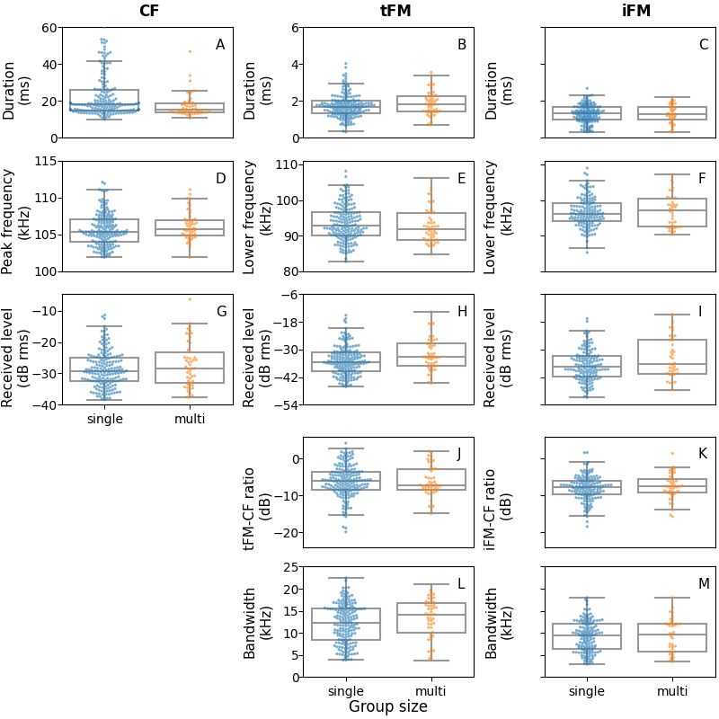

Figure 3: Measured acoustic parameters for the constant frequency (CF), initial frequency modulated (iFM) and terminal frequency modulated (tFM) components of individual calls emitted under single-bat and multi-bat conditions. Each column shows the measurements per call component, while each row shows a group of related measurements: A-C) duration D-F) spectral measurements G-I) received level J-K) relative FM-CF ratios L-M) FM component bandwidths. $Ncalls_{single}=$ 177 , $Ncalls_{multi}$ = 49. Raw data points are plotted over box plots showing the median, quartiles and whiskers of 1.5 times the inter-quartile range.

We measured 13 acoustic parameters of the initial and terminal frequency-modulated (iFM, tFM) and of the central constant-frequency (CF) component of 226 individual horseshoe bat echolocation calls (Figure 3). Most call parameters showed no difference between single-bat and multi-bat observations (Table 1). Only the median duration of the CF-component was ~3ms shorter (*p*=0.003) and the median level of the terminal FM-component was ~3 dB fainter in multi-bat situations (*p*=0.01) compared to single-bat situations. The remaining parameters were very similar between the single-bat and multi-bat conditions (*p*>0.05, Table 1). For instance, some call parameters that showed change in previous studies had overlapping ranges such as tFM duration (single-bat:0.32-4.04, multi-bat:0.72-3.57 ), tFM bandwidth (single-bat:3.85-22.45, multi-bat:3.81-20.98) and CF peak frequency (single-bat:101.9-112.1, multi-bat:101.9-111.1 ).

Our ‘whole dataset’ results somewhat matched the results from the ‘clustered’ and ‘isolated’ subsets (SI 0.6). Median CF duration differed by ~3ms in both isolated and clustered subsets, while iFM and tFM median durations differed by ~ 0.1ms. The spectral parameters (CF peak frequency, tFM bandwidth, i/tFM lower frequency) differed in the magnitude of difference across the ‘clustered’ and ‘isolated’ subsets. If pseudo-replication was not a major concern, we expect the results of the isolated and clustered datasets to match. The observed deviations imply that pseudo-replication may have been a concern however. Before reaching this conclusion, it is important to consider the severe drop in sample size in the isolated data subset as a possible cause for the deviation in trends across parameters. In the isolated subset, $N_{multi}$ = 5 calls, in contrast to the much higher $N_{single}$ =53. The severe drop in sample size in the ‘isolated’ data set and the different trends in the spectral parameters make it hard to conclude whether pseudo-replication has played a major role in the individual call analysis.

Table 1: *Difference between multi and single bat call parameters. The median difference is reported for all parameters except CF peak frequency, where the difference in range is reported.*

| Measurement | Difference (multi – single) | Permutation test p-value |
| --- | --- | --- |
| Median CF duration (ms) | -2.95 | 0.003 |
| Median tFM duration (ms) | 0.14 | 0.16 |
| Median iFM duration (ms) | -0.04 | 0.7 |
| Range CF peak frequency (kHz) | -1 | 0.18 |
| Median tFM lower frequency (kHz) | -1.03 | 0.29 |
| Median iFM lower frequency (kHz) | 1.07 | 0.24 |
| Median CF level (dB RMS) | -1.48 | 0.2 |
| Median tFM level (dB RMS) | -3.15 | 0.01 |
| Median iFM level (dB RMS) | -1.66 | 0.32 |
| Median tFM-CF ratio (dB) | -1.08 | 0.16 |
| Median iFM-CF ratio (dB) | 0.25 | 0.75 |
| Median tFM bandwidth (kHz) | 1.83 | 0.12 |
| Median iFM bandwidth (kHz) | 0.27 | 0.82 |

### 3.2 Windowed call analysis

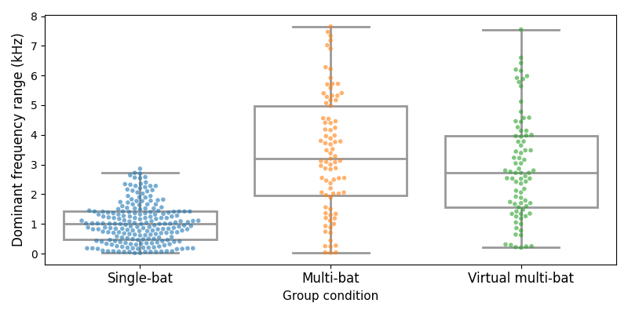

Figure 4 Measured dominant frequency range (max-min) across flight activities in single-bats, multi-bat and virtual multi-bat conditions. Variation in dominant frequency in single-bat condition arises from the combination of active Doppler-shift compensation by the bat and Doppler-shift due to bat flight past the microphone. The dominant frequency range in multi-bat and virtual multi-bat is larger because of there are more than one bat. The median multi-bat dominant frequency range is greater than single-bat range by 2.2 kHz (p<10-4). Virtual multi-bat and multi-bat median range difference was much lower and negligible at 0.48 kHz (p=0.16)

We split flight-activity audio into windows of 50 ms duration and analysed two parameters for each window: received level and FM lower frequency. For each flight-activity audio we also measured the dominant-frequency range (maximum – minimum dominant frequency of all windows in that audio). Dominant frequency ranges indicate the amount of shifting or convergence in the CF frequencies within a flight activity (Figure 4). An increase in frequency range indicates a reduced frequency overlap, while a decrease in frequency range indicates a convergence of frequencies. The median dominant frequency range (Figure 4) was 2.2 kHz larger (*p*<10-4) in multi-bat conditions (range: 0.03-7.65 kHz) compared to the single-bat condition (range: 0.02-2.86 kHz). The observed median difference in dominant frequency range matches the expected magnitude in simulations when bats do not show any special responses to each other (SI ). The estimated median differences for received level (95%ile range: -0.88-1.61 dB) and FM lower frequency (95%ile range: -1.46-0.98 kHz) showed no systematic trend, indicating no relative increase or decrease. Subset analysis revealed the same trends in both isolated and clustered data for multi-bat and single-bat comparisons (SI 0.7). Both isolated and clustered subsets showed a dominant frequency range difference of ~2 kHz. The median difference ranges of both received level and FM lower frequency were similarly located on either of zero. Isolated and clustered subsets showed the same trends with an increased dominant frequency range of ~2 kHz and with estimated received level and lower frequency median differences on either side of zero (SI 0.7).

Median difference in dominant frequency range in the mutli-bat was relatively low at 0.48 kHz more (*p*=0.16) than the virtual-multi-bat conditions (range:0.2-7.55 kHz) condition. Median differences of received level (95%ile range: -0.72-2.1 dB) and FM lower frequency (95%ile range: -1.95-0.98 kHz) indicate no systematic trend towards a relative increase or decrease in multi-bat windows in comparison to virtual-multi bat. Subset analysis also revealed similar trends (SI 0.7). Isolated and clustered subsets showed similarly low dominant frequency range differences of between 0-0.6 kHz. For both subsets, received level and lower frequency the estimated median difference range was on either side of zero.

The results of both window-analysis reveals a consistency between the isolated and clustered subsets, hints at the possibility that pseudo-replication may not be an issue. Even though the parameter trends match, here too, the isolated subsets suffered from a drop in sample size, with Nmulti-bat=8, in comparison to Nmulti-bat=79 in the clustered subset.

## 4 Discussion

We quantified whether multiple acoustic parameters of the echolocation calls of horseshoe bat differ when bats were flying alone or in groups in the field, using two analysis approaches. For both the individual call analysis and the windowed call analysis, our results do not support a biologically meaningful difference in acoustic call parameters. This may seem somewhat unexpected, especially considering the fact that bats in our field site were flying in an enclosed reverberant volume - which should only amplify the problem of masking in multi-bat echolocation.

To address the problem of analyzing calls that overlap in time and frequency, we introduced two automated analyses that can be performed on audio recordings of multiple CF-FM bats. First, we performed automated individual call analyses using the open-source itsfm package allows call component segmentation based on rate of frequency change in a sound. This frequency-modulation-based segmentation performs better than filtering around the peak frequency and results in more accurate CF-FM call component segmentation, and thus better measurements. [@itsfmbiorxivref]. Second, to analyse audio with overlapping calls, we measured the overall acoustic parameters of short audio windows without assigning the measurements to individual calls. While coarser in time (?) than the individual call analysis, this window-based approach complements the individual call analyses by returning related measurements such as FM terminal frequency and dominant frequency range.

4.1 CF component

To avoid spectral overlap in groups, the spectral jamming avoidance response (JAR) hypothesis predicts that individual bats in groups shift their call frequencies away from those of other individuals (REF). JAR has mixed support from studies. Several studies in CF-FM / Hipp & Rhino bats found no changes in CF frequencies (Jones et al. 1993; Jones, Sripathi, and Waters 1994; Fawcett and Ratcliffe 2015; Pye 1972). In contrast, Habersetzer (1981) observed CF frequency shifting in groups of the quasi-CF rhinopomatid bat *Rhinopoma hardwickei*, while Cvikel et al. (2015) found no support in the same species. However, the echolocation of *R. hardwickei* is not entirely comparable with those of the more specialised CF-bats of the families Hipposideridae and Rhinlophidae (Simmons, Kick, and Lawrence 1984). Hipposiderids and rhinolophids are more constrained in their echolocation as they show a marked individual-specific acoustic fovea that does not vary over short periods of time (Neuweiler 2000; Schnitzler, Suga, and Simmons 1976). CF-FM bats are thus constrained to emit calls so that the Doppler-shifted echoes arrive within their own acoustic fovea’s range.

Our data does not support CF frequency shifting in a group (Jones et al. 1993; Jones, Sripathi, and Waters 1994; Fawcett and Ratcliffe 2015; Pye 1972). If bats were to show ‘jamming avoidance’ type responses, one would expect an overall increase in the CF frequency range in groups, and thus an increased range difference between single and multi bat audio. If they were to show ‘convergence’ (eg. as in Furusawa et al. 2012), we expect a reduction in range. The observed CF and dominant frequency range differences of around 2 kHz between single and multi bats falls within the expected magnitude seen when bats do not show any special responses to each other (SI 8.0). More convincingly however, the low difference in dominant frequency range between multi and virtual multi audio shows that even when bats are indeed flying together they are not actively altering their CF frequencies to reduce or increase overlap. Our simulations (SI 0.8) and single bat audio data show that a receiver (eg. a microphone or another bat) placed in the proximity of a flying CF-FM bat may hear a series of CF frequencies that vary by upto $±$ 3 kHz from the emitted frequency. This relatively large variation in the received frequency thus decreases the extent of spectral overlaps during multi-bat echolocation. The combination of individual specific acoustic foveas and Doppler-shift driven variation in received CF frequency make it unlikely that the CF component would be masked effectively even in groups. For the duration of CF component, we found a median decrease by around 3 ms in multi-bat calls, matching the decrease by ~1.2 ms found by Fawcett et al. (2015). Note that our procedure of selecting non-overlapping calls in the individual call analysis might bias our selection to shorter calls in multi-bat recordings, because shorter calls might be less prone to temporal overlap. The bias is not very evident in our data however, as the range of CF durations (the longest part of a CF-FM call) overlap in both single-bat and multi-bat conditions.

4.2 FM component

The FM component is likely used for ranging and undergoes large variation as bats approach objects . Frequency-changes in group flying FM-bats could indicate a JAR, but could also be a responseto the physical presence of other bats in the vicinity (Cvikel;Fawcett2015]. Corresponding to FM-bats, we hypothesized that the (f)FM components should show changes / …

The tFM call component can undergo alterations in groups. Fawcett et al. (2015) found that the tFM minimum frequency (-10 dB call peak frequency) increase by 5 kHz on average in pairs. In contrast, we only found a drop by ~1 kHz of the tFM lower frequency (-10 dB tFM peak frequency) and an increase by maximally 1.8 kHz of tFM bandwidth. Our window analysis revealed no systematic differences in terminal frequency estimates between single-bat and multi-bat situations. Both FM and CF-(???) bats also change call duration in the presence of conspecifics and noise (Fawcett et al. 2015; Lu, Zhang, and Luo 2020). While we found only found an increase in tFM duration by 0.1 ms, previous studies found 0.6-1.8 ms (Lu et al; Fawcett et al). Fawcett et al. (2015) found an average increase in tFM duration by 1.8 ms in pairs, while we find a slight median increase by about 0.1 ms in multi-bat calls. In another study with artifical playbacks, Lu, Zhang, and Luo (2020) found an increase of 0.6ms in comparison to calls in silence. An increased tFM duration may provide an increase in in echo detection [amichai;LuoGoerlitzBrummwiegrebe;]. The current increase in duration corresponds to a negligible fraction (~5%), and is unlikely to have any major sensory implications. Compared to previous studies, our effects are small, and unlikely to have biological relevance.

4.3 Call levels

CF-FM Bats increase call source levels in the presence of experimental playbacks (Hage et al. 2013, 2014; Lu, Zhang, and Luo 2020). In our study, we could not measure the bats source level because bats were free-flying and we did not track their 3D-position. Instead, we analysed the *received* level at the microphone. In addition to the bat’s source level, received levels also depend on the bats’ distance to and calling direction relative to the microphone. The received level of the tFM of individual calls was 3dB lower median in the multi-bat condition than in the single-bat condition, while the difference was only ~1.5 dB in the iFM and CF components. The windowed call analysis revealed no systematic alteration in received level in multi-bat vs single-bat and in multi-bat vs. virtual-multi-bat conditions. The relative received levels between the CF and FM components changed by around 1 dB between the multi-bat and single-bat conditions, indicating no shift in call energy between the components. Why was there no major difference in received levels between single-bat and multi-bat conditions even in the window analysis, where overlapping calls are expected to lead to a higher received level? The similarity in received levels of multi-bat and single-bat windows can be explained by the inequal contribution the nearest bat’s call makes to the received level due to spherical spreading, and the directionality of calls. The fact that multi-bat and virtual-multi bat audio have similar received levels thus indirectly suggests there is no change in source level even in the presence of another bat. However, the tFM received level showed a drop of around 3dB that we are not sure how to interpret. This apparent drop in received level could be the result of bats flying further away or emitting more directional calls.

There are a set of parameters that we were not able to measure and thus excluded in our analyses. We did not measure call-sequence related parameters such as inter-call-intervals or duty-cycle. Bats in acoustically difficult situations are known to alter their call rate (Amichai, Blumrosen, and Yovel 2015; Jarvis, Jackson, and Smotherman 2013), and thus their duty cycle. Measuring inter-call-intervals is possible in single bat contexts, but extremely challenging in multi-bat recordings with overlapping calls and reverberation. Calls are difficult to assign to their source individuals, which complicates call interval measurement.

What are the possible explanations for the absence of a strong echolocation response in groups? Our data suggests that echolocation in groups with a few bats (2-4) bats may not be very challenging for multiple reasons. CF-FM bats rely on the tFM component to detect the distance of objects around them (Tian and Schnitzler 1997). The tFM components are short (<=3.4 ms, 95 percentile value), and are emitted about every 40-50 ms which is equivalent to a tFM duty cycle between 6.8-8.5%. For a pair of bats at these duty cycles, the probability of one tFM echo being overlapped by another bat’s tFM call component is relatively low at most between 1.6 - 2.1% (SI 0.9 for calculations). Even if a single tFM echo is overlapped by another call, a bat may still be able to detect it if the signal-to-noise ratio is sufficient. FM bats in small groups are unlikely to face major detriments to their echolocation (Beleyur and Goerlitz 2019), which should also apply to using the FM for raning, explaining why the horseshoe bats did not show call changes from solitary echolocation. Secondly, Fawcett et al. (2015) observed an increased tFM duration and bandwidth in *R. capensis* flying in pairs in a novel flight room setting. The combination of flight room characteristics (Surlykke, Boel Pedersen, and Jakobsen 2009) and species differences, may perhaps have led to the difference in results between their study and ours. Bats show long-term spatial memory (Barchi, Knowles, and Simmons 2013; Möhres and Oettingen-Spielberg 1949) and familiarity with the cave’s structure may have allowed them to easily recognise their location over time. Bats also use echoes across multiple calls and are thus resistant to occasional disruptions in echo arrival (Salles, Diebold, and Moss 2020). The combination of spatial memory and multi-echo integration may have allowed our bats to continue echolocating with conspecifics without altering their calls drastically.

It is well established that bats adapt and alter their echolocation strategy in the face of sensory challenge. Our results add a subtle twist to this line of investigations by suggesting that bats may not always employ a special strategy even when faced with the sensory challenge of a group . We highlight the importance of observational studies in field settings to understand the frequency with which various sensory strategies are actually employed in ecological contexts.

## Data and code availability

All data and code used process data and generate the results and figures in the paper are available in the Zenodo repository [INSERT DOI HERE].

## Acknowledgements

We thank the electronics team (Markus Abels, Hannes Sagunsky, Reinhard Biller) at the MPIO workshop for help preparing the electronic circuits to run the ON/OFF signal splitting. We also thank Antoniya Hubancheva for logistical support, Stefan Greif for help collecting the data, the 2018 Tabachka field crew, Klaus Hochradel for the point-cloud scan of the cave and Diana Schoeppler, Annette Denzinger and Hans-Ulrich Schnitzler for their helpful discussions. We also thank Manjari Jain for her support and and encouragement of the project. TB was funded by a DAAD doctoral fellowship and the IMPRS for Organismal Biology, HRG was funded by the Emmy Noether program of the DFG (German Research Foundation, grant no. 241711556)

## Author Contributions

Study design and conception: NMR, TB; Data collection: AK, NMR, TB; Audio and video annotation: AK, NMR; Audio-video synchronisation: TB; Analysis: HRG, NMR, TB; Interpretation of results: HRG, NMR, TB; Manuscript preparation: HRG, NMR, TB.

## References

Adams, Amanda M, Kaylee Davis, and Michael Smotherman. 2017. “Suppression of Emission Rates Improves Sonar Performance by Flying Bats.” *Scientific Reports* 7 (1): 1–9.

Amichai, Eran, Gaddi Blumrosen, and Yossi Yovel. 2015. “Calling Louder and Longer: How Bats Use Biosonar Under Severe Acoustic Interference from Other Bats.” *Proceedings of the Royal Society B: Biological Sciences* 282 (1821): 20152064.

Audacity-Team. 2019. “Audacity(R): Free Audio Editor and Recorder [Computer Application] Version 2.3.3.” <https://audacityteam.org/>.

Barchi, Jonathan R, Jeffrey M Knowles, and James A Simmons. 2013. “Spatial Memory and Stereotypy of Flight Paths by Big Brown Bats in Cluttered Surroundings.” *Journal of Experimental Biology* 216 (6): 1053–63.

Bechtold, Bastian, and Matthias Geier. 2019. *SoundFile* (version 0.10.3). <https://github.com/bastibe/SoundFile>.

Beleyur, Thejasvi. 2020. “Itsfm: Identify, Track and Segment Sounds by Frequency and Its Modulation, V 0.1.0.” <https://itsfm.readthedocs.io/en/latest/>.

Beleyur, Thejasvi, and Holger R. Goerlitz. 2019. “Modeling Active Sensing Reveals Echo Detection Even in Large Groups of Bats.” *Proceedings of the National Academy of Sciences* 116 (52): 26662–8. <https://doi.org/10.1073/pnas.1821722116>.

Chen, Y, Q Liu, YG Shao, LJ Tan, ZF Xiang, and LB Zhang. 2015. “Variation in Echolocation Calls of Hipposideros Amiger During Habituation to a Novel, Captive Environment.” *Behaviour* 152 (7-8): 1083–95.

Cvikel, Noam, Eran Levin, Edward Hurme, Ivailo Borissov, Arjan Boonman, Eran Amichai, and Yossi Yovel. 2015. “On-Board Recordings Reveal No Jamming Avoidance in Wild Bats.” *Proceedings of the Royal Society B: Biological Sciences* 282 (1798): 20142274.

Database, Mammal Diversity. 2020. “Mammal Diversity Database.” Zenodo. <https://doi.org/10.5281/zenodo.4139818>.

Dietz, Christian, and Andreas Kiefer. 2016. *Bats of Britain and Europe*. Bloomsbury Publishing.

Fawcett, Kayleigh, David S Jacobs, Annemarie Surlykke, and John M Ratcliffe. 2015. “Echolocation in the Bat, Rhinolophus Capensis: The Influence of Clutter, Conspecifics and Prey on Call Design and Intensity.” *Biology Open* 4 (6): 693–701.

Fawcett, Kayleigh, and John M Ratcliffe. 2015. “Clutter and Conspecifics: A Comparison of Their Influence on Echolocation and Flight Behaviour in Daubenton’s Bat, Myotis Daubentonii.” *Journal of Comparative Physiology A* 201 (3): 295–304.

Fenton, M Brock, Paul A Faure, and John M Ratcliffe. 2012. “Evolution of High Duty Cycle Echolocation in Bats.” *Journal of Experimental Biology* 215 (17): 2935–44.

Furusawa, Yuto, Shizuko Hiryu, Kohta I Kobayasi, and Hiroshi Riquimaroux. 2012. “Convergence of Reference Frequencies by Multiple Cf–Fm Bats (Rhinolophus Ferrumequinum Nippon) During Paired Flights Evaluated with Onboard Microphones.” *Journal of Comparative Physiology A* 198 (9): 683–93.

Gillam, Erin H., Nickolay I. Hristov, Thomas H. Kunz, and Gary F. McCracken. 2010. “Echolocation behavior of Brazilian free-tailed bats during dense emergence flights.” *Journal of Mammalogy* 91 (4): 967–75. <https://doi.org/10.1644/09-MAMM-A-302.1>.

Götze, Simone, Jens C Koblitz, Annette Denzinger, and Hans-Ulrich Schnitzler. 2016. “No Evidence for Spectral Jamming Avoidance in Echolocation Behavior of Foraging Pipistrelle Bats.” *Scientific Reports* 6 (1): 1–13.

Griffin, Donald R. 1958. “Listening in the Dark: The Acoustic Orientation of Bats and Men.”

Habersetzer, Joerg. 1981. “Adaptive Echolocation Sounds in the Batrhinopoma Hardwickei.” *Journal of Comparative Physiology* 144 (4): 559–66.

Hage, Steffen R, Tinglei Jiang, Sean W Berquist, Jiang Feng, and Walter Metzner. 2013. “Ambient Noise Induces Independent Shifts in Call Frequency and Amplitude Within the Lombard Effect in Echolocating Bats.” *Proceedings of the National Academy of Sciences* 110 (10): 4063–8.

Hage, Steffen R, Tinglei Jiang, Sean W Berquist, Jiang Feng, and Walter Metzner 2014. “Ambient Noise Causes Independent Changes in Distinct Spectro-Temporal Features of Echolocation Calls in Horseshoe Bats.” *Journal of Experimental Biology* 217 (14): 2440–4.

Hase, Kazuma, Yukimi Kadoya, Yosuke Maitani, Takara Miyamoto, Kohta I Kobayasi, and Shizuko Hiryu. 2018. “Bats Enhance Their Call Identities to Solve the Cocktail Party Problem.” *Communications Biology* 1 (1): 1–8.

Ho, Joses, Tayfun Tumkaya, Sameer Aryal, Hyungwon Choi, and Adam Claridge-Chang. 2019. “Moving Beyond P Values: Data Analysis with Estimation Graphics.” *Nature Methods* 16 (7): 565–66.

Hunter, John D. 2007. “Matplotlib: A 2D Graphics Environment.” *Computing in Science & Engineering* 9 (3): 90–95.

Ivanova, Teodora. 2005. “Important Bat Underground Habitats (Ibuh) in Bulgaria.” *Acta Zool. Bulg* 57 (2): 197–206.

Izadi, Mohammad Rasool, Robert L Stevenson, and Laura Kloepper. 2019. “Segmentation of Overlapping Sources in Mixtures of Bat Echolocation Calls.” *The Journal of the Acoustical Society of America* 146 (4): 3026–6.

Jarvis, Jenna, William Jackson, and Michael Smotherman. 2013. “Groups of Bats Improve Sonar Efficiency Through Mutual Suppression of Pulse Emissions.” *Frontiers in Physiology* 4: 140.

Jones, G, M Morton, PM Hughes, and RM Budden. 1993. “Echolocation, Flight Morphology and Foraging Strategies of Some West African Hipposiderid Bats.” *Journal of Zoology* 230 (3): 385–400.

Jones, G, K Sripathi, and Dean A Waters. 1994. “Individual Variation in the Echolocation Calls of Three Sympatric Indian Hipposiderid Bats, and an Experimental Attempt to Jam Bat Echolocation.” *Folia Zoologica* 43: 347–62.

Kluyver, Thomas, Benjamin Ragan-Kelley, Fernando Pérez, Brian Granger, Matthias Bussonnier, Jonathan Frederic, Kyle Kelley, et al. 2016. “Jupyter Notebooks – a Publishing Format for Reproducible Computational Workflows.” Edited by F. Loizides and B. Schmidt. IOS Press.

Lin, Yuan, Nicole Abaid, and Rolf Müller. 2016. “Bats Adjust Their Pulse Emission Rates with Swarm Size in the Field.” *The Journal of the Acoustical Society of America* 140 (6): 4318–25.

Lu, Manman, Guimin Zhang, and Jinhong Luo. 2020. “Echolocating Bats Exhibit Differential Amplitude Compensation for Noise Interference at a Sub-Call Level.” *Journal of Experimental Biology* 223 (19).

McKinney, Wes, and others. 2010. “Data Structures for Statistical Computing in Python.” In *Proceedings of the 9th Python in Science Conference*, 445:51–56. Austin, TX.

Merten, Sophie von, and Björn M Siemers. 2020. “Shrew Twittering Call Rate Is High in Novel Environments—a Lab-Study.” *Mammal Research*, 1–11.

Möhres, FP, and Th Oettingen-Spielberg. 1949. “Versuche über Die Nahorientierung Und Das Heimfindevermögen Der Fledermäuse.” *Verhandlungen Der Deutschen Zoologen in Mainz*, 248–52.

Møhl, B., and A. Surlykke. 1989. “Detection of Sonar Signals in the Presence of Pulses of Masking Noise by the Echolocating Bat, Eptesicus Fuscus.” *J. Comp. Physiol. A* 165: 119–24.

Neuweiler, Gerhard (transl. Ellen Covey). 2000. “The Biology of Bats.” Oxford University Press.

Neuweiler, G, W Metzner, U Heilmann, R Rübsamen, M Eckrich, and HH Costa. 1987. “Foraging Behaviour and Echolocation in the Rufous Horseshoe Bat (Rhinolophus Rouxi) of Sri Lanka.” *Behavioral Ecology and Sociobiology* 20 (1): 53–67.

Oliphant, Travis E. 2006. *A Guide to Numpy*. Vol. 1. Trelgol Publishing USA.

Pye, JD. 1972. “Bimodal Distribution of Constant Frequencies in Some Hipposiderid Bats (Mammalia: Hipposideridae).” *Journal of Zoology* 166 (3): 323–35.

Ratcliffe, John M, Hannah M ter Hofstede, Rafa Avila-Flores, M Brock Fenton, Gary F McCracken, Stephania Biscardi, Jennifer Blasko, Erin Gillam, Jasmine Orprecio, and Genvieve Spanjer. 2004. “Conspecifics Influence Call Design in the Brazilian Free-Tailed Bat, Tadarida Brasiliensis.” *Canadian Journal of Zoology* 82 (6): 966–71.

Salles, Angeles, Clarice Anna Diebold, and Cynthia F. Moss. 2020. “Echolocating Bats Accumulate Information from Acoustic Snapshots to Predict Auditory Object Motion.” *Proceedings of the National Academy of Sciences*. <https://doi.org/10.1073/pnas.2011719117>.

Schnitzler, Hans-Ulrich. 1973. “Control of Doppler Shift Compensation in the Greater Horseshoe Bat, Rhinolophus Ferrumequinum.” *Journal of Comparative Physiology* 82 (1): 79–92.

Schnitzler, Hans-Ulrich, and Annette Denzinger. 2011. “Auditory Fovea and Doppler Shift Compensation: Adaptations for Flutter Detection in Echolocating Bats Using Cf-Fm Signals.” *Journal of Comparative Physiology A* 197 (5): 541–59.

Schnitzler, H-U, N Suga, and JA Simmons. 1976. “Peripheral Auditory Tuning for Fine Frequency Analysis by the Cf-Fm Bat, Rhinolophus Ferrumequinum.” *Journal of Comparative Physiology* 106 (1): 99–110.

Schoeppler, Diana, Hans-Ulrich Schnitzler, and Annette Denzinger. 2018. “Precise Doppler Shift Compensation in the Hipposiderid Bat, Hipposideros Armiger.” *Scientific Reports* 8 (1): 1–11.

Schuchmann, Maike, Sébastien J Puechmaille, and Björn M Siemers. 2012. “Horseshoe Bats Recognise the Sex of Conspecifics from Their Echolocation Calls.” *Acta Chiropterologica* 14 (1): 161–66.

Siemers, Björn M, Kristian Beedholm, Christian Dietz, Isabel Dietz, and Teodora Ivanova. 2005. “Is Species Identity, Sex, Age or Individual Quality Conveyed by Echolocation Call Frequency in European Horseshoe Bats?” *Acta Chiropterologica* 7 (2): 259–74.

Simmons, James A, Shelley A Kick, and Beatrice D Lawrence. 1984. “Echolocation and Hearing in the Mouse-Tailed Bat, Rhinopoma Hardwickei: Acoustic Evolution of Echolocation in Bats.” *Journal of Comparative Physiology A* 154 (3): 347–56.

Surlykke, Annemarie, Simon Boel Pedersen, and Lasse Jakobsen. 2009. “Echolocating Bats Emit a Highly Directional Sonar Sound Beam in the Field.” *Proceedings of the Royal Society B: Biological Sciences* 276 (1658): 853–60.

Tian, Biao, and Hans-Ulrich Schnitzler. 1997. “Echolocation Signals of the Greater Horseshoe Bat (Rhinolophus Ferrumequinum) in Transfer Flight and During Landing.” *The Journal of the Acoustical Society of America* 101 (4): 2347–64.

Ulanovsky, Nachum, M Brock Fenton, Asaf Tsoar, and Carmi Korine. 2004. “Dynamics of Jamming Avoidance in Echolocating Bats.” *Proceedings of the Royal Society of London. Series B: Biological Sciences* 271 (1547): 1467–75.

Ulanovsky, Nachum, and Cynthia F Moss. 2008. “What the Bat’s Voice Tells the Bat’s Brain.” *Proceedings of the National Academy of Sciences* 105 (25): 8491–8.

Van Rossum, Guido, and Fred L Drake Jr. 1995. *Python Reference Manual*. Centrum voor Wiskunde en Informatica Amsterdam.

Virtanen, Pauli, Ralf Gommers, Travis E. Oliphant, Matt Haberland, Tyler Reddy, David Cournapeau, Evgeni Burovski, et al. 2020. “SciPy 1.0: Fundamental Algorithms for Scientific Computing in Python.” *Nature Methods* 17: 261–72. <https://doi.org/https://doi.org/10.1038/s41592-019-0686-2>.

Xie, Yihui, J. J. Allaire, and Garrett Grolemund. 2018. *R Markdown: The Definitive Guide*. Boca Raton, Florida: Chapman; Hall/CRC. <https://bookdown.org/yihui/rmarkdown>.

Yamada, Yasufumi, Yurina Mibe, Yuya Yamamoto, Kentaro Ito, Olga Heim, and Shizuko Hiryu. 2020. “Modulation of Acoustic Navigation Behaviour by Spatial Learning in the Echolocating Bat Rhinolophus Ferrumequinum Nippon.” *Scientific Reports* 10 (1): 1–15.