High duty-cycle bats in the field do not alter echolocation calls when flying in groups

Neetash Mysuru , Thejasvi Beleyur, Aditya Krishna, Holger R Goerlitz; : joint first authors

Last Updated : 2021-04-06 15:40:20

Living in groups provides animals with many advantages, yet also disadvantages, such as the possibility for sensory overload. Many animals yet form large groups at roosting, foraging and mating sites that are filled with a multitude of signals, of varying relevance to each individual. Studies to date have looked at groups of passive sensing animals that are only receivers of sensory stimuli. Each individual in a passive sensing group senses its surroundings without majorly interfering with the sensory perception of their neighbors. Active sensing animals in contrast emit probes of energy to detect their surroundings. Free flying echolocating bats emit intense calls and listen for weak returning echoes to perceive their environment. In groups, echo detection might be severely limited due to masking by the intense calls of their neighbors. Bats use a variety of sensory strategies to cope with such acoustically challenging conditions. To date however, most studies have been performed on low duty-cycle bats that emit short frequency-modulated calls with long pauses. In contrast, high duty-cycle bats that emit long calls with short pauses are understudied despite their higher chances of call-echo overlap during group echolocation. Studying high duty-cycle bats has also been hindered by a lack of methods to analyze overlapping calls. We developed methods to analyze average call parameters of temporally overlapping calls and studied the echolocation of multiple free-flying high-duty cycle bats of the genus *Rhinolophus* in the field. The bats did not alter their call parameters in a biologically relevant way, even when flying in groups of up to four other individuals. Our results highlight the robustness of bat echolocation, and the importance of studying behavior under natural conditions.

## 0.1 Introduction

Living in groups provides both costs and benefits to the group members, which individuals have to balance (Pulliam & Caraco 1984). Advantages of being in a group might be increased foraging success, reproductive success (not sure if this is true, no paper on my mind), offspring survival, or thermoregulation, while challenges might include increased parasitism, and competition *(Pulliam & Caraco 1984 and refs therein)*.. An individual’s sensory perception is also challenged in groups, due to the multitude of dynamic sensory information from group members, for example in roosting sites, or even at human gatherings (Cherry 1953, Bee & Micheyl 2008 and refs therein)). Only a small fraction of this information is relevant to a receiver ( Carrasco 2014, *Krauzulis et al. 2014*), which necessitates various adaptations to filter out irrelevant information, including unique individual calls (Bradbury and Vehrencamp 2011).

Many studies to date have focused on sensory filtering in passive sensing animals, i.e., animals that sense their surroundings by receiving external energy (Zweifel and Hartmann 2020; Nelson and MacIver 2006). As each passively-sensing group member receives external information independently, their sensory processes do not affect other individuals around them. In contrast, active sensing animals like electrolocating fish or echolocating bats face a unique sensory challenge when actively sensing in social groups (Ulanovsky and Moss (2008); Gillam et al. (2010); Watanabe and Takeda (1963)). Echolocating bats emit intense ultrasonic calls and detect their surroundings by listening for the echoes reflecting off objects around them (Griffin 1958). In groups however, a bat’s returning echoes can be overlapped by the calls and echoes from its neighbours, preventing detection of its surroundings (Ulanovsky and Moss 2008). Active sensing animals thus face the issue that their information of interest is potentially masked by the multitude of surrounding signals in a group. An echolocating bat in a group may thus end up metaphorically flying ‘blind’, as without detecting it’s own echoes the bat cannot sense the environment.

A combination of laboratory and field studies have shown the diverse behavioural responses of bats in response to sensory challenge from groups and experimental playbacks. Bats increase call levels, alter temporal features such as call rate, duration and duty cycle (GILLAM-ULANOVSKY-MCCRACKEN2007, Amichai, Blumrosen, and Yovel 2015; Jarvis, Jackson, and Smotherman 2013; Lu, Zhang, and Luo 2020; Hage et al. 2013; Lin, Abaid, and Müller 2016; Gomes and Goerlitz 2020), and spectral properties such as bandwidth and terminal frequency (Hase et al. 2018; Cvikel et al. 2015; Götze et al. 2016; Fawcett et al. 2015). These responses however are not uniform across species, with different species showing seemingly opposite responses to similar situations (Ulanovsky et al. 2004; Amichai, Blumrosen, and Yovel 2015; Jarvis, Jackson, and Smotherman 2013; Adams, Davis, and Smotherman 2017).

There are two broad groups of echolocating bats (Fenton, Faure, and Ratcliffe 2012) characterised by their duty cycle, i.e., the fraction of time spent emitting calls. The first and major group of bats are THE low-duty cycle bats. They typically emit frequency-modulated (FM) calls. The second group IS high-duty cycle bats which typically emit calls with a long constant-frequency (CF) component and one or two flanking short FM components (CF-FM calls). In contrast to low-duty cycle bats, the calls of high-duty cycle bats are longer (10 to 50ms) and thus have higher duty cycles of ~30-60 (Fenton, Faure, and Ratcliffe 2012). Higher duty cycle directly increases the probability of temporal overlap and thus masking of echoes by calls (Beleyur and Goerlitz 2019). High-duty cycle bats such as rhinolophids and hipposiderids are thus likely to be more affected in group echolocation than low-duty cycle bats, making them a unique system to understand the sensory strategies echolocators use in challenging conditions. Most studies on group echolocation so far HAVE investigated low-duty cycle bats (Lin, Abaid, and Müller 2016; Fawcett and Ratcliffe 2015; Götze et al. 2016), likely due their speciosity (~87% of all echolocating bats (Fenton, Faure, and Ratcliffe 2012; Mammal Diversity Database 2020) and ease of call analysis. A wider variety of species need to be studied, to understand the echolocation responses in context of their ecology and auditory systems.

A typical CF-FM call has of up to three call components: a short initial upwards FM sweep (iFM), a long central CF segment (CF), and a short terminal downward FM sweep (tFM) (*sensu* Tian and Schnitzler (1997)). The CF component is used for the flutter detection of prey wingbeats (Schnitzler and Denzinger 2011) based on high-resolution frequency analysis around the CF frequency in the acoustic fovea (Neuweiler 2000). Different CF-FM bat species, and even individuals within a species use specific CF-frequencies that are matched to their acoustic foveas (Schnitzler, Suga, and Simmons 1976). Individual bats also compensate for flight-induced Doppler shifts to keep the CF-frequency of the returning echo within their acoustic fovea (Schnitzler 1973; Schoeppler, Schnitzler, and Denzinger 2018). Despite potential temporal overlap of emitted call and returning echo, Doppler-shift compensation spectrally separates the CF parts of the echo and call when a bat is echolocating alone. In groups however, temporal and spectral overlaps between neighbours’ calls and own incoming echoes is bound to occur. While the CF component is involved in prey detection, the tFM component is thought to be involved in target ranging (Tian and Schnitzler 1997; Neuweiler et al. 1987), and the role of the iFM remains ambiguous. Comparable to call alterations in FM-bats (Fenton et al. 2014), CF-FM bats show rapid alterations in tFM bandwidth and duration based on the behavioural context, e.g. resting, landing or prey capture (Neuweiler et al. 1987; Schoeppler, Schnitzler, and Denzinger 2018; Tian and Schnitzler 1997).

Previous investigations of group echolocation in CF-FM bats found no support for changes in CF frequencies to avoid spectral overlap (“jamming avoidance response”)(Jones et al. 1993; Jones, Sripathi, and Waters 1994; Fawcett et al. 2015). Recent studies in low duty cycle FM bats also questioned the efficacy of a jamming avoidance response in groups (Götze et al. 2016; Mazar and Yovel 2020). While there are multiple studies investigating the CF-component, we are only aware of one study that quantified changes of the FM-component in group flight, reporting an increased tFM duration and bandwidth (Fawcett et al. 2015,). Given the tFM’s flexibility and role in ranging, there is a strong need for its explicit quantification in multi-bat contexts. The tFM may show the same kinds of changes in multi-bat contexts as shown in low-duty cycle bats, which also use their FM calls primarily for ranging (Fawcett and Ratcliffe 2015; Amichai, Blumrosen, and Yovel 2015; Hase et al. 2018).

To study the effect of group size on free flying horseshoe bats, we recorded bat flight activity in their natural habitat using a synchronized audio and video setup. We used two lines of acoustic analysis, the first extracts parameters from non-overlapping individual calls and the second, which extracts parameters from multiple overlapping and non-overlapping calls. The analysis of recordings with overlapping calls is a nascent field (but see Izadi, Stevenson, and Kloepper (2019)), and acoustic measurements have not been attempted on overlapping CF-FM calls to the best of our knowledge. We compared the difference in CF and FM call parameters *across two groups, single or multi bats*. The results from both lines of acoustic analysis suggest no major differences in the measured call parameters when bats were echolocating alone or in the presence of others.

## 2 Methods

### 2.1 Study species and site

Two species of rhinolophid bats, *Rhinolophus mehelyi* and *R. euryale*, were recorded in their natural environment. Both species emit CF-FM calls with peak frequencies between 102-112 kHz, and are not acoustically distinguishable due to overlap in their call characteristics (Dietz and Kiefer 2016). For the purposes of this study, we thus treated them as a single group of bats that may face the problem of acoustic jamming due to the similarity in spectro-temporal call structure.

We observed bats that flew in and out of and rested inside a small dome-shaped cave (Figure 1) next to the main entrance of the Orlova Chuka cave system, NE-Bulgaria. The cave had a size of approximately 5 x 3 x 1.6 m (l x b x h) and one opening where bats flew in and out of throughout the night

### 2.2 Experimental setup

We placed an experimental audio-video setup inside the cave, consisting of three microphones and two infrared cameras. Two consumer grade CCTV cameras (UVAHDBP716; *944x1080*) with infrared lamps were connected to a digital video recorder (XVR1004) to record the flight of bats as they flew in and out of the cave. The system recorded video mostly at 22 Hz, however there was frame rate variation between 18-27 Hz. Video feeds were time-synchronised (but not frame-synchronised) by common time stamps burnt-in on the frame. The two cameras were placed in approximately the same position on every recording nightAudio from three CM16 microphones (Avisoft Bioacoustics, Glienicke, Germany) were recorded by a 416H soundcard (Avisoft Bioacoustics, 250 kHz sampling rate, 16-bit resolution). To increase the number of calls recorded on-axis, the three microphones were placed at three different positions, which remained approximately constant across recording nights (Fig. 1). The audio and video feeds were synchronised by generating ON-OFF signals of variable durations (0.08-0.5 s; Raspberry Pi 3), which were recorded on the soundcard and used to flash an LED that was recorded by the two cameras (; see Supplementary Information (SI) 0.9.1 for signal generation script, electronic circuit and associated notes). The video was recorded continuously throughout the recording nights for X – Y hours, while audio was recorded as consecutive multichannel files of 1 minute duration.

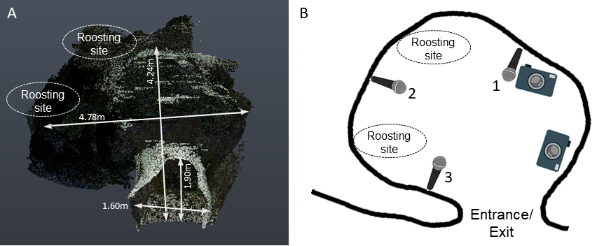

Figure 1: Point cloud scan (A) and schematic of the cave (B), indicating the entrance/exit, the typical roosting sites inside the cave, and the position of microphones and cameras. The numbers next to the microphone correspond to the positions in the main text. (3D scanning by Klaus Hochradel, UMIT Tirol.)

### 2.3 Video analysis to determine group sizes

Bat activity in the cave was recorded for a total of about 12 hours across *three* nights (16-19 August 2018). After entering the cave, bats typically flew around for a few seconds or flew to one of *two* roosting sites, where they stayed for several seconds to minutes, and later exited from the cave again. We watched the videos and manually identified periods of bat flight activity (hereby referred to as ‘bat activity period’), noting its start and end time and the number of visible bats. We defined a bat activity period as the interval during which the number of visible bats flying inside the cave was constant. Successive bat flight activities were operationally defined as being separated from one another by at least 6 frames (~0.3 s). We defined the start of a bat activity period as the frame a bat was observed to fly in either of the two camera views. Similarly, the end of a bat activity period was when a bat was not observed anymore in either of the camera views (for example, because the left the cave or were hanging at a roosting site). We used the maximum number of bats observed during each bat activity period to categorize bat activity periods as single-bat context (only one bat visible) or multi-bat contexts (more than one bat visible). Multi-bat contexts could have dynamic transitions in the number of bats, and we annotated the start and end of the multi-bat activity with the part of the video that had the maximum number of bats (See SI 0.9.2 for more details).

### 2.4 Synchroni*s*ing bat flight activity in video and audio

For each bat flight activity period identified in the video, we identified the corresponding region of the recorded audio. We quantified the median intensity of the pixels in the region around the LED for each frame and then cross-correlated the normalized pixel intensity with the recorded ON/OFF voltage signal in the audio files. We managed to successfully find audio matches for 1181 bat flight activity periods (55% of 2132). The low match rate is primarily due to the fluctuating camera frame rates, and because many of the matched audio files originated from non-target bat species, which could not be visually discriminated from our target speices *R. mehelyi/euryale* while annotating bat activity periods in the videos. Observed non-target species were *R. ferrumequinum*, vespertilionid and miniopterid FM bats, all of which occur in the Orlova Chuka cave system (Ivanova 2005). For the acoustic analysis we chose matched audio files that contained only calls of *R. euryale* and/or *R. meheyli*.

## 2.5 Acoustic parameter analysis

acoustic ,only 1becauseappeared to suffer least from and because it recorded calls of both entering and exiting bats First, all audio files corresponding to the bat activity periods (henceforth referred to as flight-activity audio) were high-pass filtered at 70 kHz (2nd order zero-phase Butterworth filter). Next, we used two complementary acoustic analyses to quantify frequency, duration and amplitude parameters of the three components of the echolocation call (initial FM, CF and terminal FM). The first analysis is the ‘individual call’ analysis, where we measured parameters of one echolocation call from each flight-activity audio. The second analysis is the ‘windowed call’ analysis, were we split each flight-activity audio into consecutive 50-ms-long windows and measured the acoustic parameters of each window. In recordings with multiple bats, each window could contain multiple and potentially overlapping calls.

The analysis of individual calls is advantageous because it directly reveals sensory decisions of the bats. Its disadvantage, however, is that it can be difficult to find a non-overlapped call, particularly in reverberant and multi-bat situations. The windowed call analysis therefore complements the individual call analysis by enabling measurements even on audio with overlapping calls. Windowed call analysis also allows a kind of null-hypothesis testing where the observed multi-bat audio can be compared with 1) single bat audio and 2) ‘virtual’ multi-bat audio files created by adding multiple single bat audio files. These ‘virtual’ multi-bat audio files recreate a scenario where two bats echolocate in the same space without altering their calls in response to each other’s presence. The disadvantage of the windowed call analysis is the lack of call-level measurements. Using both approaches simultaneously strengthens the interpretation of our results.

#### 2.5.1 Individual call analysis

Per flight activity audio, we chose one call that was not overlapped by other calls and that had a signal-to-noise ratio of at least 20 dB (Fig. 2A) through a random search protocol (SI 0.9.3). Briefly, from a randomly determined time point, an experimenter began searching into a randomly determined direction (backward or forward in time) until a suitable call was found. Across all flight activity audio files, we found 226 individual calls, which we automatically segmented based on their frequency-time-course into their iFM, CF and tFM components (Fig. 2) with the itsfm package (Beleyur 2021). Most segmentation approaches to date segment CF-FM calls into their components by high/low pass filtering around the call’s peak frequency (Siemers et al. 2005; Schuchmann, Puechmaille, and Siemers 2012; Tian and Schnitzler 1997; Lu, Zhang, and Luo 2020; Schoeppler, Schnitzler, and Denzinger 2018). This approach requires call recordings with a prominent CF component to accurately estimate the peak frequency, which is suitable under controlled laboratory settings. The peak-frequency but often fails under realistic and variable field-conditions. *itsfm* overcomes these limitations by tracking the change in frequency over time and using the rate of change to segment a call into its FM and CF components. For our analysis, we defined FM components as those portions of a call where frequency modulation was larger than 2 kHz/ms. Further settings were a maximum acceleration of 3 kHz/ms, an extrapolation window of 50 s and a window size of 375 samples. Threshold signal level and time-frequency clip range were manually tuned for each calls using the pwvd-method, since each call had differing received levels.

From the three components of each call, we measured specific parameters. For the CF component, we measured the peak frequency, RMS level and duration. The CF peak frequency was quantified because bats may shift their CF frequencies in the presence of conspecifics. For the FM components, we measured the lowest frequency (at 10 dB below the level of the peak frequency of the FM component), bandwidth (defined as difference between the CF peak frequency and the lowest frequency of the FM component), RMS level and duration. We also calculated the iFM/CF and tFM/CF level difference, i.e., the level of the iFM and tFM components relative to the CF component, because CF-FM bats independently vary the level of call components in a context specific manner (Tian and Schnitzler 1997; Lu, Zhang, and Luo 2020).

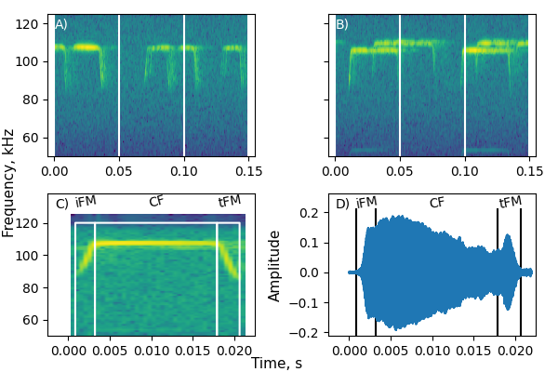

**Figure 2: Individual and windowed call analysis examples.**

A-B: Examples of a single bat (A) and a multi-bat (B) recording used for windowed call analysis. The vertical lines indicate the borders between the 50-ms-long windows.

C-D: Example of a manually selected call used for individual call analysis, showing its spectrogram (C) and waveform (D) representation. The call was automatically segmented into its initial frequency-modulated (iFM), central constant-frequency (CF) and terminal frequency-modulated (tFM) components based on frequency change over time , using the itsfm package..

#### 2.5.2 Windowed call analysis

Each flight activity audio was split into consecutive 50-ms-long windows (Fig. 2; SI 0.9.4 for details of window splitting). We chose a window duration of 50 ms as it provided high spectral resolution (20 Hz at 250 kHz sampling rate) that allows to distinguish between multiple CF components that may be contained in the window. Initial observations showed that 50 ms was about the longest observed duration of a bat call in our data, and was about twice the length of typical calls. To exclude windows without calls or with very faint calls, we excluded all windows whose RMS level was less than 20 dB above the maximum RMS level of silent windows (for details, see SI 0.9.4.1). From the remaining windows that contained echolocation calls, we measured each window’s received RMS level, dominant frequencies and FM lower frequencies. We chose these measurements to complement the The dominant frequencies describe the CF frequencies of multiple calls in the same window and were defined as local peaks of the smoothed power spectrum (SMOOTHING INFO: type of smoothing, smoothing factor/frequency range) with a level of not more than 14 dB below the highest peak (for details, see SI 0.9.4.2). They complement the CF peak frequency measurement of individual calls. FM lower frequencies describe XXX and were determined by a spectrogram-based method which identified FM regions and chose the lowest frequency in all FM regions identified in a window (SI 0.9.4.3). They correspond to the lowest frequency of the individual calls (NOT: bandwidth, as was written before!). RMS level describes XXX and was defined as XXX. And corresponds to the RMS-level of the the FM part of individual calls. There could be multiple terminal and dominant frequency values for a single window, however only one received RMS level measurement per window.

We created ‘virtual multi-bat’ data (Fawcett et al. 2015; Ratcliffe et al. 2004) by combining single bat audio-files that were of similar durations (SI 0.9.4.4). This generated a ‘null’ dataset of multiple bats that were echolocating without altering their calls in groups. We performed the same windowed call analysis on the virtual multi-bat audio as described above for the real multi-bat audio, to compare real echolocation during group flight during virtual group flight without call alterations.

### 2.6 Statistical analysis

We observed up to four bats flying in the cave at the same time. Especially in the individual call dataset the number of recordings of multi-bat ( 2 bats) calls was low (N=177, 40, 7, 2 for group sizes of 1, 2, 3, 4 respectively,). We thus combined all annotations with 2 bats into a multi-bat class and compared ‘single’ and ‘multi’ bat calls in the individual call analysis. To maintain consistency with individual call analysis we also performed comparisons of ‘single-bat’, ‘multi-bat’ and ‘virtual-multi-bat’ flight-activity audio in the windowed analysis.

#### 2.6.1 Individual call analysis

We fitted linear mixed-models (LMMs) to each of our three response variables, using group size as predictor (categorical: single, multi) and recording hour (continuous???) as random intercept. [Add details about: distribution family? Any link-functions? What is recording hour? That was not introduced before. Is that hour of night? (if so, why not time used?) Or is a continuous count across all nights? Should night be included as random?  
How was model fit evaluated and confirmed?]

Model coefficients were estimated using a Bayesian approach with non-informative priors using the sim function of the ‘arm’ package (Gelman and Su 2020), and the 93% compatibility intervals were used in reporting. The compatibility interval represents the most probable range of values the estimate will lie within, given the statistical model and data at hand.

#### 2.6.2 Windowed call analysis (Needs more work, see some comments below. In general, please extent and explain more)

GENERAL EXPLANATION: What is the difference between multiple bat and single bat analysis / what is the problem and/or benefit of this, and how does this lead to our decision to analysis not the windows, but to calculate yet another summary parameter (= dom freq range).

Why do we compare real-single with real-multi-bat, AND with virtual-multi-bat situations (Reasons, advantages, disadvantages. Maybe also why you do NOT do this for single bat analysis).

To compare these situations, we cacluated dom freq range across the flight acitivty periods for dom CF frequency, but used the data of all windows for level and low freq. …

We first calculated the dominant frequency range () across each flight activity audio.

The peak frequency of flying CF bats that is recorded at a microphone varies because of the bat’s active Doppler shift compensation (REF) and because of the Doppler shift due to the bat’s motion relative to the microphone. The dominant frequency range will therefore be larger than Zero even for single-bat flight activity periods (WHAT IS IN THIS SI? SI 0.9.5).

Since different bat individuals emit different CF frequencies (REF), we expected an increased dominant frequency range in virtual multi-bat contexts compared to single-bat contexts. Furthermore, if bats in real multi-bat contexts actively alter their call frequency, we expected an increase dominant frequency range compared to both single-bat and to virtual multi-bat contexts.

~~In multi-bat and virtual-multi-bat situations, we expect an increased dominant frequency range due to multiple bats calling at different individual frequencies.~~

The test for a difference in dominant frequency range across contexts, we fitted a MODEL TYPE to the dominant frequency range as response variable, using group type as predictor. (FURTHER MODEL DETAILS, see above) Residual analysis showed no correlation with any of the predictors, or any form of auto-correlation, and a simple linear model was thus justified.

To understand the theoretically expected dominant frequency range from single and multi bat flights, (and thus the expected range difference) we also performed simulations quantifying Doppler shift and Doppler shift compensation parametrised by the observed data (SI 0.9.5 for details of simulation and results). Briefly we simulated a Doppler-shift compensating bat emitting frequencies between 100-111 kHz, flying past a microphone at various speeds between 1.5-4.5 m/s. The dominant frequency range was calculated as the absolute difference between the frequency recorded by the microphone at the beginning of the flight and the end of the flight. The dominant frequency range estimates from the simulations informed the interpretation of the observed data.

The received level and lowest frequency measurements resulted in multiple values per flight-activity audio (one value per window). The measurements from one flight-activity audio are potentially correlated. We estimated the difference between single, multi and virtual-multi bat audio using an LMM with group-type as predictor and flight-activity as random intercept.

### 0.3.2 Software packages used in this paper

Signal analysis, data manipulation and visualisation were done in Python (Van Rossum and Drake Jr 1995) through its scientific ecosystem: the scipy, numpy, matplotlib, soundfile and pandas packages (Virtanen et al. 2020; Oliphant 2006; Hunter 2007; Bechtold and Geier 2019; McKinney and others 2010). Reproducible analysis, documentation and presentation were enabled by the Jupyter Notebook and Rmarkdown projects(Kluyver et al. 2016; Xie, Allaire, and Grolemund 2018). Audio visualisation, preliminary measurements and single call annotations were done with Audacity (Audacity-Team 2019). LMMs were run in R (R Core Team 2021) and its statistical ecosystem: the ‘lme4’, ‘arm’ and ‘coda’ packages (Bates et al. 2015; Gelman and Su 2020; Plummer et al. 2006).

## 3 Results

We recorded echolocation and flight behaviour of mixed-species groups of the high-duty cycle bats *Rhinolophus euryale* and *R. mehelyi* as they flew alone and with other bats in a natural cave. The bats performed various flight behaviours in the cave, such as circling, approach (two or more bats flying towards each other) and following (one bat flying behind another) flights. The duration of continuously observed flight bouts varied strongly, ranging from about 0.1 s to 62 s (median: 1.04 s, 95%ile range: 0.5-8.54 s).

In general, the acoustic parameters of individual calls mostly did not differ between single-bat and multi-bat contexts. Likewise, the windowed call-analysis revealed no major differences in received level and FM lowest frequency between single-bat and multi-bat and between multi-bat and virtual-multi-bat conditions. In contrast, the dominant-frequency range of the windowed analysis was larger in multi-bat conditions compared to single-bat conditions.

### 0.4.1 Individual call analysis

We measured 13 acoustic parameters of the initial and terminal frequency-modulated (iFM, tFM) and of the central constant-frequency (CF) component of 226 individual horseshoe bat echolocation calls (Figure 3). Most call parameters showed little to no difference between single-bat and multi-bat contexts, as the confidence interval of the difference between contexts was close to or included zero (Table 1). Compared to single-bat contexts, the calls in multi-bat contexts had slightly shorter CF-components (by 1.4-4.2 ms, 95% comparability interval), slightly lower received levels for all three components (CF, iFM and tFM, X – -4 dB), and slightly broader bandwidth of the tFM component (0.0-2.6 kHz).

~~The CF component of calls in multi-bat contexts was slightly shorter than in single-bat contexts, by 1.37-4.29 ms (95% comparability interval). The received level of all three call components (CF, tFM and iFM) seemed to be slightly lower by up to -4 dB in multi-bat contexts compared to single-bat contexts. tFM bandwidth seemed to be higher by 0.02-2.58 kHz in in multi-bat contexts compared to single-bat contexts.~~

All remaining parameters had smaller differences between single- and multi-bat contexts, with the estimated difference between their means centered on zero (Table 1).

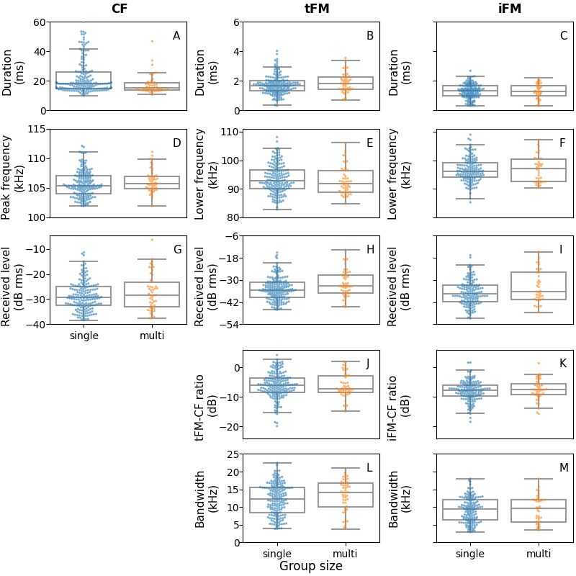

Figure 3: Measured acoustic parameters for the constant frequency (CF), initial frequency modulated (iFM) and terminal frequency modulated (tFM) components of individual calls emitted under single-bat and multi-bat contexts. Each column shows the measurements per call component, while each row shows a group of related measurements: A-C) duration D-F) spectral measurements G-I) received level J-K) level differences L-M) FM component bandwidths. Raw data points are plotted over box plots showing the median, quartiles and whiskers of up to 1.5 times the inter-quartile range.

Table 1: Range of measured parameters of individual bat calls in single- and multi-bat contexts and the 95%-compatibility interval (???) (CI) of their means.

~~Difference between means and range of values for multi and single bat call parameters. The 93% compatibility interval (CI) for the difference of means is reported.~~

| Component | Measurement | Difference (3.5,96.5)%CI | Single bat range | Multi bat range |
| --- | --- | --- | --- | --- |
| CF | Duration, ms | (-4.29,-1.37) | 10.08-60.16 | 10.69-46.84 |
| tFM | Duration, ms | (0,0.37) | 0.32-4.04 | 0.72-3.57 |
| iFM | Duration, ms | (-0.14,0.18) | 0.32-2.69 | 0.3-2.22 |
| CF | Peak frequency, kHz | (-0.18,1.01) | 101.91-112.11 | 101.9-111.1 |
| tFM | Lower frequency, kHz | (-2.36,0.53) | 82.77-108.11 | 84.73-106.1 |
| iFM | Lower frequency, kHz | (-1.28,1.43) | 85.29-108.97 | 90.35-107.14 |
| CF | Amplitude, dB rms | (-3.89,-0.31) | -37.63--6.35 | -37.96--14.4 |
| tFM | Amplitude, dB rms | (-4.11,-0.3) | -46.2--13.53 | -44.67--12.4 |
| iFM | Amplitude, dB rms | (-4.25,0.34) | -50.39--14.7 | -48.98--17.99 |
| tFM-CF | Ratio, dB | (-1.22,1.14) | -19.92-4.18 | -14.91-1.99 |
| iFM-CF | Ratio, dB | (-0.35,1.7) | -18.47-1.62 | -15.75-1.41 |
| tFM | Bandwidth | (0.02,2.58) | 3.85-22.45 | 3.81-20.98 |
| iFM | Bandwidth | (-0.85,1.48) | 2.94-17.98 | 3.49-17.97 |

| **Measurement** | **Component** | **Measured data range** | | **Predicted difference (multi – single???, 3.5 – 96.5% CI)** |
| --- | --- | --- | --- | --- |
|  |  | **Single bat** | **Multi bat** |  |
| **Duration (ms)** | CF | 10.1 - 60.2 | 10.7 - 46.8 | -4.3 – -1.4 |
| tFM | 0.3 - 4.0 | 0.7 - 3.6 | 0.0 – 0.4 |
| iFM | 0.3 - 2.7 | 0.3 - 2.2 | -0.1 – 0.2 |
| **Peak frequency (kHz)** | CF | 101.91-112.11 | 101.9-111.1 | (-0.18,1.01) |
| **Lower frequency (kHz)** | tFM | 82.77-108.11 | 84.73-106.1 | (-2.36,0.53) |
| iFM | 85.29-108.97 | 90.35-107.14 | (-1.28,1.43) |
| **Received level (dB rms)** | CF | -37.63--6.35 | -37.96--14.4 | (-3.89,-0.31) |
| tFM | -46.2--13.53 | -44.67--12.4 | (-4.11,-0.3) |
| iFM | -50.39--14.7 | -48.98--17.99 | (-4.25,0.34) |
| **Level difference (dB)** | tFM-CF | -19.92-4.18 | -14.91-1.99 | (-1.22,1.14) |
| iFM-CF | -18.47-1.62 | -15.75-1.41 | (-0.35,1.7) |
| **Bandwidth (UNIT)** | tFM | 3.85-22.45 | 3.81-20.98 | (0.02,2.58) |
| iFM | 2.94-17.98 | 3.49-17.97 | (-0.85,1.48) |

### 0.4.2 Windowed call analysis

We split the audio recorded during (flight bouts of ???) single- and multi-bat contexts into windows of 50 ms duration and analysed three parameters for each window: dominant frequencies, received level and FM lower/lowest?? frequency (=233, 87). For each flight bout, we calculated the range of the dominant frequencies during that bout (maximum – minimum dominant frequency of all windows in that audio). Dominant frequency ranges indicate the amount of shifting or convergence in the CF frequencies within a flight activity (Figure 4). An increase in frequency range indicates a reduced frequency overlap, while a decrease in frequency range indicates a convergence of frequencies.

Compared to single-bat contexts, the dominant frequency range during multi-bat contexts was larger by 1.8 – 2.5 kHz (XX% comparability interval; Fig. 4, Table 2). In contrast, received level (-0.4 – 0.8 dB XX% CI) and FM lowest frequency (-0.8 – 0.3 kHz 93% CI) did not differ between single- and multi-bat contexts, as their comparability interval included zero (Fig. 4, Table 2).

~~The mean dominant frequency range (Figure 4) was between -0.4 - 0.8 kHz larger in multi-bat conditions (range:0.03-7.65 kHz 93% CI) compared to the single-bat condition (range:0.02-2.86 kHz).~~ The observed difference in dominant frequency range matches the magnitude in simulations of virtual multi-bat, when bats do not show any special responses to each other (SI 0.9.5). ~~Aside from dominant frequency, single and virtual multi received level and FM lower frequency showed little difference to multi-bat audio (Table 2). Received level showed little difference between multi and single bat recordings (-0.4 - 0.8 dB 93% CI) as well as did FM lower frequency (-0.77 - 0.26 kHz 93% CI).~~

We compared the observed multi-bat recordings to virtual-multi bat recordings to estimate if bats were adjusting their echolocation behaviour to the presence of conspecifics. The difference between observed and virtual multi-bat contexts for all three acoustic parameters were small and included Zero in the X% comparability interval (Table 2) , indicating that the bats did not change their echolocation calls in the presence of echolocating conspecifics.

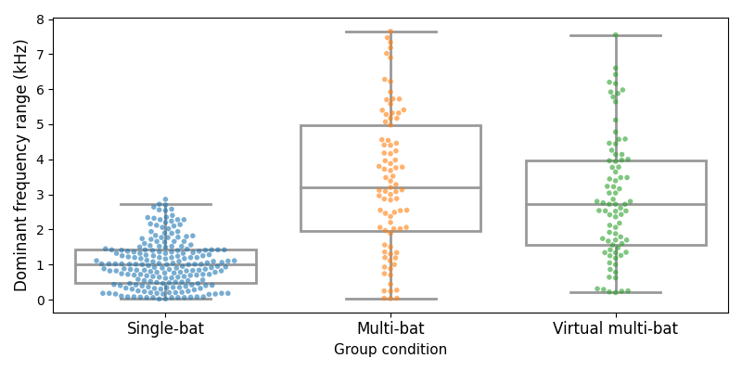

Figure 4: Measured dominant frequency range (max-min) during flight bouts in single-bat, multi-bat and virtual multi-bat contexts. The dominant frequency range is the difference between the maximum and minimum dominant frequencies observed during all 50-ms-long windows of a flight bout.

Variation in dominant frequency in single-bat condition arises from the combination of active Doppler-shift compensation by the bat and Doppler-shift due to bat’s movement relative to the microphone. The dominant frequency range in multi-bat and virtual multi-bat contexts is larger because there are more than one bat. Shown are data per flight bout (dots) and boxplots (median, quartiles, and whiskers up to 1.5 times the interquartile range).

Table 2: Difference between the mean call parameters during single-bat, multi-bat, and virtual-multi bat contexts, along with their estimated means. The 93% compatibility interval (CI) for all parameters is reported

| Parameter | Multi-single bat | Multi-virtual multi bat | Mean single bat | Mean multi bat | Mean virtual multi bat |
| --- | --- | --- | --- | --- | --- |
| Received level, dB rms | (-0.4,0.8) | (-0.1,1.3) | (-33,-32) | (-33,-32) | (-33,-32) |
| FM lower frequency, kHz | (-0.77,0.26) | (-0.95,0.27) | (89.81,90.39) | (89.4,90.24) | (89.73,90.62) |
| Dominant frequency range, kHz | (1.77,2.5) | (-0.16,0.82) | (0.6,0.81) | (2.51,3.2) | (2.17,2.85) |

|  | Data range | | | Difference (X – Y% CI) | |
| --- | --- | --- | --- | --- | --- |
| Parameter | single bat | multi bat | virtual multi bat | Multi-single | Multi-virtual multi |
| Dominant frequency range (kHz) | (0.6,0.81) | (2.51,3.2) | (2.17,2.85) | (1.77,2.5) | (-0.16,0.82) |
| Received level (dB rms) | (-33,-32) | (-33,-32) | (-33,-32) | (-0.4,0.8) | (-0.1,1.3) |
| FM lower frequency (kHz) | (89.81,90.39) | (89.4,90.24) | (89.73,90.62) | (-0.77,0.26) | (-0.95,0.27) |

## 0.5 Discussion

The high duty cycle horseshoe bats, are observed to fly among conspecifics and in cluttered environments. Studies with FM bats show the effect of conspecifics leading to changes in the echolocation behavior. Using two different approaches, we quantified several echolocation call parameters in horseshoe bats when flying alone or with conspecifics in the field. Our results do not support a biologically meaningful difference in echolocation calls between single and group-flying bats. This may seem somewhat unexpected, especially considering that bats in our field site were flying in an enclosed reverberant cave, which should only amplify the problem of masking in multi-bat echolocation.

The calls of horseshoe bats pose a fundamental problem for signal analysis due to their long duration leading to spectral and temporal overlap (REF). To address this problem, we introduced two automated analyses that can be performed on audio recordings of multiple CF-FM bats. First, we analyzed individual calls using the open-source itsfm package that segments sounds based on their rate of frequency change, which results in more accurate CF-FM call component segmentation, and thus improved reproducible measurements, compared to filtering around the peak frequency (Beleyur 2021). Second, to analyse audio with overlapping calls, we measured the overall acoustic parameters of short audio windows without assigning the measurements to individual calls. While coarser in time than the individual call analysis, the window-based approach returns frequency- and level-measurements that are related to individual call parameters and thus complements the individual call analyses. With this, our work presents a useful methodological advance for quantifying overlapping echolocation calls.

### 0.5.1 CF component

To avoid spectral overlap in groups, the spectral jamming avoidance response (JAR) hypothesis predicts that individual bats in groups will shift their call frequencies away from those of other individuals (Ulanovsky et al. 2004). JAR received mixed support for constant-frequency bats. Several studies in hipposiderid & rhinolophid bats found no changes in CF frequencies (Jones et al. 1993; Jones, Sripathi, and Waters 1994; Fawcett and Ratcliffe 2015; Pye 1972). In contrast, Habersetzer (1981) observed CF frequency shifting in groups of the quasi-CF bat, *Rhinopoma hardwickei*, while Cvikel et al. (2015) found no support in the same species. Note, however, that *R. hardwickei* is not entirely comparable to the specialized CF-bats of the families Hipposideridae and Rhinlophidae (Simmons, Kick, and Lawrence 1984), which possess individual-specific acoustic fovea that constrain their echolocation call frequency (Neuweiler 2000; Schnitzler, Suga, and Simmons 1976).

Our data does not support CF frequency shifting in group echolocation. The spectral jamming avoidance response (JAR) predicts that bats diverge (REF) or converge (REF) their call frequencies. Compared to single bats, this would lead to an increase or decrease in the overall CF frequency range in groups . We observed differences between single- and multi-bat contexts of around 0 kHz for the CF-component (individual call analysis) and of around 2 kHz for the dominant frequency range (windowed call analysis). This difference of up to 2 kHz between single- and multi-bat contexts falls within the expected magnitude due to XXX (the larger variability of multiple bats? Interindividual variation in groups??), even without any special responses of the bats to each other (SI 0.9.5). Furthermore, our comparison between observed and virtual multi-bat contexts shows that the CF-peak-frequency range observed during real multi-bat contexts does not differ from the CF-peak-frequency range of a random combination of non-reacting bat individuals (virtual multi-bat context). This suggests that bats that are flying together do not actively change their CF frequencies to reduce or increase overlap.

Our simulations (SI 0.9.5) and our recordings of single bats (REFERENCE TO DATA POSSIBLE?) show that a receiver (e.g., a microphone or another bat) in the proximity to a flying CF-FM receives a series of CF frequencies that vary by up to ±3 kHz (Fig. 9 ???). This natural variation in received frequency thus decreases the extent of spectral overlap during multi-bat contexts. The combination of individual-specific call frequencies and Doppler-shift driven variation in received CF-peak-frequency makes it unlikely that the CF component would be strongly masked even in groups.

For the duration of the CF component, we found a mean decrease of 1.4-4.3 ms in multi-bat calls, matching the decrease of ~1.2 ms found by Fawcett et al. (2015).

[OK; so what does this mean? An interpretation and evaluation of this finding is missing. Is 1.4-4.3 ms relevant? The text below focuses only on methodological aspects. E.g.:

At a constant calling rate, shortening call duration reduces the likelihood of temporal overlap with other calls, and could thus be a potential sensory strategy of bats in multi-bat contexts. (However,), relative to the average/typical call durations of x-y ms, this amoutns to a decrease of (only?) x-y%. …

Relative to the average call duration, this amounts to a decrease of about x-y% in call duration. Bats show similar/less/stronger changes in call duration during object approach / in group flights of FM-bats / … anything that puts this observed change into context.]

As shorter calls are less susceptible to temporal overlap, it is possible, however, that our procedure of selecting non-overlapping calls might have biased our data set to shorter calls in multi-bat recordings. While our results are comparable to those of Fawcett et al (2015), they did also choose individual calls that were presumably overlapping, which might mean that both our observed reductions in call durations suffers from the same bias. Given the potential bias and the overall relatively small reduction in call duration (both in absolute and proportional terms), we cautiously suggest that shortening call durations is not a major sensory strategy used to improve echolocation during group flight of horseshoe bats.

~~The decrease in call durations is however relatively small, which may mean the sampling bias would also be minimal. Our results however remain comparable with Fawcett et al. (2015), who also choose individual calls that were presumably non-overlapping.~~

### 0.5.2 FM component

The FM-component of CF-FM high-duty cycle bats is likely used for ranging and undergoes large variation as bats approach objects (Fenton et al. 2014). Frequency changes in group flying FM-bats could indicate a JAR, but could also be a response to the physical presence of other bats in the vicinity (Cvikel et al. 2015; Fawcett and Ratcliffe 2015). While not much is known about the iFM-component of CF-FM bats, they do change their tFM-component as they approach objects and during landing (Tian and Schnitzler 1997; Schoeppler, Schnitzler, and Denzinger 2018; Fenton et al. 2014). Therefore, CF-FM bats may respond to conspecifics in groups like FM-bats do. Fawcett et al. (2015) found that the tFM minimum frequency (measured at -10 dB below the call’s peak frequency) increased by 5 kHz on average in pairs. In contrast, in our individual call analysis, we found a decrease of the tFM lowest frequency of maximally 2.4 kHz, with a correspondin increase of the tFM bandwidth by maximally ~2.5 kHz in multi-bat contexts. Our windowed analysis revealed no systematic differences in lower frequency estimates between single-bat and multi-bat situations.

Both FM and CF-FM bats also change call duration in the presence of conspecifics and noise (Cvikel et al. 2015; Amichai, Blumrosen, and Yovel 2015; Fawcett et al. 2015; Lu, Zhang, and Luo 2020; Gomes and Goerlitz 2020). While we found an increase of tFM duration from single- to multi-bat contexts of maximally ~0.4 ms, Fawcett et al. (2015) found an increase of 1.8 ms in pairs, and Lu, Zhang, and Luo (2020) found an increase of 0.6 ms in comparison to calls in silence. While increasing call duration improves echo detection (Amichai, Blumrosen, and Yovel 2015; Luo et al. 2015), the increase in duration we observed here corresponds only to about ~5% of the total call duration. Compared to previous studies, our effects are small, and thus unlikely to have any major sensory implications and biological relevance.

Do you consider our data (0.4) to be comparable to, or clearly different to 0.6 and 1.8 ms? Why? Do those three studies thus support each other, or not? How does it compare to observed duration changes in FM bats (given the supposed comparable function, comparing the FM-component to data in FM-bats is relevant. E.g., Luo et al: increase of duration by 1.1-1.8 fold)? Which species did those two other studies use? Like the previous paragraph, this is largely a summary and comparison of results, with very short discussion at the end.

### 0.5.3 Call level

A direct way of improving echo detection is to increase the call level, which both FM bats (REFS) and CF-FM bats (Hage et al. 2013, 2014; Lu, Zhang, and Luo 2020) regularly do in the presence of experimental playbacks. Because we did not track the 3D-position of the bats in our study, we could not measure their source level and instead analyzed the received level at the microphone. Received levels depend not only on the bat’s source level, but also on the bats’ distance to and calling direction relative to the microphone. Our individual call analysis showed that the received levels of all three call components were up to ~4dB lower median during group flight compared to the single-bat context. In contrast, our windowed call analysis revealed no systematic difference in received level between multi-bat and single-bat contexts and between observed multi-bat and virtual multi-bat contexts. The iFM-CF and tFM-CF relative received levels between the CF and FM components were different by at most 1 dB between the multi-bat and single-bat conditions, indicating no shift in call energy between the components.

Despite the observed increase of individually analyzed received levels, there was no change in the windowed analysis, although overlapping calls in multi-bat contexts should lead to a higher received level. We suggest that the similarity in received levels of multi-bat and single-bat windows can be explained by the inequal contribution the nearest bat’s call makes to the received level due to spherical spreading, and the directionality of calls. The fact that multi-bat and virtual-multi bat audio have similar received levels thus indirectly suggests there is no change in source level even in the presence of another bat. However, the tFM received level during group flight showed a drop of around 3dB that we are unsure how to interpret. This apparent drop in received level could be the result of bats flying further away or emitting more directional calls.

*IFF it fits – some of the points to be introduced into the discussion.*

*We expect that 1) the spectral parameters of the CF is less prone to change given that CF-FM bats need to adjust emitted calls to match their acoustic foveal frequency tuning, while the CF duration in multi bats decreases to avoid overlap from other bats calls. 2) While role of iFM is less well understood, the tFM parts of the call can be altered in both spectral and temporal domains, and we expect both the bandwidth and duration to increase in multi bat contexts. The FM parts are less prone to overlap due to their inherently short duration and by altering the parameters can maximize the information encoded in the returning echoes. 3) As for duration of CF or the entire call, we expect that short duration calls will be emitted in multi bat contexts to reduce the possibility of overlap with calls of other bats. (this is not essentially important because if anyways, the CF is not used as part of resolving complexity in multi bat contexts, then the overlap of calls is not important as long as the overlap of the FM is avoided). 4) As a proxy for the measure of change in amplitude, we expect the received levels in multi-bat contexts to reduce in multi-bat contexts in an echoic natural cave and also presence other bats very close to one another.*

### 0.5.4 Outlook

Echolocation calls have a diverse parameters that can be quantified and there are a set of parameters that we were not able to measure (like, ……) and thus excluded in our analyses. Given the challenges with overlapping calls, we could not measure call-sequence related parameters such as, multi-bat durations, inter-call-intervals or duty-cycle. Bats in acoustically difficult situations alter multiple call parameters, such as their call rate (Amichai, Blumrosen, and Yovel 2015; Jarvis, Jackson, and Smotherman 2013) and thus their duty cycle. Measuring inter-call-intervals is possible in single bat contexts, but extremely challenging in multi-bat recordings with overlapping calls and reverberation. Calls are difficult to assign to their source individuals, which complicates call interval measurement.

Bats adjust many different call parameters in a task- and context-specific ways to adjust and optimize sensory information (REFS). Besides changes in temporal, spectral and amplitude parameters on the level of individual calls, some of which we analyzed in this study, bats also change parameters on the level of call sequence, such as call intervals and duty cycle (Amichai et al; Jarvis et al). In contrast to single-bat contexts, measuring call interval is challenging in multi-bat recordings due to difficulties in assigning calls to individuals and temporal overlap between multiple calls and echoes.

In summary, our results showed no obvious change in call parameters, suggesting that free-flying CF-bats do not suffer from sensory problems when flying in small groups (2-4 bats), even in reverberant environments. We propose that multiple reasons can explain why such situations are not very challenging, and why bats thus do not alter their calls. CF-FM bats use the tFM component for object ranging (Tian and Schnitzler 1997). The tFM components are short (≤3.4ms, 95 percentile value), and emitted about every 40-50 ms which is equivalent to a tFM duty cycle between 6.8-8.5%. When two bats fly together, the probability that the tFM-component of one bat overlaps the other bat’s tFM-echo is only up to 1.6 - 2.1% (see SI 0.10 for calculations). Even if a single tFM echo is overlapped by another call, a bat may still be able to detect it if the signal-to-noise ratio is sufficient. Modelling showed that FM-bats can detect all of their echoes in groups of up to 10 individuals (Beleyur and Goerlitz 2019). In addition, FM???-integrate We suggest that the same resistance to jamming should be true for the FM-component of CF-FM-bats, explaining why the horseshoe bats here did not change their calls during group flight.

In contrast to our results, Fawcett et al. (2015) observed an increased tFM duration and bandwidth in *R. capensis* flying in pairs in a novel flight room setting. Potential explanations for this difference might be potential species-differences and the test in a novel versus familiar environment. Since bats possess long-term spatial memory (Barchi, Knowles, and Simmons 2013; Möhres and Oettingen-Spielberg 1949), the bats in our study might be sufficiently familiar with the cave to tolerate occasional echo-masking, particularly in combination with the above mentioned multi-echo integration (Salles et al 2020).

The combination of flight room characteristics (Surlykke, Boel Pedersen, and Jakobsen 2009) and species differences, may perhaps have led to the difference in results between their study and ours. Bats show long-term spatial memory (Barchi, Knowles, and Simmons 2013; Möhres and Oettingen-Spielberg 1949) and familiarity with the cave’s structure may have allowed them to easily recognise their location over time. The combination of spatial memory and multi-echo integration may have allowed our bats to continue echolocating with conspecifics without altering their calls drastically.

Bats alter and adjust their echolocation strategy to the specific sensory task (REFS! E.g. our work with Daniel JEB, and Laura Scie Adv, and many more). Our results add to the growing body of literature (REFS!) showing that echolocation in (small) groups is not so special after all and can be solved by the bats’ general repertoire of sensory strategies for dealing with sensory challenges. We extend this notion to high-duty cycle CF-FM bats in a field setting, highlighting the importance of studying animal behaviour in the natural world, to understand which sensory-behavioural strategies are employed in different ecological contexts.

Our results add a subtle twist to the literature by suggesting that bats may not always employ a special echolocation strategy even when faced with the sensory challenge of a group. We highlight the importance of studies in field settings to understand the frequency with which various sensory strategies are actually employed in ecological contexts.

## 0.6 Data and code availability

All data and code used process data and generate the results and figures in the paper are available at the following Github repository: <https://github.com/thejasvibr/mhbc-online/>

## 0.7 Acknowledgements

The authors would like to specially thank the electronics team (Markus Abels, Hannes Sagunsky, Reinhard Biller) at the MPIO workshop for help preparing the electronic circuits to run the ON/OFF signal splitting. We would also like to thank Antoniya Hubancheva for logistical support, Stefan Greif for help collecting the data, the 2018 Tabachka field crew, Klaus Hochradel for the point-cloud scan of the cave and Diana Schoeppler and Hans-Ulrich Schnitzler for their helpful discussions. We also thank Manjari Jain for her support and and encouragement of the project. TB was funded by a DAAD doctoral fellowship and the IMPRS for Organismal Biology, HRG was funded by the Emmy Noether program of the DFG (German Research Foundation, grant no. 241711556).

## 0.8 Author Contributions

Study design and conception: NM, TB; Data collection: AK, NM, TB; Audio and video annotation: AK, NM; Audio-video synchronisation: TB; Analysis: HRG, NM, TB; Interpretation of results: HRG, NM, TB; Manuscript preparation: HRG, NM, TB.

## 0.9 Supplementary Information

### 0.9.1 Audio-video synchronisation: hardware and software implementations

The audio and video data were synchronised using the protocol of (Laurijssen et al. 2018). A Raspberry Pi 3 was used to drive an ON/OFF signal from a GPIO port. This ON/OFF signal was then split between an LED and a circuit linked to capacitor. The capacitor converted the DC ON/OFF signal into positive and negative spikes - thus allowing the signal to be correctly digitised. Not all soundcards are capable of digitising DC voltages, and thus the capacitor helps in making the protocol independent of soundcard type. The entire circuit can be assembled from easily available parts (Figure 5).

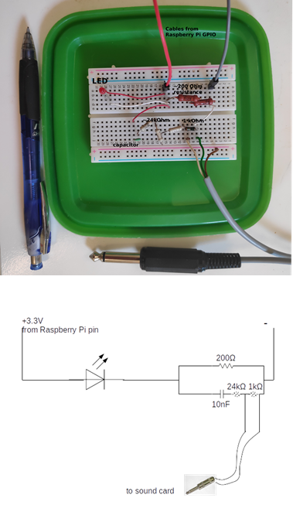

Figure 5: Top: The experimental realisation of the audio-video synchronisation signal splitting. The components can easily be assembled onto a hobby breadboard, and are easily portable. Here the breadboard is pasted on the inside of a lunch box lid, allowing easy and safe transport of the breadboard and the Raspberry Pi in the box itself. Bottom: The circuit diagram of synchronisation signal splitter.

The code to drive the GPIO port runs on Python 2 (and should also run on Python 3). For best results the python file can be set to automatically run on boot-up. This makes the synchronisation protocol field-friendly, and reduces the need of the experimenter manually running the code.

#!/usr/bin/python  
'''  
script that switches a RED LED on and off  
This script and the circuit used to  
run the system is based on the post at thePiHut  
'Turning on an LED with your Raspberry Pi's GPIO Pins'   
URL: https://thepihut.com/blogs/raspberry-pi-tutorials/  
27968772-turning-on-an-led-with-your-raspberry-pis-gpio-pins  
Accessed June 11 2015  
'''  
import RPi.GPIO as GPIO  
import sys  
import time  
GPIO.setmode(GPIO.BCM)  
GPIO.setwarnings(False)  
GPIO.setup(18,GPIO.OUT)  
import numpy as np  
  
time_ranges = np.arange(0.08,0.5,0.0001)  
  
while True:  
 try:  
 #print ('LED ON')  
 GPIO.output(18,True)  
 on_time = np.random.choice(time_ranges,1)  
 time.sleep(on_time)  
 #print('LED OFF')  
 off_time = np.random.choice(time_ranges,1)  
 GPIO.output(18,False)  
 time.sleep(off_time)  
 except KeyboardInterrupt:  
 GPIO.output(18,GPIO.LOW)  
 sys.exit()

One optional change that can be made to the code above is to set the seed manually with np.random.seed after the numpy import. Setting a fixed seed can have the advantage that problems in audio-video file synchronisation post data collection can be better fixed. A fixed seed however means that the output signal is the same across all sessions used - which might make distinguishing audio and video recordings from different sessions difficult, though not exclude it.

Another important aspect to pay attention to is the time_ranges variable. In this experiment it was assumed that the camera frame rate was going to be 25 Hz, and thus the lowest ON/OFF time was set to 0.08s, which corresponds to a signal with 12.5Hz periodicity of the Nyquist frequency. However, as Laurijssen et al. (2018) suggest, it would have been better to set the lowest duration to a longer period, which was a few times lower than the Nyquist frequency of 12.5 Hz, eg. 0.2s (5 Hz). In our experiments, the cameras turned out to have a frame rate of 22Hz, which meant that the LED signal was aliased. However, despite the aliasing, we were still able to synchronise audio and video - showing the robustness of the methodology.

### 0.9.2 Video annotation of bat flight activity in the cave

Manual annotation of the video data was carried out to determine the group sizes of free-flying horseshoe bats in their natural habitat. We annotated bat flight activity by simultaneously viewing the video feeds from both infrared cameras using SHOTCUT (“Shotcut” 2019 v 19.04.30), an open-source video editing software. The following information was documented from the video: the start and end times of bat activity periods from the burnt in timestamps from either camera 1 or 2 in “yyyy-mm-dd hh:mm:ss” format, frame number, number of bats flying and flight behavior. A bat activity period is defined as the interval during which the number of bats flying inside the cave is constant. Successive bat activity periods were operationally defined as being separated from one another by least 6 frames .

We defined the start of bat activity from the frame a bat is observed to fly in either camera view. Similarly, the end of bat flight activity was when a bat is not observed in either of the camera views. In multi-bat contexts that can have dynamic transitions in the number of bats, we annotated the start and end of the multi-bat activity with parts of the video that had the maximum number of bats. Additionally, bat activity before and after the video segment with the maximum number of bats were also annotated as single or multi-bat activity ensuring an interval of 6 frames separating each activity.  
Video from both the cameras covered most parts of the cave except the roosting sites (Main paper Figure 1). Bats were found to fly into the roosting sites, disappearing and then appearing in the camera view for short (=<10 frames) or extended periods (>10 frames) of time. If a bat appeared again after a short period, the current annotation was continued till the end of the activity. If a bat appeared after an extended period, a new annotation was begun.

We prioritized obtaining a clean data set and refrained from annotating extremely difficult bat flight annotations because of how dynamic the group size shifts could be.

### 0.9.3 Individual call analysis

Individual calls were selected from the audio files based on a set of pre-defined search protocol:

* All measurements and signal processing will be done using Audacity.
* dB rms measurements made with the ‘Contrast’ function in Audacity. Highpassing done with the inbuilt highpass filter. The SNR is calculated by difference between the foreground (bat call region) and background (silent region)
  1. Load annotation audio file, and delete all non-target channels.
  2. View audio in spectrogram mode. Set dynamic range of spectrogram to 60dB.
  3. Highpass filter audio file with 12 dB roll off/octave at 80 kHz cutoff frequency
  4. For given audio file, choose a start point using a random number generator between 0-1.
  5. Go to that fraction of time corresponding to the length of the annotation audio file
  6. Choose another random number between 0-1. If it’s <=0.5 search towards left, else search towards right.
  7. Look for a horseshoebat call with no overlaps, no interference patterns in the CF or FM, that can be isolated well.
  8. While selecting horseshoe bat calls, zoom in max till 60 milliseconds of audio occupy the whole screen. Do not zoom in more or less while selecting.
  9. Check the SNR of the selected horseshoe bat call by using a ‘silent period’ of the audio file as background. If there is not suitably long ‘silent period’ to serve as background in this audio file, choose another random audio file and measure the background dB rms.
     1. If SNR >= 20 dB, this is a suitable call to measure. Note down the start and end time of this call in the audio file.
     2. If SNR < 20dB
        1. Go back to search start point calculated in 4), and begin searching in opposite direction.
        2. Look for first suitable call to measure using criteria in 7) onwards.
     3. If a suitable call is still NOT found:
        1. No measurement takes place in this audio annotation. Proceed to next audio annotation file.

Audacity version 2.3.3 was used during the manual call selection.

### 0.9.4 Windowed call analysis

Each flight activity audio was split into consecutive 50ms windows for parameter extraction from each window. All tail-end audio that was <50 ms was discarded.

#### 0.9.4.1 Choosing the ‘silent window threshold’

A series of manually annotated audio clips were used to set the reference silent window threshold. The manually annotated audio clips were the same as those used to calculate the reference ‘silence’ segments in the individual call analysis (, min-max duration=0.002-0.03s). The threshold for a window to be chosen as silent was set at 20 dB above the maximum measured dB rms of all silent windows. This resulted in any window that was less than -23 dB rms as being considered ‘silent’. This is a conservative approach that prevents windows with poor signal-to-noise ratio from being analysed.

The code to execute this analysis is available in the what qualifies as a silent audio segment.ipynb notebook and its HTML printout.

#### 0.9.4.2 Dominant frequency measurement

Unlike typical measures used to quantify echolocation calls like peak frequency or-10 dB frequency, the dominant frequencies provide a glimpse of what may be happening in the presence of multiple calls.

The dominant frequency was determined with the following steps:

1. Create a smoothed power spectrum. A smoothed power spectrum is generated by passing the raw spectrum (FFT size = 12500 samples) with a running-mean filter of the pre-defined spectral smoothing width. The spectral smoothing width defines the ‘width’ or the number of frequency bins of the running-mean filter. We used a smoothing width of 100 Hz, which corresponds to 5 frequency bins. The smoothing is necessary as the raw power spectrum can be very ‘jagged’ otherwise, and impede peak detection which corresponds to the CF components of calls in the input audio.
2. Extract the peaks in the smoothed power spectrum. Only peaks that are a minimum ‘distance’ from each other, and that are within a threshold of the highest peak are chosen. We chose an inter-peak distance of 250 Hz, and all valid dominant frequency peaks needed to lie within 14 dB of the peak with the highest power.
3. Map the valid peaks to the frequencies they correspond to. These are the dominant frequencies in this

The code to execute this function is available in the inbuilt_measurement_functions.py module.

#### 0.9.4.3 FM lower frequency measurement

The FM lower frequency (Figure 6) is determined in the following steps:

1. Make spectrogram of the audio window (512 samples FFT, 256 samples overlap).
2. Identify all spectrogram ‘pixels’ in the FM frequency band that are above the baseline level. The FM bandwidth was defined as ranging from 70 kHz to 98 kHz. The baseline power level across pixels was calculated by calculating the 95%ile value of power in the frequency band below 70 kHz, i.e., the part of the spectrogram without any bat calls. All pixels whose power was 46 dB above the baseline power level and whose frequency was within 70 - 98 kHz were considered valid FM pixels
3. Identify contiguous clusters of FM pixels. These clusters represent single iFM or tFM components of calls.
4. From the identified continuous clusters, extract the lowest frequency pixel in a cluster

Given the current parameter values used for our analysis, the lower frequency measurements have a spectral resolution of 488 Hz.

The code to execute this function is available in the inbuilt_measurement_functions.py module.

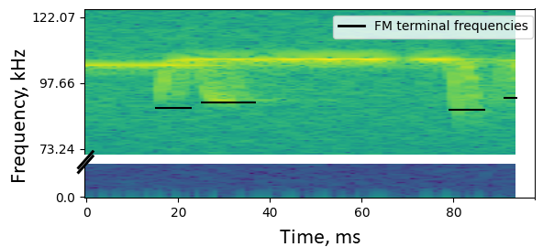

Figure 6: Example showing extracted FM lower frequencies from the spectrogram of a 50ms window. The method allows extraction of lower frequencies in the presence of multiple overlapping calls, though it doesn’t allow discrimination of iFM and tFM components

#### 0.9.4.4 Making virtual multi bat audio files

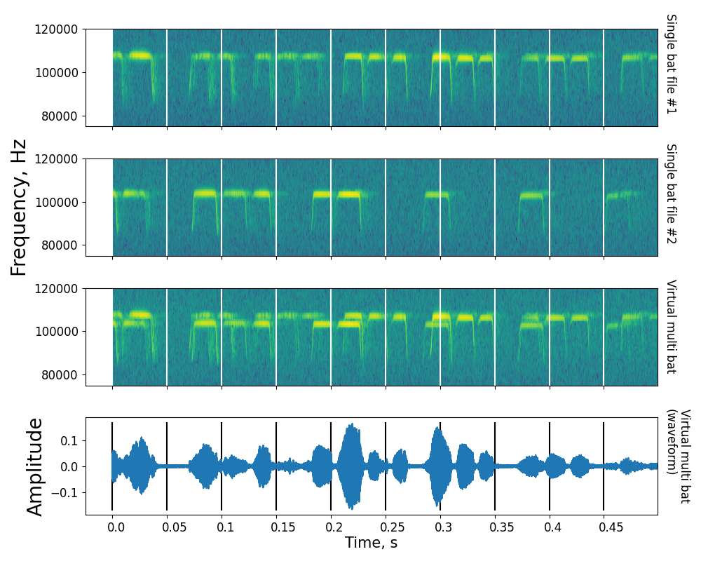

Figure 7: Example showing the steps involved in creating a virtual multi bat file. Shown here are spectrograms of the first 500ms of two single bat audio files (A), (B), along with the resulting virtual multi bat audio file. Vertical lines delineate 50ms windows that are used for acoustic measurements.

Virtual multi bat audio files (Figure 7) were created with the following steps:

1. For each multi bat file generate a virtual multi bat audio file
   1. Among the pool of single bat audio file choose all files that are within 0.9-1.1 times the length of the current multi bat file.
   2. From the pool of duration matched single bat audio files, randomly select 2 or 3 files - depending on how many bats were observed in the current multi bat file
   3. Add the chosen single bat audio files together. Set the final virtual multi bat length to the length of the shortest single bat audio file.
   4. Remove the chosen single bat audio files from the pool of single bat audio files. The single bat audio files will not be used again to generate a virtual multi bat file.

The code to execute this function is available in the Making virtual multi bat audio.ipynb notebook and its HTML printout.

### 0.9.5 Calculating expected dominant frequency ranges due to Doppler shift

The amount of Doppler shift in our audio recordings is primarily affected by multiple factors: 1) the flight speed of the bat, 2) the flight direction of the bat with respect to the microphone, 3) active Doppler shift compensation carried out by the bats, and 4) differences in the acoustic fovea of each individual bat. These factors may combine to give rise to a dominant frequency (DF) max-min range of up to around 3 kHz even when a single bat flies by the microphone. For example, a bat echolocating with a very high individual call frequency that flies fast will result in a larger DF range than a slow flying bat with the same foveal frequency but flying slower.

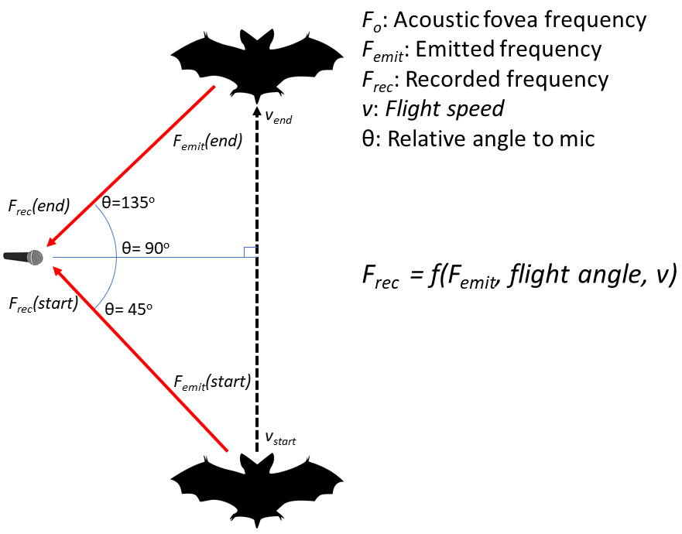

Figure 8: Schematic showing the simple model used to calculate the expected dominant frequency variation arising from a single bat flying past the microphone. is the doppler compensated emitted frequency. is the received frequency at the start of the flight, the received frequency at the end of the flight. and are the speed of the bat at the start and end of the flight. is a function of the emitted frequency, relative flight angle and flight speed at the start and end of the fly by.

Our simulations recreated the frequency recorded at the microphone at the ‘start’ and ‘end’ of the bat’s flight past the microphone (Figure 8). The start position was assumed to be 45 degrees and end position was 135 degrees relative to the microphone (where 90 deg. corresponds to the bat flying exactly perpendicular to the microphone’s direction). The speed at the start and end flight positions of the bat was assumed to be between 1.5-4.5 m/s, and the acoustic fovea’s of the bat population was assumed to be between 100-111 kHz, matching the range of the study species’ *R. euryale/mehelyi*. The frequency recorded at the microphone due to Doppler shift from the bat flying at an angle was calculated by: . The bat’s Doppler shift compensation was modelled by assuming the bat perfectly compensated for Doppler shift due to it’s own flight speed. The was calculated at the start and end points as , where depended on the flight speed at the start and end points, m/s, and was a randomly chosen value between 100-111 kHz. The DF range was calculated as . Figure 9 shows that our the DF ranges from simulations match the observed DF ranges well for the single bat case.

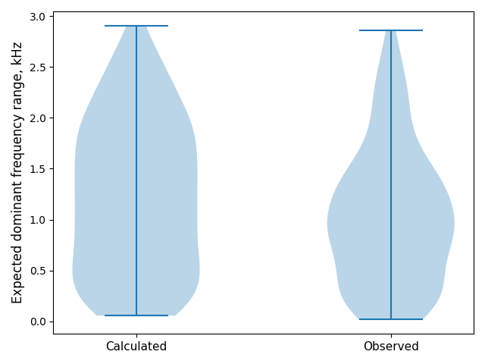

Figure 9: Calculated (left) and observed (right) dominant frequency range for a single bat flying past the microphone. The calculated and observed ranges match fairly well, indicating the broad processes behind the observed dominant frequency range have been captured.

When two or more bats echolocate in the same volume, it is expected that the DF range will increase because of the unique acoustic fovea’s each bat has. What is the expected range increase when the two bats echolocate independently however? To understand the expected DF range when multiple bats are flying we simulated the case of two bats echolocating independently in the same volume. The acoustic fovea of both bats was randomly chosen, and so were their start and end speeds. The DF range for the two bat case was thus calculated over a series of 1,000 random parameter combinations to reveal the range of dominant frequency ranges expected in two bat cases. In the two bat case, without reference to when or which bat emitted the call.

Figure 10 shows the dominant frequency ranges expected from single and a pair of bats. The median difference of the multi-single DF ranges is expected to be around 3.9 kHz, even though there is a wide variation in the observed DF ranges. The experimentally observed multi-single DF range difference of ~2 kHz falls within the range difference shown in Figure 10, however more detailed parametrisation of the flight speeds and relative positions may lead to a better match of the observed data.

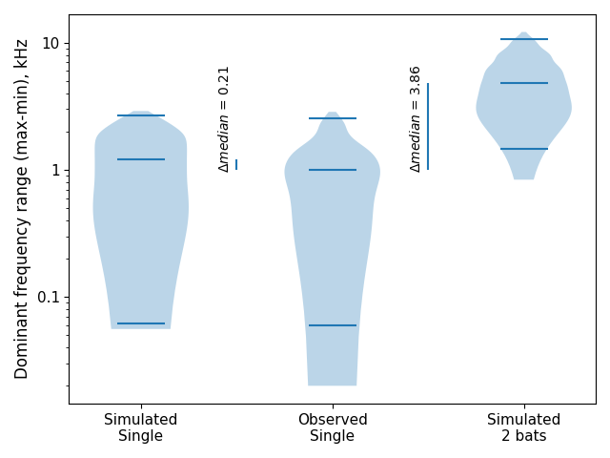

Figure 10: The distribution of dominant frequency ranges expected when a single bat echolocates (left), observed when a single bat (middle), and calculated when two bats fly.

The code to implement this calculation is in the Combined analysis notebook.ipynb and its HTML version.

## 0.10 tFM echo-call overlap probabilities

The probability of a tFM echo overlapping with the tFM portion of another bat’s call was derived through simulation. The echo/call duration was fixed at 3.4ms and the inter-tFM duration was set to 40 and 50ms. A tFM echo was placed randomly in a time-span between 0-(echo + inter-tFM duration). A tFM call was also randomly placed in the same time-span, and a temporal overlap was checked. The random placement and overlap checking was done 20,000 times to derive a probability of echo-call overlap at the two inter-tFM intervals.

For *3* bats, an echo may be overlapped by two calls. The probability of echo-call overlap here is between 1.6 to 2.1%. Further details are in the Jupyter notebook titled tFM-overlaps.ipynb.

## 

## 0.11 References

Adams, Amanda M, Kaylee Davis, and Michael Smotherman. 2017. “Suppression of Emission Rates Improves Sonar Performance by Flying Bats.” *Scientific Reports* 7 (1): 1–9.

Amichai, Eran, Gaddi Blumrosen, and Yossi Yovel. 2015. “Calling Louder and Longer: How Bats Use Biosonar Under Severe Acoustic Interference from Other Bats.” *Proceedings of the Royal Society B: Biological Sciences* 282 (1821): 20152064.

Audacity-Team. 2019. “Audacity(R): Free Audio Editor and Recorder [Computer Application] Version 2.3.3.” <https://audacityteam.org/>.

Barchi, Jonathan R, Jeffrey M Knowles, and James A Simmons. 2013. “Spatial Memory and Stereotypy of Flight Paths by Big Brown Bats in Cluttered Surroundings.” *Journal of Experimental Biology* 216 (6): 1053–63.

Bates, Douglas, Martin Mächler, Ben Bolker, and Steve Walker. 2015. “Fitting Linear Mixed-Effects Models Using lme4.” *Journal of Statistical Software* 67 (1): 1–48. <https://doi.org/10.18637/jss.v067.i01>.

Bechtold, Bastian, and Matthias Geier. 2019. *SoundFile* (version 0.10.3). <https://github.com/bastibe/SoundFile>.

Beleyur, Thejasvi. 2021. “Itsfm, an Open-Source Package to Reliably Segment and Measure Sounds by Frequency Modulation.” *bioRxiv*. <https://doi.org/10.1101/2021.01.09.426033>.

Beleyur, Thejasvi, and Holger R Goerlitz. 2019. “Modeling Active Sensing Reveals Echo Detection Even in Large Groups of Bats.” *Proceedings of the National Academy of Sciences* 116 (52): 26662–8.

Bradbury, Jack W, and Sandra L Vehrencamp. 2011. “Social Integration.” In *Principles of Animal Communication*, 515–60. Sinauer Associates,MA.

Cvikel, Noam, Eran Levin, Edward Hurme, Ivailo Borissov, Arjan Boonman, Eran Amichai, and Yossi Yovel. 2015. “On-Board Recordings Reveal No Jamming Avoidance in Wild Bats.” *Proceedings of the Royal Society B: Biological Sciences* 282 (1798): 20142274.

Dietz, Christian, and Andreas Kiefer. 2016. *Bats of Britain and Europe*. Bloomsbury Publishing.

Fawcett, Kayleigh, David S Jacobs, Annemarie Surlykke, and John M Ratcliffe. 2015. “Echolocation in the Bat, Rhinolophus Capensis: The Influence of Clutter, Conspecifics and Prey on Call Design and Intensity.” *Biology Open* 4 (6): 693–701.

Fawcett, Kayleigh, and John M Ratcliffe. 2015. “Clutter and Conspecifics: A Comparison of Their Influence on Echolocation and Flight Behaviour in Daubenton’s Bat, Myotis Daubentonii.” *Journal of Comparative Physiology A* 201 (3): 295–304.

Fenton, Brock (M.B.), Frants H. Jensen, Elisabeth K. V. Kalko, and Peter L. Tyack. 2014. “Sonar Signals of Bats and Toothed Whales.” In *Biosonar*, edited by Annemarie Surlykke, Paul E. Nachtigall, Richard R. Fay, and Arthur N. Popper, 11–59. New York, NY: Springer New York. <https://doi.org/10.1007/978-1-4614-9146-0_2>.

Fenton, M Brock, Paul A Faure, and John M Ratcliffe. 2012. “Evolution of High Duty Cycle Echolocation in Bats.” *Journal of Experimental Biology* 215 (17): 2935–44.

Gelman, Andrew, and Yu-Sung Su. 2020. *Arm: Data Analysis Using Regression and Multilevel/Hierarchical Models*. <https://CRAN.R-project.org/package=arm>.

Gillam, Erin H., Nickolay I. Hristov, Thomas H. Kunz, and Gary F. McCracken. 2010. “Echolocation behavior of Brazilian free-tailed bats during dense emergence flights.” *Journal of Mammalogy* 91 (4): 967–75. <https://doi.org/10.1644/09-MAMM-A-302.1>.

Gomes, Dylan GE, and Holger R Goerlitz. 2020. “Individual Differences Show That Only Some Bats Can Cope with Noise-Induced Masking and Distraction.” *PeerJ* 8: e10551.

Götze, Simone, Jens C Koblitz, Annette Denzinger, and Hans-Ulrich Schnitzler. 2016. “No Evidence for Spectral Jamming Avoidance in Echolocation Behavior of Foraging Pipistrelle Bats.” *Scientific Reports* 6 (1): 1–13.

Griffin, Donald R. 1958. “Listening in the Dark: The Acoustic Orientation of Bats and Men.”

Habersetzer, Joerg. 1981. “Adaptive Echolocation Sounds in the Batrhinopoma Hardwickei.” *Journal of Comparative Physiology* 144 (4): 559–66.

Hage, Steffen R, Tinglei Jiang, Sean W Berquist, Jiang Feng, and Walter Metzner. 2013. “Ambient Noise Induces Independent Shifts in Call Frequency and Amplitude Within the Lombard Effect in Echolocating Bats.” *Proceedings of the National Academy of Sciences* 110 (10): 4063–8.

———. 2014. “Ambient Noise Causes Independent Changes in Distinct Spectro-Temporal Features of Echolocation Calls in Horseshoe Bats.” *Journal of Experimental Biology* 217 (14): 2440–4.

Hase, Kazuma, Yukimi Kadoya, Yosuke Maitani, Takara Miyamoto, Kohta I Kobayasi, and Shizuko Hiryu. 2018. “Bats Enhance Their Call Identities to Solve the Cocktail Party Problem.” *Communications Biology* 1 (1): 1–8.

Hunter, John D. 2007. “Matplotlib: A 2D Graphics Environment.” *Computing in Science & Engineering* 9 (3): 90–95.

Ivanova, Teodora. 2005. “Important bat underground habitats (IBuH) in Bulgaria.” *Acta Zool. Bulg* 57 (2): 197–206.

Izadi, Mohammad Rasool, Robert L Stevenson, and Laura Kloepper. 2019. “Segmentation of Overlapping Sources in Mixtures of Bat Echolocation Calls.” *The Journal of the Acoustical Society of America* 146 (4): 3026–6.

Jarvis, Jenna, William Jackson, and Michael Smotherman. 2013. “Groups of Bats Improve Sonar Efficiency Through Mutual Suppression of Pulse Emissions.” *Frontiers in Physiology* 4: 140.

Jones, G, M Morton, PM Hughes, and RM Budden. 1993. “Echolocation, Flight Morphology and Foraging Strategies of Some West African Hipposiderid Bats.” *Journal of Zoology* 230 (3): 385–400.

Jones, G, K Sripathi, and Dean A Waters. 1994. “Individual Variation in the Echolocation Calls of Three Sympatric Indian Hipposiderid Bats, and an Experimental Attempt to Jam Bat Echolocation.” *Folia Zoologica* 43: 347–62.

Kluyver, Thomas, Benjamin Ragan-Kelley, Fernando Pérez, Brian Granger, Matthias Bussonnier, Jonathan Frederic, Kyle Kelley, et al. 2016. “Jupyter Notebooks – a Publishing Format for Reproducible Computational Workflows.” Edited by F. Loizides and B. Schmidt. IOS Press.

Laurijssen, Dennis, Erik Verreycken, Inga Geipel, Walter Daems, Herbert Peremans, and Jan Steckel. 2018. “Low-Cost Synchronization of High-Speed Audio and Video Recordings in Bio-Acoustic Experiments.” *Journal of Experimental Biology* 221 (4).

Lin, Y., N. Abaid, and R. Müller. 2016. “Bats Adjust Their Pulse Emission Rates with Swarm Size in the Field.” *J. Acoust. Soc. Am* 140: 4318–25.

Lu, Manman, Guimin Zhang, and Jinhong Luo. 2020. “Echolocating Bats Exhibit Differential Amplitude Compensation for Noise Interference at a Sub-Call Level.” *Journal of Experimental Biology* 223 (19).

Luo, Jinhong, Holger R Goerlitz, Henrik Brumm, and Lutz Wiegrebe. 2015. “Linking the Sender to the Receiver: Vocal Adjustments by Bats to Maintain Signal Detection in Noise.” *Scientific Reports* 5: 18556.

Mammal Diversity Database. 2020. “Mammal Diversity Database.” Zenodo. <https://doi.org/10.5281/zenodo.4139818>.

Matsuta, Naohiro, Shizuko Hiryu, Emyo Fujioka, Yasufumi Yamada, Hiroshi Riquimaroux, and Yoshiaki Watanabe. 2013. “Adaptive Beam-Width Control of Echolocation Sounds by Cf–Fm Bats, Rhinolophus Ferrumequinum Nippon, During Prey-Capture Flight.” *Journal of Experimental Biology* 216 (7): 1210–8.

Mazar, Omer, and Yossi Yovel. 2020. “A Sensorimotor Model Shows Why a Spectral Jamming Avoidance Response Does Not Help Bats Deal with Jamming.” *Elife* 9: e55539.

McKinney, Wes, and others. 2010. “Data Structures for Statistical Computing in Python.” In *Proceedings of the 9th Python in Science Conference*, 445:51–56. Austin, TX.

Möhres, FP, and Th Oettingen-Spielberg. 1949. “Versuche über Die Nahorientierung Und Das Heimfindevermögen Der Fledermäuse.” *Verhandlungen Der Deutschen Zoologen in Mainz*, 248–52.

Nelson, M. E., and M. A. MacIver. 2006. “Sensory Acquisition in Active Sensing Systems.” *J. Comp. Physiol. A Neuroethol. Sens. Neural Behav. Physiol* 192: 573–86.

Neuweiler, Gerhard. 2000. “The Biology of Bats.” Oxford University Press.

Neuweiler, G, W Metzner, U Heilmann, R Rübsamen, M Eckrich, and HH Costa. 1987. “Foraging Behaviour and Echolocation in the Rufous Horseshoe Bat (Rhinolophus Rouxi) of Sri Lanka.” *Behavioral Ecology and Sociobiology* 20 (1): 53–67.

Oliphant, Travis E. 2006. *A Guide to Numpy*. Vol. 1. Trelgol Publishing USA.

Plummer, Martyn, Nicky Best, Kate Cowles, and Karen Vines. 2006. “CODA: Convergence Diagnosis and Output Analysis for Mcmc.” *R News* 6 (1): 7–11. <https://journal.r-project.org/archive/>.

Pulliam, H Ronald. 1984. “Living in Groups: Is There an Optimal Group Size?” In *Behavioural Ecology: An Evolutionally Approach*, 122–47. Blackwell Scientific.

Pye, JD. 1972. “Bimodal Distribution of Constant Frequencies in Some Hipposiderid Bats (Mammalia: Hipposideridae).” *Journal of Zoology* 166 (3): 323–35.

Ratcliffe, John M, Hannah M ter Hofstede, Rafa Avila-Flores, M Brock Fenton, Gary F McCracken, Stephania Biscardi, Jennifer Blasko, Erin Gillam, Jasmine Orprecio, and Genvieve Spanjer. 2004. “Conspecifics Influence Call Design in the Brazilian Free-Tailed Bat, Tadarida Brasiliensis.” *Canadian Journal of Zoology* 82 (6): 966–71.

R Core Team. 2021. *R: A Language and Environment for Statistical Computing*. Vienna, Austria: R Foundation for Statistical Computing. <https://www.R-project.org/>.

Salles, Angeles, Clarice Anna Diebold, and Cynthia F. Moss. 2020. “Echolocating Bats Accumulate Information from Acoustic Snapshots to Predict Auditory Object Motion.” *Proceedings of the National Academy of Sciences*. <https://doi.org/10.1073/pnas.2011719117>.

Schnitzler, Hans-Ulrich. 1973. “Control of Doppler Shift Compensation in the Greater Horseshoe Bat, Rhinolophus Ferrumequinum.” *Journal of Comparative Physiology* 82 (1): 79–92.

Schnitzler, Hans-Ulrich, and Annette Denzinger. 2011. “Auditory Fovea and Doppler Shift Compensation: Adaptations for Flutter Detection in Echolocating Bats Using Cf-Fm Signals.” *Journal of Comparative Physiology A* 197 (5): 541–59.

Schnitzler, H-U, N Suga, and JA Simmons. 1976. “Peripheral Auditory Tuning for Fine Frequency Analysis by the Cf-Fm Bat, Rhinolophus Ferrumequinum.” *Journal of Comparative Physiology* 106 (1): 99–110.

Schoeppler, Diana, Hans-Ulrich Schnitzler, and Annette Denzinger. 2018. “Precise Doppler Shift Compensation in the Hipposiderid Bat, Hipposideros Armiger.” *Scientific Reports* 8 (1): 1–11.

Schuchmann, Maike, Sébastien J Puechmaille, and Björn M Siemers. 2012. “Horseshoe Bats Recognise the Sex of Conspecifics from Their Echolocation Calls.” *Acta Chiropterologica* 14 (1): 161–66.

“Shotcut.” 2019. <https://shotcut.org/>.

Siemers, Björn M, Kristian Beedholm, Christian Dietz, Isabel Dietz, and Teodora Ivanova. 2005. “Is Species Identity, Sex, Age or Individual Quality Conveyed by Echolocation Call Frequency in European Horseshoe Bats?” *Acta Chiropterologica* 7 (2): 259–74.

Simmons, James A, Shelley A Kick, and Beatrice D Lawrence. 1984. “Echolocation and Hearing in the Mouse-Tailed Bat, Rhinopoma Hardwickei: Acoustic Evolution of Echolocation in Bats.” *Journal of Comparative Physiology A* 154 (3): 347–56.

Surlykke, Annemarie, Simon Boel Pedersen, and Lasse Jakobsen. 2009. “Echolocating Bats Emit a Highly Directional Sonar Sound Beam in the Field.” *Proceedings of the Royal Society B: Biological Sciences* 276 (1658): 853–60.

Tian, Biao, and Hans-Ulrich Schnitzler. 1997. “Echolocation Signals of the Greater Horseshoe Bat (Rhinolophus Ferrumequinum) in Transfer Flight and During Landing.” *The Journal of the Acoustical Society of America* 101 (4): 2347–64.

Ulanovsky, Nachum, M Brock Fenton, Asaf Tsoar, and Carmi Korine. 2004. “Dynamics of Jamming Avoidance in Echolocating Bats.” *Proceedings of the Royal Society of London. Series B: Biological Sciences* 271 (1547): 1467–75.

Ulanovsky, Nachum, and Cynthia F Moss. 2008. “What the Bat’s Voice Tells the Bat’s Brain.” *Proceedings of the National Academy of Sciences* 105 (25): 8491–8.

Van Rossum, Guido, and Fred L Drake Jr. 1995. *Python Reference Manual*. Centrum voor Wiskunde en Informatica Amsterdam.

Virtanen, Pauli, Ralf Gommers, Travis E. Oliphant, Matt Haberland, Tyler Reddy, David Cournapeau, Evgeni Burovski, et al. 2020. “SciPy 1.0: Fundamental Algorithms for Scientific Computing in Python.” *Nature Methods* 17: 261–72. <https://doi.org/https://doi.org/10.1038/s41592-019-0686-2>.

Watanabe, Akira, and Kimisha Takeda. 1963. “The Change of Discharge Frequency by Ac Stimulus in a Weak Electric Fish.” *Journal of Experimental Biology* 40 (1): 57–66.

Xie, Yihui, J. J. Allaire, and Garrett Grolemund. 2018. *R Markdown: The Definitive Guide*. Boca Raton, Florida: Chapman; Hall/CRC. <https://bookdown.org/yihui/rmarkdown>.

Zweifel, Nadina O, and Mitra JZ Hartmann. 2020. “Defining ‘Active Sensing’ Through an Analysis of Sensing Energetics: Homeoactive and Alloactive Sensing.” *Journal of Neurophysiology* 124 (1): 40–48.