High duty-cycle bats in the field do not alter echolocation calls when flying in groups

Neetash Mysuru, Thejasvi Beleyur, Aditya Krishna, Holger R Goerlitz

: joint first authors

*1 Max Planck Institute for Ornithology, Seewiesen, Germany*

*2 Indian Institute for Science Education and Research, Mohali, India*

Last Updated : 2021-08-10 16:07:48

Living in groups has many benefits, but also costs such as the possibility of sensory overload. Large aggregations formed by animals to roost and mate are filled with a multitude of signals of varying relevance to each individual. Here, we focus on groups of echolocating bats, which may experience strong jamming during active sensing . Consequently, several bat species may alter their vocalizations to reduce jamming. We investigate the echolocation behaviour of high duty-cycle constant-frequency bats, which emit long calls with short pauses, while flying in groups in a natural cave environment. Due to their call characteristics, the chances of spectro-temporal overlaps are higher, which increases potential jamming for the bats, and also challenges acoustic measurements. We used synchronised audio-video recordings to count the number of bats and quantify their echolocation in single and multi-bat contexts. To quantify change in echolocation behaviour we develop methods to measure and analyse individual CF-FM calls and groups of overlapping calls. We find no major difference in quantified echolocation parameters between single and multi-bat flights. We thus show that horseshoe bats, despite their long calls that are prone to spectro-temporal overlap, do not alter their calls when flying in groups of up to four bats in a complex echoic cave environment. Our results highlight the robustness of bat echolocation, and the importance of studying behaviour under natural conditions.

**Keywords : active sensing, echolocation, cocktail-party problem, group-living**

For this version COAUTHORS CAN:

#. Reduce word count, we're still *way* above 8000 words (~9200 !!!)  
#. Re-work abstract (200 word limit for R Soc Int.   
#. More concrete points:  
 #. In Discussion - not sure what was meant by 'Reference to data possible?'  
 #. try implementing some of the points in the discussion that are pasted raw

OTHER THINGS TO DO:

#. Finalise SI section numbers (They are blank right now on purpose)  
#. Check references for missing entries/typos

# 1 Introduction

Living in groups provides both costs and benefits to the group members (1). From a sensory perspective, group living can be challenging due to the multitude of dynamic sensory information provided by group members, for example in leks, at roosting sites, or at cocktail parties (2,3). As a sender, acoustic signals can be altered to maximise their uniqueness and and intensitywhen in groups. Only a small fraction of all broadcasted information is relevant, and receivers must apply massive filtering and selection during sensory processing and perception to extract relevant information (4,5).. This sensory challenge in groups is becomes particularly serious for animals that perceive their environment by actively radiating energy (9-11), i.e., active sensing animals in the strict sense (7, 8) such as electrolocating fish and echolocating bats.

Echolocating bats emit intense ultrasonic calls and perceive their surroundings by listening for the reflected echoes (12). In groups, however, the faint echoes-of-interest can be buried within the many calls and echoes from neighboring bats (9), due to interference and masking of echoes during auditory processing. To deal with these sensory challenges, bats may increase call levels, alter temporal features such as call rate, duration and duty cycle (13–19), and spectral features such as bandwidth and terminal frequency (20–24). However, there are species-specific and context-dependent differences (14,15,25,26), and increasing evidence challenging the severity of potential jamming (AMICHAI ET AL 2015, CVIKEL ET AL 2015, GÖTZE ET AL 2016, MAZAR & YOVEL 2020, BELEYUR & GOERLITZ 2019). Most of these studies (18,22,29) have been performed in FM-bats, or low duty-cycle bats, which form the majority of all bats (27,30) and emit short and frequency-modulated (FM) calls with long pauses between calls. A second, less speciose group of bats are the CF- or high duty-cycle bats (mostly Rhinolophidae and Hipposideridae), which emit long calls with short pauses. (27). The CF bat call consist of a long constant-frequency (CF) component and one or two flanking short FM-components (CF-FM calls). Since these calls are long (10 to 50ms) with high duty cycles (~30-60 and constant frequency (27), they have a high probability of spectro-temporal overlap of echoes and calls (28).

A typical CF-FM call has up to three call components: a short initial upwards FM sweep (iFM), a long central CF-component (CF), and a short terminal downward FM sweep (tFM) (31). The CF-component is used for prey detection based on a highly resolved frequency analysis in the bat’s auditory fovea (32,33). The CF-frequency differs between species and even individuals (34? ALSO SCHUCHMANN & SIEMERS). CF frequency also varies during flight, where bats lower their emission frequency to compensate for flight-induced Doppler-shifts to keep the returning echo-frequency constant (35,36). When flying alone, this Doppler-shift compensation separates temporally overlapping calls and echoes in frequency space. In groups, however, both temporal and spectral overlap between own echoes, and the calls and echoes of close-by bats is bound to occur. The tFM-component is thought to be involved in target ranging (31,37), while the role of the iFM remains ambiguous. Comparable to call alterations in FM-bats (38), CF-FM bats adjust tFM bandwidth and duration to the behavioural task such as prey capture and landing (31,36,37).

Previous investigations of group echolocation in high duty-cycle CF-FM bats found no support for changes in CF-frequencies to avoid spectral overlap (“jamming avoidance response”)(23,39,40), and only one study quantified changes of the FM-component, reporting increased tFM duration and bandwidth in group flight (23). Even in FM bats the effectiveness of a jamming avoidance response is strongly debated(22, 41). Given the tFM’s flexibility and role in ranging, matching its flexibility (JAMMING REFS) and role (14,20,29) in low duty-cycle bats, there is a strong need for its explicit quantification in multi-bat contexts.

Here, we recorded the activity of two species of horseshoe bats flying in their natural habitat alone and in groups of up to four individuals. Using synchronized audio and video recordings and custom-developed analysis routines, we quantified the effect of group size on multiple temporal and spectral parameters of horseshoe bat echolocation calls. Using two approaches, we analyzed both non-overlapping individual calls as well as multiple overlapping and non-overlapping calls. The analysis of overlapping calls is a nascent field (but see 42), and has, to our knowledge, not yet applied to overlapping CF-FM calls. Based on both analysis approaches, we found major differences in call duration and frequency parameters. Despite their long calls that are prone to spectro-temporal overlap, horseshoe bats seem not to alter their calls when flying in groups of up to four bats in a complex echoic cave environment.

# 2 Methods

## 2.1 Study species and site

We recorded two species of rhinolophid bats, *Rhinolophus mehelyi* and *R. euryale*, in their natural environment during August 2018. Both species emit CF-FM calls with peak frequencies between 102-112 kHz, and cannot be acoustically distinguished due to CF-frequency overlap (43). For the purposes of this study, we thus treated them as one group of bats, which may face acoustic jamming due to the similarity in spectro-temporal call structure. We observed the bats next to the main entrance of the Orlova Chuka cave system, NE-Bulgaria, where they flew in and out of, and rested inside a small dome-shaped cave (Figure 2.1). The cave had a size of approximately 5 x 3 x 1.6 m (l x b x h), and one opening where bats flew in and out of throughout the night.

## 2.2 Experimental setup

We placed an experimental audio-video setup inside the cave (Figure 2.1), consisting of three microphones and two consumer-grade CCTV infrared cameras (UVAHDBP716, 944x1080 pixels). The cameras were connected to a digital video recorder (XVR1004), which recorded video mostly at 22 Hz, but with a variation in frame rate between 18-27 Hz. Audio from the three microphones (CM16/CMPA, Avisoft Bioacoustics, Glienicke, Germany) was recorded by a soundcard (416H, Avisoft Bioacoustics, 250 kHz sampling rate, 16-bit resolution). The cameras and microphones were placed at different positions, which remained approximately constant across recording nights (Figure 2.1). Video feeds were time-synchronised (but not frame-synchronised) by common time stamps burnt-in on the frame. Audio-video-synchronization was achieved by feeding a random ON-OFF signal into both the soundcard and to a flashing LED recorded on the video (Laurijssen et al. 2018; see Supplementary Information (SI) for details on our implementation). The video was recorded continuously throughout the three recordingnights , yielding 1.75-8 hours of analysable video, while audio was recorded as consecutive multichannel files of 1 minute duration.

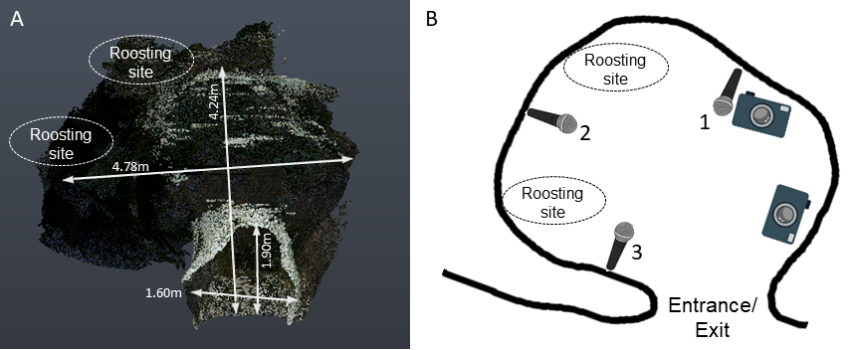

**Figure 1: Experimental cave site and set-up for audio-video recordings:** (A) Point cloud scan and (B) schematic of the cave, indicating the opening, typical roosting sites, and the positions of microphones and cameras (3D scanning by Klaus Hochradel, UMIT Tirol).

## 2.3 Video analysis to determine group sizes

After entering the cave, bats typically flew around for a few seconds or flew to one of two roosting sites, where they stayed for fraction of a second to minutes, and later exited from the cave again. We watched the videos for time periods with flying bats and noted their start and end times and the number of visible bats. We then restricted our analysis to interval during which the number of visible bats flying inside the cave was constant for at least 10 frames and separated from other bat activity periods by at least 6 frames, referred to as “bat activity periods” (see SI for more details). We then checked the synchronized audio recordings of the bat activity periods and excluded all recordings that did contained bat calls other than *R. mehelyi/euryale* calls (see SI section X).

## 2.4 Acoustic parameter analysis

We only analysed recordings from microphone 1 (Fig. 1), because they appeared to suffer least from reverberance and contained calls of both entering and exiting bats. ~~First, all audio files corresponding to the bat activity periods (henceforth referred to as flight-activity audio) were~~ After high-pass filtering at 70 kHz (2nd order zero-phase Butterworth filter), we used two complementary acoustic analysis approaches to quantify frequency, duration and amplitude parameters of all three components of the echolocation calls (initial FM, CF and terminal FM). (i) In the “individual call analysis”, we measured the acoustic parameters of one echolocation call from each bat activity audio. Individual call analysis directly reveals sensory decisions of individual bats. However, this approach suffers from the difficulty of finding a non-overlapped single call, particularly in reverberant and multi-bat situations, which may bias analysis of shorter calls that are suffer less from overlaps relative to longer calls. (ii) The “windowed call analysis” therefore complements the individual call analysis by enabling measurements of audio with overlapping calls. We split each flight-activity audio into consecutive 50-ms-long windows, which could contain multiple and potentially overlapping calls, and quantified the average acoustic parameters of each window. ~~Windowed call analysis~~ The windowed call analysis provides average results per time bin, but lacks call-level resolution. Both approaches simultaneously strengthen the interpretation of our results.

### 2.4.1 Individual call analysis

Per bat activity audio, we randomly (see SI section X) chose one call that was not overlapped by other calls with a signal-to-noise ratio of at least 20 dB (Figure 2.2). ~~Briefly, from a randomly determined time point, an experimenter began searching into a randomly determined direction (backward or forward in time) until a suitable horseshoebat call was found.~~ We found 226 individual calls across all the bat-activity audio files, which we automatically segmented into their iFM-, tFM- and CF-components (Figure 2.2). We used the *itsfm* package (44) for automatic segmentation of call components based on frequency-time-contours instead of the more commonly used high-/low-pass filtering (16,31,36,45,46) (which does not work well under noisy natural conditions) (44). ~~Most approaches to date segment CF-FM calls into their components by high/low pass filtering around the call’s peak frequency For an accurate estimate of the peak frequency, this approach requires a recording of the call with a prominent CF component, which is suitable under controlled laboratory settings. Peak frequency estimation often fails in the analysis of CF-FM calls recorded in the field under a variety of conditions eg. calls with loud FM and faint CF components.~~ *~~itsfm~~* ~~overcomes these limitations by tracking the change in frequency over the call time to segment it into FM and CF components.~~ We defined FM components as those portions of a call where frequency modulation was larger than 2 kHz/ms (further itsfm-settings (44): 3 kHz/ms maximum acceleration, 50 µs extrapolation window, 375 samples window size; threshold signal level and time-frequency clip range manually tuned for each call using the pwvd method, since each call had differing received levels).

We measured specific parameters for each of the three call components. For the CF-component, we measured peak frequency, received root-mean-square (RMS) sound pressure level (SPL) and duration (refer SI for parameter estimation settings). For the FM-components, we measured the lowest frequency (at 10 dB below the level of the peak frequency of the FM-component), bandwidth (difference between the CF peak frequency and the FM lowest frequency), received RMS SPL and duration. To analyse how bats adjust their call energy between call components (16,31), we calculated the SPL-difference between the iFM and tFM components, and the CF-component.

CF-duration in multi-bat contexts showed a non-negligible reduction (4.1). This apparent reduction, however, could originate from a selection bias of our individual call analysis, since shorter calls are less likely to be overlapped and thus more likely to be selected. To eliminate a possible methodological bias, we extended the CF duration analysis to multiple individual calls within each bat activity audio that were used in individual call analysis. We obtained the spectrogram of each bat activity audio and identified a main frequency band within ±1.5 kHz of the average spectrogram peak frequency, which typically contained the CF-components of one bat. If it contained ambiguous CF-components of potentially multiple bats, the file was not analysed. We manually set a SPL-threshold to identify continuous regions in the main band as candidate CF-components, which we manually verified and then calculated their duration (see SI section X for details).

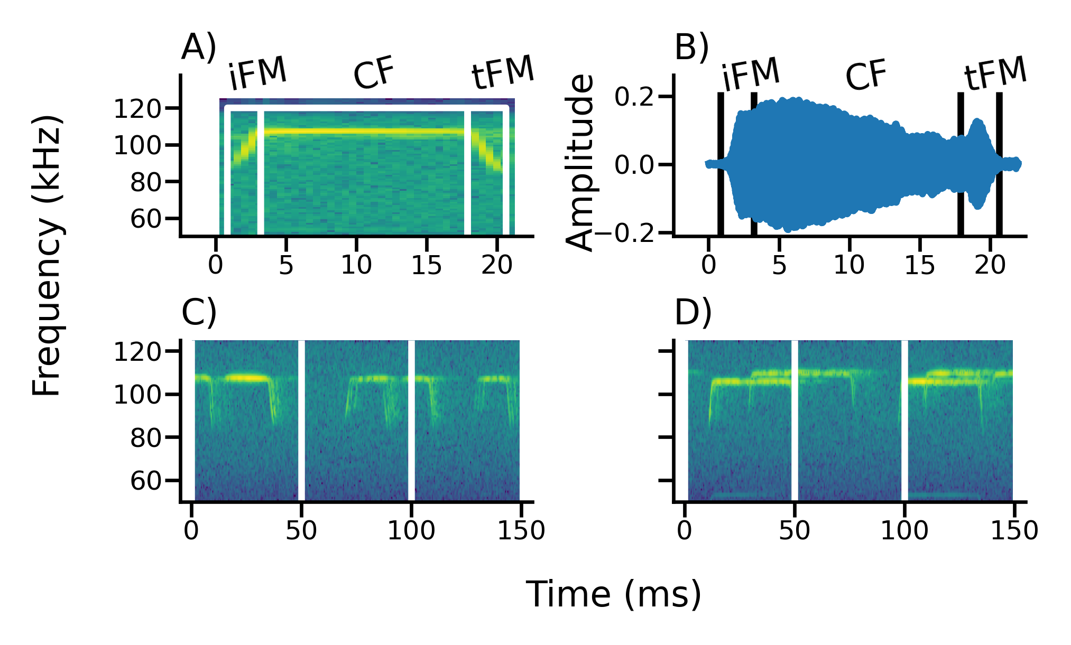

**Figure 2: A-B: Individual and windowed call analysis.**

A, B) Spectrogram (A) and oscillogram (B) of a manually selected call for the individual call analysis, with its automatically segmented components: initial frequency-modulated (iFM), central constant-frequency (CF), terminal frequency-modulated (tFM).

C, D) Spectrograms of single-bat (C) and multi-bat (D) recording used for the windowed call analysis, with the 50-ms-long analysis windows indicated.

### 2.4.2 Windowed call analysis

Each bat activity audio was split into consecutive 50 ms windows (Figure 2B, SI ?? for details of window splitting). A window duration of 50 ms provided high spectral resolution (20 Hz at 250 kHz sampling rate) to distinguish multiple CF components, and it was about twice the typical call duration and approximately the maximum call duration. To exclude windows without calls or with very faint calls, we only analysed windows whose RMS SPL was at least 20 dB above the maximum RMS SPL of silent windows (for details, see SI ??). From these windows that contained echolocation calls, we measured each window’s received dominant frequencies, FM lower frequencies, and RMS SPL, to complement the analogous/corresponding measurements in the individual call analyses. The window’s dominant frequencies are the CF frequencies of all calls in the window and were defined as local peaks of the smoothed power spectrum (~~rolling mean average, 100 Hz bin-equivalent window~~) with a level of not more than 14 dB below the highest peak (for details see SI ??). Dominant frequencies complement the CF peak frequency measurement of individual calls. For the analysis of the FM parts, we highpass filtered all the calls above x kHz and used the FM parts for lower frequency measurements. FM lower frequencies were defined as the lowest frequencies (at 10 dB below the level of the peak frequency of the FM-component ??? – AS IN IND. CALL ANALYSIS???) extracted from each identified FM region in a spectrogram representation of the window (see SI ??). FM lower frequencies in the windowed analysis are analogous to the i/tFM lower frequency of the individual call analysis. The RMS SPL, i.e., the root-mean-square of all samples in a window, describes the average received sound pressure level of the total window. Per window, there could be multiple dominant and FM frequency measurement, but only one received RMS level measurement.

# 2.5 Statistical analysis

## 2.5.1 Individual call analysis

Since the number of recordings with more than one bat was low(N=177, 40, 7, 2 for group sizes of 1, 2, 3, 4 respectively,), we combined all bat activity periods with 2 bats into a multi-bat context and compared call parameters between single- (N=177) and multi-bat contexts (N=49).

We ran linear mixed-models (LMMs) for each call parameter separately, with the call parameter as response variable, group context (single, multi) as categorical predictor and video-file ID as random intercept, using R (REF) and PACKAGE. We initially checked the model fit by performing residual diagnostics, and then estimated model coefficients with a Bayesian approach with non-informative priors (sim function, ‘arm’ package (48)) and report the 95% highest posterior-density compatibility interval (CoI), which represents the lower and upper borders of the posterior distribution of the coefficient estimates. Note that compatibility intervals are not equivalent to confidence intervals, even though the numerical values may be similar under certain cases (49). The CoI allows a true probabilistic interpretation of a given probability that the underlying parameter value falls within a range for the given dataset.

## 2.5.2 Windowed call analysis

The windowed call analysis does not provide individual-call level data, but a broader characterization of the average call characteristics during single- and multi-bat contexts. Potential changes observed during multi-bat contexts could thus be either an active change in call parameters, but also a side-effect of jointly analyzing the call parameters of multiple bats. We thus created virtual multi-bat contexts (23, 47), by combining audio-files from single-bat contexts that were of similar duration (SI ???), and then performed the same windowed call analysis on the generated audio files of this virtual multi-bat context. The virtual multi-bat context generates a null dataset of multiple bats that echolocate together without altering individual call parameters. For all three call parameters, we compared real single-bat, real multi-bat and virtual multi-bat contexts.

Per bat activity audio file, we combined the call parameter measurements obtained from each analysis window into one measure per bat activity audio.

To quantify potential change in dominant frequencies, we calculated the range of dominant frequencies for each bat activity audio from the maximum and minimum dominant frequencies of all analysis windows of the bat activity audio file (). Even in single bat contexts, the recorded dominant frequencies vary because of (and thus, a non-zero dominant frequency range) across any bat activity for two reasons: 1) the effect of the bat’s Doppler shift compensation and 2) the Doppler shift due to the bat’s motion relative to the microphone will cause variation in the dominant frequency. These two effects will lead to non-zero dominant frequency range even for single-bat activities (SI ??). An LMM was built where dominant frequency with dominant frequency as the response variable, group-type as the fixed effect, and the video-file as a random intercept (a proxy for time). Since different bat individuals emit different CF frequencies (34), we expect an increased dominant frequency range in virtual multi-bat contexts compared to single-bat contexts. Furthermore, if bats in real multi-bat contexts actively alter their call frequency, we expected an increased dominant frequency range compared to both single-bat and to virtual multi-bat contexts.

To understand the theoretically expected dominant frequency range from single and multi-bat flights, (and thus the expected range difference) we also performed simulations quantifying Doppler shift and Doppler shift compensation parametrized by the observed data (SI ?? for details of simulation and results). Briefly we simulated a Doppler-shift compensating bat emitting frequencies between 100-111 kHz, flying past a microphone at various speeds between 1.5-4.5 m/s. The dominant frequency range was calculated as the absolute difference between the frequency recorded by the microphone at the beginning of the flight and the end of the flight. The dominant frequency range estimates from the simulations informed the interpretation of the observed data.

If bats in groups shift their CF frequencies to reduce spectral overlap, we expect an increased range of the dominant frequencies compared to single-bat contexts. FM

The received SPL and lower frequency measurements resulted in multiple values per flight-activity audio (one value per window). The measurements from one flight-activity audio are potentially correlated. We thus estimated the difference between single, multi and virtual-multi bat measurements using an LMM with group context (single, multi, virtual multi) as categorical predictor, and flight-activity period ID and video-file ID as random intercepts.

## 2.6 Software

Signal analysis, data manipulation and visualisation were done in Python (50) and its scipy, numpy, matplotlib, soundfile and pandas packages (51–55). Reproducible analysis, documentation and presentation were enabled by the Jupyter Notebook and Rmarkdown projects (56,57). Audio visualisation, preliminary measurements and single call annotations were done with Audacity (58). LMMs were run in R (59) and the ‘lme4’,‘arm’ and ‘coda’ packages (48,60,61).

# 3 Results

We recorded echolocation and flight behaviour of mixed-species groups of the high-duty cycle bats *Rhinolophus euryale* and *R. mehelyi* as they flew alone and with other bats in a natural cave. The bats performed various flight behaviours in the cave, such as circling, approaches (when two or more bats flew towards each other) and following (one bat behind another) flights. The duration of continuously observed flight bouts varied strongly, ranging from about 0.1 s to 62 s (median: 1.04 s , 95%ile range: 0.5-8.54 s).

In general, the acoustic parameters of individual calls mostly did not differ between single-bat and multi-bat contexts. Likewise, the windowed call-analysis revealed no major differences in received level and FM lower frequency between single-bat and multi-bat and between multi-bat and virtual-multi-bat conditions. In contrast, the dominant-frequency range in the windowed analysis, however, was larger in multi-bat conditions compared to single-bat conditions.

## 3.1 Individual call analysis

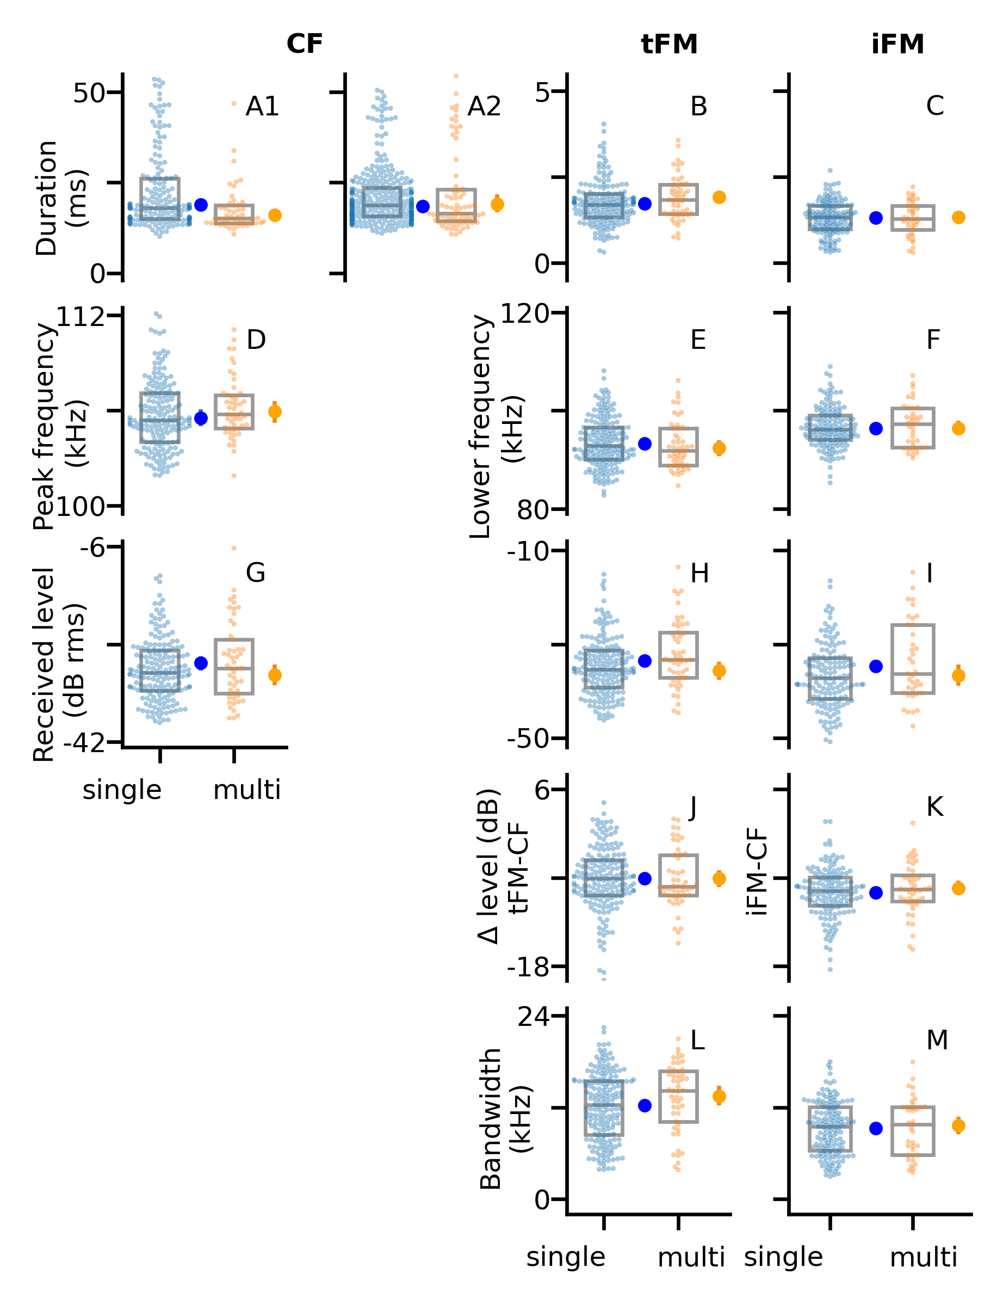

**Figure 3: Individual call analysis.**

Acoustic parameters of the constant-frequency (CF), initial frequency-modulated (iFM) and terminal frequency-modulated (tFM) components of individual calls in single-bat and multi-bat contexts (columns). Each row shows a group of related measurements: call duration (**A-C**; **A1**: CF-duration of one individual call per bat flight activity; **A2**: CF-duration of multiple calls per bat flight activity), peak and lower frequency (**D-E**), received SPL (**G-I**)**J-K)** relative FM-CF SPL difference (FM-CF; **J-K**), bandwidth (**L-M**). 177, = 49. Graphs show raw data, box plots (median and quartiles), and the modelled maximum a-posterior estimate (MAP, large dots) with their 95% compatibility intervals (vertical bar; mostly not visible due to narrow range).

We measured 13 acoustic parameters of the initial and terminal frequency-modulated (iFM, tFM) and of the central constant-frequency (CF) component of 226 individual horseshoe bat echolocation calls (Figure 4.1). Most call parameters showed little or no difference between single-bat and multi-bat observations (Table 4.1) with very small maximum a posteriori (MAP) estimates or compatibility intervals distributed either side of zero. The CF component of multi-bat calls showed slight reduction in duration between -4.45–1.32 ms (95% CoI). However, this apparent reduction in CF duration was not supported by the multi-call extension, indicating no change (Table 4.1 (multi-call extension)) between -1.7-3.02 ms (95% CoI). Multi-bat calls showed a slight decrease in amplitude of upto 0-4 dB in multi-bat calls, and a slight increase in tFM bandwidth of -2.42-0.71 kHz (95% CoI). All remaining had smaller differences between single and multi-bat contexts centered around zero Table 4.1.

**Table 1: LMM results of individual call analysis data showing differences in call parameters between single- and multi-bat contexts.**

We report the predicted difference and the predicted ratio between the acoustic call parameters in the single- and multi-bat context for the various parameters we measured. The maximum a-posteriori estimate (MAP) is the most likely estimate, and the 95% highest posterior density compatibility intervals (CoI) provide the range of uncertainty in the parameter estimate.

| Measurement | Call component | Difference (Multi-Single) | | | Ratio (Multi/Single) | | |
| --- | --- | --- | --- | --- | --- | --- | --- |
|  |  | MAP | Lower 95% CoI | Upper 95% CoI | MAP | Lower 95% CoI | Upper 95% CoI |
| Duration (ms) | CF | -2.86 | -4.45 | -1.32 | 0.85 | 0.77 | 0.93 |
|  | CF (multi-call extension) | 0.64 | -1.70 | 3.02 | 1.04 | 0.91 | 1.17 |
|  | tFM | 0.19 | -0.01 | 0.39 | 1.11 | 0.99 | 1.23 |
|  | iFM | 0.02 | -0.16 | 0.19 | 1.02 | 0.88 | 1.15 |
| Peak frequency (kHz) | CF | 0.40 | -0.26 | 1.02 | 1.004 | 0.998 | 1.01 |
| Lower frequency (kHz) | tFM | -0.87 | -2.42 | 0.71 | 0.99 | 0.97 | 1.01 |
|  | iFM | 0.02 | -1.45 | 1.49 | 1 | 0.99 | 1.02 |
| Sound pressure level (dB rms) | CF | -2.16 | -4.09 | -0.22 | - | - | - |
|  | tFM | -2.06 | -4.19 | -0.11 | - | - | - |
|  | iFM | -2.00 | -4.32 | 0.63 | - | - | - |
| SPL difference (dB) | tFM-CF | -0.01 | -1.30 | 1.25 | - | - | - |
|  | iFM-CF | 0.62 | -0.49 | 1.72 | - | - | - |
| Bandwidth (kHz) | tFM | 1.24 | -0.13 | 2.63 | 1.1 | 0.99 | 1.22 |
|  | iFM | 0.38 | -0.90 | 1.62 | 1.04 | 0.9 | 1.18 |

**Table 2:** **LMM results from the windowed call analysis data showing the differences in call parameters between single and multi-bat contexts .**

We report the predicted difference and the predicted ratio between the acoustic call parameters, comparing the single- to the real multi-bat context, and the real multi- to the virtual multi-bat context for the three parameters we measured in the windowed call analysis. The maximum a-posteriori estimate (MAP) is the most likely estimate, and the 95% highest posterior density compatibility intervals (CoI) provide the range of uncertainty in the parameter estimate.

| Measurement | Comparison | Difference (Multi-Single) | | | Ratio (Multi/Single) | | |
| --- | --- | --- | --- | --- | --- | --- | --- |
|  |  | MAP | Lower 95% CoI | Upper 95% CoI | MAP | Lower 95% CoI | Upper 95% CoI |
| Received SPL (dB RMS) | Multi-Single | 0.20 | -0.40 | 0.90 | - | - | - |
| Lower frequency (kHz) |  | -0.25 | -0.82 | 0.28 | 1 | 0.99 | 1 |
| Dominant frequency range (kHz) |  | 2.14 | 1.74 | 2.62 | 4.91 | 3.48 | 6.48 |
| Received SPL (dB RMS) | Multi-Virtual multi | 0.50 | -0.40 | 1.40 | - | - | - |
| Lower frequency (kHz) |  | -0.41 | -1.20 | 0.37 | 1 | 0.99 | 1 |
| Dominant frequency range (kHz) |  | -0.03 | -0.80 | 0.78 | 1 | 0.71 | 1.29 |

## 

## 3.2 Windowed call analysis

For each window in a flight-activity audio we obtained received level and FM lower frequency (=233, 87). For each flight-activity audio we also measured the dominant-frequency range.

There was little difference in the received levels and FM lower frequency between multi and single bat contexts (received level: -0.4-0.9 dB 95% CoI, FM lower freq. -0.82-0.28 kHz 95% CoI) (Figure 4.2, Table 4.2).

The mean dominant frequency range (Figure 4.2) was between -0.4 - 0.9 kHz (95% CoI) larger in multi-bat conditions compared to the single-bat condition. The observed difference in dominant frequency range matches the magnitude in simulations when bats do not show any special responses to each other (SI ??). Received level showed little difference between multi and single bat recordings (-0.4 - 0.9 dB 95% CoI) as well as did FM lower frequency (-0.82 - 0.28 kHz 95% CoI). Compared to single-bat contexts, the dominant frequency range during multi-bat contexts was larger by 1.74 – 2.62 kHz (95% CoI).

We compared the observed multi-bat recordings to virtual-multi bat recordings to estimate if bats were adjusting their echolocation behaviour to the presence of conspecifics. There was little difference in received level and FM lower frequency (received level: -0.4-1.4 dB 95% CoI, FM lower freq. -1.2-0.37 kHz 95% CoI). The difference in dominant frequency range between observed and virtual multi-bat was low as well (-0.8 - 0.78 kHz 95% CoI) (Table 4.2.

All these results taken together suggest bats did not change their echolocation behaviour in the presence of other bats.

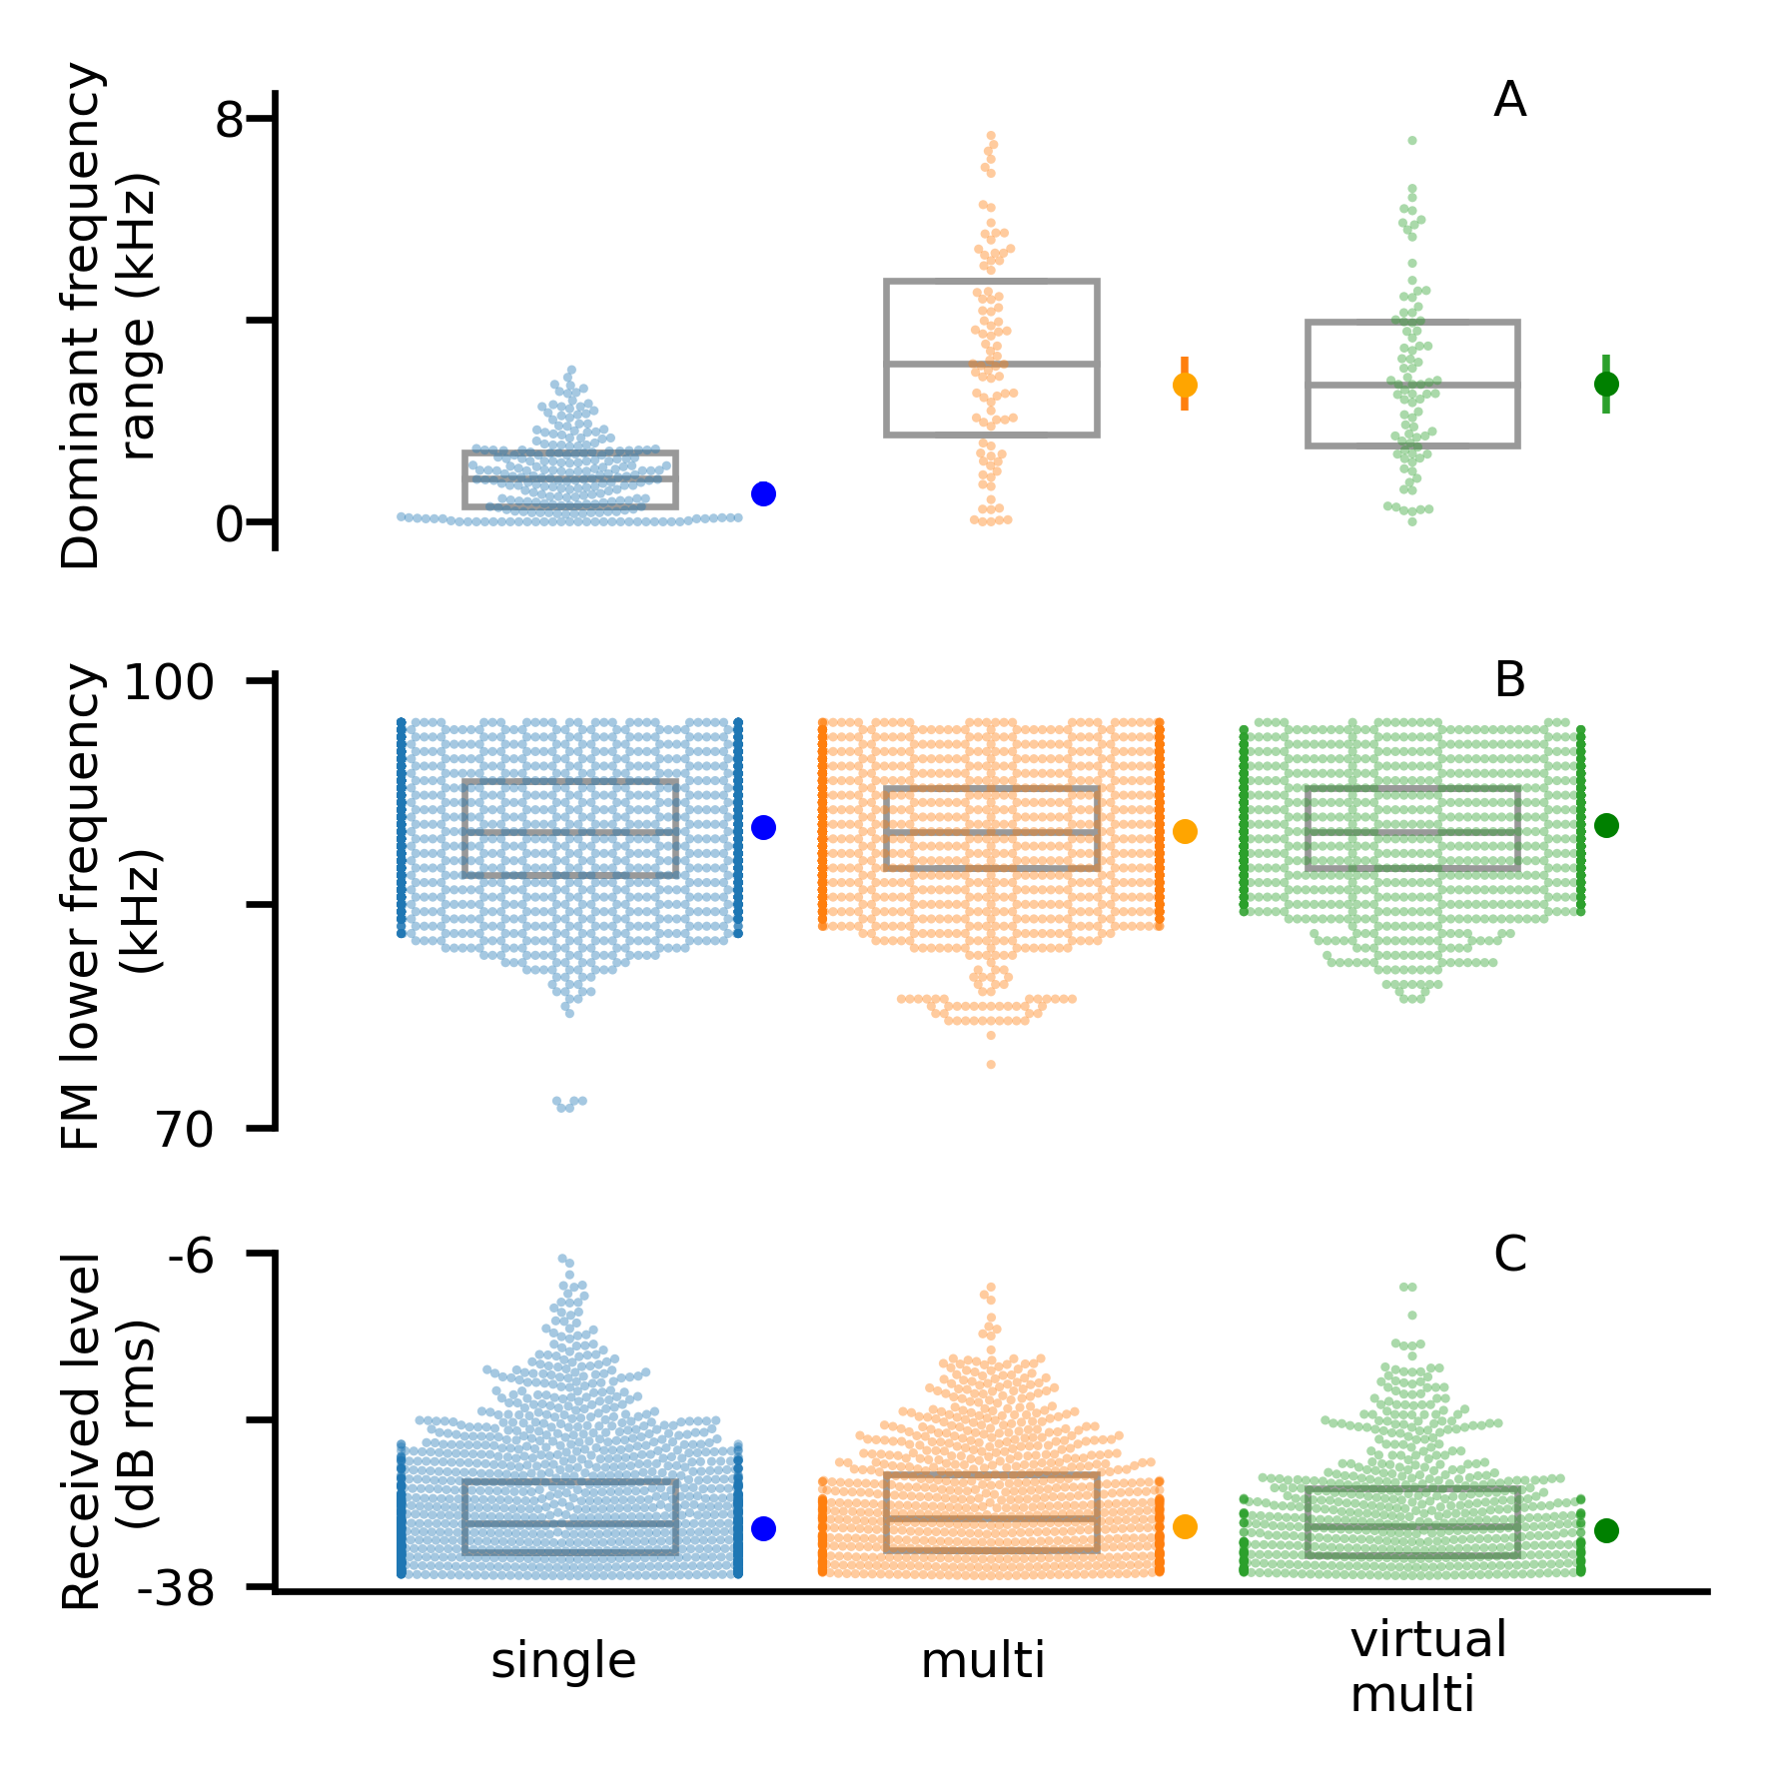

**Figure 4: Windowed call analysis.**

Average acoustic parameters of audio recordings in single-bat, real multi-bat and virtual multi-bat contexts (columns) Rows show dominant frequency range of CF-components (**A**), FM lower frequency (**B**), and received SPL (**C**).

Graphs show raw data, boxplots (median and quartiles), and the modelled maximum a-posterior estimates (MPA, large dots) with their 95% compatibility interval CoI (vertical bar; mostly not visible due to narrow interval).

# 4 Discussion

The CF bats have long duration calls that are more likely to suffer from acoustic interference of echoes when in groups. Yet, they are found flying and foraging in cluttered habitats among other conspecifics While many FM bat species have been studied in group flight contexts to alter their echolocation call parameters, studies of group echolocating horseshoe bats are nascent/fewer. One of the reasons for it to be less investigated comes with the technical challenges of analyzing the overlapping signals. Despite the challenge, we quantify the call parameters of echolocating CF bats, when in group by developing/introducing two alternate approaches of extracting information and analyzing the parameters. The first approach used extracts call parameters from identified non-overlapping calls in single and multi-bat activities. Parameters were extracted using the open source itsfm package that segments sounds based on their rate of frequency change, which results in more accurate CF-FM call component segmentation, and thus improved reproducible measurements compared to filtering around the peak frequency (44). The second approach is independent of finding individual non-overlapping sounds but divides the bat activity into successive 50 ms time windows. From each window we measured the overall acoustic parameters without assigning the measurements to individual calls. Results from both these approaches did not support a biologically meaningful difference in echolocation calls with reference to group size for all of the call parameters measured.

ed the overall acoustic parameters of short audio windows without assigning the measurements to individual calls.

## 4.1 CF component

To avoid spectral overlap in groups, the spectral jamming avoidance response (JAR) hypothesis predicts that individual bats in groups will shift their call frequencies away from those of other individuals (25). JAR received mixed support for constant-frequency bats. Several studies in hipposiderid & rhinolophid bats found no changes in CF frequencies (29,39,40,64). In contrast, (24) observed CF frequency shifting in groups of the quasi-CF bat, while (21) found no support in the congeneric *Rhinopoma microphyllum*. Note, however, that *R. hardwickei* is not entirely comparable to the specialized CF-bats of the families Hipposideridae and Rhinolophidae (65), which possess individual-specific acoustic fovea that constrain their echolocation call frequency (33,34).

Our data does not support CF frequency shifting in group echolocation. The spectral jamming avoidance response (JAR) predicts that bats diverge their call frequencies to reduce overlap (25). Compared to single bats, this divergence would lead to an increase in the overall CF frequency range in groups. In our windowed analysis we observed an increase of ~2 kHz in CF frequency range. This observed increase falls within the range of expected values from simulations with no active avoidance responses in them. Variation in flight speed, relative angle to the microphone and inter-individual CF frequency variation can explain the observed increase in dominant frequency range in groups - without any special responses of bats to each other (SI ??). Furthermore, our comparison between observed and virtual multi-bat contexts shows that the CF frequency range observed during real multi-bat contexts does not differ from the CF-peak-frequency range of a random combination of non-reacting bat individuals (virtual multi-bat context). Together, the results suggest that bats that are flying together do not actively change their CF frequencies to reduce or increase overlap.

Our simulations (SI ??) and our recordings of single bats (REFERENCE TO DATA POSSIBLE?) show that a receiver (e.g., a microphone or another bat) in the proximity to a flying CF-FM receives a series of CF frequencies that vary by up to $$3 kHz (Figure ??). This natural variation in received frequency thus decreases the extent of spectral overlap during multi-bat contexts. The combination of individual-specific call frequencies and Doppler-shift driven variation in received CF-peak-frequency makes it unlikely that the CF component would be strongly masked even in groups.

While our individual call analysis suggested a small reduction in multi-bat CF durations by about ms (MAP). This result was not supported by the more robust extended analysis, which showed a negligible difference of ms (MAP) between multi and single bats. We suspect the results from the individual call analysis to be a result of biased sampling as it favoured shorter calls that had a slight advantage in not being overlapped by other calls. Along with CF frequency, *Rhinolophus mehelyi/euryale* do not seem to alter their CF duration too.

## 4.2 FM component

The FM component of CF-FM high duty-cycle bats is likely used for ranging and undergoes large variation as bats approach objects (38). Frequency-changes in group flying FM-bats could indicate a JAR, but could also be a response to the physical presence of other bats in the vicinity (21,29). While not much is known about the iFM-component of CF-FM bats, they do change their tFM-component as they approach objects and during landing (31,36,38). CF-FM bats may thus be expected to respond to conspecifics like FM-bats in groups. (23) Fawcett et al., found that the tFM minimum frequency (-10 dB call peak frequency) decreased by 5 kHz on average in pairs of *Rhinolophus capensis*. In contrast, we only found a decrease of about -0.87 kHz of the tFM lower frequency (-10 dB tFM peak frequency) from the individual call analysis. Our windowed analysis revealed an even smaller decrease of -0.25 kHz in multi-bat calls. Both FM and CF-FM bats also change call duration in the presence of conspecifics and noise (14,16,19,21,23). While we found an increase of tFM duration from single- to multi-bat contexts of 0.19 ms, (23) found an increase of 1.8 ms in pairs, and (16) found a median increase of 0.35 ms in noise compared to calls in silence. Our results are closer to those of (16), while clearly not as strong as (23). FM bats too are known to increase their call durations in the presence of noise (14,19,66), though here too the extent of increase varies across species. While increasing call duration improves echo detection (14,66), the increase in duration we observed here corresponds to about ~10% increase (Table (tab:indcallsummary)), which falls on the lower end of effects seen in FM bats. At least compared to the one other rhinolophid study (23), our effects are small. Whether such small increses in tFM duration lead to biologically relevant improvements in detecting the surroundings in groups remains to be seen.

In contrast to our results, (23) observed an increased tFM duration and bandwidth in *R. capensis* flying in pairs in a novel flight room setting. Potential explanations for this difference might be potential species-differences and the test in a novel versus familiar environment. Since bats possess long-term spatial memory (69,70), the bats in our study might be sufficiently familiar with the cave to tolerate occasional echo masking, particularly in combination with multi-echo integration (68).

## 4.3 Call level

A direct way of improving echo detection is to increase the call level, which both FM bats (14,19,66) and CF-FM bats (16,17,67) regularly do in the presence of experimental playbacks. Because we did not track the 3D-position of the bats in our study, we could not measure their source level and instead analyzed the received level at the microphone. Received levels depend not only on the bat’s source level, but also on the bats’ distance to and calling direction relative to the microphone. Our individual call analysis showed that the received levels of all three call components were ~2 dB lower (MAP) during group flight compared to the single-bat context. In contrast, our windowed call analysis revealed no systematic difference in received level between multi-bat and single-bat contexts and between observed multi-bat and virtual multi-bat contexts.

Despite the observed increase of individually analyzed received levels, there was no change in the windowed analysis, although overlapping calls in multi-bat contexts should lead to a higher received level. We suggest that the similarity in received levels of multi-bat and single-bat windows can be explained by the inequal contribution the nearest bat’s call makes to the received level due to spherical spreading, and the directionality of calls. The fact that multi-bat and virtual-multi bat audio have similar received levels thus indirectly suggests there is no change in source level even in the presence of another bat. However, the tFM received level during group flight showed a drop of around 2 dB that we are unsure how to interpret. This apparent drop in received level could be the result of bats flying further away or emitting more directional calls.

*TB: Not sure how/where to put the points below in…please helppp!!!*

*We expect that 1) the spectral parameters of the CF is less prone to change given that CF-FM bats need to adjust emitted calls to match their acoustic foveal frequency tuning, while the CF duration in multi bats decreases to avoid overlap from other bats calls. 2) While role of iFM is less well understood, the tFM parts of the call can be altered in both spectral and temporal domains, and we expect both the bandwidth and duration to increase in multi bat contexts. The FM parts are less prone to overlap due to their inherently short duration and by altering the parameters can maximize the information encoded in the returning echoes. 3) As for duration of CF or the entire call, we expect that short duration calls will be emitted in multi bat contexts to reduce the possibility of overlap with calls of other bats. (this is not essentially important because if anyways, the CF is not used as part of resolving complexity in multi bat contexts, then the overlap of calls is not important as long as the overlap of the FM is avoided). 4) As a proxy for the measure of change in amplitude, we expect the received levels in multi-bat contexts to reduce in multi-bat contexts in an echoic natural cave and also presence other bats very close to one another.*

[DON’T HAVE A SEPARATE “OUTLOOK” section, on the same level as INTRO/METHODS/RESULTS/DISCUSSION. The journal won’t let you have it anyway; also this section is not so important to warrant a separate high-level section.

Use subheadings in the discussion, if you like.

Also, this section is too long. Try to condense it to one (or two) final paragraphs that provide a conclusion and outlook. If there are still details, the belong to the previous sections. Here, you want to provide a concise statement outlining the general scientific ideas, results and ways forward]

Besides changes in temporal, spectral and amplitude parameters on the level of individual calls, some of which we analyzed in this study, bats also change parameters on the level of call sequence, such as call intervals and duty cycle (14,15). In contrast to single-bat contexts, measuring call intervals is challenging in multi-bat recordings due to difficulties in assigning calls to individuals and temporal overlap between multiple calls and echoes.

Despite bats’ outstanding flexibility in adjusting to ss , we found no obvious change in call parameters in free-flying CF-bats in small groups of up to four bats. This strongly suggests that free-flying CF-bats do not suffer from sensory problems when flying in small groups, even in reverberant environments. We propose that multiple reasons can explain why such situations are not very challenging, and why bats thus do not alter their calls.What are the possible explanations for the absence of a strong echolocation response in groups? Our data suggests that echolocation in groups with a few bats (2-4) bats may not be very challenging for multiple reasons. CF-FM bats rely use on the tFM component to detect the distance of objects around them for object ranging (31). The tFM components are short ($\leq$3ms, 95 percentile value), and likely emitted about every 40-50 ms which is equivalent to a tFM duty cycle between 6-7.5%. When two bats fly togetherFor a pair of bats at these duty cycles, the probability that the tFM-component of one bat overlaps the other bat’s tFM-echo of one tFM echo being overlapped by another bat’s tFM call component is only relatively low at most between up to 1.6 - 2.1% (see SI 0.10 for calculations). Even if a single tFM echo is overlapped by another call, a bat may still be able to detect it if the signal-to-noise ratio is sufficient. Modelling showed that FM- bats can detect all of their echoes in small groups of up to 10 individualsare unlikely to face major detriments to their echolocation (28). FM bats integrate echoes across multiple calls and are thus resistant to occasional disruptions in echo arrival (68). We suggest that the same resistance to jamming should also apply in CF-FM bats using the FM component for ranging, explaining why the horseshoe bats here did not show call change their calls during group flights from solitary echolocation.

In contrast to our results, (23) observed an increased tFM duration and bandwidth in *R. capensis* flying in pairs in a novel flight room setting. Potential explanations for this difference might be potential species-differences and the test in a novel versus familiar environment. Since bats possess long-term spatial memory (69,70), the bats in our study might be sufficiently familiar with the cave to tolerate occasional echo masking, particularly in combination with multi-echo integration (68).

In our opinion, the primary obstacle to furthering studies in group echolocation is technical, especially in analysing overlapping sounds. Here, we presented a series of workflows such as the windowed call analysis and measurement of CF durations in multi-bat contexts. To improve the reliability of call component measurement, we also developed the itsfm toolkit to segment call-components. Further work still remains to be done, as highlighted above, in the development of call-identity assignment when there are multiple overlapping calls recorded under reverberant conditions.

**4.x Conclusions**

Despite bats’ outstanding flexibility in adjusting call parameters to tasks and contexts to optimize sensory information, we found no obvious change in call parameters in free-flying CF-bats in small groups of up to four bats. This strongly suggests that free-flying CF-bats do not suffer from sensory problems when flying in small groups, even in reverberant environments. Our results add to the growing body of literature (21,22,40) showing that echolocation in (small) groups is not so special after all and can be solved by the bats’ general repertoire of sensory strategies for dealing with sensory challenges. While bats do indeed alter their echolocation behaviour in the face of sensory challenge in groups, it is important to consider that not all types of group-situations will lead to the same type of sensory challenge. Our results thus match the increasing evidence that jamming does not pose a problem for FM-bats (14,21,22,28,41) now extending this to high-duty cycle CF bats. We highlight the importance of observational studies in field settings to understand the frequency with which various sensory strategies are actually employed in ecological contexts. To also advance the understanding of group echolocation, which is often an egocentric perspective, it would be interesting to record and measure calls in the field with on board microphones in freely behaving bats.

# Data and code availability

All data and code used process data and generate the results and figures in the paper are available at the following Github repository: <https://github.com/thejasvibr/mhbc-online/> and the Zenodo link *INSERT ZENODO LINK HERE*

# Acknowledgements

We would like to specially thank the electronics team (Markus Abels, Hannes Sagunsky, Reinhard Biller) at the MPIO workshop for help preparing the electronic circuits to run the ON/OFF signal splitting. We would also like to thank Antoniya Hubancheva for logistical support, Stefan Greif for help collecting the data, the 2018 Tabachka field crew, Klaus Hochradel for the point-cloud scan of the cave and Diana Schoeppler and Hans-Ulrich Schnitzler for their helpful discussions. We also thank Manjari Jain for her support and and encouragement of the project. TB was funded by a DAAD doctoral fellowship and the IMPRS for Organismal Biology, HRG was funded by the Emmy Noether program of the DFG (German Research Foundation, grant no. 241711556)

# Author Contributions

Author contributions in alphabetical order. Study design and conception: NMR, TB; Data collection: AK, NMR, TB; Audio and video annotation: AK, NMR; Audio-video synchronisation: TB; Analysis: HRG, NMR, TB; Interpretation of results: HRG, NMR, TB; Manuscript preparation: HRG, NMR, TB.

# References

**Krause J & Ruxton GD** **(2002)**: Living in groups. Oxford University Press, New York.

1. Pulliam HR, Caraco T. Living in groups: Is there an optimal group size? In: Behavioural ecology: An evolutionally approach. Blackwell Scientific; 1984. p. 122–47.

2. Cherry EC. Some experiments on the recognition of speech, with one and with two ears. J Acoust Soc Am. 1953;25:975–9.

3. Bee MA, Micheyl C. The cocktail party problem: What is it? How can it be solved? And why should animal behaviorists study it? Journal of comparative psychology. 2008;122(3):235.

4. Carrasco M. Spatial covert attention: Perceptual modulation. 2014;

5. Krauzlis RJ, Bollimunta A, Arcizet F, Wang L. Attention as an effect not a cause. Trends in cognitive sciences. 2014;18(9):457–64.

6. Bradbury JW, Vehrencamp SL. Social integration. In: Principles of animal communication. Sinauer Associates,MA; 2011. p. 515–60.

7. Zweifel NO, Hartmann MJ. Defining ‘active sensing’ through an analysis of sensing energetics: Homeoactive and alloactive sensing. Journal of Neurophysiology. 2020;124(1):40–8.

8. Nelson ME, MacIver MA. Sensory acquisition in active sensing systems. J Comp Physiol A Neuroethol Sens Neural Behav Physiol. 2006;192:573–86.

9. Ulanovsky N, Moss CF. What the bat’s voice tells the bat’s brain. Proceedings of the National Academy of Sciences. 2008;105(25):8491–8.

10. Gillam EH, Hristov NI, Kunz TH, McCracken GF. Echolocation behavior of Brazilian free-tailed bats during dense emergence flights. Journal of Mammalogy. 2010 Aug;91(4):967–75. Available from: <https://doi.org/10.1644/09-MAMM-A-302.1>

11. Watanabe A, Takeda K. The change of discharge frequency by AC stimulus in a weak electric fish. Journal of Experimental Biology. 1963;40(1):57–66.

12. Griffin DR. Listening in the dark: The acoustic orientation of bats and men. 1958;

13. Gillam EH, Ulanovsky N, McCracken GF. Rapid jamming avoidance in biosonar. Proceedings of the Royal Society B: Biological Sciences. 2007;274(1610):651–60.

14. Amichai E, Blumrosen G, Yovel Y. Calling louder and longer: How bats use biosonar under severe acoustic interference from other bats. Proceedings of the Royal Society B: Biological Sciences. 2015;282(1821):20152064.

15. Jarvis J, Jackson W, Smotherman M. Groups of bats improve sonar efficiency through mutual suppression of pulse emissions. Frontiers in physiology. 2013;4:140.

16. Lu M, Zhang G, Luo J. Echolocating bats exhibit differential amplitude compensation for noise interference at a sub-call level. Journal of Experimental Biology. 2020;223(19).

17. Hage SR, Jiang T, Berquist SW, Feng J, Metzner W. Ambient noise induces independent shifts in call frequency and amplitude within the lombard effect in echolocating bats. Proceedings of the National Academy of Sciences. 2013;110(10):4063–8.

18. Lin Y, Abaid N, Müller R. Bats adjust their pulse emission rates with swarm size in the field. J Acoust Soc Am. 2016;140:4318–25.

19. Gomes DG, Goerlitz HR. Individual differences show that only some bats can cope with noise-induced masking and distraction. PeerJ. 2020;8:e10551.

20. Hase K, Kadoya Y, Maitani Y, Miyamoto T, Kobayasi KI, Hiryu S. Bats enhance their call identities to solve the cocktail party problem. Communications biology. 2018;1(1):1–8.

21. Cvikel N, Levin E, Hurme E, Borissov I, Boonman A, Amichai E, et al. On-board recordings reveal no jamming avoidance in wild bats. Proceedings of the Royal Society B: Biological Sciences. 2015;282(1798):20142274.

22. Götze S, Koblitz JC, Denzinger A, Schnitzler H-U. No evidence for spectral jamming avoidance in echolocation behavior of foraging pipistrelle bats. Scientific reports. 2016;6(1):1–3.

23. Fawcett K, Jacobs DS, Surlykke A, Ratcliffe JM. Echolocation in the bat, rhinolophus capensis: The influence of clutter, conspecifics and prey on call design and intensity. Biology Open. 2015;4(6):693–701.

24. Habersetzer J. Adaptive echolocation sounds in the batrhinopoma hardwickei. Journal of Comparative Physiology. 1981;144(4):559–66.

25. Ulanovsky N, Fenton MB, Tsoar A, Korine C. Dynamics of jamming avoidance in echolocating bats. Proceedings of the Royal Society of London Series B: Biological Sciences. 2004;271(1547):1467–75.

26. Adams AM, Davis K, Smotherman M. Suppression of emission rates improves sonar performance by flying bats. Scientific reports. 2017;7(1):1–9.

27. Fenton MB, Faure PA, Ratcliffe JM. Evolution of high duty cycle echolocation in bats. Journal of Experimental Biology. 2012;215(17):2935–44.

28. Beleyur T, Goerlitz HR. Modeling active sensing reveals echo detection even in large groups of bats. Proceedings of the National Academy of Sciences. 2019;116(52):26662–8.

29. Fawcett K, Ratcliffe JM. Clutter and conspecifics: A comparison of their influence on echolocation and flight behaviour in daubenton’s bat, myotis daubentonii. Journal of Comparative Physiology A. 2015;201(3):295–304.

30. Mammal Diversity Database. Mammal diversity database. Zenodo; 2020. Available from: <https://doi.org/10.5281/zenodo.4139818>

31. Tian B, Schnitzler H-U. Echolocation signals of the greater horseshoe bat (rhinolophus ferrumequinum) in transfer flight and during landing. The Journal of the Acoustical Society of America. 1997;101(4):2347–64.

32. Schnitzler H-U, Denzinger A. Auditory fovea and doppler shift compensation: Adaptations for flutter detection in echolocating bats using CF-FM signals. Journal of Comparative Physiology A. 2011;197(5):541–59.

33. Neuweiler G. The biology of bats. Oxford University Press; 2000.

34. Schnitzler H-U, Suga N, Simmons J. Peripheral auditory tuning for fine frequency analysis by the CF-FM bat, rhinolophus ferrumequinum. Journal of comparative physiology. 1976;106(1):99–110.

35. Schnitzler H-U. Control of doppler shift compensation in the greater horseshoe bat, rhinolophus ferrumequinum. Journal of comparative physiology. 1973;82(1):79–92.

36. Schoeppler D, Schnitzler H-U, Denzinger A. Precise doppler shift compensation in the hipposiderid bat, hipposideros armiger. Scientific reports. 2018;8(1):1–1.

37. Neuweiler G, Metzner W, Heilmann U, Rübsamen R, Eckrich M, Costa H. Foraging behaviour and echolocation in the rufous horseshoe bat (rhinolophus rouxi) of sri lanka. Behavioral ecology and sociobiology. 1987;20(1):53–67.

38. Fenton B(MB), Jensen FH, Kalko EKV, Tyack PL. Sonar signals of bats and toothed whales. In: Surlykke A, Nachtigall PE, Fay RR, Popper AN, editors. Biosonar. New York, NY: Springer New York; 2014. p. 11–59. Available from: <https://doi.org/10.1007/978-1-4614-9146-0_2>

39. Jones G, Morton M, Hughes P, Budden R. Echolocation, flight morphology and foraging strategies of some west african hipposiderid bats. Journal of Zoology. 1993;230(3):385–400.

40. Jones G, Sripathi K, Waters DA. Individual variation in the echolocation calls of three sympatric indian hipposiderid bats, and an experimental attempt to jam bat echolocation. Folia Zoologica. 1994;43:347–62.

41. Mazar O, Yovel Y. A sensorimotor model shows why a spectral jamming avoidance response does not help bats deal with jamming. Elife. 2020;9:e55539.

42. Izadi MR, Stevenson RL, Kloepper L. Segmentation of overlapping sources in mixtures of bat echolocation calls. The Journal of the Acoustical Society of America. 2019;146(4):3026–6.

43. Dietz C, Kiefer A. Bats of britain and europe. Bloomsbury Publishing; 2016.

44. Beleyur T. Itsfm, an open-source package to reliably segment and measure sounds by frequency modulation. bioRxiv. 2021; Available from: <https://www.biorxiv.org/content/early/2021/01/09/2021.01.09.426033>

45. Siemers BM, Beedholm K, Dietz C, Dietz I, Ivanova T. Is species identity, sex, age or individual quality conveyed by echolocation call frequency in european horseshoe bats? Acta Chiropterologica. 2005;7(2):259–74.

46. Schuchmann M, Puechmaille SJ, Siemers BM. Horseshoe bats recognise the sex of conspecifics from their echolocation calls. Acta Chiropterologica. 2012;14(1):161–6.

47. Ratcliffe JM, Hofstede HM ter, Avila-Flores R, Fenton MB, McCracken GF, Biscardi S, et al. Conspecifics influence call design in the brazilian free-tailed bat, tadarida brasiliensis. Canadian Journal of Zoology. 2004;82(6):966–71.

48. Gelman A, Su Y-S. Arm: Data analysis using regression and multilevel/hierarchical models. 2020. Available from: <https://CRAN.R-project.org/package=arm>

49. Nalborczyk L, Bürkner P-C, Williams DR, Savalei V. Pragmatism should not be a substitute for statistical literacy, a commentary on albers, kiers, and van ravenzwaaij (2018). Collabra: Psychology. 2019;5(1).

50. Van Rossum G, Drake Jr FL. Python reference manual. Centrum voor Wiskunde en Informatica Amsterdam; 1995.

51. Virtanen P, Gommers R, Oliphant TE, Haberland M, Reddy T, Cournapeau D, et al. SciPy 1.0: Fundamental Algorithms for Scientific Computing in Python. Nature Methods. 2020;17:261–72. doi: <https://doi.org/10.1038/s41592-019-0686-2>

52. Oliphant TE. A guide to NumPy. Vol. 1. Trelgol Publishing USA; 2006.

53. Hunter JD. Matplotlib: A 2D graphics environment. Computing in science & engineering. 2007;9(3):90–5.

54. Bechtold B, Geier M. SoundFile. 2019. Available from: <https://github.com/bastibe/SoundFile>

55. McKinney W, others. Data structures for statistical computing in python. In: Proceedings of the 9th python in science conference. Austin, TX; 2010. p. 51–6.

56. Kluyver T, Ragan-Kelley B, Pérez F, Granger B, Bussonnier M, Frederic J, et al. Jupyter notebooks – a publishing format for reproducible computational workflows. Loizides F, Schmidt B, editors. IOS Press; 2016. p. 87–90.

57. Xie Y, Allaire JJ, Grolemund G. R markdown: The definitive guide. Boca Raton, Florida: Chapman; Hall/CRC; 2018. Available from: <https://bookdown.org/yihui/rmarkdown>

58. Audacity-Team. Audacity(r): Free audio editor and recorder [computer application] version 2.3.3. 2019. Available from: <https://audacityteam.org/>

59. R Core Team. R: A language and environment for statistical computing. Vienna, Austria: R Foundation for Statistical Computing; 2021. Available from: <https://www.R-project.org/>

60. Bates D, Mächler M, Bolker B, Walker S. Fitting linear mixed-effects models using lme4. Journal of Statistical Software. 2015;67(1):1–48. doi: [10.18637/jss.v067.i01](https://doi.org/10.18637/jss.v067.i01)

61. Plummer M, Best N, Cowles K, Vines K. CODA: Convergence diagnosis and output analysis for MCMC. R News. 2006;6(1):7–11. Available from: <https://journal.r-project.org/archive/>

62. Rossiter SJ, Jones G, Ransome RD, Barratt EM. Relatedness structure and kin-biased foraging in the greater horseshoe bat (rhinolophus ferrumequinum). Behavioral Ecology and Sociobiology. 2002;51(6):510–8.

63. Denzinger A, Kalko EK, Tschapka M, Grinnell AD, Schnitzler H-U. Guild structure and niche differentiation in echolocating bats. In: Bat bioacoustics. Springer; 2016. p. 141–66.

64. Pye J. Bimodal distribution of constant frequencies in some hipposiderid bats (mammalia: hipposideridae). Journal of Zoology. 1972;166(3):323–35.

65. Simmons JA, Kick SA, Lawrence BD. Echolocation and hearing in the mouse-tailed bat, rhinopoma hardwickei: Acoustic evolution of echolocation in bats. Journal of Comparative Physiology A. 1984;154(3):347–56.

66. Luo J, Goerlitz HR, Brumm H, Wiegrebe L. Linking the sender to the receiver: Vocal adjustments by bats to maintain signal detection in noise. Scientific reports. 2015;5:18556.

67. Hage SR, Jiang T, Berquist SW, Feng J, Metzner W. Ambient noise causes independent changes in distinct spectro-temporal features of echolocation calls in horseshoe bats. Journal of Experimental Biology. 2014;217(14):2440–4.

68. Salles A, Diebold CA, Moss CF. Echolocating bats accumulate information from acoustic snapshots to predict auditory object motion. Proceedings of the National Academy of Sciences. 2020; Available from: <https://www.pnas.org/content/early/2020/10/27/2011719117>

69. Barchi JR, Knowles JM, Simmons JA. Spatial memory and stereotypy of flight paths by big brown bats in cluttered surroundings. Journal of Experimental Biology. 2013;216(6):1053–63.

70. Möhres F, Oettingen-Spielberg T. Versuche über die nahorientierung und das heimfindevermögen der fledermäuse. Verhandlungen der deutschen Zoologen in Mainz. 1949;248–52.

71. Lewanzik D, Goerlitz HR. Task-dependent vocal adjustments to optimize biosonar-based information acquisition. Journal of Experimental Biology. 2021;224(1):jeb234815.

72. Stidsholt L, Greif S, Goerlitz HR, Beedholm K, Macaulay J, Johnson M, et al. Hunting bats adjust their echolocation to receive weak prey echoes for clutter reduction. Science Advances. 2021;7(10):eabf1367.

73. Taub M, Yovel Y. Segregating signal from noise through movement in echolocating bats. Scientific reports. 2020;10(1):1–0.