VERSION 8: High duty-cycle bats in the field do not alter echolocation calls when flying in groups

Neetash Mysuru

Thejasvi Beleyur[1]

Aditya Krishna

Holger R Goerlitz

:Equal contribution :Acoustic and Functional Ecology, Max Planck Institute for Biological Intelligence (MPI-BI), Seewiesen :Neural Circuits for Vocal Communication, MPI-BI, Seewiesen :Centre for the Advanced Study of Collective Behaviour, Konstanz :Max Planck Institute of Animal Behaviour, Radolfzell :Indian Institute of Science Education and Research, Mohali :Dept. of Psychological & Brain Sciences, Johns Hopkins University, Baltimore

Abstract

Sociality in animals implies managing a constant flow of sensory signals from conspecifics and the environment. Active sensing animals like echolocating bats additionally suffer from sensory degradation in groups because of auditory masking or jamming. Each individual in a group emits loud ultrasonic calls and must detect its own faint echoes. Bats in groups thus effectively mutually jam each other. Previous studies in the lab and field report bats altering echolocation in response to jamming from playbacks and conspecifics. We study groups of 1-4 constant frequency (CF) bats of genus Rhinolophus in a natural cave setting to see if bats adapt their echolocation calls across group size. CF bats are particularly prone to jamming because of their long call durations and high repetition rates. Using synchronised audio and video recordings, we quantify group-size and echolocation call attributes using two modes of analysis. We find that CF bats do not alter their call properties in the presence of other individuals – suggesting they do not suffer sensory degradation. Our study contributes methods to handle overlapping audio, a technical challenge till date. We also highlight the importance of more field studies to assess the frequency with which various sensory strategies are adopted.

**Keywords : active sensing, echolocation, cocktail-party problem, group-living**

# 1 Introduction

Living in groups provides both costs and benefits to the group members (1,2). From a sensory perspective, group living can be challenging due to the high volume of sensory information provided by group members and the environment, for example in leks, roosting sites, or at cocktail parties (3,4). Since only a small fraction of this information is relevant, the receiver must apply massive filtering and selection to extract and process only the relevant information (5,6). This sensory challenge in groups is even higher for animals that perceive their environment by actively emitting energy into their environment (7,8), i.e., active sensing animals (9,10) such as electrolocating fish and echolocating bats.

Sensory filtering in groups of passive sensing animals, i.e., animals that receive external energy (e.g., frogs, fish, humans)(4,9–11) show individuals can handle high sensory volumes through various anatomical and cognitive mechanisms. As each passively-sensing group member receives external information independently, their sensory processes do not affect other individuals around them. In contrast, active sensing animals like electrolocating fish or echolocating bats face a unique sensory challenge when actively sensing in groups (7,12,13). Echolocating bats emit intense ultrasonic calls and detect their surroundings by listening for the echoes reflecting off objects around them (14). In groups however, a bat’s returning echoes will be overlapped by the calls and echoes from its neighbours, preventing detection of its surroundings(7). Active sensing animals thus face the issue that their information of interest is potentially masked by the multitude of surrounding signals in a group. An echolocating bat in a group may thus end up metaphorically flying ‘blind’, as without detecting its own echoes the bat cannot sense the environment. To deal with the sensory challenges in groups, bats may increase call levels, alter temporal features such as call rate, duration and duty cycle, and spectral features such as bandwidth and terminal frequency , yet with species-specific and situation-dependent differences (15–19). These responses however are not uniform across species, with different species showing seemingly opposite responses to similar situations (15,19–21). Increasing evidence has also challenged the severity of potential jamming in groups (15,22–25).

There are two broad groups of echolocating bats (26) characterised by their duty cycle, i.e., the fraction of time spent emitting calls. The first and major group of bats are the low-duty cycle bats. They emit frequency-modulated (FM) calls. Most studies on group echolocation so far have investigated low-duty cycle bats (15,18,19,22,23,27,28), likely due their speciosity (~87% of all echolocating bats emit FM calls(26,29)), and ease of call analysis. The second group is the high-duty cycle bats which emit calls with a long constant-frequency (CF) component and one or two flanking short FM components (CF-FM calls). In contrast to low-duty cycle bats, the calls of high-duty cycle bats are longer (10 to 50ms) and thus have higher duty cycles of ~30-60 (26). Higher duty cycle directly increases the probability of temporal overlap and thus masking of echoes by calls (30). High-duty cycle bats such as rhinolophids and hipposiderids are thus more likely to be affected in group echolocation than low-duty cycle bats. A majority of studies on jamming in groups have been with FM-bats (15,18,19,22,23,28), despite the unique and importance of high-duty-cycle echolocation in groups (31–33). A wider variety of species need to be studied, to understand the echolocation responses in context of their ecology and auditory systems.

A typical CF-FM call has up to three call components: a short initial upwards FM sweep (iFM), a long central CF component (CF), and a short terminal downward FM sweep (tFM) (34). The CF component is used for the flutter detection of prey wingbeats (35) based on based on a highly resolved frequency analysis in the bat’s auditory fovea (36). The CF-frequency differs between species and even individuals (37,38). CF frequency is also changed during flight, with bats lowering their emission frequency to compensate for flight-induced Doppler-shifts to keep the returning echo frequency constant (39,40). When flying alone, this Doppler-shift compensation separates the temporally overlapping emitted call and returning echoes spectrally. In groups, however, both temporal and spectral overlap between own echoes, and the calls and echoes of close-by bats is bound to occur. The tFM component is thought to be involved in target ranging (34,41). Comparable to call alterations in FM-bats (42), CF-FM bats show rapid alterations in tFM bandwidth and duration based on the behavioural context, e.g. resting, landing or prey capture (34,40,41). The role of the iFM remains ambiguous.

Previous investigations of group echolocation in CF-FM bats found no support for changes in CF frequencies to avoid spectral overlap (“jamming avoidance response”)(31,33,43). Recent studies in low duty cycle FM bats also questioned the efficacy of a jamming avoidance response in groups (23,24). With regards to the FM component, we are only aware of two studies that quantified changes of the FM-component in paired flight (32,33), reporting alterations in tFM duration and bandwidth. Given the tFM’s flexibility and role in ranging, there is a strong need for its explicit quantification in multi-bat contexts. The tFM may show the same kinds of changes in multi-bat contexts as shown in low-duty cycle bats, which also use their FM calls primarily for ranging (15,17,28).

To study the effect of group size on free flying horseshoe bats, we recorded bat activity in their natural habitat using a synchronized audio and video setup. We used two lines of acoustic analysis, the first extracts parameters from non-overlapping individual calls and the second, which extracts parameters from multiple overlapping and non-overlapping calls. The analysis of recordings with overlapping calls is a nascent field (but see 44), and acoustic measurements have not been attempted on overlapping CF-FM calls to the best of our knowledge. We compared the difference in CF and FM call parameters across single and multiple bat flight periods. The results from both lines of acoustic analysis suggest no major differences in the measured call parameters when bats were echolocating alone or in the presence of others.

# 2 Methods

## 2.1 Study species and site

Two species of rhinolophid bats *Rhinolophus mehelyi* and *R. euryale* were recorded in their natural environment. Both species emit CF-FM calls with peak frequencies between 102-112 kHz, and are not acoustically distinguishable due to overlap in their call characteristics (45). For the purposes of this study, we thus treated them as a single group of bats that may face the problem of acoustic jamming due to similarity in spectro-temporal call structure.

We observed bats that flew in and out of and rested inside a small dome-shaped cave (Figure 2.1A) next to the main entrance of the Orlova Chuka cave system, NE-Bulgaria. The cave had a size of approximately 5 x 3 x 1.6 m (l x b x h), and one opening where bats flew in and out of throughout the night.

## 2.2 Experimental setup

We placed an experimental audio-video setup inside the cave (Figure 2.1B), consisting of three microphones and two infrared cameras. Two consumer grade CCTV cameras (UVAHDBP716, 944x1080 pixels) with infrared lamps were connected to a digital video recorder (XVR1004) to record the flight of bats as they flew in and out of the cave. The system recorded video mostly at 22 Hz, with some frame rate variation between 18-27 Hz. Video feeds between the cameras were time-synchronised by the common recorder time stamps burnt-in on the frames. The two cameras were placed in approximately the same position on every recording night. Audio from three CM16 microphones (Avisoft Bioacoustics, Germany) were recorded by a 416H soundcard (Avisoft Bioacoustics) at 250 kHz sampling rate with 16-bit resolution). To increase the number of on-axis calls recorded, the three microphones were placed at three different positions, which remained approximately constant across recording nights (Figure 2.1). The audio and video feeds were synchronised by generating ON-OFF signals of variable durations (46), which was simultaneously recorded on the soundcard and used to flash an LED recorded by the two cameras (see Supplementary Information). The video was recorded continuously throughout the recording nights (16th, 19th and 20th August 2018), which yielded between 1.75-8 hours of analysable video (16/8/2018: 8.17, 19/8/2018: 1.67, 20/8/2018: 2 hours) and audio.

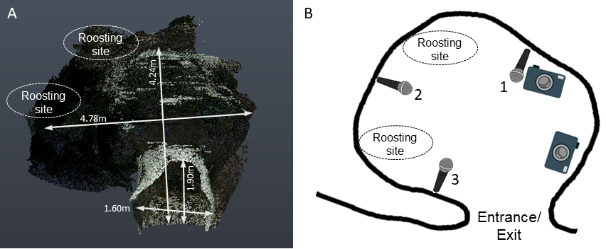

Figure 2.1: A) Point cloud scan of the cave B) top-view schematic of the cave , indicating the entrance/exit, the typical roosting sites inside the cave, and the position of microphones and cameras. (3D scanning by Klaus Hochradel, UMIT Tirol) The numbers next to the microphone correspond to the positions in the main text.

## 2.3 Video analysis to determine group sizes

After entering the cave, bats typically flew around for a few seconds or flew to one of two roosting sites, where they stayed for seconds to minutes, and later left the cave again. We manually identified periods of bat flight activity (hereby referred to as ‘bat activity period’ or ‘bat activity’), and the number of visible bats during each activity period. We defined a bat activity period as the interval during which the number of visible bats flying inside the cave is constant. (See SI ?? for more details).

The annotated video bat activities were synchronised with the audio and inspected to check they only had *R. mehelyi/euryale* calls in them (See SI).

## 2.4 Acoustic parameter analysis

For the acoustic analysis, we used only recordings from microphone 1 because the audio had the least reverberance and as it recorded calls of both entering and exiting bats (see Figure 2.1). First, all audio from bat activity periods (referred to as flight-activity audio) were high-pass filtered at 70 kHz (2nd order zero-phase Butterworth filter). Next, we used two complementary acoustic analyses to quantify echolocation behaviour. The first analysis is the ‘individual call’ analysis, where we measured iFM, tFM and CF component parameters of one non-overlapped echolocation call from each flight-activity audio. The second analysis is the ‘windowed call’ analysis, were we split each flight-activity audio into consecutive 50-ms-long windows and measured the acoustic parameters of each window. In recordings with multiple bats, each window could contain multiple, potentially overlapping calls.

The analysis of individual calls is advantageous because it directly reveals sensory decisions of the bats. Its disadvantage, however, is that it can be difficult to find a non-overlapped call, particularly in reverberant and multi-bat situations. The windowed call analysis therefore complements the individual call analysis by enabling measurements even on audio with overlapping calls. The windowed call analysis also permits a form of null-hypothesis testing where the observed multi-bat audio can be compared with 1) single bat audio and 2) ‘virtual’ multi-bat audio files created by adding many single-bat audio files. These ‘virtual’ multi-bat audio files recreate a scenario where two bats echolocate in the same space without responding to each other’s presence (33,47). The disadvantage of the windowed call analysis is the lack of call-level measurements. Using both approaches simultaneously strengthens the interpretation of our results.

### 2.4.1 Individual call analysis

Per bat activity audio, we chose one call that was not overlapped by other calls and that had a signal-to-noise ratio of at least 20 dB (Figure 2.2) through a random search protocol (SI ??). Briefly, from a randomly determined time point, an experimenter began searching into a randomly determined direction (backward or forward in time) until a suitable horseshoebat call was found. We were able to find 226 individual calls across all the synchronised audio files. Calls were automatically segmented into their corresponding parts iFM, tFM or CF (Figure 2.2) ) using the *itsfm* package (48). Most approaches to date segment CF-FM calls into their components by high/low pass filtering around the call’s peak frequency (34,38,40,49,50). For an accurate estimate of the call’s peak frequency, this approach requires a recording of the call with a prominent CF component, which is suitable under controlled laboratory settings. Peak frequency estimation often fails in the analysis of CF-FM calls recorded in the field under a variety of conditions e.g. calls with loud FM and faint CF components. *itsfm* overcomes these limitations by robustly tracking the actual change in frequency over the call time to segment it into FM and CF components (48). For our analysis, we defined the i/tFM components as those portions of a CF-FM call where frequency modulation was larger than 2 kHz/ms. See SI for further details.

From the three components of each call, we measured specific parameters. For the CF component, we measured the peak frequency, root-mean-square (RMS) level and duration. For the FM components, we measured the lowest frequency (at 10 dB below the level of the peak frequency of the FM component), bandwidth (defined as difference between the CF peak frequency and the lowest frequency of the FM component), RMS level and duration. We also calculated the iFM/CF and tFM/CF level difference, i.e., the level of the iFM and tFM components relative to the CF component, because CF-FM bats independently vary the relative levels of call components in a context specific manner (34,50).

The first statistical analysis of the individual call data revealed that multi-bat calls showed a non-negligible reduction in CF duration (Table 4.1). The apparent reduction may have also been due to a bias in the call selection protocol that favoured non-overlapping, and thus shorter calls. To eliminate the possibility of a methodological bias we extended the CF duration analysis by measuring multiple calls within each bat activity audio. The spectrogram of a bat activity audio was calculated, and a ‘main’ band was chosen consisting of the peak frequency 1.5 kHz. The main band typically consisted of the CF components of a bat’s call. Within the main band, continuous segments above a chosen threshold were labelled as CF call components. These CF component detections were then manually verified and their duration was calculated (SI ?????).

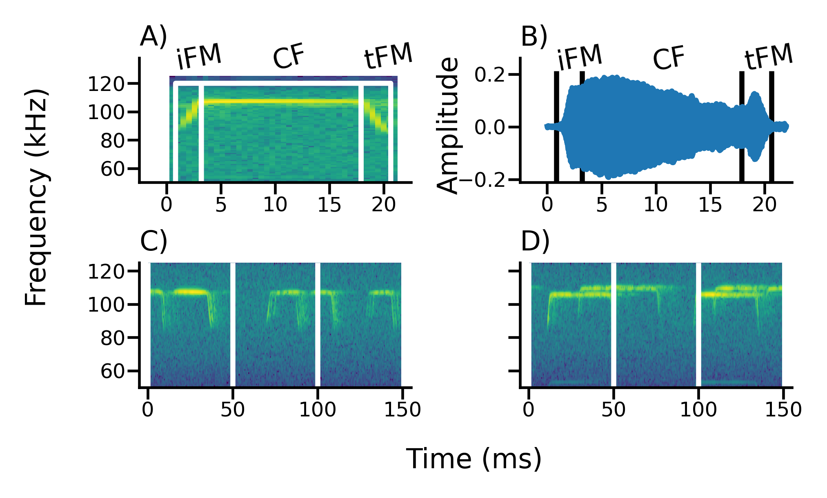

Figure 2.2: Example input data for the individual (A,B) and windowed (C,D) call analysis. A-B: Example of a manually selected call used for individual call analysis, showing its spectrogram (A) and waveform (B) representation. C-D: Examples of a single bat (C) and a multi-bat (D) recording used for windowed call analysis. The vertical lines indicate the 50-ms-long windows used to split recordings.

### 2.4.2 Windowed calls analysis

Each bat activity audio was split into consecutive 50 ms windows (See Figure 2.2 and SI ??). We chose a window duration of 50 ms as it provided high spectral resolution (FFT resolution of 20 Hz) that permits differentiating multiple CF components in the same window. Initial observations showed that 50 ms was also about the longest observed duration of a bat call in our data, and was about twice the length of typical calls. We kept only windows with loud calls by excluding all windows whose RMS level was less than 20 dB above the maximum RMS level of silent windows (SI ??). From windows that contained echolocation calls, we measured received RMS level, dominant frequencies and FM lower frequencies. We chose these measurements to complement the analogous measurements in the individual call analyses. The dominant frequencies describe the CF frequencies of multiple calls in the same window and were defined as local peaks of the smoothed power spectrum (SI ???). Dominant frequencies complement the individual call analysis’ CF peak frequency measurement. For instance, if bats ‘widen’ the bandwidth of their CF frequencies in groups to reduce overlap, we expect an increased dominant frequency range in multi-bat audio. FM lower frequencies were defined as the lowest frequencies extracted from each identified FM region in a spectrogram representation of the window (see SI ??). FM lower frequencies in the windowed analysis are analogous to the i/tFM lower frequency of the individual call analysis. The RMS level describes the received level of the window, and was defined as the root-mean-square of all samples in a window. In a single window, there could be multiple terminal and dominant frequency measurements, but only one received RMS level measurement.

We created ‘virtual multi-bat’ data by combining single bat audio-files that were of similar durations (SI ??). This generated a ‘null’ dataset of multiple bats that were echolocating together without altering their calls in groups. We performed the same windowed call analysis on the virtual multi-bat audio as described above for the real multi-bat audio.

# 3 Statistical analysis

We observed up to four bats flying in the cave at the same time. Especially in the individual call dataset the number of recordings of multi-bat ( 2 bats) calls was low (N=177, 40, 7, 2 for group sizes of 1, 2, 3, 4 respectively,), we thus combined all bat activity periods with 2 bats into a multi-bat class and compared ‘single’ and ‘multi’ bat ( bats) calls in the individual call analysis. The same categorisation was used even for the windowed call analysis too.

To analyse differences in echolocation between single and multi-bat contexts we ran linear-mixed models (LMMs). Model fit was checked by performing residual diagnostics. Model coefficients were estimated using a Bayesian approach with non-informative priors, and the 95% highest posterior-density compatibility intervals (CoI) were used in reporting. The compatibility interval represents the lower and upper borders of the posterior distribution of the coefficient estimates. We would like to highlight that a compatibility interval is not equivalent to a confidence interval, even though the numerical values may be similar under certain cases (51). Unlike confidence intervals, the compatibility interval allows a true probabilistic interpretation that the underlying parameter value falls within a range for the given dataset.

To interpret the change in echolocation behaviour we calculated the difference and ratio of estimated coefficients between group and individual contexts.

## 3.1 Individual call analysis

LMMs were run with each component measurement as response, group size as a categorical predictor (single, multi) and video-file ID as random intercept for all parameters.

## 3.2 Windowed call analysis

The received level and lowest frequency measurements resulted in multiple values per flight-activity audio (one value per window). The measurements from one flight-activity audio are potentially correlated. We thus estimated the difference between single, multi and virtual-multi bat measurements using an LMM with group size as a categorical fixed effect (single, multi, virtual-multi), with flight-activity bout and hour of the night as random intercepts. Flight-activity bout was chosen to account for correlation across multiple windows of the same flight-activity, while hour of the night was chosen to account for overall changes in activity across the night.

If bats are altering their CF frequencies to avoid spectral overlap, we expect an increase in the observed dominant frequency ranges from the windowed call analysis. To quantify the change in dominant frequency range (), we first calculated it across each bat activity audio. We expect a baseline non-zero variation in the dominant frequency even within one flight-activity recording for two reasons: 1) the bat’s Doppler shift compensation in flight and 2) the Doppler shift due to the bat’s motion relative to the microphone will cause variation in the dominant frequency. These two effects will lead to non-zero dominant frequency range even for single-bat activities (SI ??). We thus compare the dominant frequency range between single, multi and virtual-multi bat audio. An LMM was built with dominant frequency as the response variable, group-type as the fixed effect, and the video-file as a random intercept (a proxy for time).

Since individual bats emit unique CF frequencies (37), we expect an obvious increased dominant frequency range in virtual multi-bat contexts compared to single-bat contexts. Furthermore, if bats in real multi-bat contexts actively alter their call frequency, we expected an increased dominant frequency range compared to both single-bat and to virtual multi-bat contexts. To understand the theoretically expected dominant frequency range from single and multi bat flights, (and thus the expected range difference) we also performed simulations quantifying Doppler shift and Doppler shift compensation parametrised by the observed data (SI ?? for details of simulation and results). Briefly, we simulated a bat emitting frequencies between 100-111 kHz while flying at a constant speed (set to between 1.5-4.5 m/s), flying past a microphone located on one side. The dominant frequency range was calculated as the absolute difference between the frequency recorded by the microphone at the beginning of the flight and the end of the flight. The dominant frequency range estimates from the simulations informed the interpretation of the observed data.

## 3.3 Software packages used in this paper

Signal analysis, data manipulation and visualisation were done in Python (52) through its scientific ecosystem: the scipy, numpy, matplotlib, soundfile and pandas packages (53–57). Reproducible analysis, documentation and presentation were enabled by the Jupyter Notebook and Rmarkdown projects(58,59). Audio visualisation, preliminary measurements and single call annotations were done with Audacity (60). LMMs were run in R (61) and its statistical ecosystem: the ‘lme4’,‘arm’ and ‘coda’ packages (62–64).

# 4 Results

We recorded echolocation and flight behaviour of mixed-species groups of the high-duty cycle bats *Rhinolophus euryale* and *R. mehelyi* as they flew alone and with other bats in a natural cave. The bats performed various flight behaviours in the cave, such as circling, approaches (when two or more bats flew towards each other) and following (one bat behind another) flights. A total of 2126 flight activities were annotated from video, of which 1180 synchronised audio clips with only *Rhinolophus* calls were found. The synchronised audio clips ranged from 0.08 - 37.92 s duration (median 1.02 s). The synchronised audio clips were used in the individual and windowed call analysis.

In general, the acoustic parameters of individual calls mostly did not differ between single-bat and multi-bat contexts. Likewise, the windowed call-analysis revealed no major differences in received level and FM lowest frequency between single-bat and multi-bat and between multi-bat and virtual-multi-bat conditions. As theoretically expected, the dominant-frequency range in the windowed analysis, was larger in multi-bat conditions compared to single-bat conditions.

## 4.1 Individual call analysis

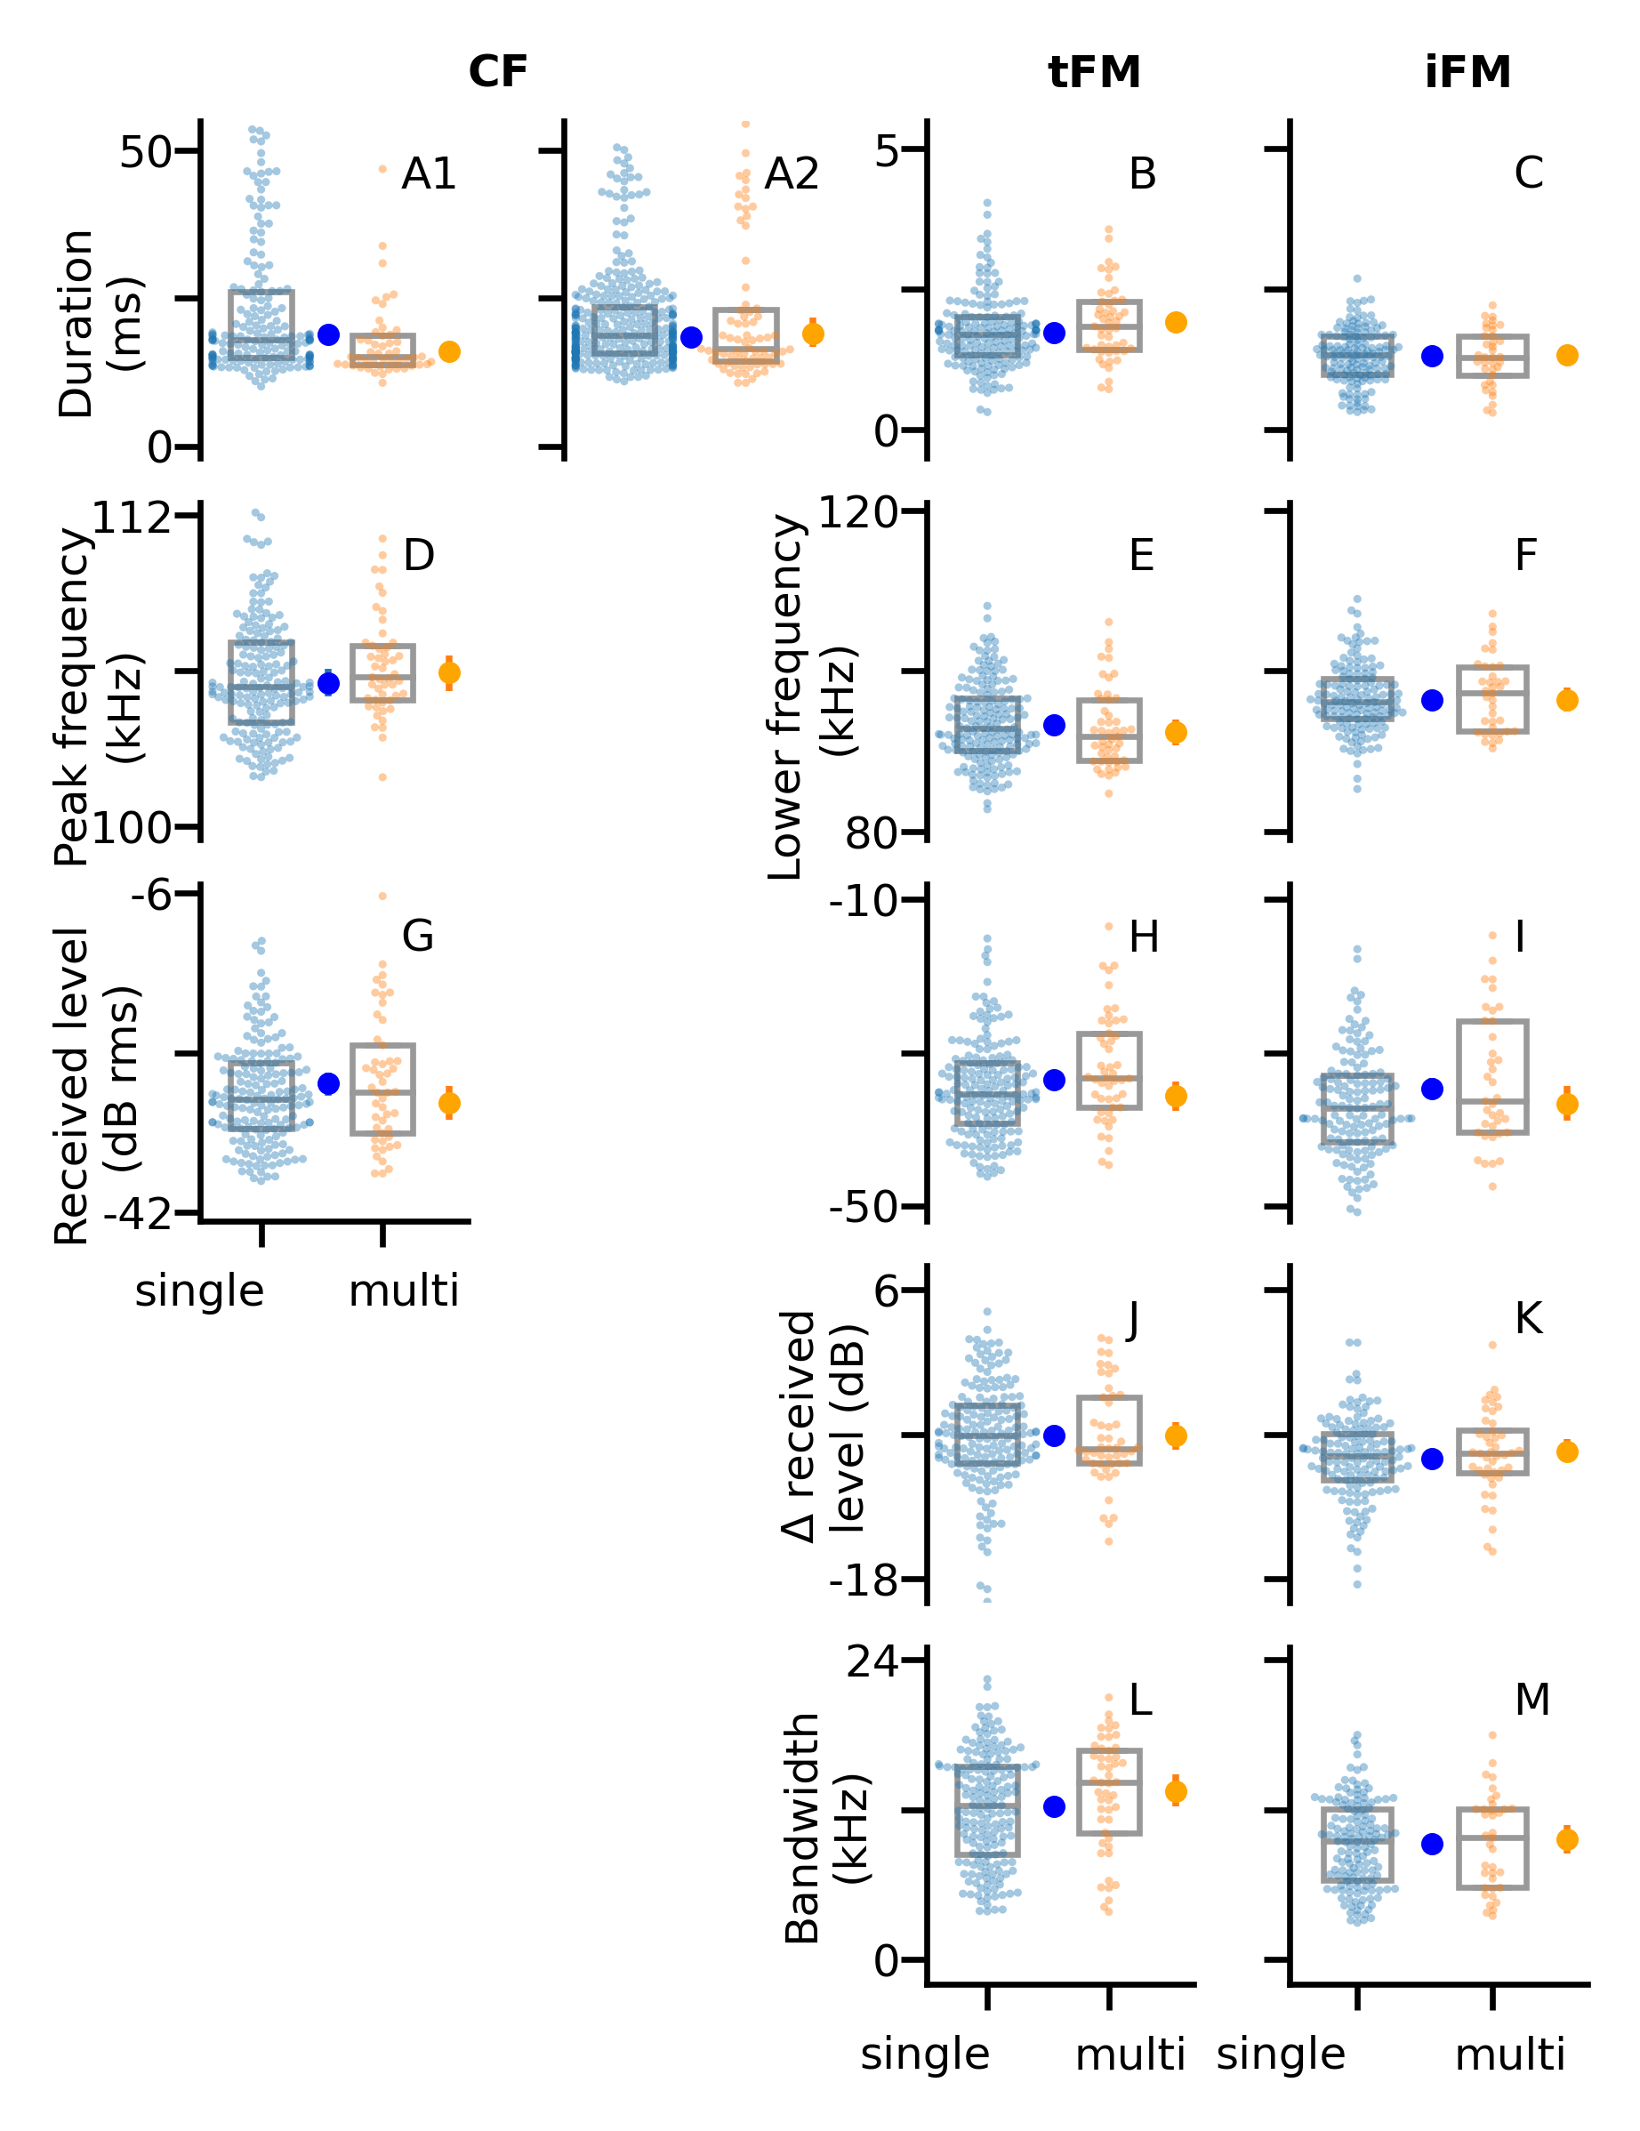

Figure 4.1: Measured acoustic parameters for the constant frequency (CF), initial frequency modulated (iFM) and terminal frequency modulated (tFM) components of individual calls emitted under single-bat and multi-bat conditions. Each column shows the measurements per call component, while each row shows a group of related measurements: A-C) duration. A1 is the first individual call analysis which analysed the CF duration from single calls. A2 is the multi-call extension which measured CF component duration of multiple calls. D-F) spectral measurements G-I) received level J-K) relative FM-CF ratios L-M) FM component bandwidths. 177 , = 49 . Raw data points are plotted over box plots (lines indicate 25, 50, 75 percentiles). The dots with bars indicate the mean MAP estimates and 95% compatibility intervals

We measured 13 acoustic parameters of the initial and terminal frequency-modulated (iFM, tFM) and of the central constant-frequency (CF) component of 226 individual horseshoe bat echolocation calls ( 177, 49. . Most call parameters showed little or no difference between single-bat and multi-bat observations (Figure 4.1, Table 4.1) with very small maximum a posteriori (MAP) estimates or compatibility intervals distributed either side of zero. The CF component of multi-bat calls showed a duration difference of -4.45 to -1.32 ms (95% CoI). As stated before, this apparent drop in duration may have been due to a sampling bias that selected for shorter calls in multi-bat audio. The apparent reduction in CF duration from the original individual call analysis, was not supported by the multi-call extension, indicating negligible difference in CF duration (Table 4.1 (multi-call extension)) between -1.7 to 3.02 ms (95% CoI). Multi-bat calls showed a slight decrease in amplitude of upto 0-4 dB in multi-bat calls, and a slight increase in tFM bandwidth of -2.42-0.71 kHz (95% CoI). All remaining parmeters had negligible differences between single and multi-bat contexts centered around zero (see Table 4.1).

Table 4.1: The predicted difference and ratio between multi and single bat call parameters. The maximum a posteriori (MAP) is the most likely estimate, and 95% highest posterior density compatibility intervals (CoI) provides the range of uncertainty in the parameter estimate.

| Measurement | Component | Difference (Multi-Single) | Difference, 95% CoI | | Ratio (Multi/Single) | Ratio, 95% CoI | |
| --- | --- | --- | --- | --- | --- | --- | --- |
|  |  | MAP | Lower | Upper | MAP | Lower | Upper |
| Duration, ms | CF | -2.86 | -4.45 | -1.32 | 0.85 | 0.77 | 0.93 |
|  | CF (multi-call extension) | 0.64 | -1.70 | 3.02 | 1.04 | 0.91 | 1.17 |
|  | tFM | 0.19 | -0.01 | 0.39 | 1.11 | 0.99 | 1.23 |
|  | iFM | 0.02 | -0.16 | 0.19 | 1.02 | 0.88 | 1.15 |
| Peak frequency, kHz | CF | 0.40 | -0.26 | 1.02 | 1.004 | 0.998 | 1.01 |
| Lower frequency, kHz | tFM | -0.87 | -2.42 | 0.71 | 0.99 | 0.97 | 1.01 |
|  | iFM | 0.02 | -1.45 | 1.49 | 1 | 0.99 | 1.02 |
| Amplitude, dB rms | CF | -2.16 | -4.09 | -0.22 | - | - | - |
|  | tFM | -2.06 | -4.19 | -0.11 | - | - | - |
|  | iFM | -1.96 | -4.32 | 0.63 | - | - | - |
| Level difference, dB | tFM-CF | -0.01 | -1.30 | 1.25 | - | - | - |
|  | iFM-CF | 0.62 | -0.49 | 1.72 | - | - | - |
| Bandwidth, kHz | tFM | 1.24 | -0.13 | 2.63 | 1.1 | 0.99 | 1.22 |
|  | iFM | 0.38 | -0.90 | 1.62 | 1.04 | 0.9 | 1.18 |

Table 4.2: Results of the windowed call analysis. The statistically estimated difference and ratio between the two comparisons (Multi-Single and Multi-Virtual multi) are reported.

| Measurement | Comparison | Difference | Difference, 95% CoI | | Ratio | Ratio, 95% CoI | |
| --- | --- | --- | --- | --- | --- | --- | --- |
|  |  | MAP | Lower | Upper | MAP | Lower | Upper |
| Received level (dB RMS) | Multi-Single | 0.20 | -0.40 | 0.90 | - | - | - |
| Lower frequency (kHz) |  | -0.25 | -0.82 | 0.28 | 1 | 0.99 | 1 |
| Dominant frequency range (kHz) |  | 2.14 | 1.74 | 2.62 | 4.91 | 3.48 | 6.48 |
| Received level (dB RMS) | Multi-Virtual multi | 0.50 | -0.40 | 1.40 | - | - | - |
| Lower frequency (kHz) |  | -0.41 | -1.20 | 0.37 | 1 | 0.99 | 1 |
| Dominant frequency range (kHz) |  | -0.03 | -0.80 | 0.78 | 1 | 0.71 | 1.29 |

## 4.2 Windowed call analysis

For each window in a flight-activity and virtual audio we obtained received level ( 1753, 1039, 722) and FM lower frequency ( 2660, 2927, 1668), and dominant frequency range ( 233, 87, 83).

The windowed call analysis also showed overall little to no difference between single, multi and virtual multi-bat contexts in all of the parameters considered.

There was little difference in the received levels and FM lower frequency between multi and single bat contexts (received level: -0.4-0.9 dB 95% CoI, FM lower freq. -0.82-0.28 kHz 95% CoI) (Figure 4.2, Table 4.2). The observed difference in dominant frequency range matches the magnitude in simulations when bats do not show any special responses to each other (SI ??). Compared to single-bat contexts, the dominant frequency range during multi-bat contexts was larger by 1.74 – 2.62 kHz (95% CoI).

We compared the observed multi-bat recordings to virtual-multi bat recordings to estimate if bats were adjusting their echolocation behaviour to the presence of conspecifics. There was little difference in received level and FM lower frequency (received level: -0.4-1.4 dB 95% CoI, FM lower freq. -1.2-0.37 kHz 95% CoI). The difference in dominant frequency range between observed and virtual multi-bat was low as well (-0.8 - 0.78 kHz 95% CoI) (Table 4.2 .

The results of the two lines of analysis (individual and windowed calls) taken together suggest bats did not change their echolocation behaviour in the presence of conspecifics.

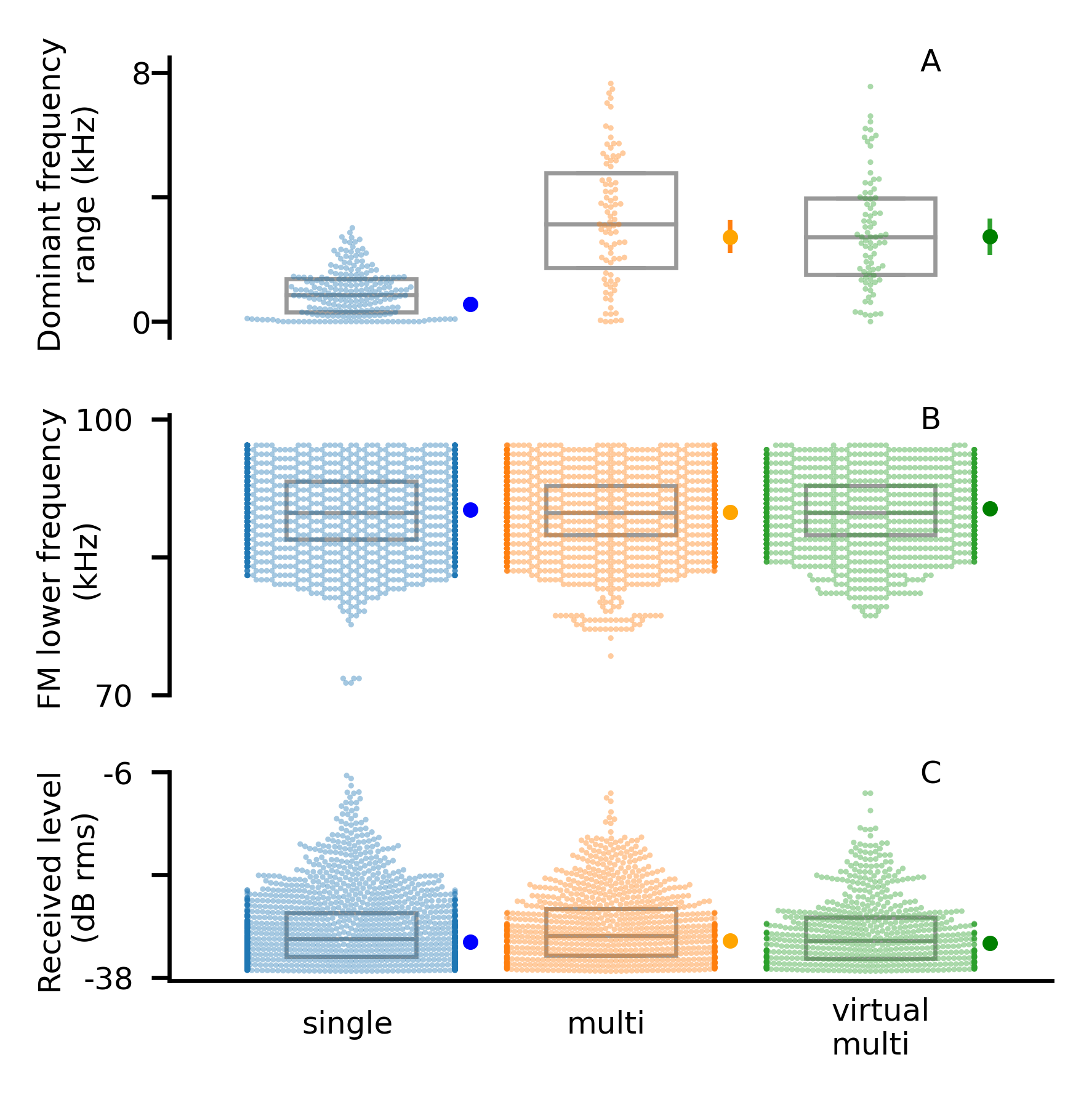

Figure 4.2: Windowed analysis measurements and mean estimates: A) Dominant frequency range B) FM lower frequency C) Received level. The raw data points are plotted over a boxplot (lines indicate 25,50 and 75th percentiles). The modelled mean estimates with the MAP (dot) and the 95% CoI (vertical bar). For most means, the central point engulfs the compatibility interval.

# 5 Discussion

Active sensing animals experience sensory detriment when in groups. Echolocating bats suffer drops in echo detection while electrolocating fish suffer from interference in their electric fields (8). The idea that animals perform an explicit evasive maneuver is embodied in the term ‘jamming avoidance response’. The term arose to describe (8) electrolocating fish shifting their field frequencies in response to conspecifics or external fields. The acoustic jamming avoidance response has been heavily investigated in echolocating bats, more specifically FM bats which emit short calls with long silences in between. Many FM bat species appear to show some kind of jamming avoidance response by altering their call duration, repetition rate, amplitude or frequency ranges (15,17,19,28). While FM bats may seem to alter their call parameters in groups, literature also paints a picture where the call alterations of FM bats are better explained by factors not related to spectral jamming avoidance (22–24,32). Our results contribute to this re-interpretative line of thought, highlighting that the absence of a clear jamming avoidance response may be much more common than expected.

*CF component*: Previous studies have shown no spectral jamming avoidance response in rhinolophid and hipposiderid bats (31–33), with some mixed evidence in the quasi-CF rhinopomids (e.g. present in *Rhinopoma hardwickeii* (18), absent in *R. microphyllum* (22)). However, it is important to stress that there is likely no ‘need’ for a jamming avoidance response due to individual specific acoustic foveas at least in rhinolophids and hipposiderids. Our data also does not support CF frequency shifting. The windowed analysis showed an increase of ~2 kHz in dominant frequency range in multi-bat recordings. The observed increase is well explained by inter-individual variation in acoustic foveas and Doppler shift effects alone. We also observed no systematic change in CF duration, as revealed by our multi-call extension analysis.

*FM component:* The tFM component of CF-FM high duty-cycle bats is likely used for ranging. CF-FM bats alter the tFM based on the behaviour at hand, much like FM bats do (42). Not much is known about the role of iFM in CF-FM bats. Between the two rhinolophid species studied so far, we also see opposing results. Fawcett et al. 2015 found a drop of 5 kHz tFM terminal frequency in pairs of *Rhinolophus capensis*, while Ding et al. 2024 also observe a ~4-5 kHz difference, but instead a *decrease* in tFM terminal frequency. The results are notable, despite the slightly different measurement conventions used (-10 & -30 dB respectively). Our results are similar to Ding et al. 2025, but with a much lower change of -0.87 kHz in tFM terminal frequency. Increasing call duration increases echo detection (16). In terms of tFM duration alteration, Fawcett et al. 2015 found an increase of 1.8 ms in pairs, while Lu et al. 2020 report a 0.35 ms increase in noise. We find a 0.19 ms increase in groups, a smaller effect than both comparable studies. The tFM duration increase corresponds to a relative ~10% increase in duration. Whether the relative 10% increase provides a sensory advantage is unclear to us. Results from FM bats also show increases of call duration in noise (15,65), along with a species dependent response. We suspect the differences in our results in comparison to Ding et al. 2024 and Fawcett et al. 2015 may lie in either the species or the experimental setting. We studied wild bats in a familiar environment while the other studies (32,33) flew captured bats in a novel flight environment.

Since the tFM components are used for ranging, the tFM echoes are of primary importance to CF-FM bats for navigation. How often are a bat’s tFM echoes masked by the tFM components of others? tFM components are short ( $$3 ms, 95 percentile value), and likely emitted about every 40-50 ms which is equivalent to a tFM duty cycle between 6-7.5%. For a pair of bats at these duty cycles, the probability that the tFM-component of one bat overlaps the other bat’s tFM-echo of one tFM echo being overlapped by another bat’s tFM call component is only relatively low at most between up to 1.6 - 2.1% (see Supp. Info. for calculations). Even if a single tFM echo is overlapped by another call, a bat may still be able to detect it if the signal-to-noise ratio is sufficient. Modelling shows that FM bats with similar call durations can detect all of their echoes in small groups of up to 10 individuals, and are unlikely to face major detriments to their echolocation (25).

*Call level:* A direct way of improving echo detection is to increase the call level, which both FM bats (15,16,65) and CF-FM bats (50,66,67) regularly do in the presence of experimental playbacks. We did not track the 3D-position of the bats in our study, and thus could not measure their source level. We instead analyzed the received level of calls at the microphone. Received levels depend not only on the bat’s source level, but also on the bats’ distance and calling direction relative to the microphone. Our individual call analysis showed that the received levels of all three call components were ~2 dB lower (MAP) during group flight compared to the single-bat context. In contrast, our windowed call analysis revealed no systematic difference in received level between multi-bat and single-bat contexts and between observed multi-bat and virtual multi-bat contexts.

Free-flying CF-bats do not seem to suffer from sensory problems when flying in small groups. What are the possible explanations for the absence of a strong echolocation response in groups? Echolocation in small groups (2-4 bats) may not be very challenging for multiple reasons. CF-FM bats rely on the short tFM component to detect the distance of objects around them for object ranging (34) – which may not be overlapped often (see previous section). Bats also integrate echoes across multiple calls and are thus resistant to occasional disruptions in echo arrival (68). Bats also possess long-term spatial memory (69,70), and the ones we observed are likely very familiar with the cave’s structure. Spatial memory likely allows bats to tolerate occasional echo masking in groups, particularly in combination with multi-echo integration (68).

In our opinion, the primary obstacle to furthering studies in group echolocation is technical, especially in analysing overlapping sounds. Here, we presented a series of automated, replicable workflows such as the windowed call analysis and measurement of CF durations in multi-bat contexts. To improve the reliability of call component measurement, we also developed the *itsfm* toolkit to automatically segment call-components. Further work still remains to be done, primarily in the development of call-identity assignment when there are multiple overlapping calls recorded under reverberant conditions.

# 6 Outlook

Despite bats’ outstanding flexibility in adjusting call parameters to optimize sensory information, we found no obvious change in call parameters in free-flying CF-bats in small groups of up to four bats. This strongly suggests that free-flying CF-bats do not suffer from sensory problems when flying in small groups, even in reverberant environments. Our results add to the growing body of literature (15,17,22,24,30,31) showing that echolocation in (small) groups can be handled by a bat’s general repertoire of sensory strategies used as individuals.

In short, the presence of jamming itself does not directly imply dire sensory or motor consequences. Aside from echolocating bats, recent studies show multiple weakly electric wave-type fish in their natural habitat associate in close proximity (71). Particularly for active-sensing animals, jamming may be one of the ‘costs’ of being social (1,2). While active-sensing animals may indeed alter their sensory strategies in response to jamming (8,15), we highlight the importance of observational studies in field settings to understand the frequency with which various sensory strategies are actually employed in ecological contexts.

# 7 Data and code availability

All data and code used process data and generate the results and figures in the paper are available at the following Github repository: <https://github.com/thejasvibr/mhbc-online/> and the Zenodo link *INSERT ZENODO LINK HERE*.

# 8 Acknowledgements

The authors would like to specially thank the electronics team (Markus Abels, Hannes Sagunsky, Reinhard Biller) at the MPIO workshop for help preparing the electronic circuits to run the ON/OFF signal splitting. We would also like to thank Antoniya Hubancheva for logistical support, Stefan Greif for help collecting the data, the 2018 Tabachka field crew, Klaus Hochradel for the point-cloud scan of the cave and Diana Schoeppler and Hans-Ulrich Schnitzler for their helpful discussions. We also thank Manjari Jain for her support and and encouragement of the project. TB was funded by a DAAD doctoral fellowship, the IMPRS for Organismal Biology, a CASCB Medium grant, and funded by the Walter Benjamin program of the Deutsche Forschungsgemeinschaft (DFG, German Research Foundation) – project number 502056951, HRG was funded by the Emmy Noether program of the DFG (German Research Foundation, grant no. 241711556).

# 9 Author Contributions

Author contributions in alphabetical order. Study design and conception: NM, TB; Data collection: AK, NM, TB; Audio and video annotation: AK, NM; Audio-video synchronisation: TB; Analysis: HRG, NM, TB; Interpretation of results: HRG, NM, TB; Manuscript preparation: HRG, NM, TB.

# References

1. Pulliam HR, Caraco T. Living in groups: Is there an optimal group size? In: Behavioural ecology: An evolutionally approach. Blackwell Scientific; 1984. p. 122–47.

2. Krause J, Ruxton GD, Ruxton G, Ruxton IG, et al. Living in groups. Oxford University Press; 2002.

3. Cherry EC. Some experiments on the recognition of speech, with one and with two ears. J Acoust Soc Am. 1953;25:975–9.

4. Bee MA, Micheyl C. The cocktail party problem: What is it? How can it be solved? And why should animal behaviorists study it? Journal of comparative psychology. 2008;122(3):235.

5. Carrasco M. Spatial covert attention: Perceptual modulation. 2014;

6. Krauzlis RJ, Bollimunta A, Arcizet F, Wang L. Attention as an effect not a cause. Trends in cognitive sciences. 2014;18(9):457–64.

7. Ulanovsky N, Moss CF. What the bat’s voice tells the bat’s brain. Proceedings of the National Academy of Sciences. 2008;105(25):8491–8.

8. Bullock TH, Hamstra RH, Scheich H. The jamming avoidance response of high frequency electric fish. In: How do brains work? Springer; 1972. p. 509–34.

9. Zweifel NO, Hartmann MJ. Defining ‘active sensing’ through an analysis of sensing energetics: Homeoactive and alloactive sensing. Journal of Neurophysiology. 2020;124(1):40–8.

10. Nelson ME, MacIver MA. Sensory acquisition in active sensing systems. J Comp Physiol A Neuroethol Sens Neural Behav Physiol. 2006;192:573–86.

11. Jadhav V, Guttal V, Masila DR. Randomness in the choice of neighbours promotes cohesion in mobile animal groups. Royal Society Open Science. 2022;9(3):220124.

12. Gillam EH, Hristov NI, Kunz TH, McCracken GF. Echolocation behavior of Brazilian free-tailed bats during dense emergence flights. Journal of Mammalogy. 2010 Aug;91(4):967–75. Available from: <https://doi.org/10.1644/09-MAMM-A-302.1>

13. Watanabe A, Takeda K. The change of discharge frequency by AC stimulus in a weak electric fish. Journal of Experimental Biology. 1963;40(1):57–66.

14. Griffin DR. Listening in the dark: The acoustic orientation of bats and men. 1958;

15. Amichai E, Blumrosen G, Yovel Y. Calling louder and longer: How bats use biosonar under severe acoustic interference from other bats. Proceedings of the Royal Society B: Biological Sciences. 2015;282(1821):20152064.

16. Luo J, Goerlitz HR, Brumm H, Wiegrebe L. Linking the sender to the receiver: Vocal adjustments by bats to maintain signal detection in noise. Scientific reports. 2015;5:18556.

17. Hase K, Kadoya Y, Maitani Y, Miyamoto T, Kobayasi KI, Hiryu S. Bats enhance their call identities to solve the cocktail party problem. Communications biology. 2018;1(1):1–8.

18. Habersetzer J. Adaptive echolocation sounds in the batrhinopoma hardwickei. Journal of Comparative Physiology. 1981;144(4):559–66.

19. Ulanovsky N, Fenton MB, Tsoar A, Korine C. Dynamics of jamming avoidance in echolocating bats. Proceedings of the Royal Society of London Series B: Biological Sciences. 2004;271(1547):1467–75.

20. Jarvis J, Jackson W, Smotherman M. Groups of bats improve sonar efficiency through mutual suppression of pulse emissions. Frontiers in physiology. 2013;4:140.

21. Adams AM, Davis K, Smotherman M. Suppression of emission rates improves sonar performance by flying bats. Scientific reports. 2017;7(1):1–9.

22. Cvikel N, Levin E, Hurme E, Borissov I, Boonman A, Amichai E, et al. On-board recordings reveal no jamming avoidance in wild bats. Proceedings of the Royal Society B: Biological Sciences. 2015;282(1798):20142274.

23. Götze S, Koblitz JC, Denzinger A, Schnitzler H-U. No evidence for spectral jamming avoidance in echolocation behavior of foraging pipistrelle bats. Scientific reports. 2016;6(1):1–13.

24. Mazar O, Yovel Y. A sensorimotor model shows why a spectral jamming avoidance response does not help bats deal with jamming. Elife. 2020;9:e55539.

25. Beleyur T, Goerlitz HR. Modeling active sensing reveals echo detection even in large groups of bats. Proceedings of the National Academy of Sciences. 2019;116(52):26662–8. Available from: <https://www.pnas.org/content/116/52/26662>

26. Fenton MB, Faure PA, Ratcliffe JM. Evolution of high duty cycle echolocation in bats. Journal of Experimental Biology. 2012;215(17):2935–44.

27. Lin Y, Abaid N, Müller R. Bats adjust their pulse emission rates with swarm size in the field. J Acoust Soc Am. 2016;140:4318–25.

28. Fawcett K, Ratcliffe JM. Clutter and conspecifics: A comparison of their influence on echolocation and flight behaviour in daubenton’s bat, myotis daubentonii. Journal of Comparative Physiology A. 2015;201(3):295–304.

29. Mammal Diversity Database. Mammal diversity database. Zenodo; 2020. Available from: <https://doi.org/10.5281/zenodo.4139818>

30. Beleyur T, Goerlitz HR. Modeling active sensing reveals echo detection even in large groups of bats. Proceedings of the National Academy of Sciences. 2019;116(52):26662–8.

31. Jones G, Sripathi K, Waters DA. Individual variation in the echolocation calls of three sympatric indian hipposiderid bats, and an experimental attempt to jam bat echolocation. Folia Zoologica. 1994;43:347–62.

32. Ding J, Gu H, Zhang K, Lin A, Feng J, Liu Y. Adaptive adjustment of the FM component of calls in CF-FM bats is not involved in avoidance of conspecific jamming. Animal Behaviour. 2024;216:97–105.

33. Fawcett K, Jacobs DS, Surlykke A, Ratcliffe JM. Echolocation in the bat, rhinolophus capensis: The influence of clutter, conspecifics and prey on call design and intensity. Biology Open. 2015;4(6):693–701.

34. Tian B, Schnitzler H-U. Echolocation signals of the greater horseshoe bat (rhinolophus ferrumequinum) in transfer flight and during landing. The Journal of the Acoustical Society of America. 1997;101(4):2347–64.

35. Schnitzler H-U, Denzinger A. Auditory fovea and doppler shift compensation: Adaptations for flutter detection in echolocating bats using CF-FM signals. Journal of Comparative Physiology A. 2011;197(5):541–59.

36. Neuweiler G. The biology of bats. Oxford University Press; 2000.

37. Schnitzler H-U, Suga N, Simmons J. Peripheral auditory tuning for fine frequency analysis by the CF-FM bat, rhinolophus ferrumequinum. Journal of comparative physiology. 1976;106(1):99–110.

38. Schuchmann M, Puechmaille SJ, Siemers BM. Horseshoe bats recognise the sex of conspecifics from their echolocation calls. Acta Chiropterologica. 2012;14(1):161–6.

39. Schnitzler H-U. Control of doppler shift compensation in the greater horseshoe bat, rhinolophus ferrumequinum. Journal of comparative physiology. 1973;82(1):79–92.

40. Schoeppler D, Schnitzler H-U, Denzinger A. Precise doppler shift compensation in the hipposiderid bat, hipposideros armiger. Scientific reports. 2018;8(1):1–11.

41. Neuweiler G, Metzner W, Heilmann U, Rübsamen R, Eckrich M, Costa H. Foraging behaviour and echolocation in the rufous horseshoe bat (rhinolophus rouxi) of sri lanka. Behavioral ecology and sociobiology. 1987;20(1):53–67.

42. Fenton B(MB), Jensen FH, Kalko EKV, Tyack PL. Sonar signals of bats and toothed whales. In: Surlykke A, Nachtigall PE, Fay RR, Popper AN, editors. Biosonar. New York, NY: Springer New York; 2014. p. 11–59. Available from: <https://doi.org/10.1007/978-1-4614-9146-0_2>

43. Jones G, Morton M, Hughes P, Budden R. Echolocation, flight morphology and foraging strategies of some west african hipposiderid bats. Journal of Zoology. 1993;230(3):385–400.

44. Izadi MR, Stevenson RL, Kloepper L. Segmentation of overlapping sources in mixtures of bat echolocation calls. The Journal of the Acoustical Society of America. 2019;146(4):3026–6.

45. Dietz C, Kiefer A. Bats of britain and europe. Bloomsbury Publishing; 2016.

46. Laurijssen D, Verreycken E, Geipel I, Daems W, Peremans H, Steckel J. Low-cost synchronization of high-speed audio and video recordings in bio-acoustic experiments. Journal of Experimental Biology. 2018;221(4).

47. Ratcliffe JM, Hofstede HM ter, Avila-Flores R, Fenton MB, McCracken GF, Biscardi S, et al. Conspecifics influence call design in the brazilian free-tailed bat, tadarida brasiliensis. Canadian Journal of Zoology. 2004;82(6):966–71.

48. Beleyur T. Itsfm, an open-source package to reliably segment and measure sounds by frequency modulation. bioRxiv. 2021; Available from: <https://www.biorxiv.org/content/early/2021/01/09/2021.01.09.426033>

49. Siemers BM, Beedholm K, Dietz C, Dietz I, Ivanova T. Is species identity, sex, age or individual quality conveyed by echolocation call frequency in european horseshoe bats? Acta Chiropterologica. 2005;7(2):259–74.

50. Lu M, Zhang G, Luo J. Echolocating bats exhibit differential amplitude compensation for noise interference at a sub-call level. Journal of Experimental Biology. 2020;223(19).

51. Nalborczyk L, Bürkner P-C, Williams DR, Savalei V. Pragmatism should not be a substitute for statistical literacy, a commentary on albers, kiers, and van ravenzwaaij (2018). Collabra: Psychology. 2019;5(1).

52. Van Rossum G, Drake Jr FL. Python reference manual. Centrum voor Wiskunde en Informatica Amsterdam; 1995.

53. Virtanen P, Gommers R, Oliphant TE, Haberland M, Reddy T, Cournapeau D, et al. SciPy 1.0: Fundamental Algorithms for Scientific Computing in Python. Nature Methods. 2020;17:261–72. doi: <https://doi.org/10.1038/s41592-019-0686-2>

54. Oliphant TE. A guide to NumPy. Vol. 1. Trelgol Publishing USA; 2006.

55. Hunter JD. Matplotlib: A 2D graphics environment. Computing in science & engineering. 2007;9(3):90–5.

56. Bechtold B, Geier M. SoundFile. 2019. Available from: <https://github.com/bastibe/SoundFile>

57. McKinney W et al. Data structures for statistical computing in python. In: Proceedings of the 9th python in science conference. Austin, TX; 2010. p. 51–6.

58. Kluyver T, Ragan-Kelley B, Pérez F, Granger B, Bussonnier M, Frederic J, et al. Jupyter notebooks – a publishing format for reproducible computational workflows. Loizides F, Schmidt B, editors. IOS Press; 2016. p. 87–90.

59. Xie Y, Allaire JJ, Grolemund G. R markdown: The definitive guide. Boca Raton, Florida: Chapman; Hall/CRC; 2018. Available from: <https://bookdown.org/yihui/rmarkdown>

60. Audacity-Team. Audacity(r): Free audio editor and recorder [computer application] version 2.3.3. 2019. Available from: <https://audacityteam.org/>

61. R Core Team. R: A language and environment for statistical computing. Vienna, Austria: R Foundation for Statistical Computing; 2021. Available from: <https://www.R-project.org/>

62. Bates D, Mächler M, Bolker B, Walker S. Fitting linear mixed-effects models using lme4. Journal of Statistical Software. 2015;67(1):1–48. doi: [10.18637/jss.v067.i01](https://doi.org/10.18637/jss.v067.i01)

63. Gelman A, Su Y-S. Arm: Data analysis using regression and multilevel/hierarchical models. 2020. Available from: <https://CRAN.R-project.org/package=arm>

64. Plummer M, Best N, Cowles K, Vines K. CODA: Convergence diagnosis and output analysis for MCMC. R News. 2006;6(1):7–11. Available from: <https://journal.r-project.org/archive/>

65. Gomes DG, Goerlitz HR. Individual differences show that only some bats can cope with noise-induced masking and distraction. PeerJ. 2020;8:e10551.

66. Hage SR, Jiang T, Berquist SW, Feng J, Metzner W. Ambient noise induces independent shifts in call frequency and amplitude within the lombard effect in echolocating bats. Proceedings of the National Academy of Sciences. 2013;110(10):4063–8.

67. Hage SR, Jiang T, Berquist SW, Feng J, Metzner W. Ambient noise causes independent changes in distinct spectro-temporal features of echolocation calls in horseshoe bats. Journal of Experimental Biology. 2014;217(14):2440–4.

68. Salles A, Diebold CA, Moss CF. Echolocating bats accumulate information from acoustic snapshots to predict auditory object motion. Proceedings of the National Academy of Sciences. 2020; Available from: <https://www.pnas.org/content/early/2020/10/27/2011719117>

69. Möhres F, Oettingen-Spielberg T. Versuche über die nahorientierung und das heimfindevermögen der fledermäuse. Verhandlungen der deutschen Zoologen in Mainz. 1949;248–52.

70. Barchi JR, Knowles JM, Simmons JA. Spatial memory and stereotypy of flight paths by big brown bats in cluttered surroundings. Journal of Experimental Biology. 2013;216(6):1053–63.

71. Henninger J, Krahe R, Sinz F, Benda J. Tracking activity patterns of a multispecies community of gymnotiform weakly electric fish in their neotropical habitat without tagging. Journal of Experimental Biology. 2020;223(3):jeb206342.

1. <thejasvi.beleyur>(**bi.mpg.de?**),(**ab.mpg.de?**),(**uni-konstanz.de?**)