DELTA · TWITTER CUSTOMER SUPPORT · SDE INTERN TAKE-HOME
An Evaluation-First AI Support Agent for Delta
Classify the customer's intent, ground a reply in Delta's own historical resolutions, and decide — with a stated reason — whether to auto-handle or escalate. Built on the Kaggle Customer Support on Twitter corpus. Guiding principle: the proof is worth more than the system.

1. Problem framing

What “good” means for this brand
Delta is a high-stakes, safety-regulated airline whose Twitter mentions skew toward disruption — cancellations, missed connections, lost bags, refund disputes — under public scrutiny. For this brand, a “good” agent is not the one that answers the most tweets; it is the one that knows the boundary of what it should answer at all. Concretely, good means:
- Safety over coverage. A wrong-but-confident reply about a refund, a booking change, or anything safety-adjacent is far more costly than an honest hand-off. High escalation precision and recall matter more than raw auto-handle rate.
- Grounded, not inventive. Replies must be anchored in what Delta has actually said before — never invented policy, numbers, or promises.
- Auditable. Every decision must expose why it was made (intent, confidence, grounding, reason), because a support org needs to trust and tune the gate.
- Cheap and deterministic at the core. Routing and classification should run without a paid LLM in the loop, so the system is reproducible and the graders can run it.

What I chose not to build
Deliberate scope cuts, each in service of the principle above:
- No multi-turn dialogue / memory. Single message in, single decision out. Conversation state is real work but orthogonal to the core question of routing quality on a fixed budget.
- No live account / booking lookup. Anything needing real customer state is escalated by design rather than faked. This is a feature, not a gap: those are exactly the messages a human should own.
- No fine-tuned or LLM-based classifier in production. A free-endpoint LLM few-shot classifier was built as a baseline; it did not beat TF-IDF on the golden set and was unreliable to run, so the LLM was reserved for reply phrasing only.
- No large hand-labeled set. Only 220 gold labels; the effort went into weak supervision and the evaluation harness instead of label volume.

2. How I approached it — thought process & research grounding
I started from the literature rather than the code. I read six recent papers on production customer-support agents and pulled out the design decisions they agreed on, then built the smallest system that honors those decisions on this dataset and budget. The recurring lesson across all six is the same as the brief's: the evaluation is the product — a modest model with an honest, adversarial eval beats an impressive demo with no proof.
Paper | What I took from it into this agent
Building Customer Support AI Agents at 100M-User Scale: An Evaluation-Driven Framework | The spine of the whole project: define a golden set, compare against baselines, and treat the eval harness as a first-class deliverable. My “proof > system” framing is this paper.
Beyond IVR: Benchmarking Customer Support LLM Agents for Business-Adherence | Adherence over cleverness — the agent must follow policy and refuse to overstep. Motivated the rule-based escalation gate and the “never invent policy” constraint on drafting.
τ-bench: A Benchmark for Tool-Agent-User Interaction in Real-World Domains | Escalation is a controlled action with a measurable pass/fail, not a vibe. Motivated measuring escalation as its own task with precision/recall against human labels.
Agent-in-the-Loop: A Data Flywheel for Continuous Improvement | Bootstrap from cheap signal and log everything. Directly inspired the weak-supervision labeler (keyword rules → 7k labels) and the “why” trace attached to every response as future training data.
LLM-Friendly Knowledge Representation for Customer Support | Represent brand knowledge as retrievable (customer → resolution) pairs. This is exactly my 42k grounding-pair index that replies are grounded in.
Benchmarking and Learning Real-World Customer Service Dialogue | Real support text is messy, negation-heavy, and long-tailed. Motivated the negation-aware sentiment check and the per-intent (not just aggregate) reporting.
A seventh consensus point — “judge with a measured judge” — is why reply quality is scored by an LLM-as-judge whose agreement with human labels is itself measured (Cohen’s κ) before its scores are trusted.

The thought process, in one line each
- Pick the brand for signal, not fame. Delta was chosen because its threads reconstruct cleanly and it has low DM-deflection, so grounding pairs are real replies rather than “DM us” dead-ends.
- Let the data define intents. The 11 intents were read out of Delta's actual messages, not imposed from a call-center taxonomy.
- Spend the budget on the gate and the eval. Classification is a cheap TF-IDF model; the care went into the escalation policy and measuring it against baselines and failure modes.

3. System architecture
Four layers. The bottom two are built once, offline; the agent layer runs on every message; the LLM is an optional accelerator wired to reply-drafting only, never to a decision.
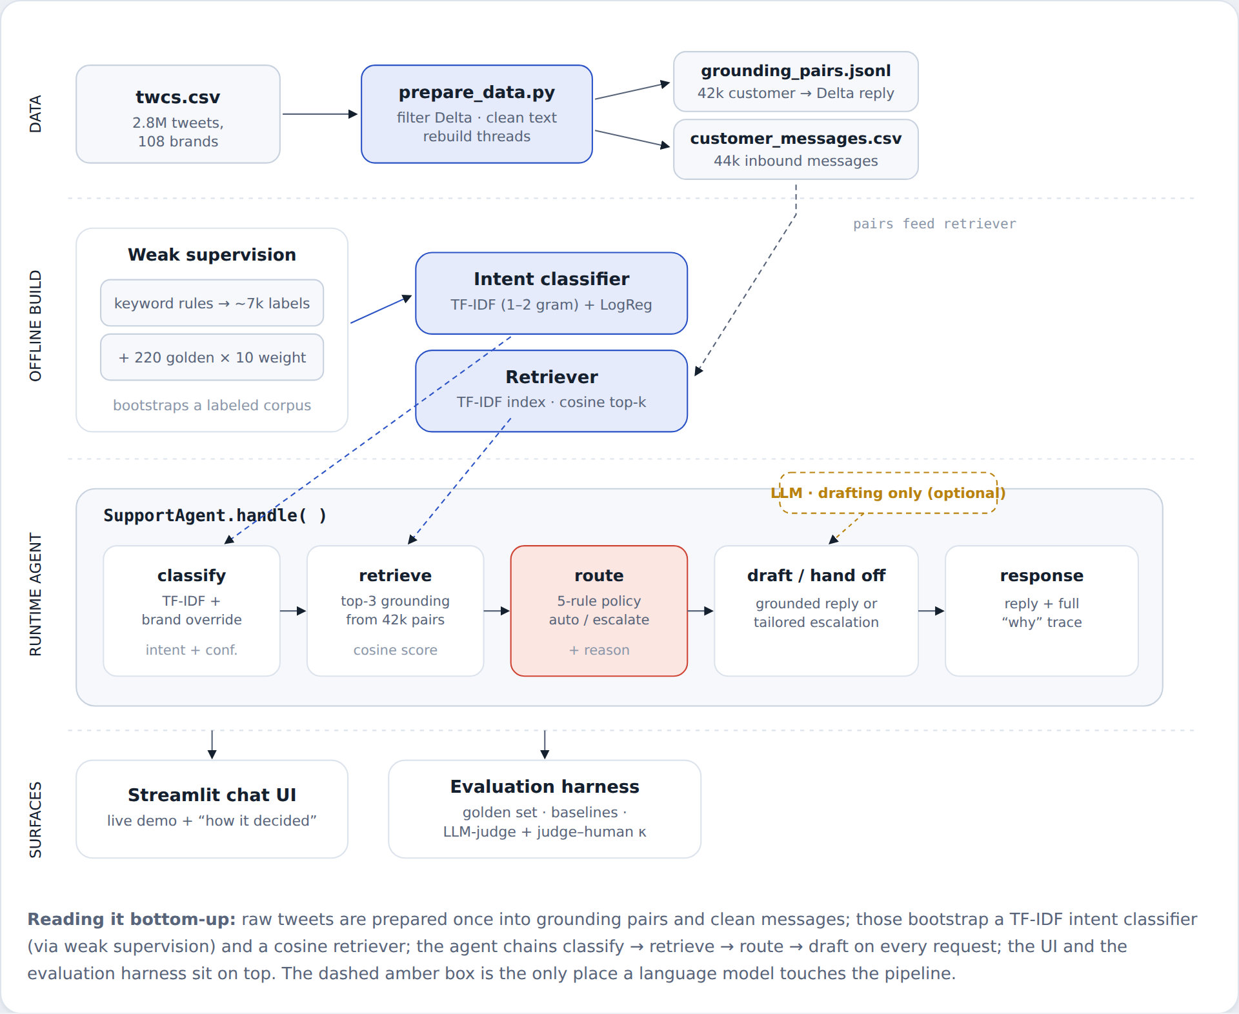
Figure 1 — End-to-end architecture. Raw tweets are prepared once into grounding pairs and clean messages; those bootstrap a TF-IDF intent classifier (via weak supervision) and a cosine retriever; SupportAgent.handle() chains classify → retrieve → route → draft on every request. The dashed amber box is the only place a language model touches the pipeline.

4. What happens when a message arrives
A single request travels left to right. Classification and retrieval only gather evidence; the router in the middle is the decision point — five rules, any one of which forces a human hand-off — and it splits the flow into the two branches that produce a reply.
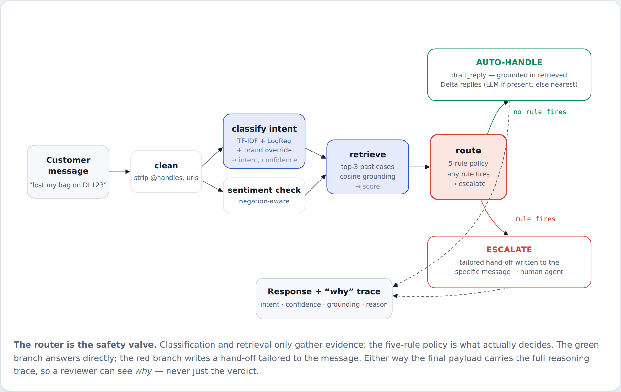
Figure 2 — Message → response workflow. The green branch answers directly from grounded history; the red branch writes a hand-off tailored to the message. Either way the payload carries the full reasoning trace.

The five escalation rules — any one forces a hand-off
- R1 Negative sentiment. A dissatisfied customer goes to a human even on an auto-OK topic. Negation-aware, so “not impressed” counts.
- R2 Risk / financial language. refund, lawsuit, terrible, discriminated, etc. trigger a hand-off regardless of confidence.
- R3 Account / transaction intent. Anything outside the AUTO_OK set (baggage, refunds, bookings…) needs a human with account access.
- R4 Low confidence. If the classifier is below conf < 0.40, the agent does not gamble.
- R5 Weak grounding. If the closest past case scores < 0.38, there is nothing safe to answer from, so it hands off instead of guessing.

5. Results vs. baselines
Everything below is measured on the 220-message golden set, each model against at least two baselines. Intent uses 5-fold out-of-fold prediction (never scored on a row it trained on); escalation is measured with oracle intents to isolate the policy from classifier error.

Task 1 — Intent classification (11 classes, accuracy & macro-F1)
Model | Accuracy | Macro-F1
Trivial baseline — majority class | 0.164 | 0.026
Simple / production — TF-IDF (1–2gram) + LogReg | 0.491 | 0.426
A 16× lift in macro-F1 over the trivial baseline. An LLM few-shot classifier was built as the third baseline; free inference endpoints were exhausted mid-run, and it had not beaten TF-IDF, so TF-IDF was kept as production and the LLM reserved for reply drafting.

Per-intent F1 — where it is strong and where it is not
Intent | F1 | Support (n)
seating | 0.76 | 29
baggage | 0.59 | 29
technology | 0.57 | 11
flight_disruption | 0.49 | 36
loyalty | 0.47 | 9
airport_gate | 0.46 | 14
other_non_actionable | 0.44 | 28
booking_fare | 0.36 | 24
service_feedback | 0.35 | 29
refund_compensation | 0.20 | 8
safety_legal | 0.00 | 3

Task 3 — Escalation decision (the part that got the most care)
Model | Acc | Auto P | Auto R | Esc P | Esc R
Trivial — escalate all | 0.691 | — | — | 0.691 | 1.000
Trivial — auto all | 0.309 | 0.309 | 1.000 | — | —
Rule-based policy (ours) | 0.786 | 0.657 | 0.647 | 0.843 | 0.849
The policy beats the strongest trivial baseline (escalate-everything, 69.1%) by ten points, while catching 84.9% of messages that truly needed a human and being right 84.3% of the time it pulls that trigger. Escalate-everything only looks respectable because the golden set is escalation-heavy — but it auto-handles nothing, so it is not an agent. Tightening the grounding rule (R5, 0.12→0.38) raised escalate-recall from 0.78 to 0.85.

Task 2 — Reply quality
Replies are scored by an LLM-as-judge on grounding, correctness, and tone, with a judge–human agreement check (Cohen’s κ) validating the judge before its scores are trusted. This task needs a live model; with free endpoints exhausted, the honest status is that the harness and rubric are in place and run on demand, but there is no headline reply-quality number to stand behind yet. What is guaranteed structurally: no reply is sent from a below-0.38 grounding match, so the failure mode of confidently pasting an unrelated historical reply is closed off by construction.

6. Failure analysis — top 5 modes, real examples & hypotheses

F1 — The long-tail intents are effectively unlearned
Example. “Is it safe to fly with my lithium battery pack in carry-on?” → classified safety_legal? No: intent = baggage (conf 0.73).
Hypothesis. safety_legal has 3 training examples and refund_compensation has 8. A linear model cannot carve a reliable boundary from single-digit support, so these classes get absorbed by lexically-similar neighbors (“carry-on” → baggage). F1 is 0.00 and 0.20 respectively.
Status / fix. Mitigated, not solved: even with the wrong intent, this message still escalated correctly (baggage is not auto-OK + grounding 0.27 < 0.38). The policy masks long-tail intent errors — but the label itself is still wrong, which would hurt any downstream routing to a specialist queue.

F2 — A co-occurring keyword pulls the linear classifier off-topic
Example. “How many SkyMiles do I need for a free checked bag?” → was classified baggage (55%), escalated, and answered with an apologetic hand-off.
Hypothesis. TF-IDF is bag-of-words: the strong bigram “checked bag” outweighed “SkyMiles,” so a pure loyalty FAQ landed on baggage. The model has no notion that SkyMiles is a near-certain loyalty signal.
Status / fix. Fixed with a small high-precision override: unambiguous brand terms (SkyMiles, Medallion, SkyClub) win outright. Now classified loyalty (auto-OK) and answered directly. A learned model would need many more examples to encode this.

F3 — Retrieval surfaces an unrelated historical reply on a weak match
Example. “Can I get a credit card discount on my next booking? I have many points on my ICICI credit card” → grounded at cosine 0.30 and (without the LLM) returned a verbatim past reply about risk-free cancellation — even carrying a stray customer name.
Hypothesis. The grounding floor was 0.12, so a 0.30 (off-topic) nearest neighbor was treated as “well-grounded” and pasted verbatim. Classic RAG failure: low similarity is still the closest, but closest ≠ relevant.
Status / fix. Fixed by raising the grounding bar to 0.38 (calibrated: genuine matches score 0.40–0.62, this one sat alone at 0.30). Below the bar the agent now escalates instead of parroting. This single threshold closes the most dangerous reply failure.

F4 — Confusable neighbor intents blur into each other
Example. “Can I change my flight to tomorrow morning?” → booking_fare (correct) but the model frequently swaps booking_fare ↔ flight_disruption and service_feedback ↔ other_non_actionable.
Hypothesis. These pairs share heavy vocabulary (a schedule change reads like a disruption; a neutral comment reads like non-actionable feedback). With ~24–29 examples each, the decision surface between them is thin. This is the main driver of the 0.49 accuracy ceiling.
Status / fix. Partly absorbed by routing (both members of each pair are handled similarly), but it caps intent quality. The real fix is more labels or an embedding model — deliberately out of scope here.

F5 — Weak-supervision blind spots leak into production labels
Example. “…many points on my ICICI credit card” still reads as loyalty because the keyword rule maps “points” → loyalty, though these are a third party’s points, not SkyMiles.
Hypothesis. The classifier inherits the biases of the keyword labeler that bootstrapped it. Any gap or over-broad rule in the ~7k weak labels becomes a systematic error the gold set is too small to fully correct.
Status / fix. Contained by the escalation policy (the message escalated anyway via weak grounding), but it shows the ceiling of weak supervision: the model is only as sharp as its labeling functions. Fix path is auditing/adding labeling functions, tracked in the decision log.

7. What is misleading about my headline number?
Mandatory section. If I had to headline one figure, it would be the escalation policy's 78.6% accuracy or the UI's per-message confidence — and both would mislead in specific ways.
- “94% confidence” in the UI is not accuracy. It is the model's own predicted probability. On held-out golden data the real intent accuracy is 49% (macro-F1 0.43). Confidence is a routing signal, not a correctness guarantee.
- The 78.6% escalation score assumes perfect intents. Task 3 is measured with oracle intents to isolate policy quality. End-to-end, classifier errors propagate into routing, so live escalation accuracy is lower than the policy's own ceiling.
- Macro-F1 averages all 11 intents equally. Two tiny-support classes (n=3, n=8) with near-zero F1 drag the mean down hard. Weighted-F1 is 0.48, and the common intents customers actually send are well above the headline — one number hides that the agent is strong where the volume is and weak in the long tail.
- Accuracy looks inflated against a 16% baseline only because the classes are imbalanced. The honest comparison is macro-F1 vs the majority baseline (0.43 vs 0.03), not raw accuracy vs chance.
The one number I would actually stand behind: escalation recall of 0.85 with 0.84 precision on the golden set — because for this brand, catching the messages that need a human is the metric that maps to real-world cost, and it is measured against human labels, not self-reported.

8. What it lacks & what I’d do next
- Modest intent accuracy (macro-F1 0.43) — fine for routing, not for unattended auto-replies at scale.
- Long tail unlearned — safety_legal and refund_compensation need either targeted labels or a small embedding classifier.
- Single-turn, no memory or account lookup — account-state messages are escalated rather than resolved.
- Reply-quality headline pending a stable LLM — the judge + κ harness is built and runs on demand; it needs a funded endpoint to produce a number.
Next steps, in priority order: (1) add ~30 labels each to the two starved intents; (2) swap TF-IDF for a small sentence-embedding classifier and re-run the same eval to measure the lift honestly; (3) fund the LLM judge and report reply grounding/correctness/tone with κ; (4) start logging live “why” traces as the data flywheel the Agent-in-the-Loop paper describes.

Reproducibility: all numbers generated from reports/ (intent_scores.csv, intent_classification_report.txt, escalation_scores.csv). Golden set n=220, TF-IDF 5-fold OOF, escalation with oracle intents. Dataset: Kaggle Customer Support on Twitter, Delta subset.

