Task1:creating a windows instance using AMI: Windows 2019

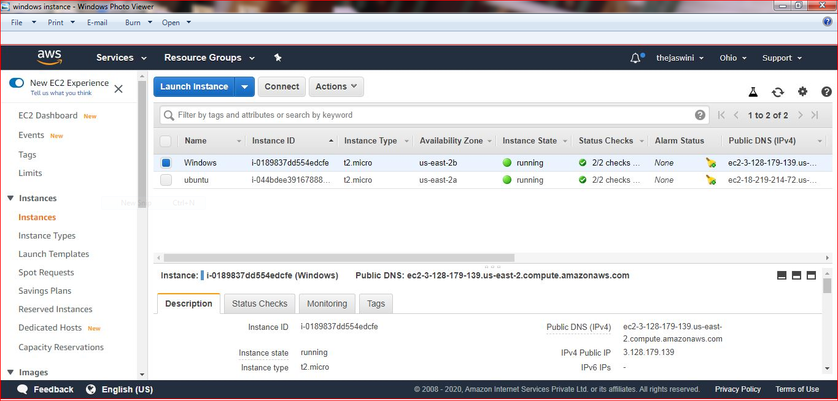

Task2:Launching windows instance using RDP

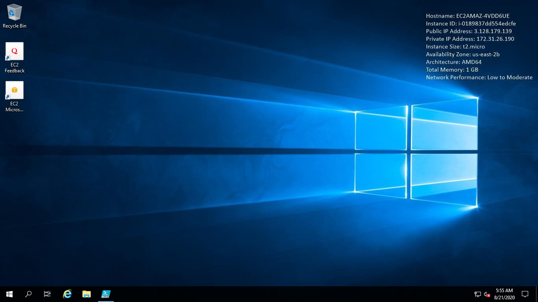

Task3:Installing IIS webserver using powershell ISE

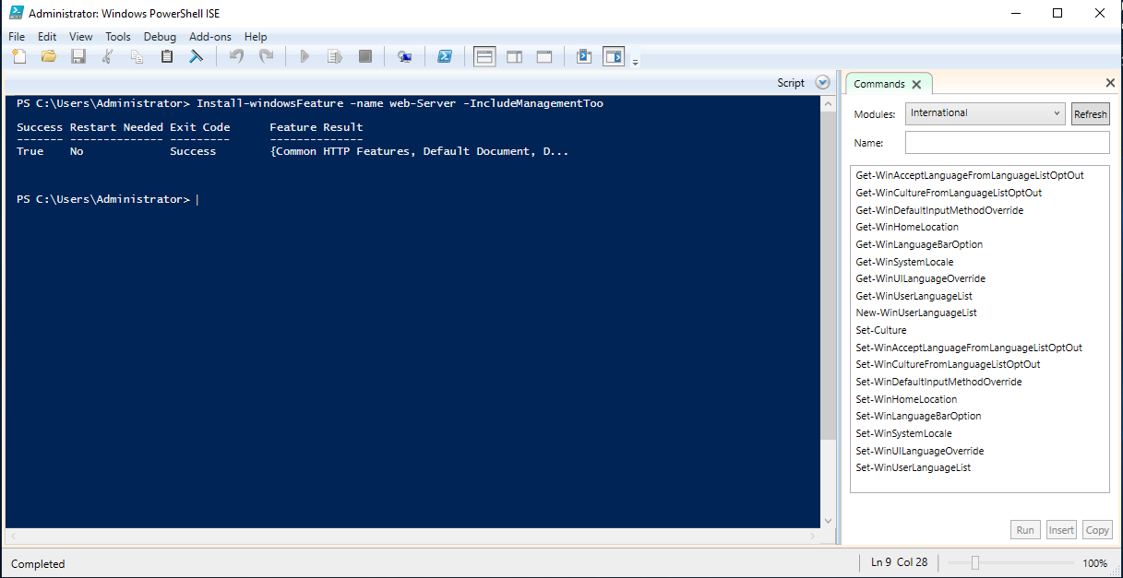

Task4: Verifying successful installation of IIS web server

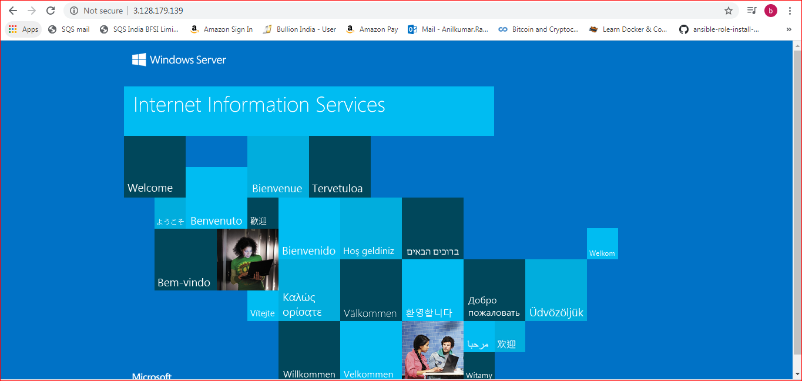

Project 2

Task 1:Creating a windows instance using AMI:Ubuntu Server 18.04 LTS(HVM)

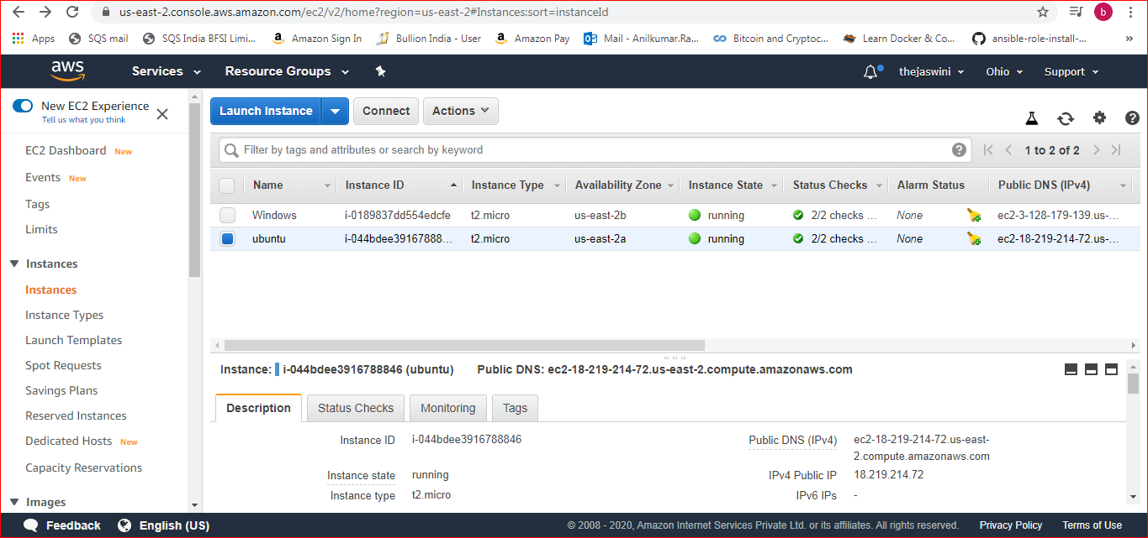

Task2:Download and install Mobaxterm portable edition

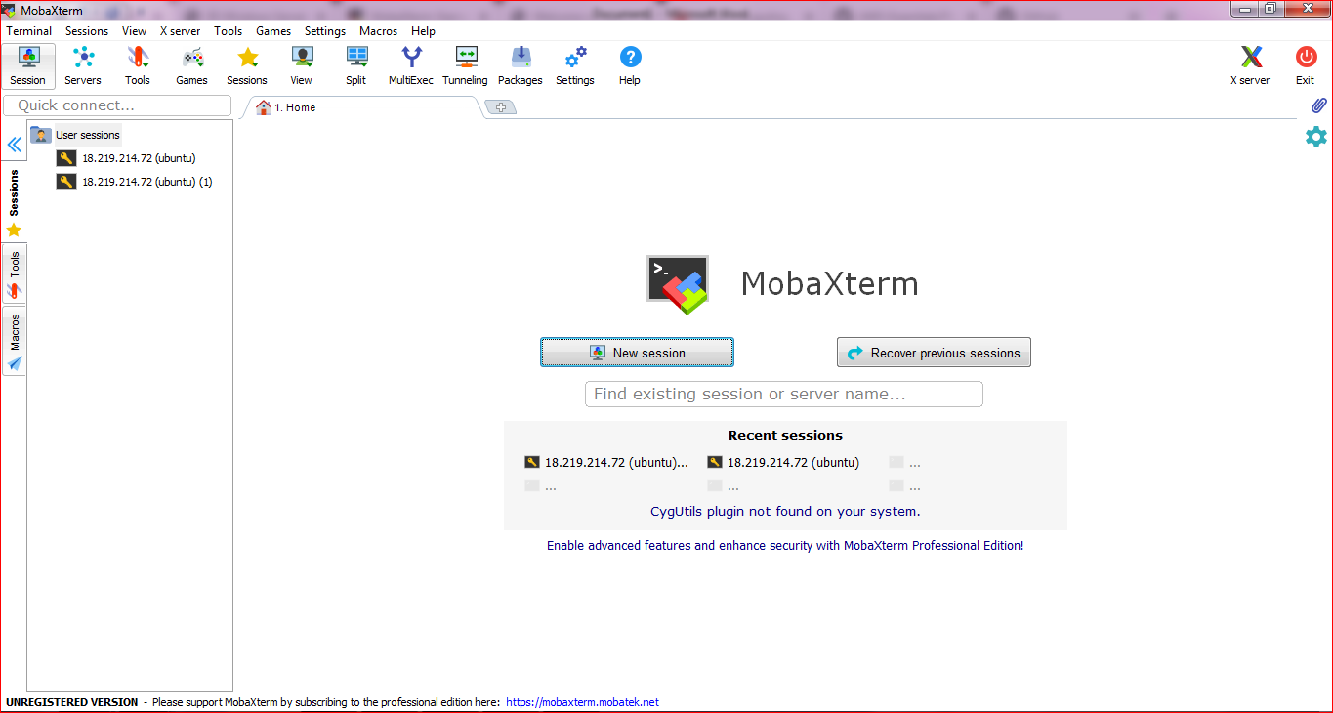

Task 3:

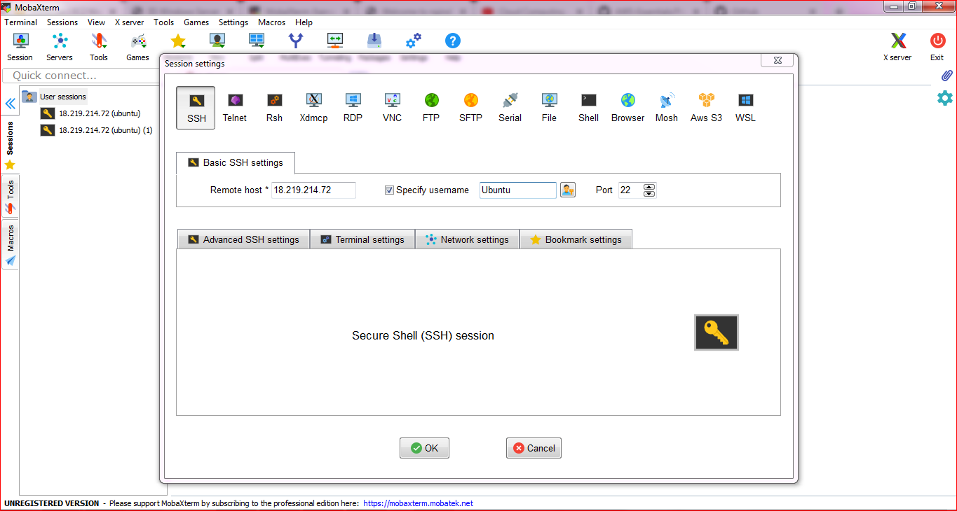

Task 4:

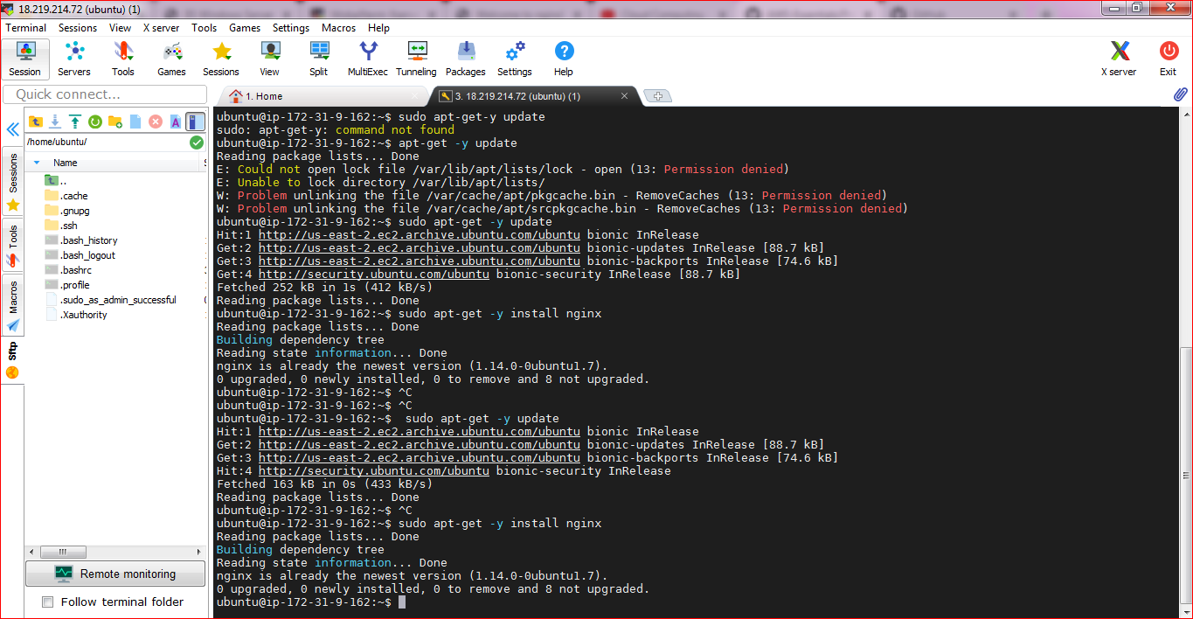

Task 5:

