Test Case Studies – DAY -1
- Design minimum 10 project or product items.

Projects
- Online Banking Management System — Manages customer accounts, fund transfers, deposits, withdrawals, and transaction history for a bank.
- Hospital Management System — Manages patient registration, doctor appointments, medical records, billing, and hospital services.
- Insurance Management System — Manages customer policies, premium payments, claims, renewals, and policy details for an insurance company.
- College Student Management System — Manages student records, course registration, attendance, marks, fees, and academic information.
- Library Management System — Manages books, student memberships, book issue/return, availability, and overdue fines.
Products
- Amazon E-Commerce Platform — Allows users to search, purchase, pay for, and track products online.
- Flipkart Online Shopping Platform — Provides product browsing, shopping cart, online payment, order tracking, and returns.
- Myntra Fashion Shopping Platform — Allows users to browse fashion products, place orders, make payments, and manage returns.
- Microsoft Teams Collaboration Platform — Provides chat, video meetings, file sharing, team collaboration, and online communication.
- Google Drive Cloud Storage Platform — Allows users to upload, store, share, download, and manage files online.

Case Study :
Black Box test case design techniques
- Equivalence Class partitioning: is done using invalid and valid conditions
Design Equivalence class partitioning for an application number filed accepts 1 to 500 digits

Case Study - 1
S. No. | Normal Test Data | Divide Values into Equivalence Classes | Test Data Using ECP
1 | First Name | Valid name / Blank value | Thejaswini / Blank
2 | Last Name | Valid name / Blank value | Random / Blank
3 | Email | Valid email format / Invalid email format / Blank value | theja@gmail.com / theja@ / Blank
4 | Phone Number | Valid phone number / Invalid phone number / Blank or incomplete value | 9876543210 / 98765 / Blank
5 | Message | Text message / Blank value | I need more information. / Blank
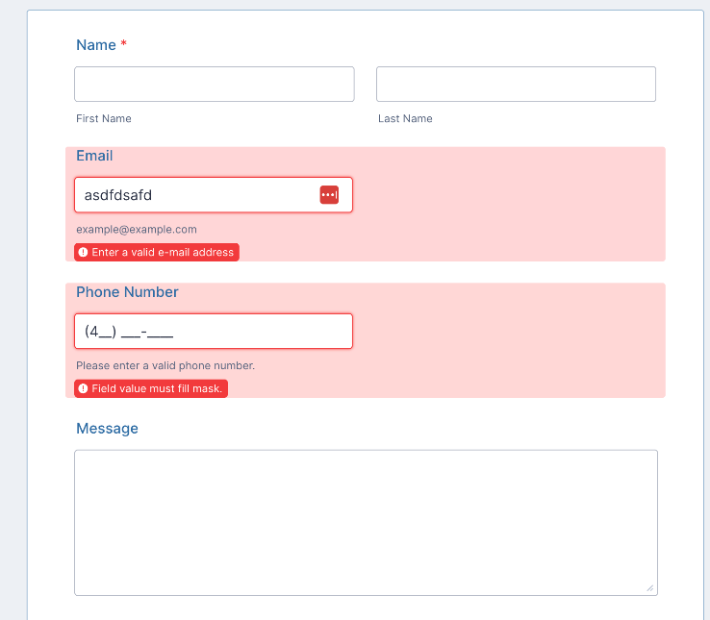

Case Study - 2

S. No. | Normal Test Data | Equivalence Class | Test Data Using ECP
1 | Phone Number | Valid phone number | 9876543210
 |  | Invalid: Number is too short | 123
 |  | Invalid: Contains non-numeric characters | abcdefghij
 |  | Invalid: Blank | Blank

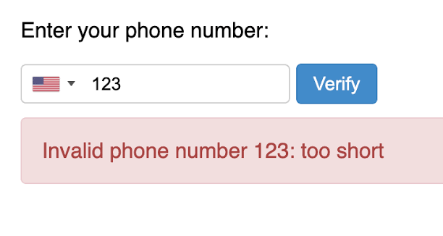

Case Study – 3

S. No. | Normal Test Data | Equivalence Class | Test Data Using ECP
1 | Name | Valid name | Thejaswini
 |  | Invalid: Blank | Blank
2 | Phone Number | Valid: Length ≤ 13 | 9876543210
 |  | Invalid: Length > 13 | 98765432101234
3 | Address | Valid: Address selected | (1) LS9 7QT
 |  | Invalid: No address selected | No selection
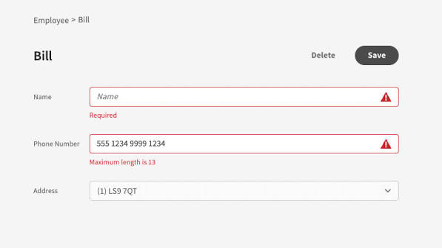

Case Study – 4
S. No. | Normal Test Data | Equivalence Class | Test Data Using ECP
1 | New Password | Acceptable password | Theja@123
 |  | Weak password | 123456
 |  | Blank password | Blank
2 | Confirm New Password | Same as New Password | Theja@123
 |  | Different from New Password | Theja@124
 |  | Blank | Blank
3 | Change My Password | Valid password and confirmation | Theja@123 / Theja@123
 |  | Invalid password or confirmation | Theja@123 / Theja@124

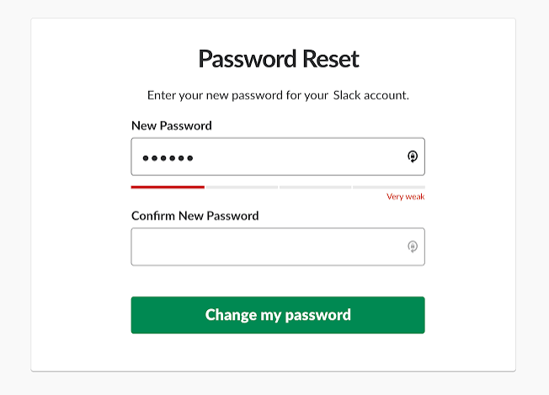
Case Study – 5
S. No. | Normal Test Data | Divide Values into Equivalence Classes | Test Data Using ECP
1 | Month (MM) | Valid month (01–12) / Invalid month / Blank | 06 / 15 / Blank
2 | Day (DD) | Valid day (01–31) / Invalid day / Blank | 15 / 35 / Blank
3 | Year (YYYY) | Valid 4-digit year / Invalid year format / Blank | 2004 / 24 / Blank
4 | Date of Birth | Valid date / Invalid date | 06/15/2004 / 02/30/2004
5 | Verify Age | Valid date entered / Invalid or incomplete date | 06/15/2004 / 06/15

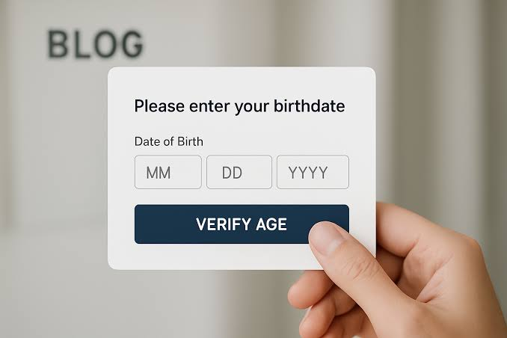

Q) Find out ECP for instance application which accepts name field, alphabets only.
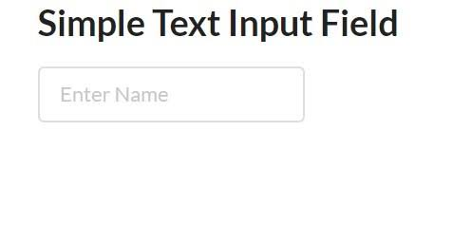
S. No. | Normal Test Data | Divide Values into Equivalence Classes | Test Data Using ECP
1 | Name | Valid – Alphabets only | Thejaswini
2 | Name | Invalid – Numeric values | 12345
3 | Name | Invalid – Special characters | @#$%
4 | Name | Invalid – Alphanumeric values | Theja123
5 | Name | Invalid – Blank value | Blank

