28-08-2026 – DAY -2 :
Q) Find out ECP and BVA for insurance application which accepts username age: 18 and 58 chars.
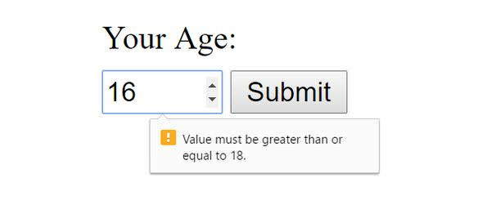
S. No. | Normal Test Data | Equivalence Class | Test Data Using ECP
1 | Username | Less than 18 characters – Invalid | 17 characters
2 | Username | Exactly 18 characters – Valid | 18 characters
3 | Username | Between 18 and 58 characters – Invalid | 30 characters
4 | Username | Exactly 58 characters – Valid | 58 characters
5 | Username | More than 58 characters – Invalid | 59 characters

BVA Condition | S. No | Condition | Status
BVA MIN | 1 | min - 1 = 17 | Failure
BVA MIN | 2 | min = 18 | Success
BVA MIN | 3 | min + 1 = 19 | Failure
BVA MAX | 4 | max - 1 = 57 | Failure
BVA MAX | 5 | max = 58 | Success
BVA MAX | 6 | max + 1 = 59 | Failure

Q) Case study for decision table: search 5 images of decision table , create conditions based on corresponding actions.
1) Decision Table – 1:
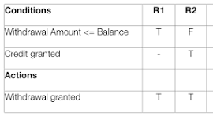
Conditions:
- Withdrawal Amount ≤ Balance
- Credit granted
Actions:
- Withdrawal granted

- Decision Table – 2:
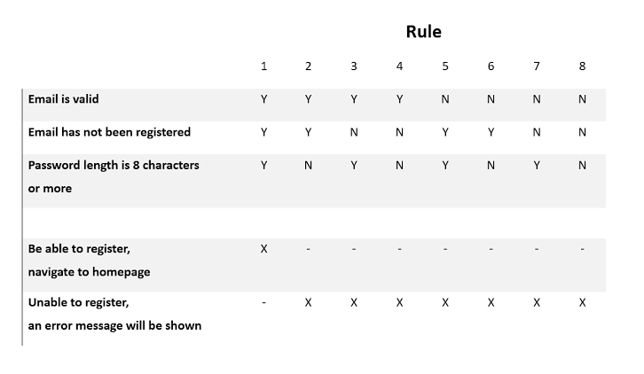
Conditions:
- Email is valid
- Email has not been registered
- Password length is 8 characters or more
Actions:
- Be able to register and navigate to homepage
- Unable to register; an error message will be shown

Decision Table – 3:
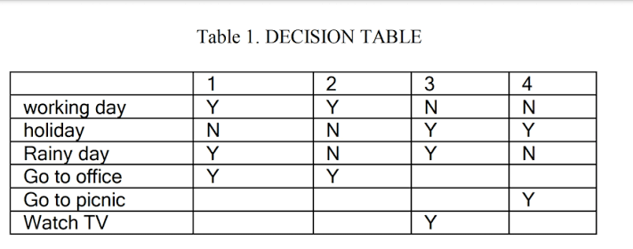
Conditions:
- Working day
- Holiday
- Rainy day
Actions:
- Go to office
- Go to picnic
- Watch TV

Decision Table - 4:
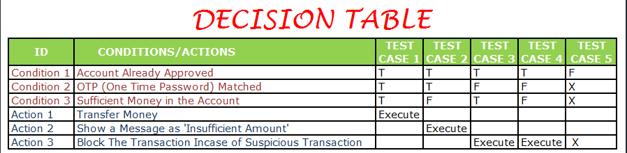

Conditions:
- Account Already Approved
- OTP (One Time Password) Matched
- Sufficient Money in the Account
Actions:
- Transfer Money
- Show a message as "Insufficient Amount"
- Block the Transaction in case of Suspicious Transaction

Decision Table – 5:
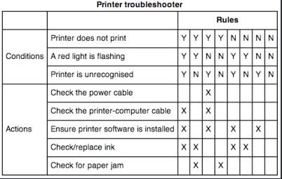
Conditions:
- Printer does not print
- A red light is flashing
- Printer is unrecognised
Actions:
- Check the power cable
- Check the printer-computer cable
- Ensure printer software is installed
- Check/replace ink

Q) Case Study: State transition technique: find out min 5 images from browser , identify state transition techniques.
State Transition – 1:
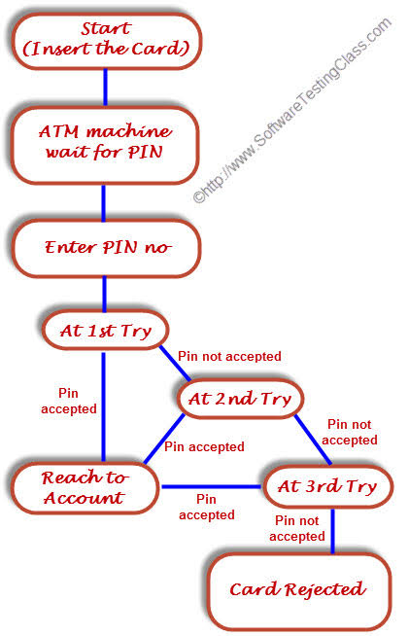
States:
Start (Insert Card) → ATM waits for PIN → Enter PIN → At 1st Try → At 2nd Try → At 3rd Try → Reach to Account / Card Rejected
- Valid Transition: Correct PIN at any attempt → Reach to Account
- Invalid Transition: Incorrect PIN at 1st or 2nd attempt → Next PIN attempt
- Final Transition: Incorrect PIN at 3rd attempt → Card Rejected

State Transition – 2:
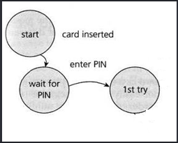
States: Start → Wait for PIN → 1st Try
- Valid Transition: Card inserted → Wait for PIN
- Valid Transition: Enter PIN → 1st Try
- Input/Event: Card inserted / Enter PIN → Next State

State Transition – 3:
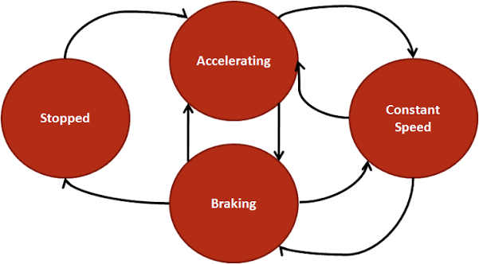
States:
Stopped → Accelerating → Constant Speed → Braking → Stopped
- Valid Transition: Vehicle starts moving from Stopped → Accelerating
- Valid Transition: Vehicle reaches a steady speed → Accelerating → Constant Speed
- Valid Transition: Vehicle slows down → Constant Speed → Braking
- Valid Transition: Vehicle comes to a complete stop → Braking → Stopped
- Final Transition: Vehicle reaches Stopped state after braking → Stopped

State Transition – 4:
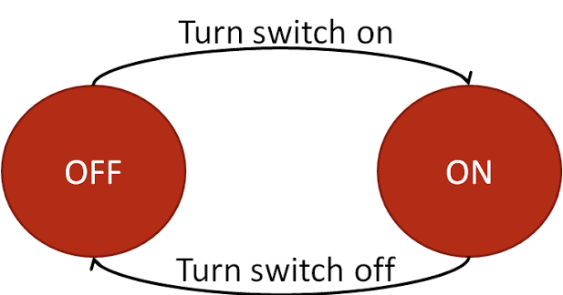
States:
OFF → ON → OFF
- Valid Transition: Turn switch on → OFF → ON
- Valid Transition: Turn switch off → ON → OFF
- State Transition: Switch is turned on and off repeatedly → OFF ↔ ON

State Transition – 5:
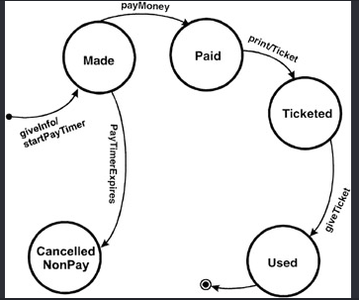
States: Made → Paid → Ticketed → Used / Cancelled NonPay
- Valid Transition: GiveInfo / StartPayTimer → Made
- Valid Transition: PayMoney → Paid
- Valid Transition: PrintTicket → Ticketed
- Valid Transition: GiveTicket → Used
- Invalid/Cancelled Transition: PayTimer Expires → Cancelled NonPay
- Final State: Used → End

Defect Report : Create minimum 5 defects and note it in excel sheet

