Software Architecture and Design Specification
Project: Student Attendance Management System (SAMS)
Version: 1.0
Authors: Venkatesh, Vishal, V Sai Sri Saketh, Thejaswini
Date: 15-09-2026
Status: Draft – Architecture/design derived from SRS

Revision History
Version | Date | Author | Change Summary | Approval
1.0 | 15-09-2026 | Project Team | Initial SAD derived from SAMS SRS | Pending

Approvals
Role | Name | Signature / Email | Date
Course Coordinator | Pavithra

1. Introduction

1.1 Purpose
This Software Architecture and Design Specification (SAD) defines the proposed architecture, component structure, interfaces, data responsibilities, security design, and key interaction flows for the Student Attendance Management System (SAMS). It translates the requirements in the SRS into a coherent implementation-oriented design without changing the stated scope.

1.2 Scope
The design covers authentication and role-based access; student and faculty management; subject and class-session management; attendance recording and authorized modification; attendance percentage calculation; attendance history/status viewing; and administrative management. The SRS states that internal institutional academic-management systems and unrelated administrative processes are outside scope.

1.3 Audience
Students, faculty members, system administrators, developers, QA engineers, and assessment evaluators.

1.4 Definitions
SAMS – Student Attendance Management System; Student – registered user whose attendance is monitored; Faculty – authorized user responsible for classes and attendance; Administrator – authorized system-level manager; Attendance Record – stored status for a student in a class session; RBAC – role-based access control.

2. Document Overview
This SAD contains the proposed architecture, component decomposition, architecture rationale, technology/data-store constraints derived from the SRS, risks and mitigations, requirements traceability, security architecture, design flows, API contracts, error handling, UX considerations, and open implementation decisions.

2.1 Related Document
Primary source: Software Requirements Specification (SRS), Student Attendance Management System, Version 1.0, dated 09-09-2026.

2.2 Design Assumptions and Boundaries
- The SRS specifies a web-based application or institutional network environment and a relational database.
- The SRS requires HTTPS between client and server.
- The SRS does not specify a programming language, web framework, database vendor, deployment platform, or authentication token/session technology; these remain implementation decisions.
- The architecture below is a proposed design derived from the SRS, not an additional requirement.

3. Architecture

3.1 Goals & Constraints
Primary architectural goals are derived from the SRS:
- Security: authenticated access, RBAC, protected credentials, and protection of attendance/user data.
- Performance: 95% of normal requests within 3 seconds and support for at least 100 concurrent users.
- Availability: at least 99% availability during scheduled operating hours.
- Reliability and integrity: attendance data must remain accurate and protected from loss/corruption.
- Maintainability: modular components should be independently changeable where possible.
- Usability: separate role-based dashboards with clear and consistent navigation.
Constraints include network connectivity, database availability, authorized attendance modification, and the SRS requirement that no specialized hardware is needed.

3.2 Stakeholders & Concerns
Stakeholder | Primary Concern | Architectural Response
Students | Secure, simple access to attendance, percentage, and history | Role-based dashboard; read-focused attendance APIs
Faculty Members | Correct class/subject access and controlled attendance recording/modification | Authorization checks before attendance operations
Administrators | User, subject, configuration and record management | Dedicated management components and RBAC
Developers / QA | Modularity and testability | Separated components and explicit interfaces
Assessment Evaluators | Traceability and correctness | Requirement-to-component/test-case mapping

3.3 Architectural Style
Proposed architecture: <b>Layered (three-tier) architecture</b>. This choice is a design interpretation of the SRS's centralized web application, role-specific dashboards, relational database, security controls, and maintainability requirement.
Layers:
- Presentation Layer – web interface and role-specific dashboards for students, faculty members, and administrators.
- Business/Application Layer – authentication/RBAC, user management, academic management, attendance management, and attendance calculation/history.
- Data Layer – relational persistence for users, students, faculty, subjects, class sessions, and attendance records.
The layered structure keeps authorization and attendance rules in the application layer rather than relying only on the UI, while keeping persistent data access behind the data layer.

3.4 Architecture Overview Diagram
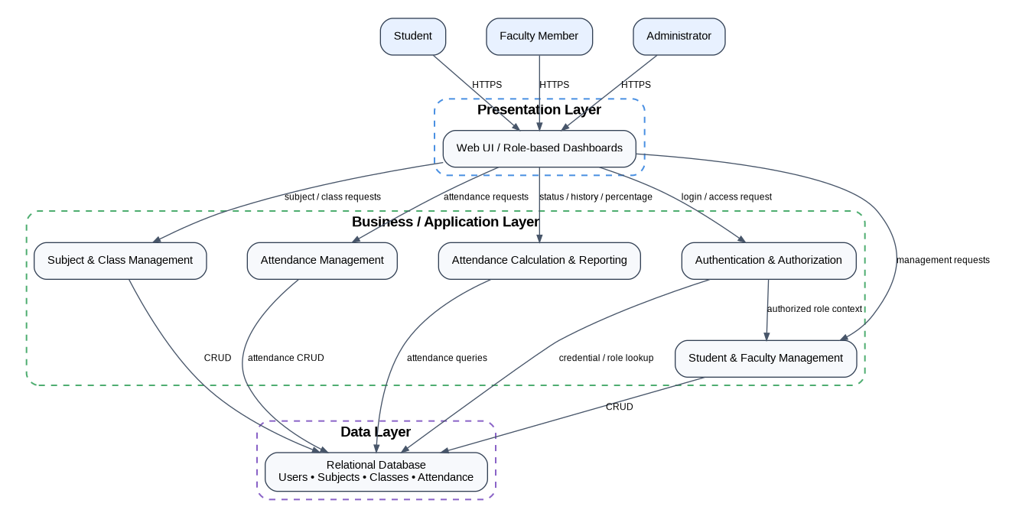
Figure 1. Proposed layered architecture for SAMS.

3.5 Component (UML) Diagram
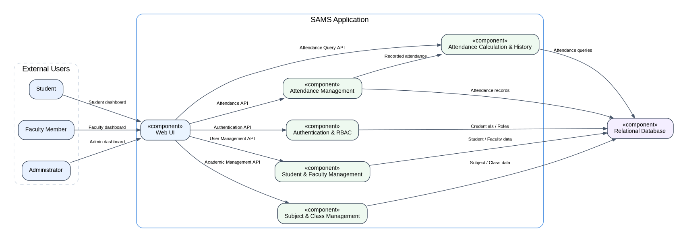
Figure 2. Proposed component structure and interfaces.

3.6 Component Descriptions
Component | Responsibility | Key SRS Coverage
Web UI | Role-specific dashboards; input/output; navigation; display of attendance, reports, and management functions | SRS 3.1; F-001–F-003; F-006; F-010; F-012; F-017
Authentication & RBAC | Validate username/password, establish authenticated access, enforce role permissions | F-001–F-003; SR-001–SR-002
Student & Faculty Management | Add, update, and view student/faculty information with authorization | F-004–F-010
Subject & Class Management | Manage subjects, faculty-subject assignments, and class sessions | F-011–F-013
Attendance Management | Record and modify attendance only for authorized users and valid class sessions | F-014–F-015; SR-003; NFR-005
Attendance Calculation & History | Calculate percentage and provide attendance status/history views | F-016–F-017
Relational Database | Persist users, roles, students, faculty, subjects, class sessions, and attendance records | SRS 2.1, 3.3; F-004–F-017

3.7 Interfaces & Dependencies
Interface | Provider | Consumer | Purpose
Authentication API | Authentication & RBAC | Web UI | Login validation and access result
User Management API | Student & Faculty Management | Web UI | Student/faculty add, update, and view operations
Academic Management API | Subject & Class Management | Web UI | Subject, assignment, and class-session operations
Attendance API | Attendance Management | Web UI | Record and authorized modification of attendance
Attendance Query API | Attendance Calculation & History | Web UI | Percentage, history, and status retrieval
Persistence Interfaces | Relational Database | Application components | CRUD/query operations for stored records
Authorization Dependency | Authentication & RBAC | Protected application components | Supplies authenticated role context before protected operations

3.8 Chosen Architecture Pattern and Rationale
Layered architecture is appropriate because the SRS describes a centralized web application with three distinct concerns: role-specific user interaction, business rules for attendance and access control, and relational data persistence. It also aligns directly with SAMS-NFR-006, which requires modular components that can be updated without affecting unrelated modules. The design avoids introducing distributed microservices, message brokers, or external services that are not required by the SRS.

3.9 Technology Stack & Data Stores
The SRS specifies a standard web browser, server environment, and relational database, but does not specify concrete vendors or frameworks. Therefore, the SAD intentionally does not invent a mandatory technology stack. The implementation shall provide: a web frontend, an application/server layer, a relational database, and HTTPS communication. The specific programming language, framework, database product, hosting environment, and authentication/session mechanism are TBD by the project team.

3.10 Risks & Mitigations
Risk | Impact | Mitigation / Design Response
Unauthorized attendance modification | High | Enforce RBAC and authorization in the application layer; students cannot modify attendance.
Credential compromise | High | Use HTTPS and secure password storage; do not store plaintext passwords.
Database failure or corruption | High | Use transactional database operations, integrity constraints, and an operational backup/recovery strategy.
Network connectivity failure | Medium | Return clear errors to the UI and avoid partial attendance updates; retry strategy may be added at implementation.
High concurrent usage | Medium | Load-test for 100 concurrent users; optimize application/database queries and use connection management appropriate to the chosen stack.
Incorrect attendance percentage | High | Calculate from persisted attendance records using a single defined calculation service and test against TC-Attendance-03.

3.11 Traceability to Requirements
Requirement(s) | Design Component(s) | Test Reference
SAMS-F-001–F-003 | Authentication & RBAC | TC-Auth-01/02/03
SAMS-F-004–F-007 | Student & Faculty Management + RBAC | TC-Student-01/02/03/04
SAMS-F-008–F-010 | Student & Faculty Management + RBAC | TC-Faculty-01/02/03
SAMS-F-011–F-013 | Subject & Class Management | TC-Subject-01/02; TC-Class-01
SAMS-F-014–F-015 | Attendance Management + RBAC | TC-Attendance-01/02
SAMS-F-016–F-017 | Attendance Calculation & History | TC-Attendance-03/04
SAMS-NFR-001–NFR-002 | Web UI + Application + Database | TC-NFR-01/02
SAMS-NFR-003 | Application/Deployment environment | TC-NFR-03
SAMS-NFR-004 | Web UI | TC-NFR-04
SAMS-NFR-005 | Attendance Management + Database | TC-NFR-05
SAMS-NFR-006 | Component-based architecture | TC-NFR-06
SAMS-SR-001–SR-005 | Authentication & RBAC + Database | TC-Sec-01–05

3.12 Security Architecture
Security controls are derived directly from the SRS security objectives and requirements:
- Authentication boundary: protected system functions require successful login (SAMS-SR-001).
- RBAC: students, faculty members, and administrators receive only their permitted functions (SAMS-SR-002).
- Attendance authorization: students are explicitly prevented from modifying attendance records (SAMS-SR-003).
- Credential protection: passwords must use secure password storage mechanisms and must not be stored in plaintext (SAMS-SR-004).
- Data protection: attendance and user data must be protected from unauthorized access or modification (SAMS-SR-005).
- Transport security: HTTPS is required between client and server by the SRS.
- Defense in depth: authorization is enforced in application services, not solely by hiding UI controls.
The SRS does not prescribe a particular hashing algorithm, token format, key-management solution, or WAF; those are implementation decisions and should be documented when selected.

4. Design

4.1 Design Overview
The design uses modular application components behind a web UI. Requests enter through the UI, are authenticated/authorized, are routed to the relevant business component, and are persisted or queried through the relational database. Attendance operations are separated from calculation/history functions so that recording rules and reporting logic remain independently testable.

4.2 UML Sequence Diagrams
The following two flows are derived from the SRS authentication and attendance requirements.
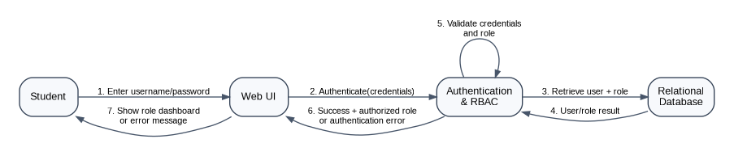
Figure 3. Sequence – User authentication and role-based access.
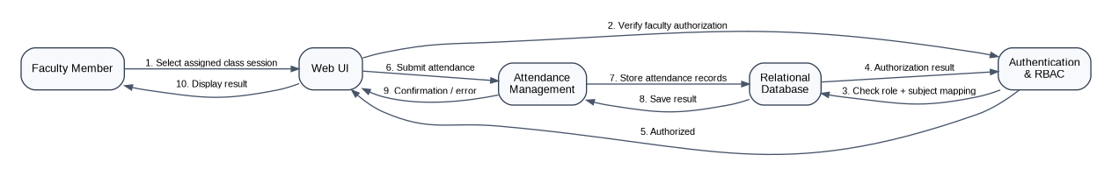
Figure 4. Sequence – Faculty records attendance for a class session.

4.3 API Design
The SRS specifies a web interface and application functions but does not define endpoint names. The following are proposed REST-style interfaces for implementation; they are design contracts and can be renamed to match the final implementation.
Interface / Endpoint | Method | Purpose | Authorization | Representative Response / Error
/api/auth/login | POST | Authenticate username/password | Public login endpoint | Success: authenticated role; Error: invalid credentials
/api/students | GET/POST | View/add student records | Faculty/Admin for view; Admin for add | Student data; Error: unauthorized/validation
/api/faculty | GET/POST | View/add faculty records | Authorized roles; Admin for add | Faculty data; Error: unauthorized/validation
/api/subjects | GET/POST | View/manage subjects | Faculty/Admin as applicable | Subject data; Error: unauthorized/validation
/api/classes | GET/POST | View/create class sessions | Faculty for assigned subjects; Admin as applicable | Class-session data; Error: unauthorized/validation
/api/attendance | POST/PATCH | Record or modify attendance | Authorized faculty / permitted admin | Confirmation; Error: unauthorized/invalid session
/api/attendance/{studentId} | GET | View attendance history/status/percentage | Student for self; authorized Faculty/Admin | Attendance history and percentage

4.4 Error Handling, Logging & Monitoring
The SRS explicitly requires appropriate error handling when network connectivity is unavailable and defines acceptance behavior for invalid login, unauthorized modification, and other operations. The design therefore uses consistent application errors and avoids committing partial attendance changes.
- Authentication failure → return a generic invalid-credentials message; do not reveal whether a username exists.
- Authorization failure → deny the operation and return an appropriate unauthorized/forbidden response.
- Invalid attendance operation → reject the request without corrupting existing records.
- Database/network failure → return a controlled error and ensure no incomplete attendance transaction is treated as successful.
- Logging/monitoring details are not specified in the SRS. As an implementation recommendation, log operational events and failures without passwords or other sensitive credentials, and monitor response time, availability, authentication failures, and attendance-operation errors.
- Performance acceptance shall include 95% of normal requests within 3 seconds and at least 100 concurrent users, matching SAMS-NFR-001 and SAMS-NFR-002.

4.5 UX Design
The SRS requires separate dashboards for students, faculty members, and administrators with clear navigation for attendance marking, attendance viewing, reports, and user management. The UI shall therefore expose only the functions relevant to the authenticated role and provide direct access to the most common role-specific tasks.

4.6 Data Design
The SRS requires a relational database and identifies the major information domains. The proposed logical data groups are:
Data Entity / Group | Key Information | Used By
User / Role | Login identity and assigned role | Authentication & RBAC
Student | Student profile and academic identity | Student Management, Attendance
Faculty | Faculty information and assignment | Faculty Management, Academic Management
Subject | Subject/course details | Academic Management
Faculty-Subject Mapping | Which subjects are assigned to faculty | Academic Management, Authorization
Class Session | Scheduled session for a subject | Academic Management, Attendance
Attendance Record | Student + class session + attendance status | Attendance, Calculation & History
The exact relational schema, primary/foreign keys, indexes, normalization choices, and database vendor are not defined in the SRS and should be specified during detailed database design.

4.7 Open Issues & Next Steps
- Select the implementation technology stack (language/framework/database) because the SRS does not prescribe one.
- Define the deployment topology for the institutional network/web environment.
- Finalize authentication/session or token mechanism while preserving the SRS security requirements.
- Define the relational database schema, integrity constraints, and indexes.
- Define exact REST endpoint paths, request/response schemas, and HTTP status codes.
- Define backup/recovery targets and detailed monitoring once the deployment environment is known.
- Update the RTM design-specification references from SRS sections to final component/API names after implementation.

5. Appendices

5.1 Glossary
SAMS – Student Attendance Management System; RBAC – Role-Based Access Control; SRS – Software Requirements Specification; SAD – Software Architecture and Design Specification; HTTPS – secure HTTP communication; Attendance Percentage – attended classes as a percentage of total conducted classes.

5.2 References
Primary reference: Student Attendance Management System – SRS, Version 1.0, dated 09-09-2026.

5.3 Tools
Diagram generation in this draft: Graphviz. Final UML diagrams may be redrawn in draw.io, StarUML, Lucidchart, or another UML tool.

