PROJECT DOCUMENTATION
Student Performance Analytics System

1. Project Title
Project: Student Performance Analytics System
Student Name: C.Thejaswini
AICTE Student ID: STU69b52638032e21773479480
Course: Python with AI, EWB Courses

2. Objective
The objective of this project is to build a Python program that reads student records and automatically analyses their academic performance. Calculating totals, averages, grades and results by hand for a whole class is slow and error-prone. This project solves that by producing a complete, accurate report in seconds, including class statistics, subject-wise performance and top performers.

3. Technologies Used
- Python 3 - core programming (variables, data types, loops, functions, conditions)
- NumPy - numerical calculations such as mean, maximum, minimum and conditional logic
- Pandas - reading the CSV file, DataFrame operations, filtering, sorting and grouping
- Git and GitHub - version control and project submission

4. Dataset Description
The dataset is stored in students.csv and contains 25 student records. Marks are out of 100 and attendance is a percentage.
Column | Description
Roll_No | Unique student ID
Name | Student name
Department | Department of the student (CSE, CSE-AI, CSE-AIML, ECE, EEE, Mech, Civil)
English | Marks in English
Maths | Marks in Maths
DBMS | Marks in DBMS
Attendance | Attendance percentage

5. Implementation
- Data loading: pandas.read_csv() loads students.csv into a DataFrame. A try/except block shows a friendly message if the file is missing. The data, number of students and column names are displayed.
- Processing with functions: functions.py contains reusable functions - calculate_total(), calculate_average(), calculate_grade(), check_result() and get_performance_level(). main.py applies them to the DataFrame to create the Total, Average, Grade, Performance and Result columns.
- Pass/fail rule: the pass mark is 40 in each subject. A student passes overall only when all three subjects are passed. NumPy's np.where() applies this condition across all students.
- Grading rule: A+ (90 and above), A (80-89), B (70-79), C (60-69), D (50-59), E (40-49), F (below 40), based on the average marks.
- Loops: a for loop with iterrows() prints each student's marks, total, average, grade and result; another loop prints the top 3 students with their ranks.
- Analysis with NumPy: np.mean(), np.max() and np.min() give the class average and the highest and lowest averages; idxmax() and idxmin() identify the top and bottom students.
- Subject-wise analysis: subject averages, the best subject, and pass/fail counts per subject.
- Additional analysis: average attendance, number of students below 75% attendance, and department-wise average marks using Pandas groupby().
- Final output: a formatted report and a complete analysis table are printed to the console.

6. Key Features
- Reads and validates a CSV dataset with Pandas
- Reusable functions kept in a separate file (functions.py)
- Total, average, grade and performance level for each student
- Subject-wise and overall pass/fail results
- Class average, highest and lowest performer
- Subject-wise averages and best-performing subject
- Top 3 students ranking
- Attendance summary and department-wise averages

7. Output / Screenshots
Final analysis produced by running python main.py:
============================================================
STUDENT PERFORMANCE ANALYTICS SYSTEM
============================================================
Roll_No Name Department English Maths DBMS Attendance
0 2 P Keerthi CSE-AIML 95 89 90 87
1 1 C Thejaswini CSE 87 85 84 94
2 3 C.M.Prathibha CSE 93 85 89 85
3 4 T Jahnavi CSE 81 90 82 80
4 5 Yashwanth MK CSE-AI 89 90 92 84
5 6 A Ravi ECE 77 65 73 85
6 7 C Pravallika EEE 25 67 39 78
7 8 B Anjali Mech 82 56 61 71
8 9 K Arjun Civil 31 34 45 67
9 10 S Latha CSE 88 82 90 93
10 11 V Madhumitha CSE-AI 82 45 26 78
11 12 N pradeep CSE 78 62 75 82
12 13 K Balu ECE 72 34 49 67
13 14 M jwala EEE 56 49 56 76
14 15 C prabhudhev ECE 67 39 59 40
15 16 C Monisha CSE 82 76 79 86
16 17 C Anjali Mech 74 67 82 77
17 18 A Prakash Civil 87 65 78 35
18 19 D Rajesh EEE 88 21 47 63
19 20 M Prabhakar CSE 71 48 59 76
20 21 L Guna ECE 87 67 65 89
21 22 A Meghana Civil 89 45 66 72
22 23 A Hanipriya CSE 88 91 89 92
23 24 B Manohar ECE 72 43 61 82
24 25 P Hasini EEE 29 37 44 57

************************************************************
DATASET INFORMATION
************************************************************
Total Students: 25
Total Subjects: 3

Available Columns:
['Roll_No', 'Name', 'Department', 'English', 'Maths', 'DBMS', 'Attendance']

************************************************************
STUDENT PERFORMANCE
************************************************************
2 | P Keerthi | English: 95 (PASS) | Maths: 89 (PASS) | DBMS: 90 (PASS) | Total: 274 | Average: 91.33 | Grade: S | Overall: PASS
1 | C Thejaswini | English: 87 (PASS) | Maths: 85 (PASS) | DBMS: 84 (PASS) | Total: 256 | Average: 85.33 | Grade: A | Overall: PASS
3 | C.M.Prathibha | English: 93 (PASS) | Maths: 85 (PASS) | DBMS: 89 (PASS) | Total: 267 | Average: 89.00 | Grade: A | Overall: PASS
4 | T Jahnavi | English: 81 (PASS) | Maths: 90 (PASS) | DBMS: 82 (PASS) | Total: 253 | Average: 84.33 | Grade: A | Overall: PASS
5 | Yashwanth MK | English: 89 (PASS) | Maths: 90 (PASS) | DBMS: 92 (PASS) | Total: 271 | Average: 90.33 | Grade: S | Overall: PASS
6 | A Ravi | English: 77 (PASS) | Maths: 65 (PASS) | DBMS: 73 (PASS) | Total: 215 | Average: 71.67 | Grade: B | Overall: PASS
7 | C Pravallika | English: 25 (FAIL) | Maths: 67 (PASS) | DBMS: 39 (PASS) | Total: 131 | Average: 43.67 | Grade: E | Overall: FAIL
8 | B Anjali | English: 82 (PASS) | Maths: 56 (PASS) | DBMS: 61 (PASS) | Total: 199 | Average: 66.33 | Grade: C | Overall: PASS
9 | K Arjun | English: 31 (FAIL) | Maths: 34 (FAIL) | DBMS: 45 (PASS) | Total: 110 | Average: 36.67 | Grade: E | Overall: FAIL
10 | S Latha | English: 88 (PASS) | Maths: 82 (PASS) | DBMS: 90 (PASS) | Total: 260 | Average: 86.67 | Grade: A | Overall: PASS
11 | V Madhumitha | English: 82 (PASS) | Maths: 45 (PASS) | DBMS: 26 (FAIL) | Total: 153 | Average: 51.00 | Grade: D | Overall: FAIL
12 | N pradeep | English: 78 (PASS) | Maths: 62 (PASS) | DBMS: 75 (PASS) | Total: 215 | Average: 71.67 | Grade: B | Overall: PASS
13 | K Balu | English: 72 (PASS) | Maths: 34 (FAIL) | DBMS: 49 (PASS) | Total: 155 | Average: 51.67 | Grade: D | Overall: FAIL
14 | M jwala | English: 56 (PASS) | Maths: 49 (PASS) | DBMS: 56 (PASS) | Total: 161 | Average: 53.67 | Grade: D | Overall: PASS
15 | C prabhudhev | English: 67 (PASS) | Maths: 39 (PASS) | DBMS: 59 (PASS) | Total: 165 | Average: 55.00 | Grade: D | Overall: PASS
16 | C Monisha | English: 82 (PASS) | Maths: 76 (PASS) | DBMS: 79 (PASS) | Total: 237 | Average: 79.00 | Grade: B | Overall: PASS
17 | C Anjali | English: 74 (PASS) | Maths: 67 (PASS) | DBMS: 82 (PASS) | Total: 223 | Average: 74.33 | Grade: B | Overall: PASS
18 | A Prakash | English: 87 (PASS) | Maths: 65 (PASS) | DBMS: 78 (PASS) | Total: 230 | Average: 76.67 | Grade: B | Overall: PASS
19 | D Rajesh | English: 88 (PASS) | Maths: 21 (FAIL) | DBMS: 47 (PASS) | Total: 156 | Average: 52.00 | Grade: D | Overall: FAIL
20 | M Prabhakar | English: 71 (PASS) | Maths: 48 (PASS) | DBMS: 59 (PASS) | Total: 178 | Average: 59.33 | Grade: D | Overall: PASS
21 | L Guna | English: 87 (PASS) | Maths: 67 (PASS) | DBMS: 65 (PASS) | Total: 219 | Average: 73.00 | Grade: B | Overall: PASS
22 | A Meghana | English: 89 (PASS) | Maths: 45 (PASS) | DBMS: 66 (PASS) | Total: 200 | Average: 66.67 | Grade: C | Overall: PASS
23 | A Hanipriya | English: 88 (PASS) | Maths: 91 (PASS) | DBMS: 89 (PASS) | Total: 268 | Average: 89.33 | Grade: A | Overall: PASS
24 | B Manohar | English: 72 (PASS) | Maths: 43 (PASS) | DBMS: 61 (PASS) | Total: 176 | Average: 58.67 | Grade: D | Overall: PASS
25 | P Hasini | English: 29 (FAIL) | Maths: 37 (PASS) | DBMS: 44 (PASS) | Total: 110 | Average: 36.67 | Grade: E | Overall: FAIL

************************************************************
FINAL ANALYSIS
************************************************************

CLASS STATISTICS
------------------------------------------------------------
Total Students : 25
Class Average : 67.76
Highest Average : 91.33
Lowest Average : 36.67

PASS / FAIL STATISTICS
------------------------------------------------------------
Passed Students : 19
Failed Students : 6
Passing Mark : 35

SUBJECT-WISE PASS / FAIL
------------------------------------------------------------
English - Passed : 22
English - Failed : 3
Maths - Passed : 22
Maths - Failed : 3
DBMS - Passed : 24
DBMS - Failed : 1

ATTENDANCE STATISTICS
------------------------------------------------------------
Average Attendance : 75.84%
Below 75% Attendance : 8

HIGHEST PERFORMING STUDENT
------------------------------------------------------------
Name : P Keerthi
Student ID : 2
Average : 91.33
Grade : S
Overall Result : PASS

LOWEST PERFORMING STUDENT
------------------------------------------------------------
Name : K Arjun
Student ID : 9
Average : 36.67
Grade : E
Overall Result : FAIL

SUBJECT-WISE PERFORMANCE
------------------------------------------------------------
English Average : 74.80
Maths Average : 61.28
DBMS Average : 67.20

Best Performing Subject: English

TOP 3 PERFORMING STUDENTS
------------------------------------------------------------
1. P Keerthi - Average: 91.33 - Grade: S - Result: PASS
2. Yashwanth MK - Average: 90.33 - Grade: S - Result: PASS
3. A Hanipriya - Average: 89.33 - Grade: A - Result: PASS

************************************************************
BRANCH-WISE REPORT
************************************************************

------------------------------------------------------------
BRANCH: CSE
Strength: 8 | Passed: 8 | Failed: 0 | Branch Average: 80.58
------------------------------------------------------------
Roll_No Name English Maths DBMS Attendance Total Average Grade Result
1 C Thejaswini 87 85 84 94 256 85.33 A PASS
3 C.M.Prathibha 93 85 89 85 267 89.00 A PASS
4 T Jahnavi 81 90 82 80 253 84.33 A PASS
10 S Latha 88 82 90 93 260 86.67 A PASS
12 N pradeep 78 62 75 82 215 71.67 B PASS
16 C Monisha 82 76 79 86 237 79.00 B PASS
20 M Prabhakar 71 48 59 76 178 59.33 D PASS
23 A Hanipriya 88 91 89 92 268 89.33 A PASS

------------------------------------------------------------
BRANCH: CSE-AI
Strength: 2 | Passed: 1 | Failed: 1 | Branch Average: 70.67
------------------------------------------------------------
Roll_No Name English Maths DBMS Attendance Total Average Grade Result
5 Yashwanth MK 89 90 92 84 271 90.33 S PASS
11 V Madhumitha 82 45 26 78 153 51.00 D FAIL

------------------------------------------------------------
BRANCH: CSE-AIML
Strength: 1 | Passed: 1 | Failed: 0 | Branch Average: 91.33
------------------------------------------------------------
Roll_No Name English Maths DBMS Attendance Total Average Grade Result
2 P Keerthi 95 89 90 87 274 91.33 S PASS

------------------------------------------------------------
BRANCH: Civil
Strength: 3 | Passed: 2 | Failed: 1 | Branch Average: 60.00
------------------------------------------------------------
Roll_No Name English Maths DBMS Attendance Total Average Grade Result
9 K Arjun 31 34 45 67 110 36.67 E FAIL
18 A Prakash 87 65 78 35 230 76.67 B PASS
22 A Meghana 89 45 66 72 200 66.67 C PASS

------------------------------------------------------------
BRANCH: ECE
Strength: 5 | Passed: 4 | Failed: 1 | Branch Average: 62.00
------------------------------------------------------------
Roll_No Name English Maths DBMS Attendance Total Average Grade Result
6 A Ravi 77 65 73 85 215 71.67 B PASS
13 K Balu 72 34 49 67 155 51.67 D FAIL
15 C prabhudhev 67 39 59 40 165 55.00 D PASS
21 L Guna 87 67 65 89 219 73.00 B PASS
24 B Manohar 72 43 61 82 176 58.67 D PASS

------------------------------------------------------------
BRANCH: EEE
Strength: 4 | Passed: 1 | Failed: 3 | Branch Average: 46.50
------------------------------------------------------------
Roll_No Name English Maths DBMS Attendance Total Average Grade Result
7 C Pravallika 25 67 39 78 131 43.67 E FAIL
14 M jwala 56 49 56 76 161 53.67 D PASS
19 D Rajesh 88 21 47 63 156 52.00 D FAIL
25 P Hasini 29 37 44 57 110 36.67 E FAIL

------------------------------------------------------------
BRANCH: Mech
Strength: 2 | Passed: 2 | Failed: 0 | Branch Average: 70.33
------------------------------------------------------------
Roll_No Name English Maths DBMS Attendance Total Average Grade Result
8 B Anjali 82 56 61 71 199 66.33 C PASS
17 C Anjali 74 67 82 77 223 74.33 B PASS

BRANCH SUMMARY
------------------------------------------------------------
Branch Strength Passed Failed Average
CSE 8 8 0 80.58
CSE-AI 2 1 1 70.67
CSE-AIML 1 1 0 91.33
Civil 3 2 1 60.00
ECE 5 4 1 62.00
EEE 4 1 3 46.50
Mech 2 2 0 70.33

COMPLETE ANALYSIS TABLE
============================================================
Roll_No Name Department English English_Result Maths Maths_Result DBMS DBMS_Result Attendance Total Average Grade Result
2 P Keerthi CSE-AIML 95 PASS 89 PASS 90 PASS 87 274 91.333333 S PASS
1 C Thejaswini CSE 87 PASS 85 PASS 84 PASS 94 256 85.333333 A PASS
3 C.M.Prathibha CSE 93 PASS 85 PASS 89 PASS 85 267 89.000000 A PASS
4 T Jahnavi CSE 81 PASS 90 PASS 82 PASS 80 253 84.333333 A PASS
5 Yashwanth MK CSE-AI 89 PASS 90 PASS 92 PASS 84 271 90.333333 S PASS
6 A Ravi ECE 77 PASS 65 PASS 73 PASS 85 215 71.666667 B PASS
7 C Pravallika EEE 25 FAIL 67 PASS 39 PASS 78 131 43.666667 E FAIL
8 B Anjali Mech 82 PASS 56 PASS 61 PASS 71 199 66.333333 C PASS
9 K Arjun Civil 31 FAIL 34 FAIL 45 PASS 67 110 36.666667 E FAIL
10 S Latha CSE 88 PASS 82 PASS 90 PASS 93 260 86.666667 A PASS
11 V Madhumitha CSE-AI 82 PASS 45 PASS 26 FAIL 78 153 51.000000 D FAIL
12 N pradeep CSE 78 PASS 62 PASS 75 PASS 82 215 71.666667 B PASS
13 K Balu ECE 72 PASS 34 FAIL 49 PASS 67 155 51.666667 D FAIL
14 M jwala EEE 56 PASS 49 PASS 56 PASS 76 161 53.666667 D PASS
15 C prabhudhev ECE 67 PASS 39 PASS 59 PASS 40 165 55.000000 D PASS
16 C Monisha CSE 82 PASS 76 PASS 79 PASS 86 237 79.000000 B PASS
17 C Anjali Mech 74 PASS 67 PASS 82 PASS 77 223 74.333333 B PASS
18 A Prakash Civil 87 PASS 65 PASS 78 PASS 35 230 76.666667 B PASS
19 D Rajesh EEE 88 PASS 21 FAIL 47 PASS 63 156 52.000000 D FAIL
20 M Prabhakar CSE 71 PASS 48 PASS 59 PASS 76 178 59.333333 D PASS
21 L Guna ECE 87 PASS 67 PASS 65 PASS 89 219 73.000000 B PASS
22 A Meghana Civil 89 PASS 45 PASS 66 PASS 72 200 66.666667 C PASS
23 A Hanipriya CSE 88 PASS 91 PASS 89 PASS 92 268 89.333333 A PASS
24 B Manohar ECE 72 PASS 43 PASS 61 PASS 82 176 58.666667 D PASS
25 P Hasini EEE 29 FAIL 37 PASS 44 PASS 57 110 36.666667 E FAIL

************************************************************
ANALYSIS COMPLETED SUCCESSFULLY
************************************************************

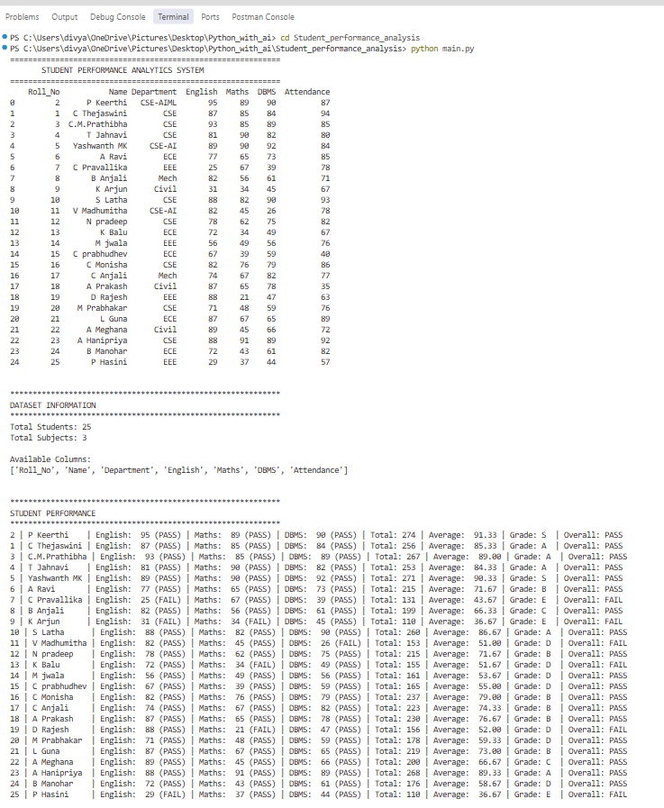
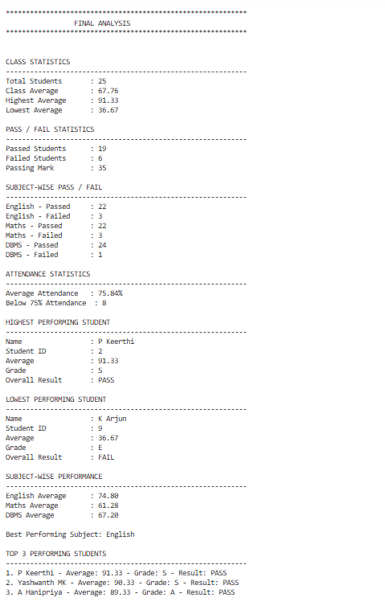
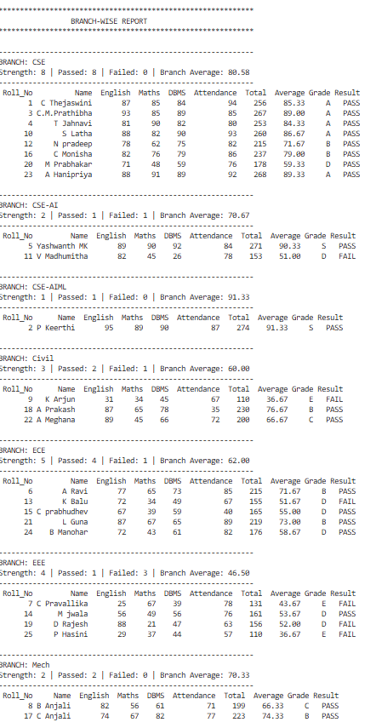
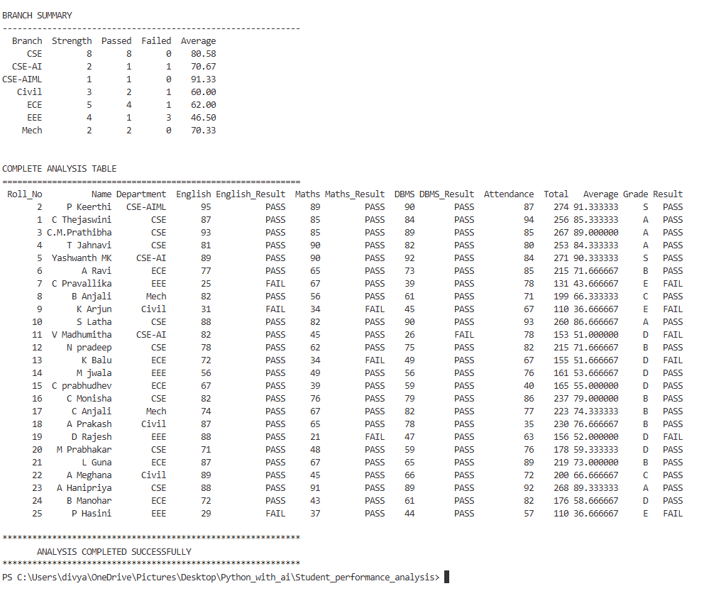

8. Final Outcome
The project runs successfully and produces a clear, complete analysis of 25 students. Results: class average 67.76; highest average 91.33 (P Keerthi); lowest average 36.67 (K Arjun and P Hasini); 18 students passed and 7 failed; English is the best-performing subject (average 74.80) and Maths the weakest (61.28). The top three students are P Keerthi, Yashwanth MK and A Hanipriya. All required features of the assignment were implemented.

9. Challenges & Learning
- Challenge: some rows in students.csv were missing the Department value, which shifted the columns and gave wrong marks for 11 students. Solution: I found the problem by inspecting the DataFrame, then corrected the CSV so every row has all 7 columns. Learning: always inspect data after loading it.
- Challenge: a variable-name typo in functions.py (English_marks_marks) would have caused a NameError. Solution: renamed the parameters and tested the function. Learning: test every function.
- Challenge: the pass mark was inconsistent (35 in one place, 40 in another). Solution: defined a single PASS_MARK constant in functions.py and used it everywhere. Learning: keep rules in one place.
- Learning: using NumPy for numerical work, Pandas for tabular data, and functions to keep code reusable and readable.

10. GitHub Repository
Repository link: GitHub - thejaswini1707/Python_with_ai · GitHub

