Q1.What is the use of JDBC in java?

Ans : The JDBC API is a Java API that can access any kind of tabular data, especially data stored in a relational database. JDBC helps you to write Java applications that manage these three programming activities: Connect to a data source, like a database. Send queries and update statements to the database.

Q2.What are the steps involved in JDBC?

Ans : Here is the 7 step process to create a Java JDBC connection:

* Import the packages: ...
* Register the drivers: ...
* Establish a connection: ...
* Create a statement: ...
* Execute the query: ...
* Retrieve results: ...
* Close the connections:

Q3.What are the types of statement in JDBC in java?

Ans : There are basically three types of statements in JDBC: Create statements, Prepared statements, Callable statements.

* Create Statement
* Prepared Statementssss
* Callable Statement

Q4.What is Servlet in Java?

Ans : A servlet is a Java programming language class that is used to extend the capabilities of servers that host applications accessed by means of a request-response programming model. Although servlets can respond to any type of request, they are commonly used to extend the applications hosted by web servers. For such applications, Java Servlet technology defines HTTP-specific servlet classes.

Q5.Explain the life Cycle of servlet?

Ans : The web container maintains the life cycle of a servlet instance. Let's see the life cycle of the servlet:

1. Servlet class is loaded.
2. Servlet instance is created.
3. init method is invoked.
4. service method is invoked.
5. destroy method is invoked.

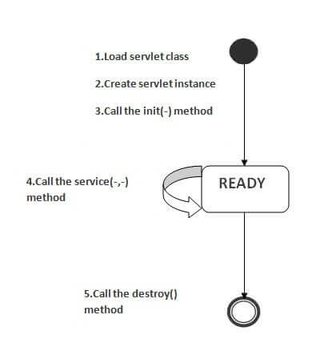

1) Servlet class is loaded

The classloader is responsible to load the servlet class. The servlet class is loaded when the first request for the servlet is received by the web container.

2) Servlet instance is created

The web container creates the instance of a servlet after loading the servlet class. The servlet instance is created only once in the servlet life cycle.

3) init method is invoked

|  |
| --- |
| The web container calls the init method only once after creating the servlet instance. The init method is used to initialize the servlet. It is the life cycle method of the javax.servlet.Servlet interface. Syntax of the init method is given below: |

1. public void init(ServletConfig config) throws ServletException

4) service method is invoked

The web container calls the service method each time when request for the servlet is received. If servlet is not initialized, it follows the first three steps as described above then calls the service method. If servlet is initialized, it calls the service method. Notice that servlet is initialized only once. The syntax of the service method of the Servlet interface is given below:

public void service(ServletRequest request, ServletResponse response)

throws ServletException, IOException

5) destroy method is invoked

The web container calls the destroy method before removing the servlet instance from the service. It gives the servlet an opportunity to clean up any resource for example memory, thread etc. The syntax of the destroy method of the Servlet interface is given below:

1. public void destroy()

Q6.Explain the difference between the RequestDispatcher.forward() and HttpServletResponse.sendRedirect() methods?

Ans :

|  |  |
| --- | --- |
| forward() method | sendRedirect() method |
| The forward() method works at server side. | The sendRedirect() method works at client side. |
| It sends the same request and response objects to another servlet. | It always sends a new request. |
| It can work within the server only. | It can be used within and outside the server. |
| Example: request.getRequestDispacher("servlet2").forward(request,response); | Example: response.sendRedirect("servlet2"); |

Q7.What is the purpose of the doGet() and doPost() methods in a servlet?

Ans : The doGet method is called by the server (via the service method) when the client requests a GET request. It is used to retrieve information from the server. The doPost method is called by the server (via the service method) when the client requests a POST request. It is used to send information to the server.

Q8.Explain the JSP Model-View-Controller (MVC) architecture.

Ans : MVC stands for Model View and Controller. It is a design pattern that separates the business logic, presentation logic and data.

Controller acts as an interface between View and Model. Controller intercepts all the incoming requests.

Model represents the state of the application i.e. data. It can also have business logic.

View represents the presentaion i.e. UI(User Interface).

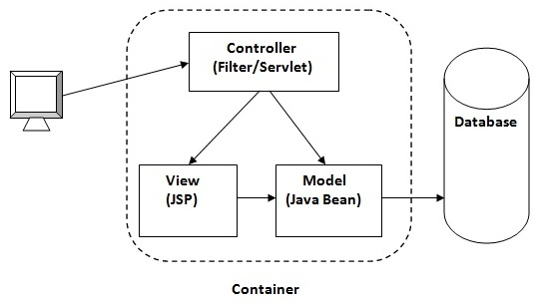

Q9.What are some of the advantages of Servlets?

Ans : Advantages of servlets

A [servlet](https://ecomputernotes.com/servlet/intro/servlet) can be imagined to be as an applet running on the server side. Some of the other server side technologies available are [Common Gateway Interface](https://ecomputernotes.com/html/tutorial/common-gateway-interface) (CGI), server side JavaScript and Active Server Pages (ASP). Advantages of servlets over these server side technologies are as follows:

• Persistent: Servlets remain in [memory](https://ecomputernotes.com/fundamental/input-output-and-memory/memory) until explicitly destroyed. This helps in serving several incoming requests. Servlets establishes connection only once with the [database](https://ecomputernotes.com/fundamental/what-is-a-database/advantages-and-disadvantages-of-dbms) and can handle several requests on the same [database](https://ecomputernotes.com/fundamental/what-is-a-database/advantages-and-disadvantages-of-dbms). This reduces the time and resources required to establish connection again and again with the same database. Whereas, CGI programs are removed from the [memory](https://ecomputernotes.com/fundamental/input-output-and-memory/memory) once the request is processed and each time a new process is initiated whenever new request arrives.

• Portable: Since servlets are written in Java, they are portable. That is, servlets are compatible with almost all operating systems. The programs written on one [operating system](https://ecomputernotes.com/fundamental/disk-operating-system/what-is-operating-system) can be executed on other [operating system](https://ecomputernotes.com/fundamental/disk-operating-system/what-is-operating-system).

• Server-independent: Servlets are compatible with any web server available today. Most of the software vendors today support servlets within their web server products. On the other hand, some of the server side technologies like server side JavaSricpt and ASP can run on only selected web servers. The CGI is compatible with the web server that has features to supports it.

• [Protocol](https://ecomputernotes.com/computernetworkingnotes/computer-network/protocol)-independent: Servlets can be created to support any of the protocols like FTP commands, Telnet sessions, NNTP newsgroups, etc. It also provides extended support for the functionality of HTTP [protocol](https://ecomputernotes.com/computernetworkingnotes/computer-network/protocol).

• Extensible: Servlets being written in Java, can be extended and polymorphed into the objects that suits the user requirement.

• Secure: Since servlets are server side programs and can be invoked by web server only, they inherit all the security measures taken by the web server. They are also safe from the problems related to memory management as Java does not support the concept of pointers and perform garbage collection automatically.

• Fast: Since servlets are compiled into bytecodes, they can execute more quickly as compared to other scripting languages. The bytecode compilation feature helps servlets to give much better performance. In addition, it also provides advantage of strong error and type checking.

Q10.What are the limitations of JSP?

Ans : Disadvantages of using JSP

* It is very difficult for developers to perform database connectivity in JSP.
* As the JSP is compiled on the server, it is not memory and time-efficient.
* It is hard to track errors in JSP files because they are an extension to Servlets.
* As JSP is an HTML file, it doesn't provide many features.