AI Assignment

Assignment submitted to
Graduate School at
The University of Arkansas at Little Rock

in partial fulfillment of
requirements for the graduate course of
202510 Spring: Data Science - Technologies (9U1)

in

March 2025

by
Deepak Singla

Instructors
Dr. Elizabeth Pierce
and
Dr. Serhan Dagtas

ABSTRACT

This assignment covers three very important aspects of AI

Introduction to AI
AI Ethics
AI Concepts

These courses have been taken from CognitiveClass.ai. These completions of courses have been shown below by taking screenshots of the progress of the course. CognitiveClass.ai has not release the quiz in these courses yet so there won’t be any completion certificates.

User account in CognitiveClass.ai is thejavascriptways as appears on top right corner of the images below.

Introducing AI

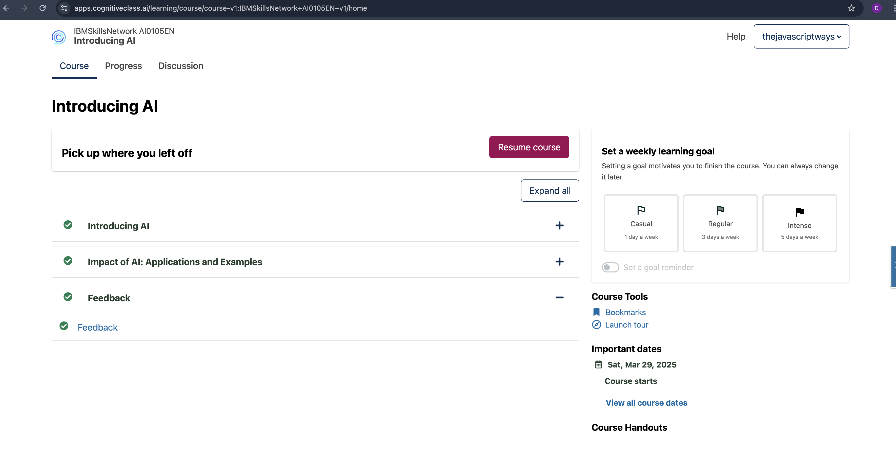

AI Ethics

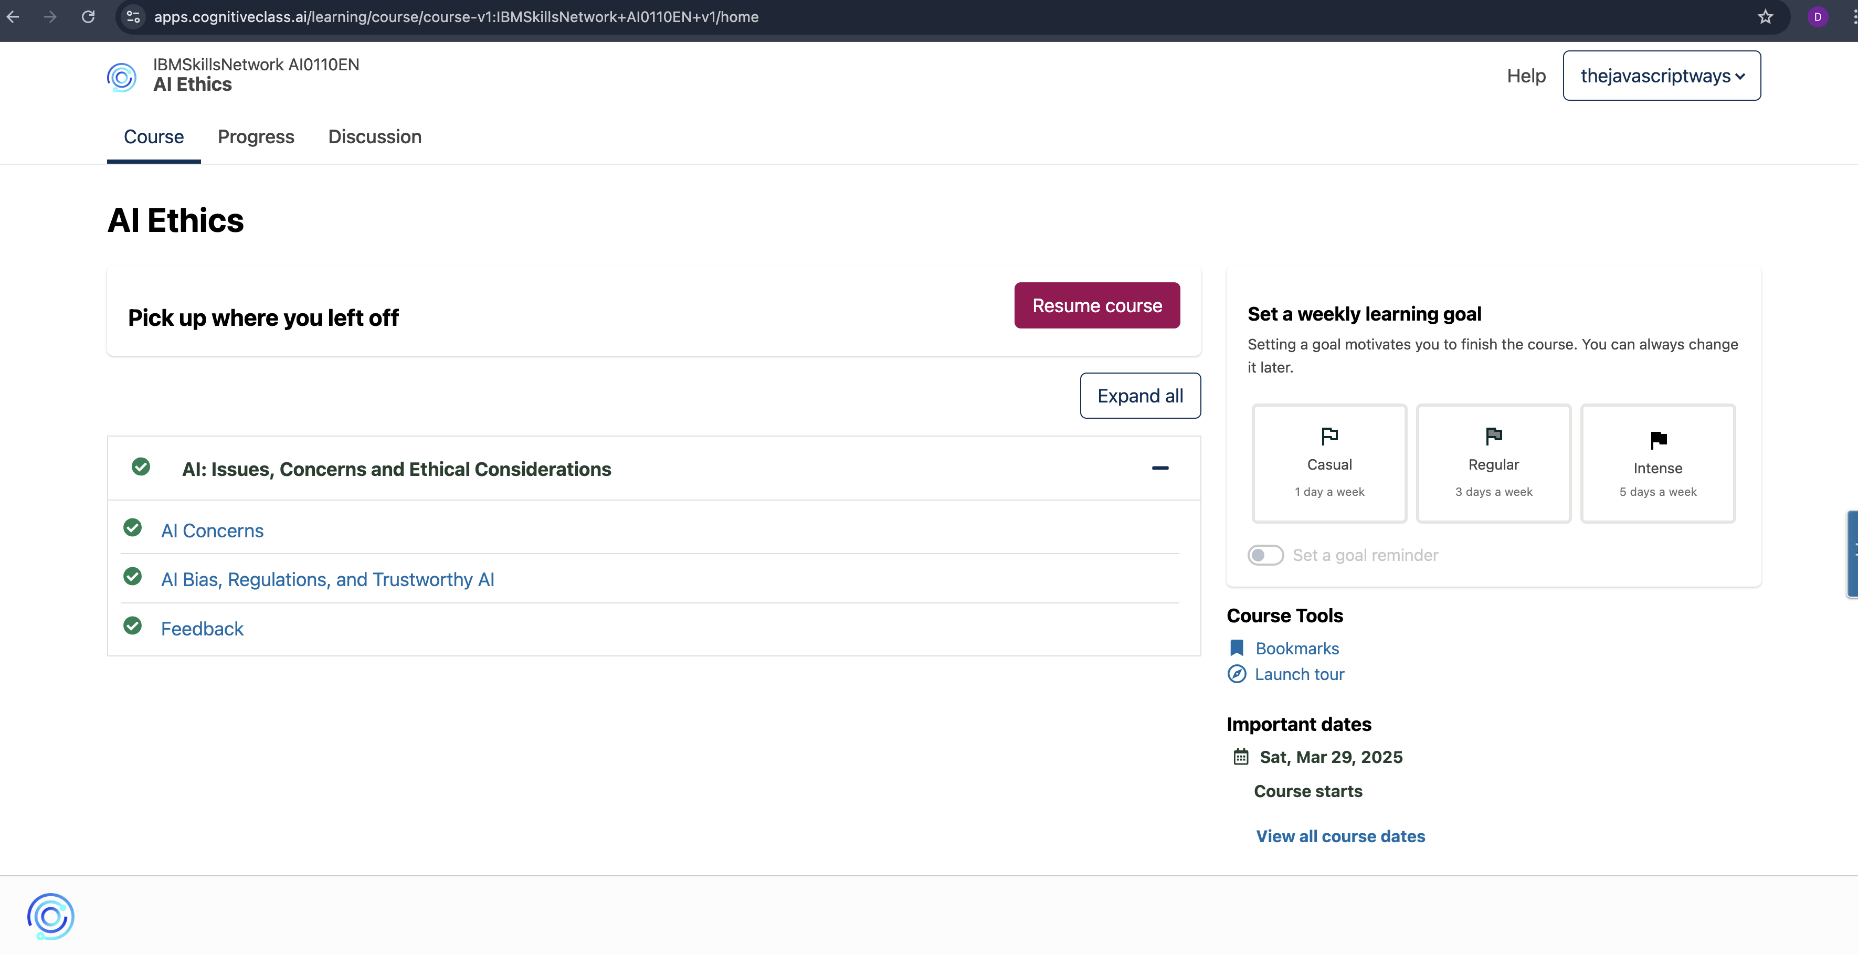

AI Concepts

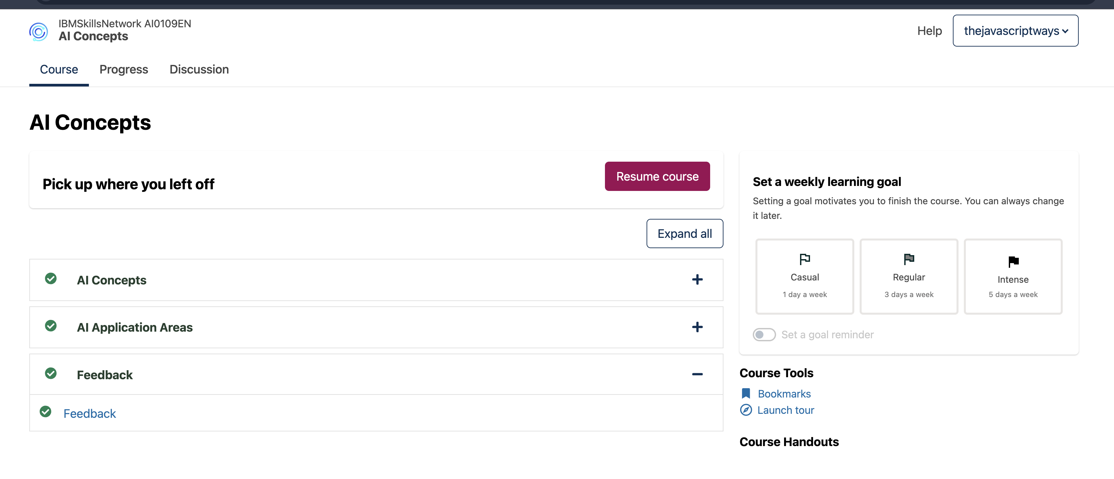

Credits

Report format has been copied from

https://www.proquest.com/pqdtlocal1009983/docview/2902800999/fulltextPDF/C967C462E7DF4DF2PQ/1?%20Theses&accountid=14482&sourcetype=Dissertations%20

Other References

https://cognitiveclass.ai/courses

