Quiz of Intelligence
Software Requirements Specification

Version 1.0



Group Id: <F190235AE7>
Supervisor Name : <Hafiz Muhammad Azeem Sarwar>

Revision History

Date (dd/mm/yyyy) | Version | Description | Author
09/12/19 | 1.0 | This document consists of the scope, functional and non-functional requirements, use case diagram and usage scenarios of the “Quiz of Intelligence” | Jawad Ali  bc160401965

Table of Contents

- Scope (of the project)
- Functional Requirements Non Functional requirements
- Use Case Diagram
- Usage Scenarios
- Adopted Methodology
- Work Plan (Use MS Project to create Schedule/Work Plan)

SRS Document

1. Scope of Project:

Quiz of intelligence is designed for educational purpose. This application will help students to go beyond their normal curriculum and learn about various other aspects which are apart from the academic education e.g. sports, medical, music and many more. The basic intent to make this application is that instead of wasting free time on useless activities, user can increase his IQ level. Quiz will take users intelligence to the next level as after every question, a short description will be given.
The system will consists of different categories from which user can select one to get questions from that particular category otherwise he’ll get questions from random categories. On every correct answer, user will get coins. In case user stuck on a question, he can take hint be investing coins or he can shuffle question.
Moreover, he can challenge his friend to examine who is more intelligent.
Results screen will be shown after every questionnaire that will show name of users, time taken to solve the questionnaire and so on. Result screen will also consists of graph to show percentage of questions from each category and correct questions answered in that particular category.

2. Functional and non Functional Requirements:

Functional Requirements
- User can login to game via FaceBook.
- There’ll be multiple categories of questions from user can select one category to start questionnaire from that particular category.
- If don’t want questions from any specific category, he can have questions form random categories.
- Questionnaire will start by fetching questions from server.
- Each questionnaire will consists of 20 questions.
- Each question will have 20 seconds to answer and remaining time will be shown by slider.
- After every question a brief summary of question will be shown.
- On every correct answer user will get 10 coins.
- In difficult questions, he can take hint by spending coins. Hint will hide two wrong options.
- In multiplayer mode of game, server will show all online players list.
- User can send game request to online players.
- The other player can either accept or reject the request.
- Both players will be given same questions and the player with more correct answers will be winner.
- At the end of each questionnaire, result screen will be shown, which will consist of the following
  - correct answers
  - time taken to solve the questionnaire
  - winner in case of multiplayer game

Non-Functional Requirements
- The application should be easy to learn and use
- Should have user friendly user interface
- There should not be any performance issues if multiple users are using the app at the same time.
- Should work properly in specified environment and for a given amount of time.
- Should have good design and color

3. Use Case Diagram(s)

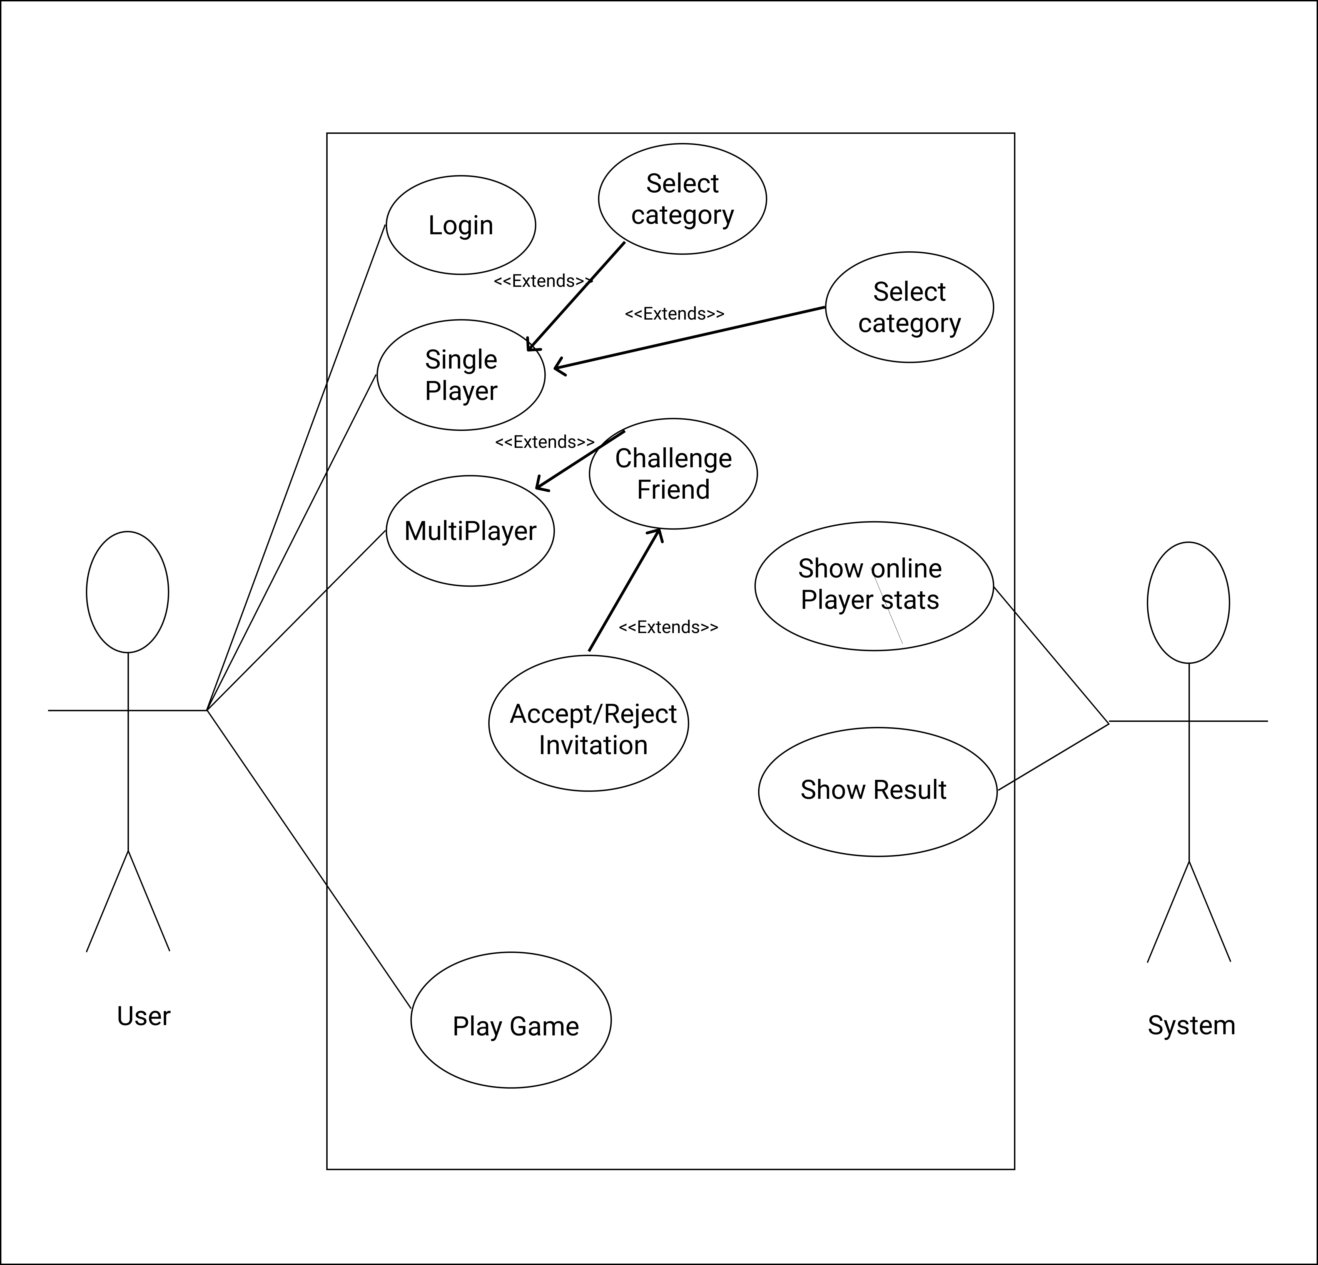
4. Usage Scenarios:

Use Case Title | Login
Use Case Id | 001
Actions | - Click on log in button  - Select your facebook account  - User’ll be logged in
Description | When user will open the application first time, login pop up will show. User can login.
Alternative Paths | Click on login button in main menu to login
Pre Conditions | When user first opens the application, show log in pop up.
Post Conditions | Log the user in
Exception | Internet connection throw Exception
Author | Jawad Ali

Use Case Title | Single Player
Use Case Id | 002
Actions | - Go to main menu  - Click on single player button
Description | If user clicks on single player button, single player quiz will starts.
Alternative Paths | Multiplayer quiz
Post Conditions | Categories list will load
Author | Jawad Ali

Use Case Title | Select Category
Use Case Id | 002
Actions | - Click on play button  - Select a category
Description | When user clicks on play button, he’ll shown category screen from which he have to select a category to get question from.
Alternative Paths | Click on back button to go back to main menu. Or click on random button.
Pre Conditions | Click on play button
Post Conditions | System will fetch questions from that particular category.
Exception | Database is empty
Author | Jawad Ali

Use Case Title | Take Hint
Use Case Id | 005
Actions | - Click on hint button
Description | In difficult questions, user can take hint to hide two wrong options.
Alternative Paths | Wrong options will not hide
Pre Conditions | User should have suitable coins to take hint
Post Conditions | Two wrong options will hide
Exception | Database is empty
Author | Jawad Ali

Use Case Title | Challenge Friend
Use Case Id | 005
Actions | - Go to main menu  - Click on Multiplayer button  - Challenge an online friend
Description | In case of multiplayer mode of game, user will get status of online players. He will challenge one of them to start competition.
Alternative Paths | Player single player game
Pre Conditions | At least one friend should be online.
Post Conditions | Challenge request will be sent to other online player.
Exception | Internet connection throw Exception
Author | Jawad Ali

Use Case Title | Accept/Reject Challenge
Use Case Id | 006
Actions | - Click on Accept button  - Click on Reject button
Description | When player A challenges other online player B, player B will get Invitation pop up. He can click on accept button to accept the challenge or click on reject button to reject the challenge.
Alternative Paths | Close the Invitation pop up
Pre Conditions | Payer should be online.
Post Conditions | Game starts if accepts the challenge and online players list will be shown if clicked on reject button
Exception | Internet connection throw Exception
Author | Jawad Ali

Use Case Title | Take Quiz
Use Case Id | 004
Actions | - Click on one of four options buttons
Description | On start of quiz, user will get MCQs with four options. User have to select one option to answer.
Alternative Paths | Time passed i.e. its wrong answer
Pre Conditions | User should start quiz
Post Conditions | User answer will be verified. Either its correct or wrong.
Exception | Database is empty
Author | Jawad Ali

Use Case Title | Online Player Status
Use Case Id | 008
Actions | - System will give the number of online players
Description | All players playing game will get online players status.
Alternative Paths | No player is online
Pre Conditions | Player should be online
Post Conditions | All online players will be shown in menu.
Exception | Internet connection Exception.
Author | Jawad Ali

Use Case Title | Show Result
Use Case Id | 009
Actions | - Show Results
Description | After completion of a questionnaire, show results.
Alternative Paths | Questionnaire is not completed.
Pre Conditions | Questionnaire should be completed.
Post Conditions | Results shown.
Exception | DB error.
Author | Jawad Ali

Use Case Title | Verify Answer
Use Case Id | 006
Actions | - Verify user’s answer
Description | When user click on one of the options, verify his answer against db.
Alternative Paths | Either answer is correct or wrong.
Pre Conditions | User should answer the question
Post Conditions | Score added if he answers correct.
Exception | Database is empty
Author | Jawad Ali

Use Case Title | Hide Two Wrong Options
Use Case Id | 006
Actions | - Hide two wrong options
Description | When user click on hint button hide two wrong options if he had enough coins.
Alternative Paths | Show him less coins error.
Pre Conditions | Click on hint button and have enough coins.
Post Conditions | Two wrong options hide
Exception | Database is empty
Author | Jawad Ali

5. Adopted Methodology

A methodology is codified set of practices that may be used to Software Engineering in collection of techniques, which are used to improve the quality of software product. Its the documented collection of policies processes and procedures are used by development team to improve Software Development Methodology (SDM) or System Development Life Cycle (SDLC). Software methodology reduces defects in software development and provides shorter delivery times and better Value. The software methodology is revising of how to guide through each phase of process model. Now a days, there are number of methodologies exists. People used a variety of model according to their needs and nature of their work. We’ll use VU Process Model.

VU Process Model:
We have used VU Process Model for this project. It is combination of Water fall and Spiral method. This model has defined starting and ending points. Development process is seen going downward like waterfall. In this model one phase is proceed to the next phase in sequence. A spiral model is divided into a number of framework activities, also called task regions. Typically, there are between three and six task regions. It minimizes the Risk.

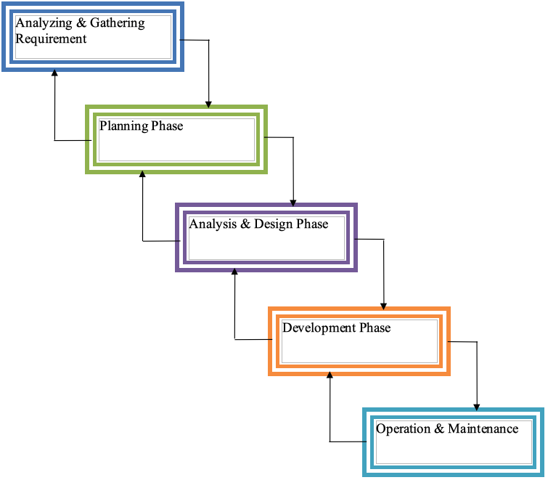

6. Work Plan (Use MS Project to create Schedule/Work Plan)
