RHYTHM GAME MAKER

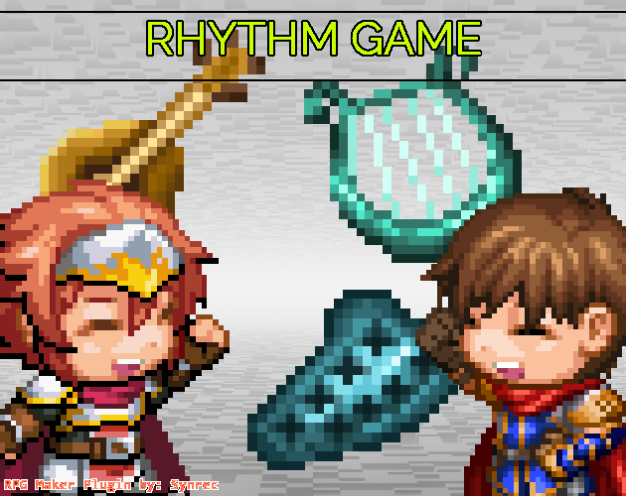

This plugin allows for the creation of rhythm games which are games that play music and allow players to trigger inputs based on the button timings. As the developer, you can fully control when the buttons will show up and how long the input duration will be or you can rely on the plugin’s built in automatic mode.

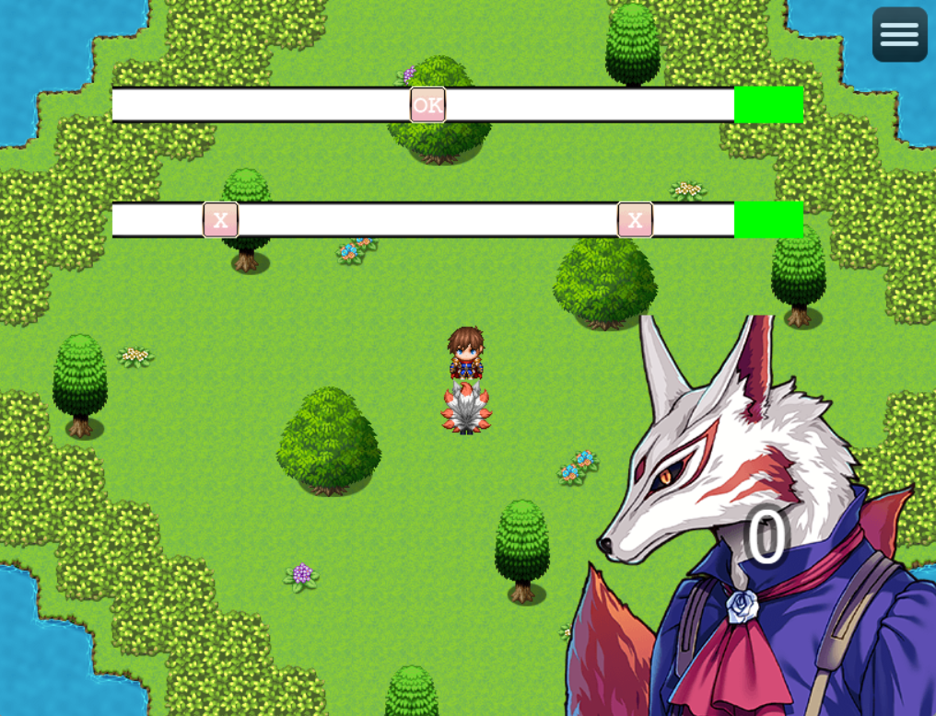
The manual mode in intended for users who are able to determine frame by frame where their wave form peaks to button input. It is a fairly complex setup in that regard and is best for sound engineers who want to make a rhythm game.

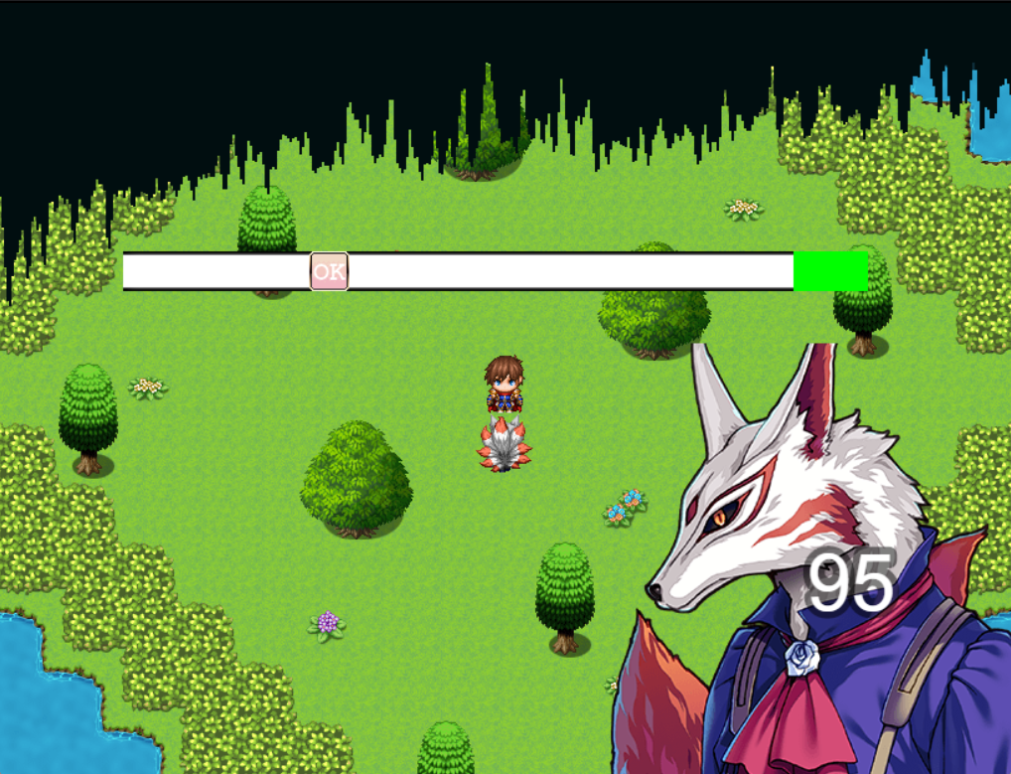
The automatic mode comes with an optional visualizer and threshold/bandwidth settings. It eases up on the difficulty presented in manual mode and attempts to take even more difficulty away if you opt to offload some of the threshold settings onto the plugin itself depending on game requirements.

We’ll look at how the plugin is setup section by section.

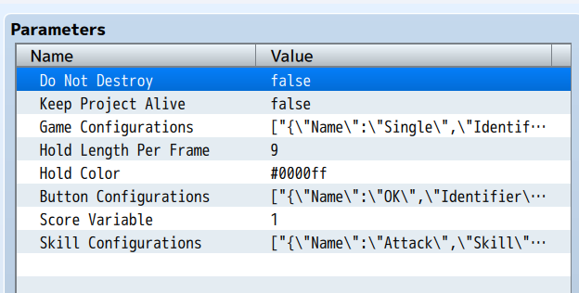
GENERAL PARAMETERS
“Do Not Destroy” will prevent the calling of sprite destroy functions related to this plugin. This parameter option should be set to true if you have plugins that take a record of all sprites added to the scene for some reason. It is purely technical and can be set to ‘true’ if you want to have everything be in relatively ‘safe’ operation.

“Keep Project Alive” will keep the game project alive even when the game window is not active. This may be required since the analysis of the game BGM is in real time with the current waveform at the time of the game window update. Setting this to true will mean your game project will always be active even when the window is not active and can lead to unexpected behavior.

“Game Configurations” is where we can setup different types of games with different BGMs, buttons inputs, game duration, manual or auto game.

“Hold Length Per Frame” is the number of pixels of “Hold Color” that will be drawn to the left of the button per frame that button is supposed to be pushed for. It is only visible for press and hold input.

“Button Configurations” is where we setup our buttons to use with the rhythm maker plugin. It is possible to setup animated buttons in which the graphics must be aligned along the horizontal axis of the image file and equally spaced by the number of “Frames” set for that button.

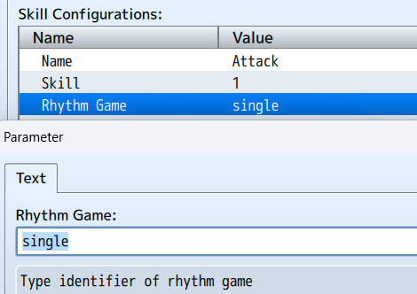
“Score Variable” is the game variable used to store the game score. You may use this variable for your own purposes.

“Skill Configurations is where we can setup what skill can call which “Game Configurations”. We select the “Skill” and then set the identifier of the “Rhythm Game” to call. The skill execution sequence is overwritten once set.
GAME CONFIGURATIONS

This is the main part of the plugin in which we can setup various rhythm games for the player to encounter
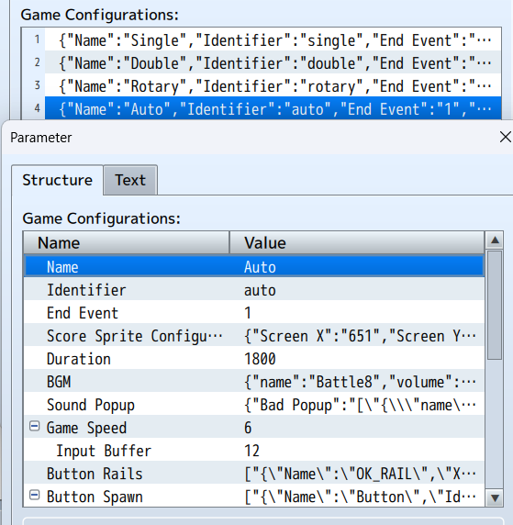
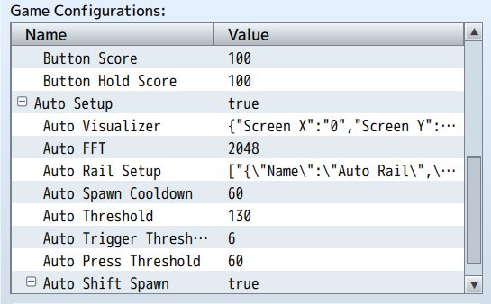
To begin, please ensure that for your “Game Configurations” the “Identifier” for each configuration is kept UNIQUE as if duplicates are used, only the first one is used.

The “End Event” is the RPG Maker common event which will be called when the game is complete/ended. Using the variable set for the game score, you can set conditional branches in your event to determine what behaviour you want.
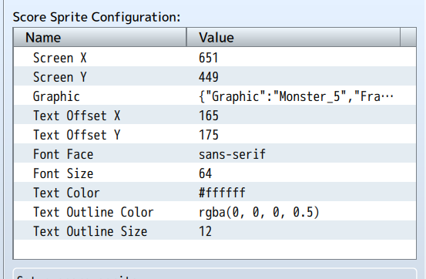
The “Score Sprite Configuration” will determine how we want to display the player’s score during the gameplay. There are options for a background “Graphic” which can be animated along the horizontal axis of the file chosen and equally spaced by the number of “Frames” set, screen position, text color, size and face.

“Duration” is mainly used during the “Auto Setup” and determines how long the game will last in frames. If “Auto Setup” is not enabled, the game duration is determined by the “Button Spawn” remaining and if any buttons still need to be triggered.

“BGM” is the audio/bgm/file.ogg used for the game. In auto mode, only the file name is considered currently. It is also such that in auto mode, the BGM will determine when buttons will appear based on waveform amplitudes.
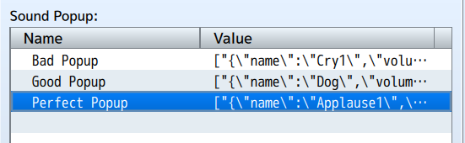
You can set the sounds to play based on if the player does a bad, good or perfect input in “Sound Popup”. It is possible to set multiple so that the sounds can be randomized.
“Game Speed” determines how many pixels to the right the button will move per update cycle (frame) of the game. A higher value will result in a faster movement.

“Input Buffer” is a mercy setting which will create a permissible input time before and after perfect to allow for perfect input regardless.
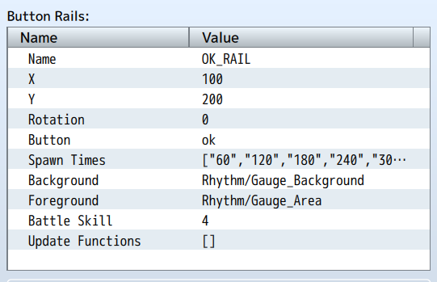
“Button Rails”will determine the input rails available during the game. You cannot and should not use multiple rails with the same “button”, it will cause errors/issues and false triggers. The “Background” is used to determine the length of the game rail and is used in calculations for the “Auto Setup”. “Foreground” is used for determining the size of the valid input area. For both the “Background and the “Foreground”, please do not use images with significant blank space. No blank space is the best scenario/condition. “Spawn Times” here is not used. If using this in battle, “Battle Skill” will be the skill the user will execute on the target. It is recommended to keep this for actors only at the moment. “Update Functions” are scripts you can have running on the game rail every update cycle, below shows a rotation setup in which the rail will rotate/spin every update cycle
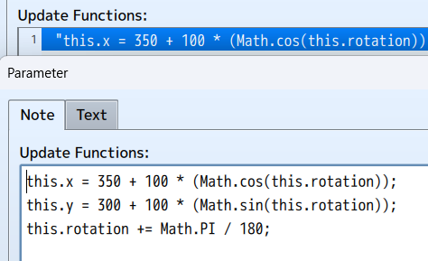
“Button Spawn” is used only during manual setup (i.e: when “Auto Setup” is set to false)
and is used to set when buttons will be spawned onto the button rails. You must consider the “Game Speed” and the length of the “Button Rails”
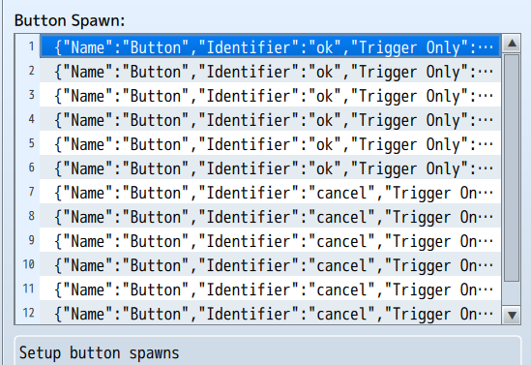
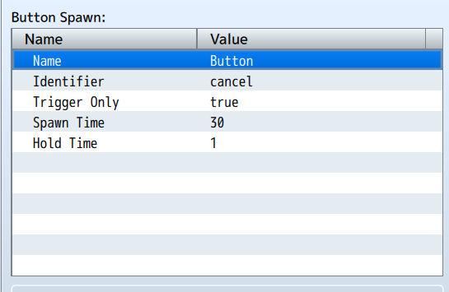
“Identifier” is only the RPG Maker input name, “Trigger Only” is if it is tap or push and hold, “Hold Time” is the number of hold frames and “Spawn Time” is the game time in which the button appears on the rail.
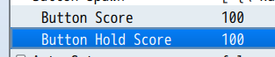
Outside of button spawn, we have “Button Score” which is the perfect score value of the button and “Button Hold Score” which is the hold score for the button.
“Auto Setup” will enable the automatic button spawn of the plugin if the manual setup is too cumbersome.
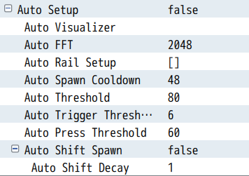

You may opt to specifically set thresholds by leaving the “Auto Shift Spawn” parameter as ‘false’ but once that parameter is enabled, buttons will be spawned based on the “Auto Threshold” set and whether or not the the last waveform magnitude read is equal to or greater than the next. The minimum threshold is then set to the waveform magnitude and this new minimum will decay per update by the value set in “Auto Shift Decay”

For auto mode, a trigger type input will be registered Only if the recorded press time, i.e: the time in which the waveform amplitude is equal to or greater than the minimum, is greater than or equal to “Auto Trigger Threshold” value and the press time recorded is less than “Auto Press Threshold”. If the recorded press time is greater than or equal to “Auto Press Threshold”, the button added will be a press and hold input.

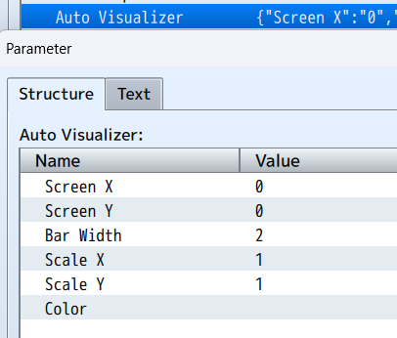
Auto mode has a benefit in which you can setup a visualizer. It is purely aesthetic and does not add anything to the gameplay but can be used by a musician to determine waveform on screen during gameplay to set specific bandwidths for the input rail in “Auto Rail Setup”. Please keep in mind that if “Auto Rail Setup” is not used, the waveform will be divided equally among the rails and each rail will handle a specific section of the waveform of which its size is determined by “Auto FFT” (FFT = Fast Fourier Transform).

In the “Auto Visualizer”, if “Color” is left blank, it will be randomized.

