**John (Joey) Wilson**

West Chester, PA 19382

484-354-3149

johnjwilson96@gmail.com

jresumes.com

# Education

Drexel University Philadelphia, PA

BS/MS in Computer Science with Honors Anticipated Graduation: June 2020

Concentrations in AI and HCI **Cumulative GPA: 3.81**

Minors in Business, Finance, CDSCI, Math, and Psychology

# Industry Experience

**Woodward McCoach, Inc. (WMI)** West Chester, PA

*Software Engineer* September2018 – March 2019

* Automated a gap in production to generate MAC addresses. (Python)
* Developed client side of system, through iterative process, to load firmware onto board over Ethernet. Load, dump, list, and initialize were functional requirements. (C)
* Aided in debugging hardware and software issues. (C)
* Created interface command to read fault log, restricted to 2500B. (C)

**Unisys** Malvern, PA

*MCP Security Developer* September2017 – March 2018

* Researched, designed, implemented, tested, and documented implementation of Microsoft AppLocker technology as a feature into next release of flagship product. (PowerShell)
* Developed a C++ program to validate and compare proprietary AES-XTS-256 encryption code to commodity implementation (OpenSSL).
* Researched network protocol fuzzing for proprietary protocols

# Analytical Graphics, Inc. (AGI) Exton, PA

*Software Developer* September 2016 - March 2017

* Collaborated with a team of 4 on scalability extension (allows for use of Parallel Computing) of flagship product, Systems Tool Kit (C#)
* Updated simulator to aid in functional and stress testing of WebApp (C#)
* Refactored Python API to follow standard python conventions and provide proper documentation (Python)
* Continued development of WebApp for better display of tray applications (JSX, Meteor, ReactJS)

# Academic Project Experience

**Dragon Carts** Drexel University

*Project Manager* January 2016 - Present

* Led a team of 4 to design and release iOS and Web applications for Drexel's food trucks
* Oversaw development to ensure quality and consistency between members
* Resolved issues that inhibited app development and ensured all phases were completed under specified timeline
* Supported development of the WebApp (HTML, CSS, JavaScript, jQuery, MySQL)

# Relevant Coursework

High Performance Computing Software Design and Engineering System Architecture and Programming

Dependable Software Systems Artificial Intelligence Machine Learning

Data Mining Web and Mobile App Development Computing in Small

Database Management Test Driven Development Corporate Financial Management

# Skills

Software: **C**, **Python**, C++, C#, CSS, HTML, Java, JavaScript, MySQL; Visual Studio, Eclipse, git, Unix; Office Suite

**John (Joey) Wilson**

West Chester, PA 19382

484-354-3149

johnjwilson96@gmail.com

jresumes.com

# Honors and Awards

Dean's List, Drexel University, 2015-Present

AJ Drexel Scholarship, Drexel University, 2015 - Present

Spellman Humanitarian Award, West Chester Area School District, 2015

# Activities

Upsilon Pi Epsilon (UPE) - Honor Society, Treasurer

Captain, Henderson High School Wrestling Team (Over 100 Career Wins), 2014-2015

Pennsylvania All-Academic High School Wrestling Team; First Team Selection 2013, 2014, 2015

See website (jresumes.com) for additional information.

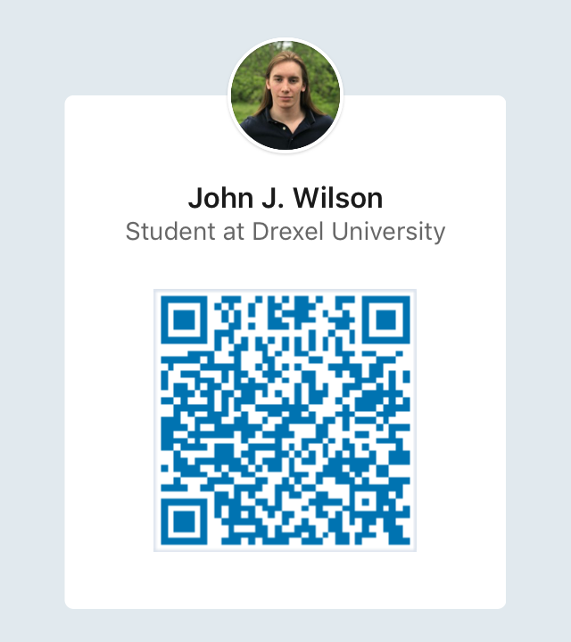LinkedIn QR Code