**Product Database Management**

**Contents:**

1. Abstract

2. Introduction

3. Requirement Specification

4. Architecture Design

5. Conclusion and Future Work Submitted By: M.Thejesh Reddy(846743)

Batch Code: CHN19AJ029.

### Abstract

The product management system is an application which helps to record and tract the product details and its availability in a store. With this application it is easy to get the product details and to make necessary changes in them. Only authorized people like a product manager of the store is allowed to access this application. This system provides high level of security for data leaking as only admin people can access the database no changes can be made in it until it verifies the user login id and password. This software is user friendly and hence easy to use.

This application shows the entire list of products available in the store. Along with the product list it also gives product details like product name, in which category does the product belongs to, its price, date of manufacturing and date of expiry of the product. Using this application, the user an update, delete the existing product details. When a new product arrives in the store, the new product details can also be added to the list using this application. A search option is also there so that the user can easily search the product details from the list by name.

### Introduction

Product management is an important organizational role. Typically, a Product management has four basic elements – Insert, Delete, Update the product list. Product management is becoming an increasingly popular role across both startups and enterprise companies. The product manager is responsible for the strategy, road-map, and feature definition for that product or product line. Product management’s general business purposes are to make the product valuable in a list. Product management is an important organizational role.

### Requirement Specification

1: Java 1.8+

2: Tomcat Server 7.0 or above

3: My SQL Database 5.0 or above

4: Eclipse IDE/STS 2018-2019

5: Maven 3.0 or above

6: Junit-4

### Architecture Design

## Outline of Project:

[Core J2EE design patterns MUST use](https://madhuraoakblog.wordpress.com/2014/06/03/design-patterns-an-enterprise-application-must-use/) and the [list of patterns that we use in layered application architecture](https://madhuraoakblog.wordpress.com/2014/04/13/layered-application-architecture-and-design-patterns/).

The term Service Layer is analogous to Business Layer in Core J2EE design patterns. Application Logic resides in Service Layer. The use of Application Service, Session Façade, Business Delegate, Service Locator, Value List Handler and Transfer Object Core J2EE design patterns is very common in Service Layer of a typical web application.

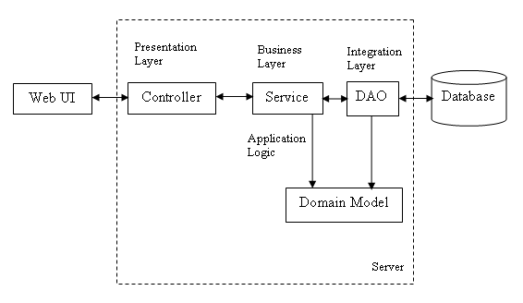

The application has the following screens:

Screen 1: WelcomeLogin Page

Screen 2: Login Page

Screen 3: Product List Data Insertion, Deletion, Updation

Screen 4: Product Data Insertion and Deletion Page

### Screen 1: Welcome page

|  |  |  |  |
| --- | --- | --- | --- |
| **UserID** | **As a** | **I want to be able to** | **so that** |
| nsrt | Admin | As An Admin I want to click proceed to get into the application | I can use the features of this application |

##### Sample UI Screen

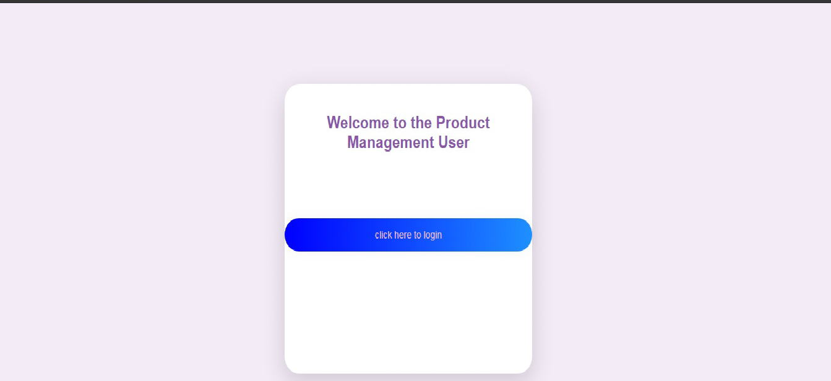

### Screen 2: Login page

|  |  |  |  |
| --- | --- | --- | --- |
| **User ID** | **As a** | **I want to be able to** | **so that** |
| nsrt | Admin | Give username and password details which should match in the database | I can move to the further page where I can insert the data ,delete the data and view the data and I can logout form the application |

##### Sample UI Screen



### Screen 3: Product Data Insertion, Deletion, Updation

|  |  |  |  |
| --- | --- | --- | --- |
| **User ID** | **As a** | **I want to be able to** | **so that** |
| nsrt | Admin | Here ,I can insert, delete, update the new Product data into the database also can view and search the list of all products. | A new Product detail is added or deleted or updated or searched inside our database |

##### Sample UI Screen

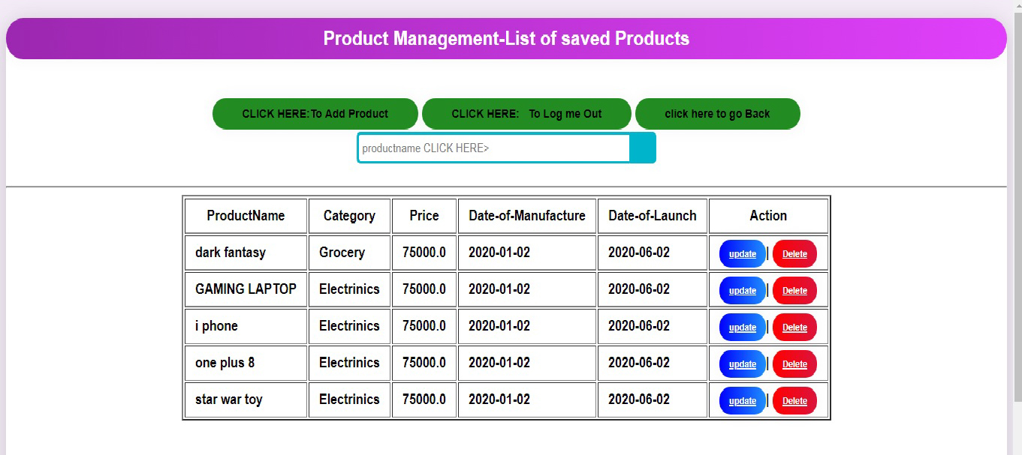

### Screen 4: Product Data Insertion and Updation page

##### Field Specification for Product Data inserting and Updation Page:

|  |  |  |
| --- | --- | --- |
| **Field Name** | **Field Type** | **Description** |
| Product Name | Text Box | Obtains the name of Product; accepts strings |
| Category | Check Box | Obtains the Category for Products |
| Price | Text Box | Obtains the Pricefor Products |
| Date of Manufacture | Date | Obtains the date for Products |
| Date of Launch | Date | Obtain the Date for Products |

|  |  |  |  |
| --- | --- | --- | --- |
| **User ID** | **As a** | **I want to be able to** | **so that** |
| nsrt | Admin | Add or Update the Product details in the database | Existing Product details can be Updated or New Product details are added here. |

##### Sample UI Screen:1

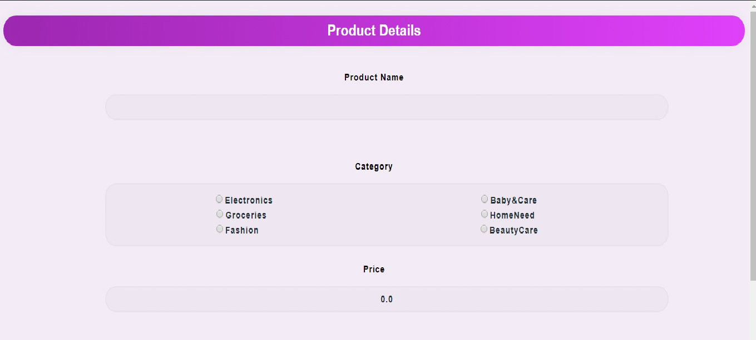

##### Sample UI Screen:2

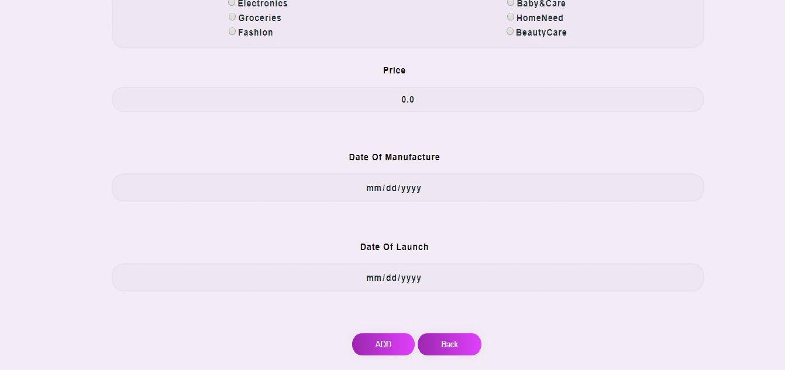

### Conclusion and Future Work

Product Management System Project is developed as a web-based project to meet the current stock management demands of an company or organization. The system can be accessed by the Product Manager. Also New features and modules can be incorporated into the system as per the user requirements.

### References

1.https://docs.spring.io/spring/docs/current/spring-framework-reference/

2. https://docs.spring.io/spring/docs/current/spring-framework- reference/core.html#spring-core

3.https://docs.spring.io/spring/docs/current/spring-framework-reference/web.html

4.https://hibernate.org/orm/documentation/5.0/

5.https://maven.apache.org/guides/getting-started/index.html