**INTRODUCTION:**

Traffic management system is a comprehensive set of technologies and strategies designed to monitor, control, and optimize traffic flow on roads, highways, and urban areas. It encompasses various components such as traffic signals, cameras, sensors, and software applications to collect and analyze data in real-time. The primary goals of a traffic management system are to reduce congestion, improve safety, and enhance overall transportation efficiency. These systems often use data-driven approaches to make informed decisions, manage traffic signals, and provide real-time information to drivers, ultimately contributing to smoother and safer traffic operations.

**Hardware required:**

Traffic management system typically requires various hardware components, including:

Cameras: Surveillance cameras for monitoring traffic conditions and capturing images or video footage.

Sensors: Vehicle and pedestrian detection sensors, such as inductive loop sensors, infrared sensors, or radar devices.

Traffic Lights: Traffic signal controllers, LED traffic lights, and pedestrian crossing signals.

Variable Message Signs (VMS): Electronic signs that display real-time information to drivers, such as traffic alerts, speed limits, or lane closures.

Data Processing Servers: Servers or computers for processing and analyzing data from cameras and sensors.

Communication Infrastructure: Networking equipment for data transmission between devices and a central control center.

Control Center Hardware: Computers, displays, and control panels for managing and monitoring the traffic system.

Power Supply: Uninterruptible power supplies (UPS) and backup generators to ensure continuous operation.

Weatherproof Enclosures: Protection for hardware deployed outdoors to withstand environmental conditions.

Cabling: Cables and wiring for connecting all the components.

The specific hardware requirements can vary depending on the scale and complexity of the traffic management system and the desired features, such as traffic analytics and automation. Additionally, modern systems may incorporate advanced technologies like artificial intelligence and remote monitoring capabilities.

**Software required:**

traffic management system typically requires a combination of hardware and software components. The specific software you might need can include:

Traffic Signal Control Software: This controls traffic lights and signals, optimizing traffic flow.

Traffic Monitoring and Surveillance Software: To collect data from cameras, sensors, and other monitoring devices.

GIS (Geographic Information System) Software: For mapping and location-based data analysis.

Traffic Data Analysis Software: To process and analyze traffic data, helping in decision-making.

Communication and Networking Software: For data exchange between different system components.

Database Management System (DBMS): To store and manage data efficiently.

User Interface Software: To provide a user-friendly interface for operators and administrators.

Maintenance and Reporting Software: To track system health and generate reports.

Emergency Management Software: For handling emergency situations and rerouting traffic.

The specific software you need may vary depending on the complexity and goals of your traffic management system. It's essential to work with a team of experts to design and implement a system that suits your requirements.

**Flow chart:**

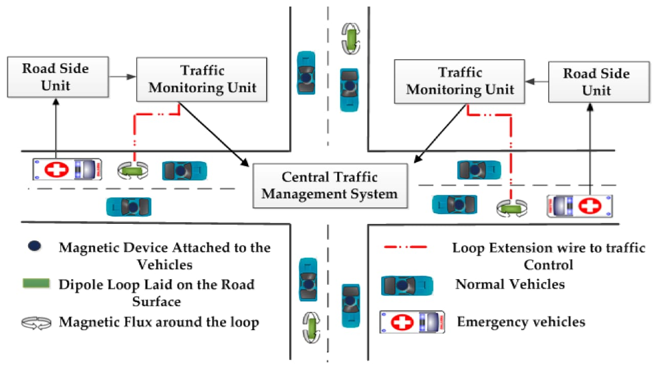

**Applications:**

Traffic Flow Optimization: It can be used to optimize traffic signal timings to reduce congestion and improve the flow of vehicles.

Public Transportation: Integrating public transportation systems with traffic management can enhance the efficiency and reliability of buses, trams, and subways.

Emergency Response: It helps emergency services respond more effectively by providing real-time traffic data and the ability to control traffic signals.

Smart Parking: Implementing sensors and data analytics can guide drivers to available parking spaces, reducing search time and congestion.

Traffic Surveillance: Use of cameras and sensors for monitoring traffic, enforcing traffic laws, and managing incidents.

Environmental Benefits: It can reduce greenhouse gas emissions by optimizing traffic flow and reducing idling.

Pedestrian Safety: Crosswalk signals and pedestrian-specific features improve safety and mobility for those on foot.

Bicycle Infrastructure: Integration with bike lanes and bike-sharing programs to encourage cycling as an alternative mode of transportation.

Urban Planning: Data collected from traffic management systems can inform city planning decisions, like where to build new roads or public transportation routes.

Adaptive Systems: Utilizing AI and machine learning for adaptive traffic management that can respond in real-time to changing conditions.

Congestion Pricing: Implementing tolls and pricing strategies to reduce traffic during peak hours and fund transportation infrastructure.