Jonathan Pfefferle
CSCD 439
1/26/2018

Task 1 deliverable

Part 1: Automatic shifting with Linear Engine Model

Part 2: Automatic shifting with Nonlinear Engine Model

Part 3: Manual shifting with Linear Engine Model

Part 4: Manual shifting with Nonlinear engine model

Part 5: Automatic shifting with Linear Engine Model, finer timestep increments.

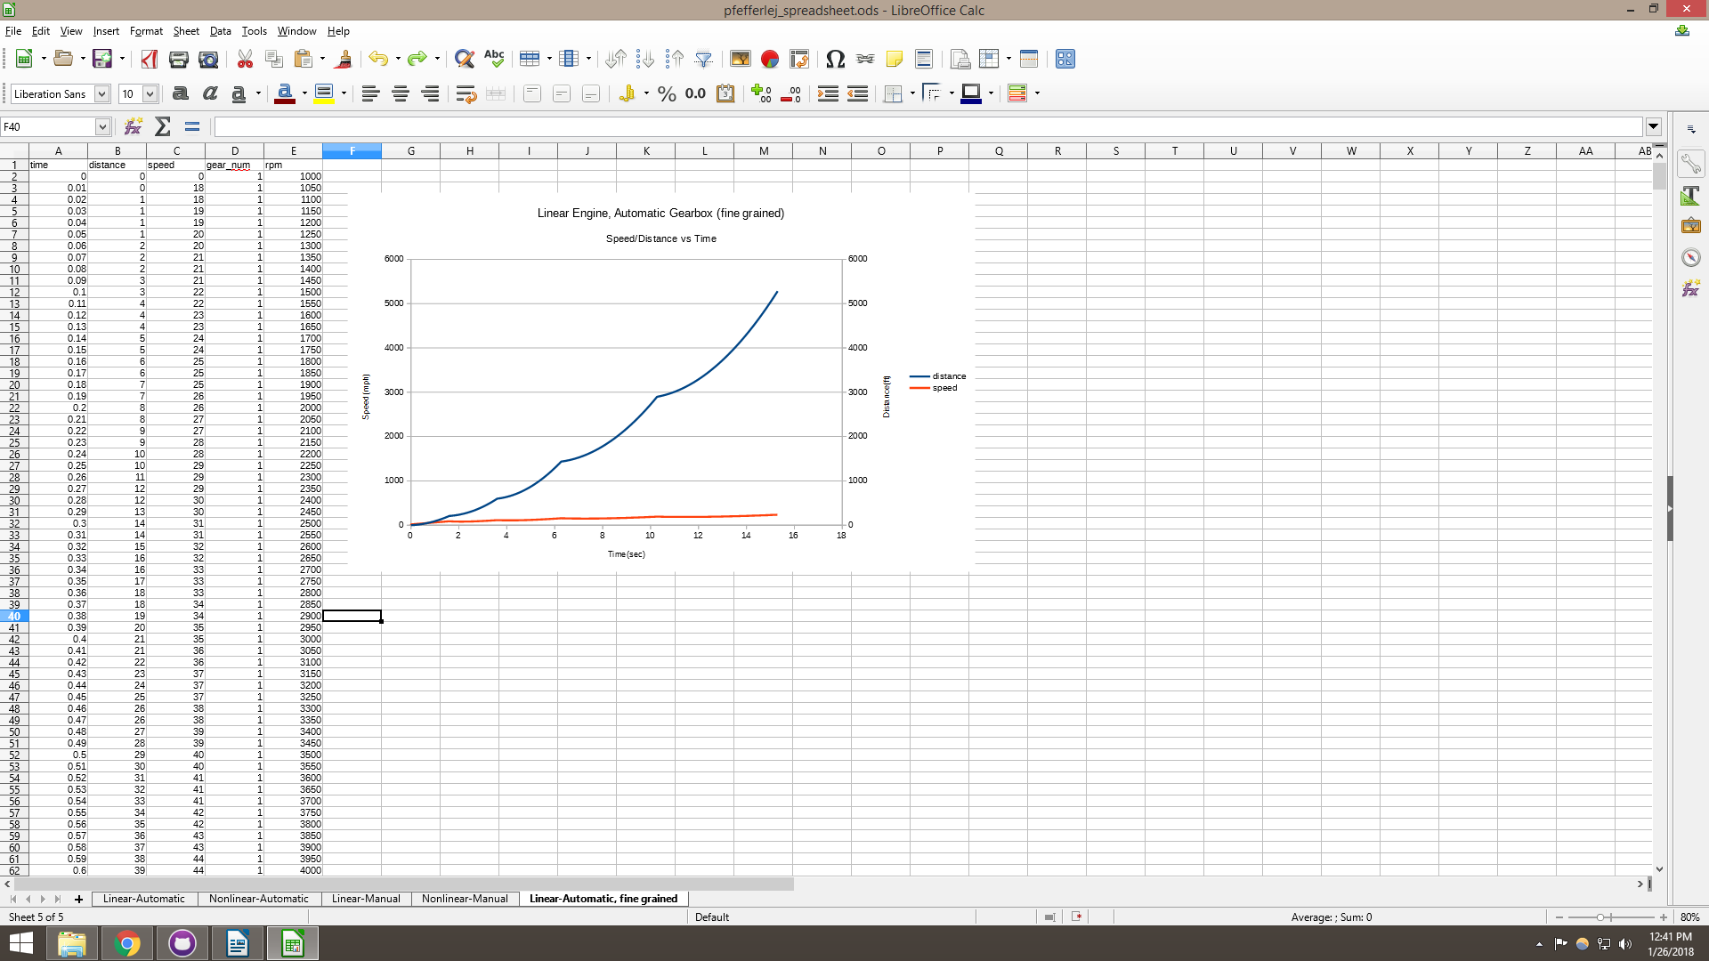
Observations/Issues:
None that weren’t covered by your writeup.

