Jonathan Pfefferle

Test 1 Fly straight north for 30 seconds while holding altitude.
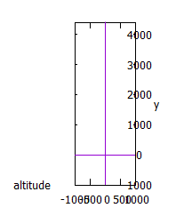
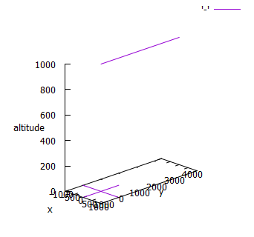
Test 2 Fly straight north for 30 seconds while climbing at 10 degrees of pitch.
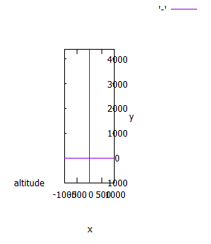
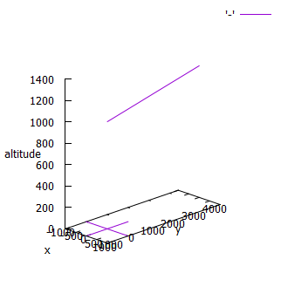
Test 3 Fly a complete clockwise circle at bank 30 and pitch 0.
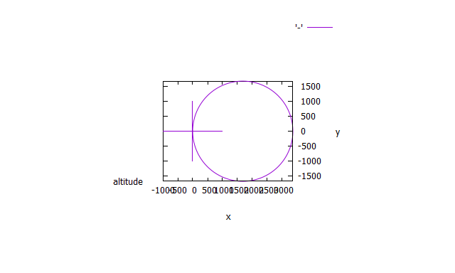
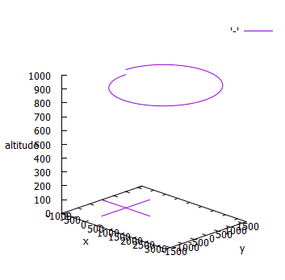
Test 4 Fly a complete clockwise circle at bank angle 30 while climbing at 10 degrees of pitch.
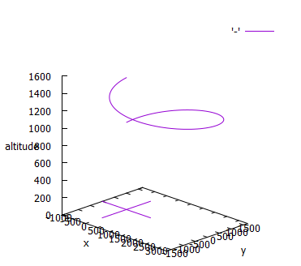
Test 5 Fly a complete clockwise circle at bank angle 30 while holding altitude with pitch. Adjust the vertical scale in Gnuplot (see below) so the deviation is apparent but not misleading. Your solution will not be perfect. Gnuplot by default will scale any error to fill the vertical graph limits, which makes minor (acceptable) errors look extreme against the scale of the horizontal plane
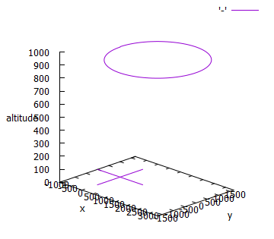
Test 6 Fly a complete clockwise circle at bank 30, 45, and 60 and pitch 0. Do the flights with three airplanes. Use a different filename for each. Manually combine the three Gnuplot datasets into one output file with a blank line between each. Keep the configuration the same at the top.
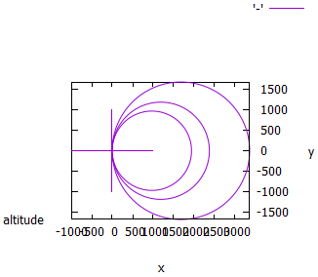
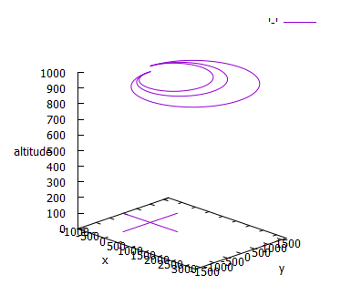
Test 7 Fly a complete clockwise circle at bank 30 with speeds 50, 100, and 150 and pitch 0. Do all three experiments simultaneously with three airplanes as in Test 6
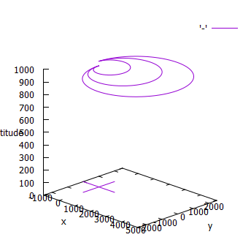
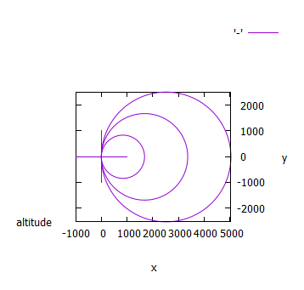
Test 8 Fly an S-turn to the east at bank 30 right and left while holding altitude. The flight path should resemble this:
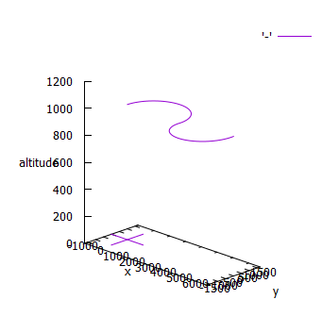
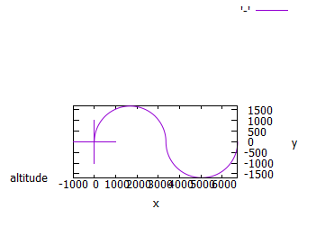
Task 9 Fly two clockwise turns at bank 30 starting at speed 100. Halfway through the first turn (A), increase speed to 150. At one complete turn (B), increase to 200 and complete the second turn. The flight path should resemble something like this:
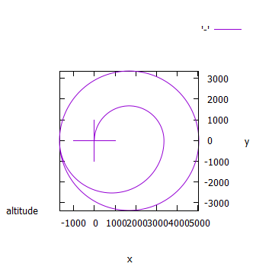
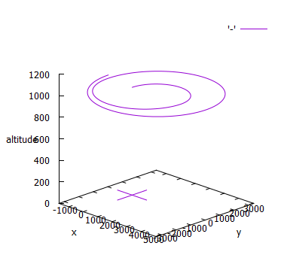
Task 10 Assume a runway 5,000 feet long facing east at 0 feet altitude. Start at the left (0,0) at 60 mph down the runway. At the three-quarter point, increase speed to 80 and climb to 500 feet. Turn left 90 degrees at 30 degrees of bank and continue climbing to 1,000 feet. Turn left (parallel to the runway in the opposite direction of takeoff), fly level until abeam the start of the runway (x=0), descend to 750 feet, turn left, descend to 500, turn left one last time to align with the runway, reduce speed to 60, land, and stop halfway down the runway. The flight path should resemble this
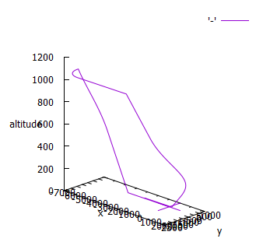
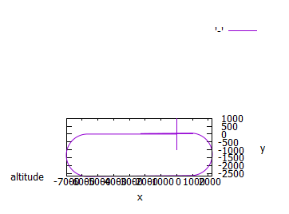
Task 11 Attempt to loop the airplane. It is not possible, but try anyway to see what happens. Every three simulation seconds, increase the pitch by 10 degrees until it reaches 360. In addition to the graphs, use the Excel output to try to explain why this does not work. What should happen? In particular, look at the yaw, pitch, and roll data and compare against what an inside loop is supposed to look like.
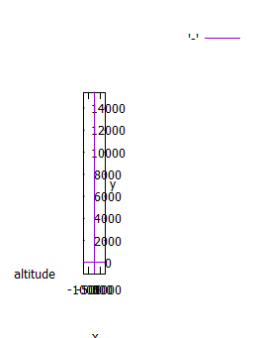
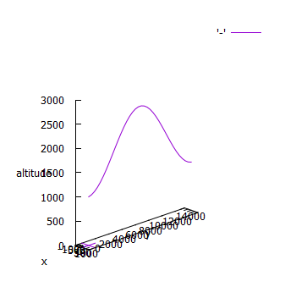
By examining the data, I saw that roll never changes value, when you’d assume roll would invert when the plane reached 90 degrees of pitch. From previous experience with three-dimensional simulations at extreme levels of pitch, this sounds like a gimbal-lock related problem. The simulation isn’t set up to handle the complexities of true three-axis freedom, and instead of representing the proper roll inversion simply broke.
Task 12 Repeat Test 5.
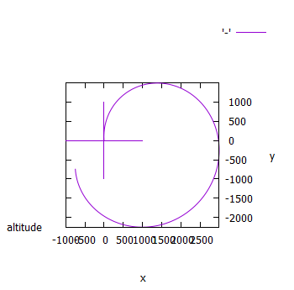
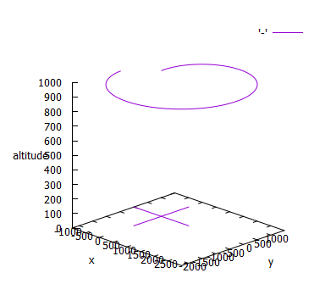

Task 13 Repeat Test 5 counterclockwise.
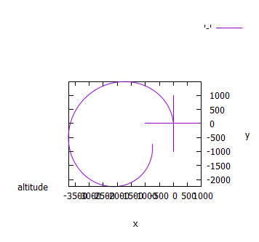
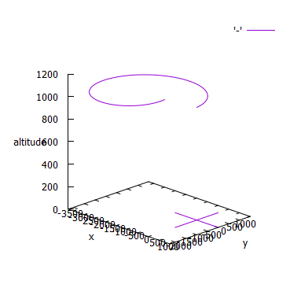
Task 14 Repeat Test 8.
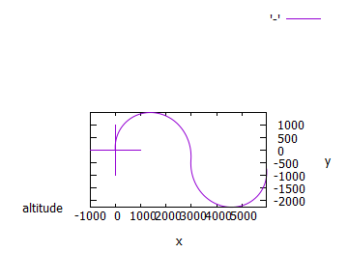
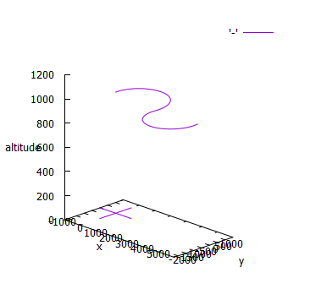
Task 15 Repeat Test 10.
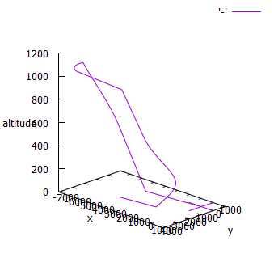
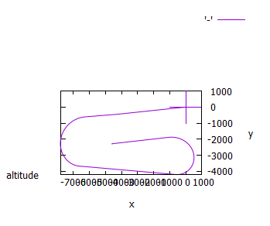

Task 16 Repeat Test 1.
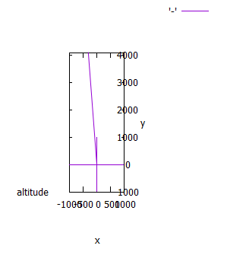
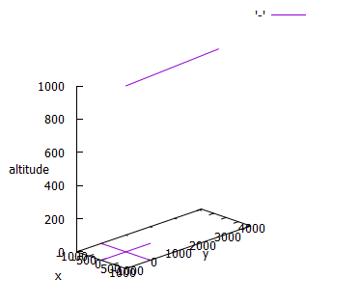
Task 17 Repeat Test 1. Try to stay reasonably on course. Report the cross-track error as the average error in position between the actual and expected x positions at each time step.
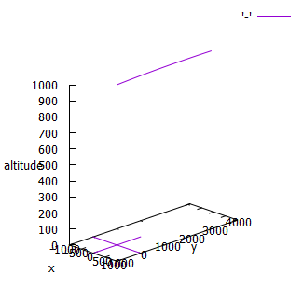
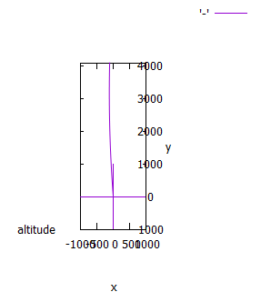

Average Error was found to be 88.426 feet, with a standard deviation of 34.865 feet
Task 18 Repeat Test 5. Try to stay reasonably on course. Report the cross-track error as the average error in position between the actual and expected x and y positions at each time step. Use the Pythagorean Theory.
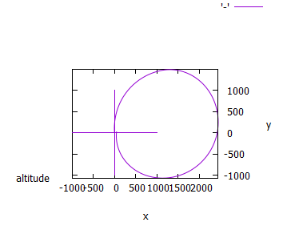
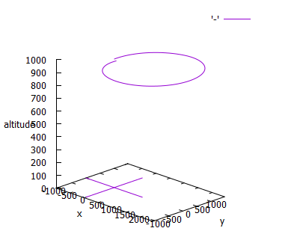
Total cross-track error is 1011.31 feet, with standard deviation 858 feet.

