Test 1.A: Colliding Bodies A
Bodies A and B are initially stationary and are pulled toward to each other. The solution is already provided. This is a test of your analyzer only.

Procedures:
Test 1.A was run as given, no changes were made to the code.

Result: The result was a collision at the origin at time index 135000.2, as shown by the following screenshot. Analyzer data dump is on the next page, for clarity.
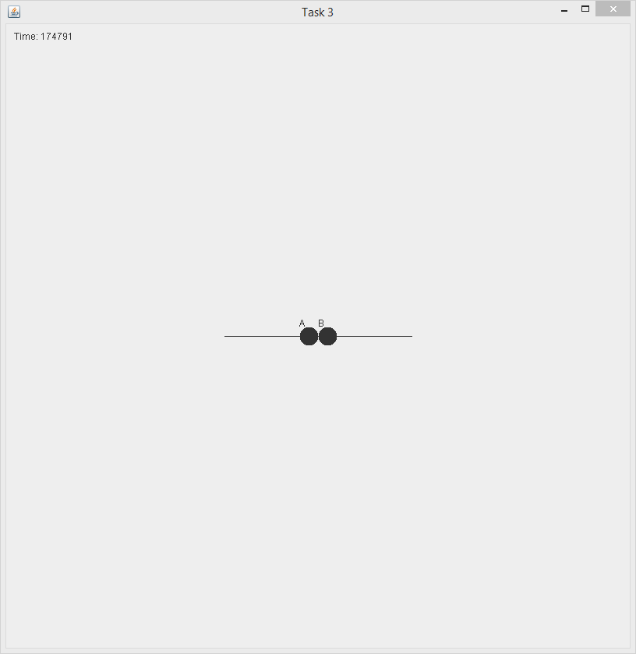
Test 1.A analyzer data dump.
Body: A
Time: 174791.0
Distance: 135000.2
Velocity:
Min: 5.8910514219983834E-8
Max: 2.2815948370361717E-7
Avg: 7.664457079305429E-8
Std: 2.6405682825364865E-8
Acceleration:
Min: 3.6924667988545616E-21
Max: 1.4726538211107254E-8
Avg: 1.1966205006730266E-14
Std: 1.1461529528956586E-11

Body: B
Time: 174791.0
Distance: 135000.2
Velocity:
Min: 5.8910514219983834E-8
Max: 2.2815948370361717E-7
Avg: 7.664457079305429E-8
Std: 2.6405682825364865E-8
Acceleration:
Min: 3.6924667988545616E-21
Max: 1.4726538211107254E-8
Avg: 1.1966205006730266E-14
Std: 1.1461529528956586E-11

Test 1.B: Colliding Bodies B

Repeat 1.A, but they are initially moving toward each other. Choose a reasonable speed.

Procedures: Two bodies were set up as per test 1.A, but they were given an initial velocity of one unit per second towards the origin. This speed was picked because it seemed reasonable at the time, and gave a pleasing simulation visual.

Results: The result was a collision of the two bodies at the origin at time index 85831.7, as demonstrated by the below screenshot. Analyzer data dump is on the next page.
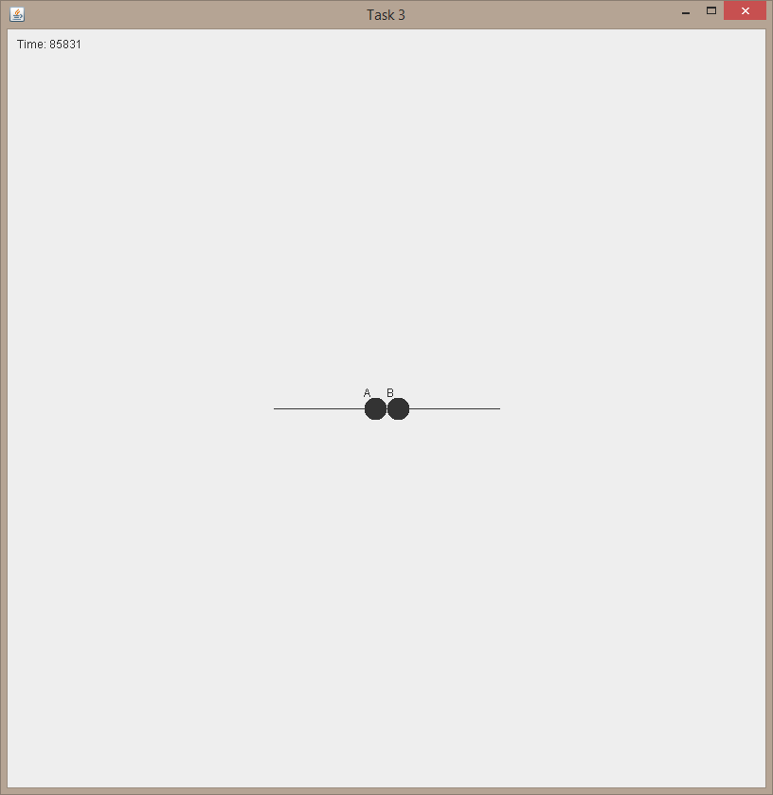
Test 1.B Analyzer data dump
Body: A
Time: 85831.7
Distance: 135000.2
Velocity:
Min: 2.774666177562345E-7
Max: 0.10000011781812645
Avg: 1.7657779375424052E-6
Std: 1.3842610063860992E-4
Acceleration:
Min: 1.3173672680690928E-23
Max: 0.025000014727993403
Avg: 4.136776459098131E-8
Std: 2.7766289251645176E-5

Body: B
Time: 85831.7
Distance: 135000.2
Velocity:
Min: 2.774666177562345E-7
Max: 0.10000011781812645
Avg: 1.7657779375424052E-6
Std: 1.3842610063860992E-4
Acceleration:
Min: 1.3173672680690928E-23
Max: 0.025000014727993403
Avg: 4.136776459098131E-8
Std: 2.7766289251645176E-5

Test 1.C: Colliding Bodies C
Repeat 1.A, but they are initially moving away from each other. Choose a reasonable speed.

Procedure: Bodies were set up as per Test 1.A, but they were each given an initial velocity of 0.5 units away from the origin. This value was picked because it seemed reasonable. Even something as small as 1 unit resulted in the bodies still moving away from each other as late as time index 350,000 which did not look right.

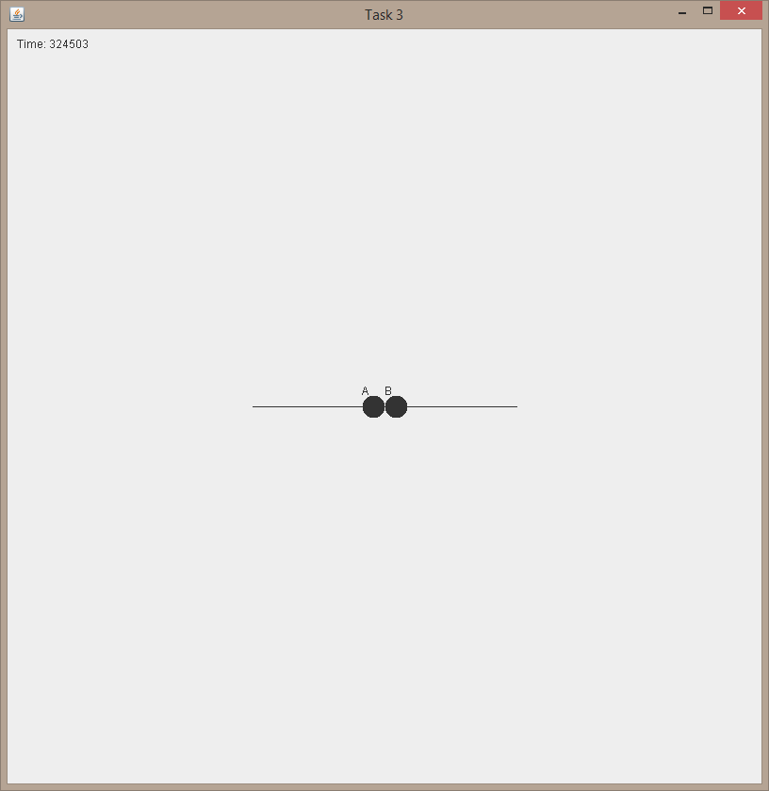
Results: The result was a collision at the origin at time index 184435.0, as shown by the following screenshot. Analyzer dump is provided on the next page for clarity.A
Test 1.C Analyzer Data Dump
Body: A
Time: 324503.9
Distance: 184435.0
Velocity:
Min: 1.2493073486944547E-14
Max: 0.04999988217605278
Avg: 2.2502638813044098E-7
Std: 3.559761666430649E-5
Acceleration:
Min: 7.878569374825392E-21
Max: 0.012499985263275448
Avg: 5.4708991800505865E-9
Std: 7.14004516982605E-6

Body: B
Time: 324503.9
Distance: 184435.0
Velocity:
Min: 1.2493073486944547E-14
Max: 0.04999988217605278
Avg: 2.2502638813044098E-7
Std: 3.559761666430649E-5
Acceleration:
Min: 7.878569374825392E-21
Max: 0.012499985263275448
Avg: 5.4708991800505865E-9
Std: 7.14004516982605E-6

Test 2.A: Passing Bodies A
Repeat 1.B, but they are on opposite parallel paths. How far apart (y) do they need to be to avoid an initial collision?

Procedure: Bodies were set up as per test 1.B, but the bodies were displaced 130,000 units along the y axis. This value was picked as experiments showed it would produce a very close approach with no actual contact. I split the displacement between both bodies (+/- 65000 each) to keep the visualization centered on the origin. As there would be no collision to terminate the simulation, I set the runToTime to 120,000 time units.

Results: The result was a close-approach and near-miss of the two bodies around time-index 100,000, as shown by the below screen shot. Analyzer data dump is on the next page as always.
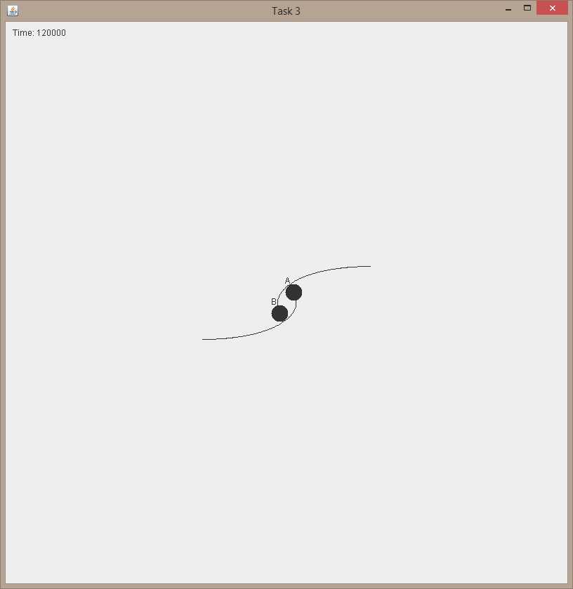
Test 2.A analyzer dump:
Body: A
Time: 119999.9
Distance: 210611.4
Velocity:
Min: 2.1931735627025817E-7
Max: 0.10000009101350638
Avg: 1.3111939066458488E-6
Std: 1.1707360476186057E-4
Acceleration:
Min: 9.15911279929495E-25
Max: 0.02500001138105241
Avg: 2.958889054428063E-8
Std: 2.3482871070020377E-5

Body: B
Time: 119999.9
Distance: 210611.4
Velocity:
Min: 2.1931735627025817E-7
Max: 0.10000009101350638
Avg: 1.3111939066458488E-6
Std: 1.1707360476186057E-4
Acceleration:
Min: 9.15911279929495E-25
Max: 0.02500001138105241
Avg: 2.958889054428063E-8
Std: 2.3482871070020377E-5

Test 2.B: Passing Bodies B
Repeat 1.B, but they are on opposite parallel paths. How fast do they need to be to avoid an initial collision? Use the same speed for both.

Procedure: The bodies were setup as per Test 1.B, but they were given a displacement on the y axis of 50,000 units from each other. This value was picked because, as per test 2.A, it will not cause the bodies to avoid a collision if they both start from zero speed. The bodies were then given a velocity of 3.2 unit towards the center.

Results: The two bodies made a close approach around time index 50,000, but did not collide, as shown by the below screen shot. Analyzer dump is on the next page.
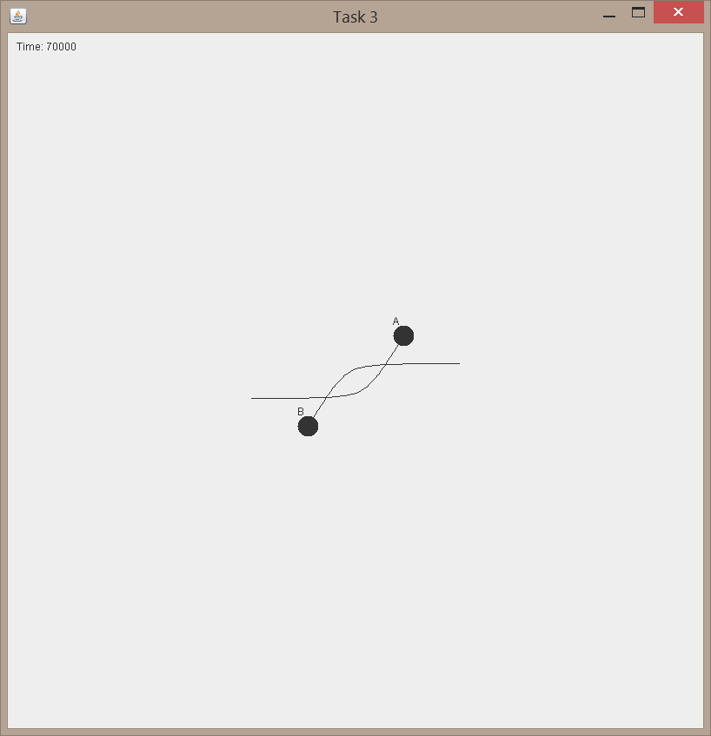
Test 2.B Analyzer dump
Body: A
Time: 70000.0
Distance: 260158.7
Velocity:
Min: 4.798508551149428E-7
Max: 0.3200001130753668
Avg: 6.555797256665447E-6
Std: 4.90498225341296E-4
Acceleration:
Min: 7.09293047502089E-23
Max: 0.08000001413893183
Avg: 1.623161157150298E-7
Std: 9.838807994804406E-5

Body: B
Time: 70000.0
Distance: 260158.7
Velocity:
Min: 4.798508551149428E-7
Max: 0.3200001130753668
Avg: 6.555797256665447E-6
Std: 4.90498225341296E-4
Acceleration:
Min: 7.09293047502089E-23
Max: 0.08000001413893183
Avg: 1.623161157150298E-7
Std: 9.838807994804406E-5

Test 3.A: Launch to Orbit A
The rocket is launched on a tangent to Earth. How fast does the rocket need to go to reach a reasonable orbit without using thrusters? What is the issue in the results?

Procedure: The given setup for Test 3.A was used, but the rocket was given an initial velocity of 19 units along the positive x axis.

Results: The rocket achieved a nice circular orbit, as shown by the below screenshot. However, this doesn’t really approximate a true rocket launch, as the rocket’s simply “Godzilla’d”--to borrow a bit of terminology from Dr. Tappan—into the correct height and speed, instead of simulating a full launch from ground level. As always, the analyzer data dump is below.
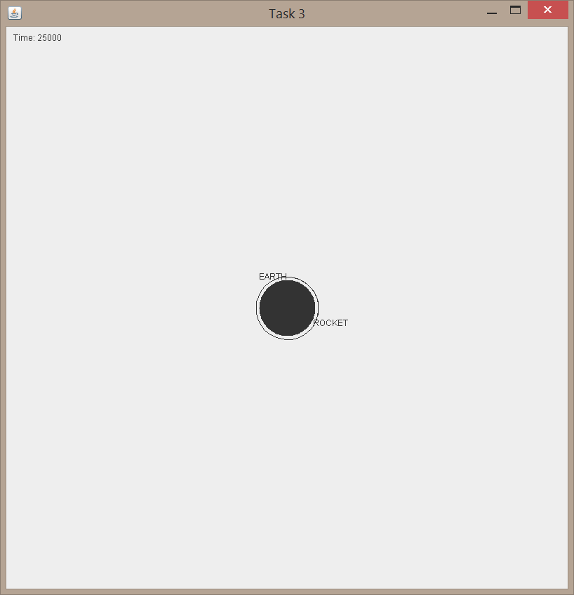
Task 3.A Analyzer data dump.
Body: EARTH
Time: 25000.0
Distance: .6
Velocity:
Min: 6.014798695046579E-17
Max: 1.298178782609765E-10
Avg: 3.0242863001163574E-11
Std: 2.2187184358807026E-11
Acceleration:
Min: 2.5060762586456865E-22
Max: 1.622723476675035E-11
Avg: 9.219191555154073E-17
Std: 3.339458182031475E-14

Body: ROCKET
Time: 25000.0
Distance: 470208.3
Velocity:
Min: 7.468017297781742E-6
Max: 1.9000000021926073
Avg: 9.86270239071795E-5
Std: 0.004872693536593374
Acceleration:
Min: 1.2877481079834828E-16
Max: 0.47500000028339484
Avg: 2.698511888002026E-6
Std: 9.775187582556526E-4

Test 3.B: Launch to Orbit B
Repeat 3.A, but thrusters are allowed

Procedure: The bodies were set up as per Test 3.A, but the rocket was given an initial velocity of 10 along the positive x axis. This speed was chosen because—on its own—it will not allow the rocket to complete an orbit, but it will keep the rocket from plowing into the earth long enough for engine burns to accelerate the rocket into orbit. Burns were then scheduled every quarter-time step between time-indices .25 and 1.75.

Result: The rocket was inserted into an orbit that, while less pretty and circular than in test 3.A, was achieved in a more realistic manner. See screenshot below. As always, Analyzer data dump is below.
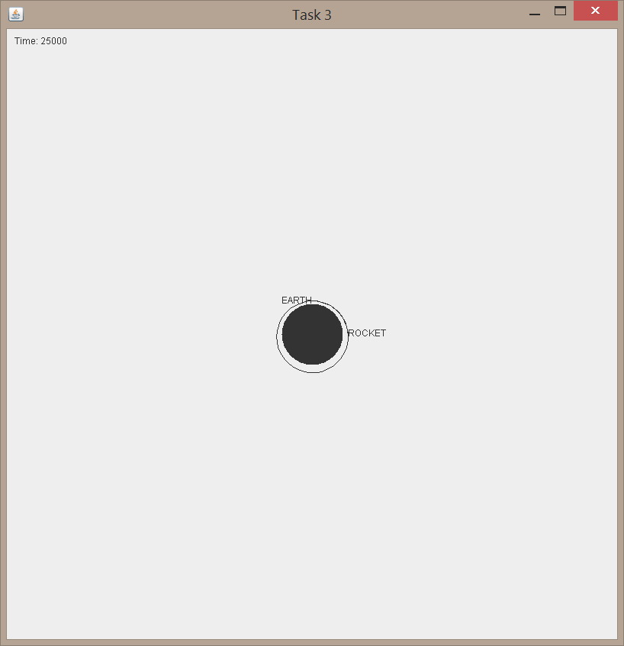
Test 3.B Analyzer data dump.
Body: EARTH
Time: 25000.0
Distance: .6
Velocity:
Min: 1.1534634128152195E-16
Max: 1.298178783309816E-10
Avg: 3.0021789079601996E-11
Std: 2.158521913116032E-11
Acceleration:
Min: 4.498802201400264E-22
Max: 1.6227234717746767E-11
Avg: 9.219210082444598E-17
Std: 3.339458168695143E-14

Body: ROCKET
Time: 25000.0
Distance: 460356.8
Velocity:
Min: 7.3213043967687366E-6
Max: 1.0000000072461779
Avg: 8.900628951505426E-5
Std: 0.0027721023188621253
Acceleration:
Min: 1.7528416459727975E-16
Max: 0.2499999997683941
Avg: 1.3969545747611433E-6
Std: 5.136484927228092E-4

Test 3.C: Launch to Orbit C
Repeat 3.A but straight away from Earth, what happens?

Procedure: The bodies were setup as per Test 3.A, but instead of assigning a velocity along the positive X axis, the rocket was assigned a velocity of equal magnitude along the positive Y axis.

Result: The rocket launched up for a small distance, then fell back to earth. Then, because collisions were turned off, it fell through the earth and got spat out the other side at an unreasonably high speed, as detailed in the screenshot below. As always, analyzer data dump is on the next page.
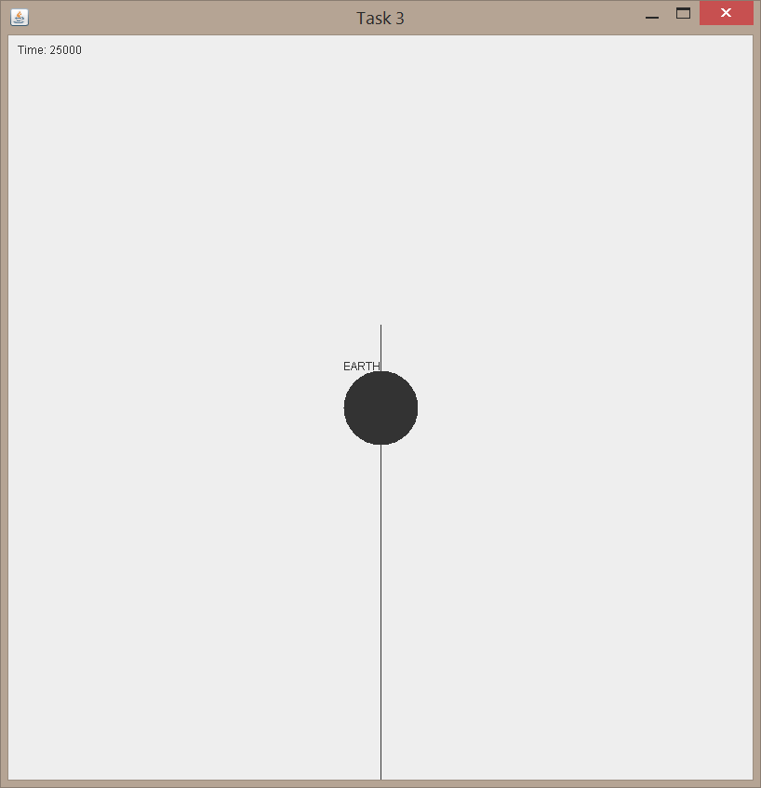
Test 3.C analyzer data dump.
Body: EARTH
Time: 25000.0
Distance: 13.8
Velocity:
Min: 2.220241874750335E-11
Max: 1.0747681058536218E-9
Avg: 2.7968274548183915E-10
Std: 3.661913342932719E-10
Acceleration:
Min: 8.205967334422214E-28
Max: 1.622835567912645E-11
Avg: 9.22985116169632E-17
Std: 3.3397249390105846E-14

Body: ROCKET
Time: 25000.0
Distance: 13452014.4
Velocity:
Min: 4.178654214070793E-11
Max: 1.8998701866075862
Avg: 3.385438019432607E-4
Std: 0.004881939966856969
Acceleration:
Min: 1.052242117485573E-15
Max: 0.4749837716444745
Avg: 2.698419653872982E-6
Std: 9.774853604222755E-4

Test 4: Leave Orbit
The rocket is already in orbit around Earth. How fast does the rocket need to go to break orbit? Set the initial velocity; do not use thrusters.

Procedure: The bodies were setup as per Test 3.A, but the rocket was given an initial velocity of 28 units along the positive X axis.

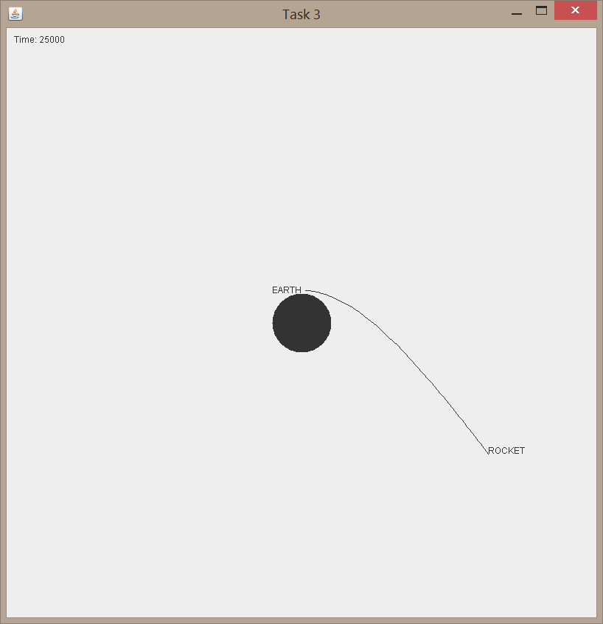
Result: The rocket left orbit as depicted in the screenshot below. As always, the analyzer data dump is on the next page.

Test 4 analyzer data dump
Body: EARTH
Time: 25000.0
Distance: .5
Velocity:
Min: 9.051523658583E-12
Max: 1.2981787814751999E-10
Avg: 2.3323773580898946E-11
Std: 1.5424949352200888E-11
Acceleration:
Min: 1.351417686631858E-22
Max: 1.622723484616993E-11
Avg: 9.219665317987815E-17
Std: 3.339458202215838E-14

Body: ROCKET
Time: 25000.0
Distance: 432174.6
Velocity:
Min: 5.2390033606893735E-6
Max: 2.799999999704953
Avg: 1.358434571762315E-4
Std: 0.007180934823510769
Acceleration:
Min: 1.0383584454504852E-16
Max: 0.7000000006380263
Avg: 3.976754391825181E-6
Std: 0.0014405539601297377

