Below are the additional(and clarified) figures for Project 1.

For clarity, I’ve added printouts of the buffer (size = 5) where empty cells display as “null”. Previously, consumed elements were simply made available to the producer, rather than overwritten.

**Balanced Producing and Consuming**

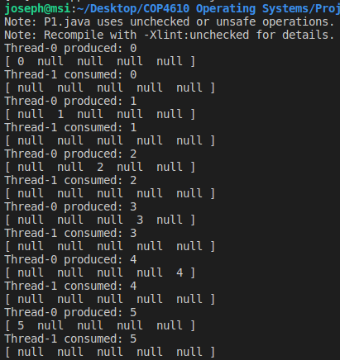

**2 Producers and 1 Consumer**

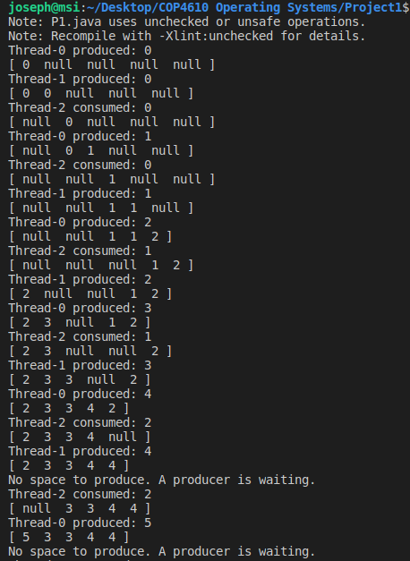

**2 Consumers and 1 Producer**

