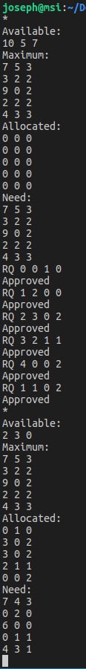Joseph Allen

COP 4610 – Operating Systems

11/10/18

Program tests the example on page 333.

Left image shows request approval and image below show request denial.

