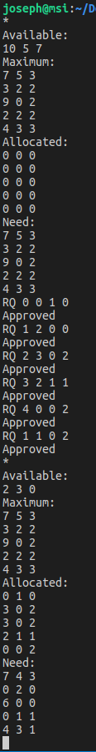
Joseph Allen
COP 4610 – Operating Systems
11/10/18

Left image shows request approval and image below show request denial.
