COP4610 - Operating Systems
Programming Assignment 1
Joseph Allen
10/2/18
Program 1) In my program I have 4 classes:
- P1 – contains main; creates BoundedBuffer object; creates and starts Producers & Consumers.
- BoundedBuffer – has a constructor to create a generic-type array of a given size; contains methods to produce or consume items in the array.
- Producer – used to create a thread that continuously calls produce() on a BoundedBuffer instance; in this program I pass produce incrementing integers starting from 0.
- Consumer – used to create a thread that continuously calls consume() on a BoundedBuffer instance.
The program handles the following conditions:
- A producer (consumer) producing (consuming) past the end (beginning) of the buffer.
  - It handles this by telling producers (consumers) to wait() if the buffer is full (empty).
- A producer writing to an array element that is not EMPTY and a consumer reading (i.e. setting the array element to EMPTY) from an array element that is not FULL.
  - I handle this by keeping track of the index in the array that a producer (consumer) can set to FULL (can set to EMPTY). I use index % BUFFER_SIZE to keep indices within the buffer.
- Use wait() and notify() to avoid errors producing and consuming and to ensure thread synchronization.
  - My program uses wait() and notifyAll() within synchronized blocks to ensure only one thread at a time can access the critical buffer data.
Examples of output when the BoundedBuffer instance has BUFFER_SIZE of 5:
- On the left is an example of the program executing with 2 producers and 1 consumer. The consumer can’t keep up with the 2 producers and the producers end up waiting on it to free up space for them.
- On the right is an example of the program executing with 1 producer and 2 consumers. From the very start, the consumers are waiting for items to consume.
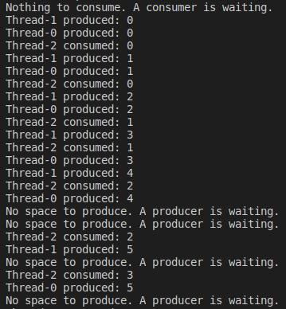
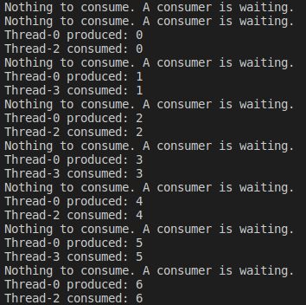

Program 2) In my program I have 4 functions:
- main – runs program loop that 1) captures user input, 2) calls parse_input(), 3) calls translate(), and 4) forks the process and calls execute() within the child (the parent waits for child)
- parse_input – accepts an input string and parses it for a command and any number of arguments; returns pointers to each token.
- translate – accepts pointers to strings and translates the first one (the command) if appropriate.
- execute – calls chdir() if the command is ‘cd’, otherwise it calls execvp(<command>, <args>)
My program functions as a DOS to UNIX interpreter and successfully translates the commands dir, type, del, ren, and copy. Any non-DOS commands skip the translation process and are executed in the shell as normal commands.
