Práctica Arduino: José Santos Salvador

1.- Zumbador pasivo

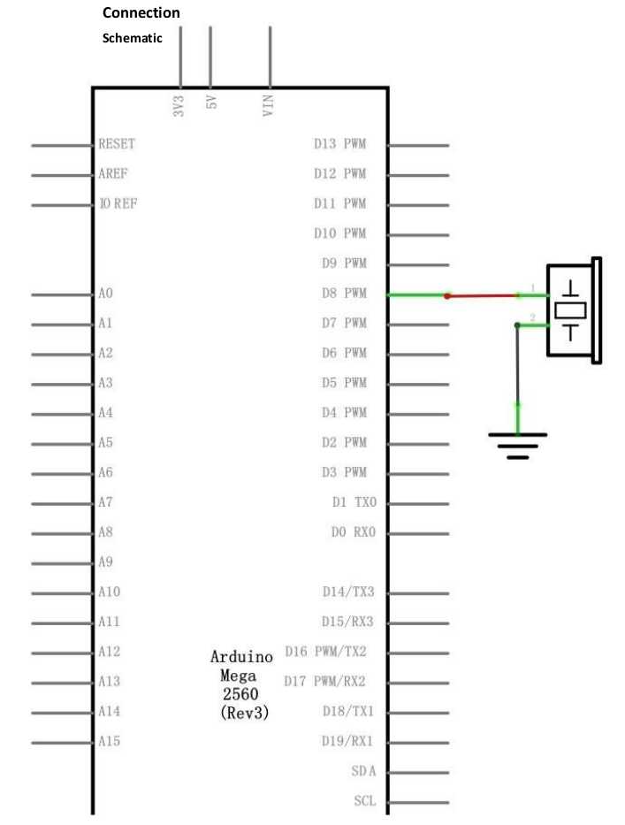
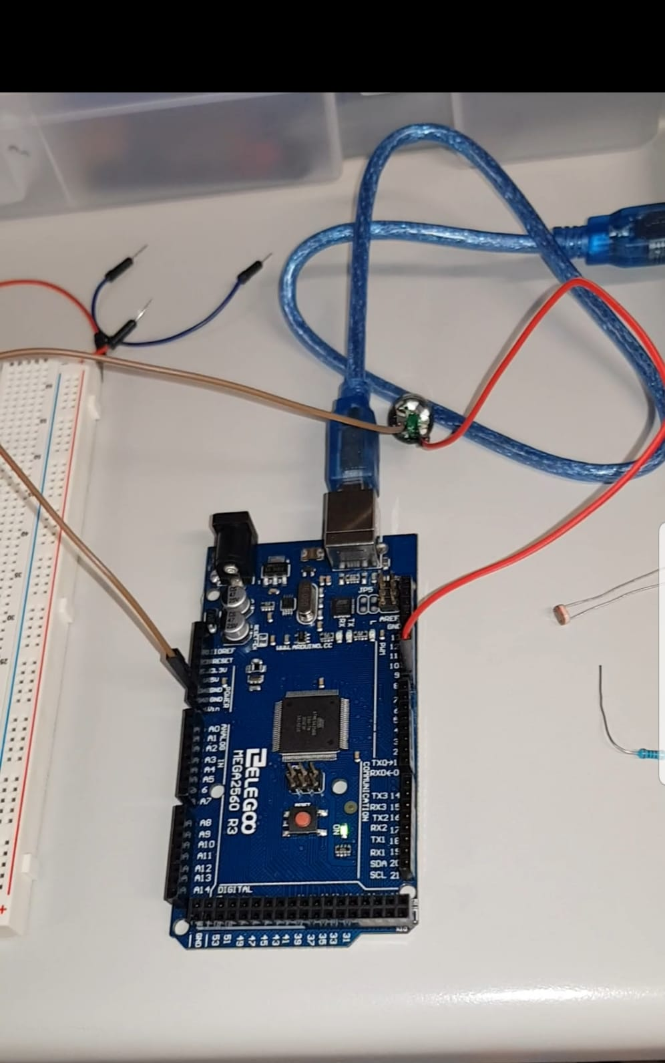
Con el zumbador pasivo y tras seguir el esquema del circuito monté esta parte de la práctica. Sabiendo que notas tenemos y buscando la canción original cambie el código para que sonase una canción. El código se puede buscar ya escrito en plataformas como github.

Realicé dos canciones diferentes, con sus dos códigos diferentes
https://drive.google.com/open?id=1P25OvBtMYIwk01h6BTZ7fbZwkGBAlODD
https://drive.google.com/open?id=1BvFeubjEFYRxklmeo90bh9rpLISQ3x26

Primer código:
#include "pitches.h"

// notes in the melody:
int melody[] = {
NOTE_C4, NOTE_A4, NOTE_G4, NOTE_F4, NOTE_G4, NOTE_E4,
NOTE_C4, NOTE_A4, NOTE_G4, NOTE_F4, NOTE_E4, NOTE_F4,
NOTE_C4, NOTE_A4, NOTE_G4, NOTE_F4, NOTE_G4, NOTE_CS4,
NOTE_C4, NOTE_A4, NOTE_G4, NOTE_F4, NOTE_CS4, NOTE_C4,
NOTE_C4, NOTE_A4, NOTE_G4, NOTE_F4, NOTE_DS4, NOTE_CS4,
NOTE_A3, NOTE_G3, NOTE_G4, NOTE_F4, NOTE_FS4, NOTE_F4,
NOTE_G4, NOTE_F4, NOTE_G4, NOTE_CS4, NOTE_F4, NOTE_G4,
NOTE_F4, NOTE_CS4, NOTE_C4
};

// note durations: 4 = quarter note, 8 = eighth note, etc.:
int noteDurations[] = {
3, 4, 4, 6, 6, 3,
4, 6, 6, 4, 4, 3,
2, 6, 6, 4, 6, 6,
3, 4, 4, 6, 6, 3,
3, 4, 4, 6, 6, 3,
4, 6, 6, 4, 4, 3,
4, 6, 6, 4, 6, 6,
3, 4, 4
};

void setup() {
// iterate over the notes of the melody:
for (int thisNote = 0; thisNote < 45; thisNote++) {

// to calculate the note duration, take one second
// divided by the note type.
//e.g. quarter note = 1000 / 4, eighth note = 1000/8, etc.
int noteDuration = 1000/noteDurations[thisNote];
tone(8, melody[thisNote],noteDuration);

// to distinguish the notes, set a minimum time between them.
// the note's duration + 30% seems to work well:
int pauseBetweenNotes = noteDuration * 1.30;
delay(pauseBetweenNotes);
// stop the tone playing:
noTone(8);
}
}

void loop() {
// no need to repeat the melody.
}

Segundo código:

#define NOTE_B0 31
#define NOTE_C1 33
#define NOTE_CS1 35
#define NOTE_D1 37
#define NOTE_DS1 39
#define NOTE_E1 41
#define NOTE_F1 44
#define NOTE_FS1 46
#define NOTE_G1 49
#define NOTE_GS1 52
#define NOTE_A1 55
#define NOTE_AS1 58
#define NOTE_B1 62
#define NOTE_C2 65
#define NOTE_CS2 69
#define NOTE_D2 73
#define NOTE_DS2 78
#define NOTE_E2 82
#define NOTE_F2 87
#define NOTE_FS2 93
#define NOTE_G2 98
#define NOTE_GS2 104
#define NOTE_A2 110
#define NOTE_AS2 117
#define NOTE_B2 123
#define NOTE_C3 131
#define NOTE_CS3 139
#define NOTE_D3 147
#define NOTE_DS3 156
#define NOTE_E3 165
#define NOTE_F3 175
#define NOTE_FS3 185
#define NOTE_G3 196
#define NOTE_GS3 208
#define NOTE_A3 220
#define NOTE_AS3 233
#define NOTE_B3 247
#define NOTE_C4 262
#define NOTE_CS4 277
#define NOTE_D4 294
#define NOTE_DS4 311
#define NOTE_E4 330
#define NOTE_F4 349
#define NOTE_FS4 370
#define NOTE_G4 392
#define NOTE_GS4 415
#define NOTE_A4 440
#define NOTE_AS4 466
#define NOTE_B4 494
#define NOTE_C5 523
#define NOTE_CS5 554
#define NOTE_D5 587
#define NOTE_DS5 622
#define NOTE_E5 659
#define NOTE_F5 698
#define NOTE_FS5 740
#define NOTE_G5 784
#define NOTE_GS5 831
#define NOTE_A5 880
#define NOTE_AS5 932
#define NOTE_B5 988
#define NOTE_C6 1047
#define NOTE_CS6 1109
#define NOTE_D6 1175
#define NOTE_DS6 1245
#define NOTE_E6 1319
#define NOTE_F6 1397
#define NOTE_FS6 1480
#define NOTE_G6 1568
#define NOTE_GS6 1661
#define NOTE_A6 1760
#define NOTE_AS6 1865
#define NOTE_B6 1976
#define NOTE_C7 2093
#define NOTE_CS7 2217
#define NOTE_D7 2349
#define NOTE_DS7 2489
#define NOTE_E7 2637
#define NOTE_F7 2794
#define NOTE_FS7 2960
#define NOTE_G7 3136
#define NOTE_GS7 3322
#define NOTE_A7 3520
#define NOTE_AS7 3729
#define NOTE_B7 3951
#define NOTE_C8 4186
#define NOTE_CS8 4435
#define NOTE_D8 4699
#define NOTE_DS8 4978
#define REST 0

int tempo=88;

// change this to whichever pin you want to use
int buzzer = 11;

// notes of the moledy followed by the duration.
// a 4 means a quarter note, 8 an eighteenth , 16 sixteenth, so on
// !!negative numbers are used to represent dotted notes,
// so -4 means a dotted quarter note, that is, a quarter plus an eighteenth!!
int melody[] = {

//Based on the arrangement at https://www.flutetunes.com/tunes.php?id=169

NOTE_AS4,-2, NOTE_F4,8, NOTE_F4,8, NOTE_AS4,8,//1
NOTE_GS4,16, NOTE_FS4,16, NOTE_GS4,-2,
NOTE_AS4,-2, NOTE_FS4,8, NOTE_FS4,8, NOTE_AS4,8,
NOTE_A4,16, NOTE_G4,16, NOTE_A4,-2,
REST,1,

NOTE_AS4,4, NOTE_F4,-4, NOTE_AS4,8, NOTE_AS4,16, NOTE_C5,16, NOTE_D5,16, NOTE_DS5,16,//7
NOTE_F5,2, NOTE_F5,8, NOTE_F5,8, NOTE_F5,8, NOTE_FS5,16, NOTE_GS5,16,
NOTE_AS5,-2, NOTE_AS5,8, NOTE_AS5,8, NOTE_GS5,8, NOTE_FS5,16,
NOTE_GS5,-8, NOTE_FS5,16, NOTE_F5,2, NOTE_F5,4,

NOTE_DS5,-8, NOTE_F5,16, NOTE_FS5,2, NOTE_F5,8, NOTE_DS5,8, //11
NOTE_CS5,-8, NOTE_DS5,16, NOTE_F5,2, NOTE_DS5,8, NOTE_CS5,8,
NOTE_C5,-8, NOTE_D5,16, NOTE_E5,2, NOTE_G5,8,
NOTE_F5,16, NOTE_F4,16, NOTE_F4,16, NOTE_F4,16,NOTE_F4,16,NOTE_F4,16,NOTE_F4,16,NOTE_F4,16,NOTE_F4,8, NOTE_F4,16,NOTE_F4,8,

NOTE_AS4,4, NOTE_F4,-4, NOTE_AS4,8, NOTE_AS4,16, NOTE_C5,16, NOTE_D5,16, NOTE_DS5,16,//15
NOTE_F5,2, NOTE_F5,8, NOTE_F5,8, NOTE_F5,8, NOTE_FS5,16, NOTE_GS5,16,
NOTE_AS5,-2, NOTE_CS6,4,
NOTE_C6,4, NOTE_A5,2, NOTE_F5,4,
NOTE_FS5,-2, NOTE_AS5,4,
NOTE_A5,4, NOTE_F5,2, NOTE_F5,4,

NOTE_FS5,-2, NOTE_AS5,4,
NOTE_A5,4, NOTE_F5,2, NOTE_D5,4,
NOTE_DS5,-2, NOTE_FS5,4,
NOTE_F5,4, NOTE_CS5,2, NOTE_AS4,4,
NOTE_C5,-8, NOTE_D5,16, NOTE_E5,2, NOTE_G5,8,
NOTE_F5,16, NOTE_F4,16, NOTE_F4,16, NOTE_F4,16,NOTE_F4,16,NOTE_F4,16,NOTE_F4,16,NOTE_F4,16,NOTE_F4,8, NOTE_F4,16,NOTE_F4,8

};

// sizeof gives the number of bytes, each int value is composed of two bytes (16 bits)
// there are two values per note (pitch and duration), so for each note there are four bytes
int notes=sizeof(melody)/sizeof(melody[0])/2;

// this calculates the duration of a whole note in ms (60s/tempo)*4 beats
int wholenote = (60000 * 4) / tempo;

int divider = 0, noteDuration = 0;

void setup() {
// iterate over the notes of the melody.
// Remember, the array is twice the number of notes (notes + durations)
for (int thisNote = 0; thisNote < notes * 2; thisNote = thisNote + 2) {

// calculates the duration of each note
divider = melody[thisNote + 1];
if (divider > 0) {
// regular note, just proceed
noteDuration = (wholenote) / divider;
} else if (divider < 0) {
// dotted notes are represented with negative durations!!
noteDuration = (wholenote) / abs(divider);
noteDuration *= 1.5; // increases the duration in half for dotted notes
}

// we only play the note for 90% of the duration, leaving 10% as a pause
tone(buzzer, melody[thisNote], noteDuration*0.9);

// Wait for the specief duration before playing the next note.
delay(noteDuration);

// stop the waveform generation before the next note.
noTone(buzzer);
}

}

void loop() {
// no need to repeat the melody.
}

2.- Theremin de luz sin LEDS

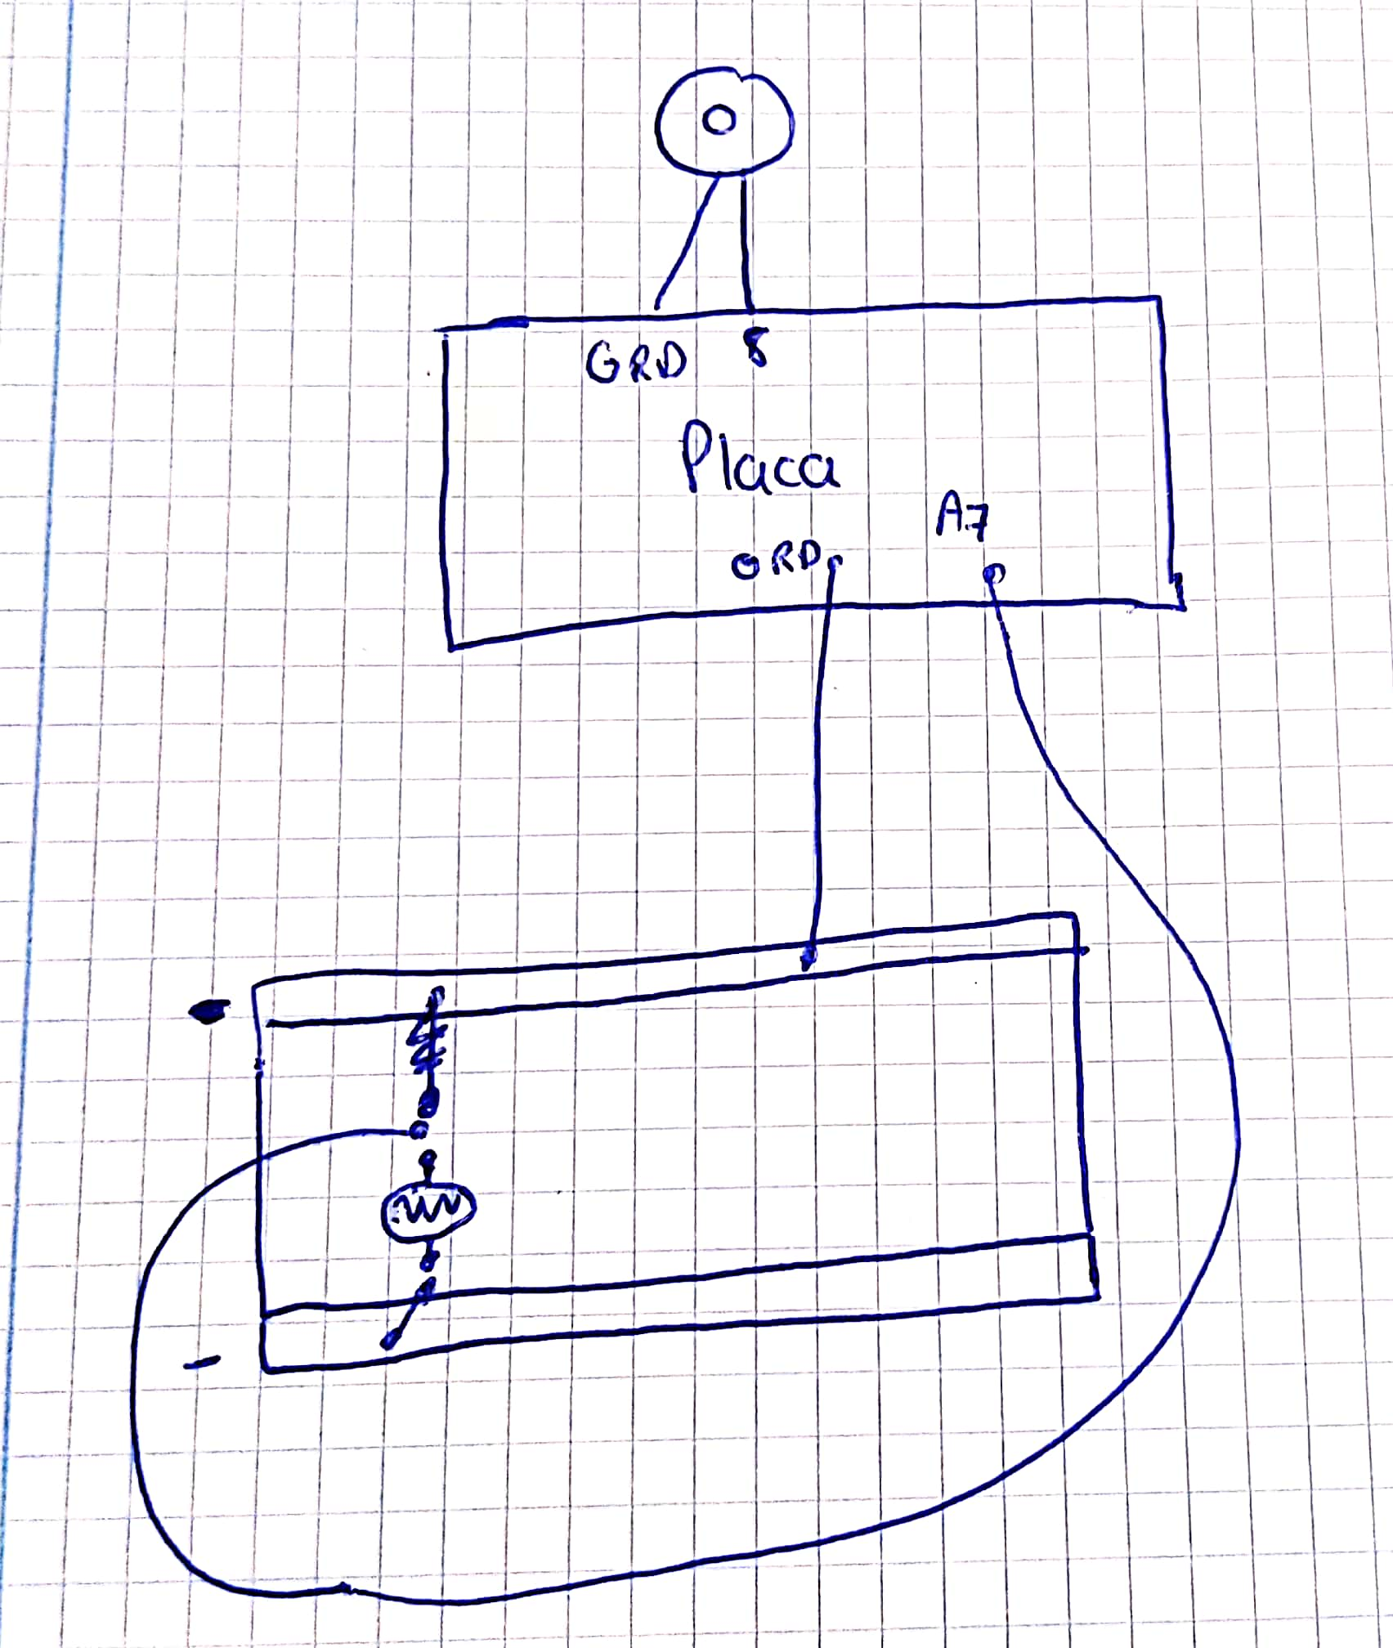
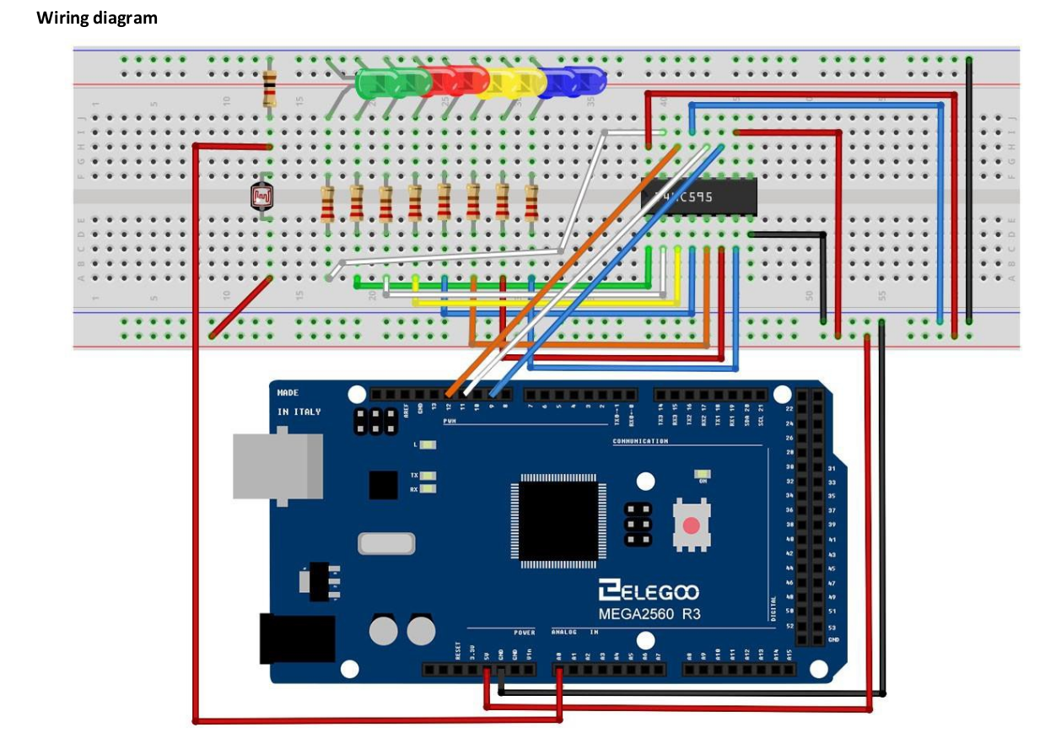
Manteniendo el circuito del zumbador pasivo le añadí lo necesario para crear el theremin de luz sin leds siguiendo los siguientes esquemas.

(En este esquema ignoramos los leds)

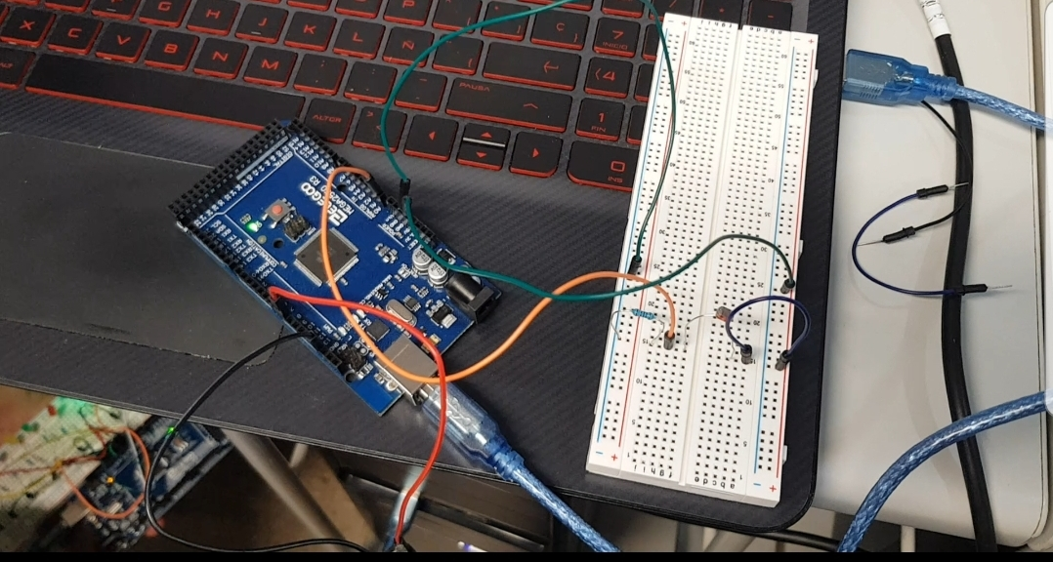

video sobre el circuito:
https://drive.google.com/open?id=1BgTYlBzRLegk6RL1NKjLZOzfdmZV1KY7

código:
/*
Arduino Starter Kit example
Project 6 - Light Theremin

This sketch is written to accompany Project 6 in the Arduino Starter Kit

Parts required:
- photoresistor
- 10 kilohm resistor
- piezo

created 13 Sep 2012
by Scott Fitzgerald

http://www.arduino.cc/starterKit

This example code is part of the public domain.
*/

// variable to hold sensor value
int sensorValue;
// variable to calibrate low value
int sensorLow = 1023;
// variable to calibrate high value
int sensorHigh = 0;
// LED pin
const int ledPin = 13;

void setup() {
// Make the LED pin an output and turn it on
pinMode(ledPin, OUTPUT);
digitalWrite(ledPin, HIGH);

// calibrate for the first five seconds after program runs
while (millis() < 5000) {
// record the maximum sensor value
sensorValue = analogRead(A0);
if (sensorValue > sensorHigh) {
sensorHigh = sensorValue;
}
// record the minimum sensor value
if (sensorValue < sensorLow) {
sensorLow = sensorValue;
}
}
// turn the LED off, signaling the end of the calibration period
digitalWrite(ledPin, LOW);
}

void loop() {
//read the input from A0 and store it in a variable
sensorValue = analogRead(A0);

// map the sensor values to a wide range of pitches
int pitch = map(sensorValue, sensorLow, sensorHigh, 50, 4000);

// play the tone for 20 ms on pin 8
tone(8, pitch, 20);

// wait for a moment
delay(10);
}

3.- Semáforo de LEDS
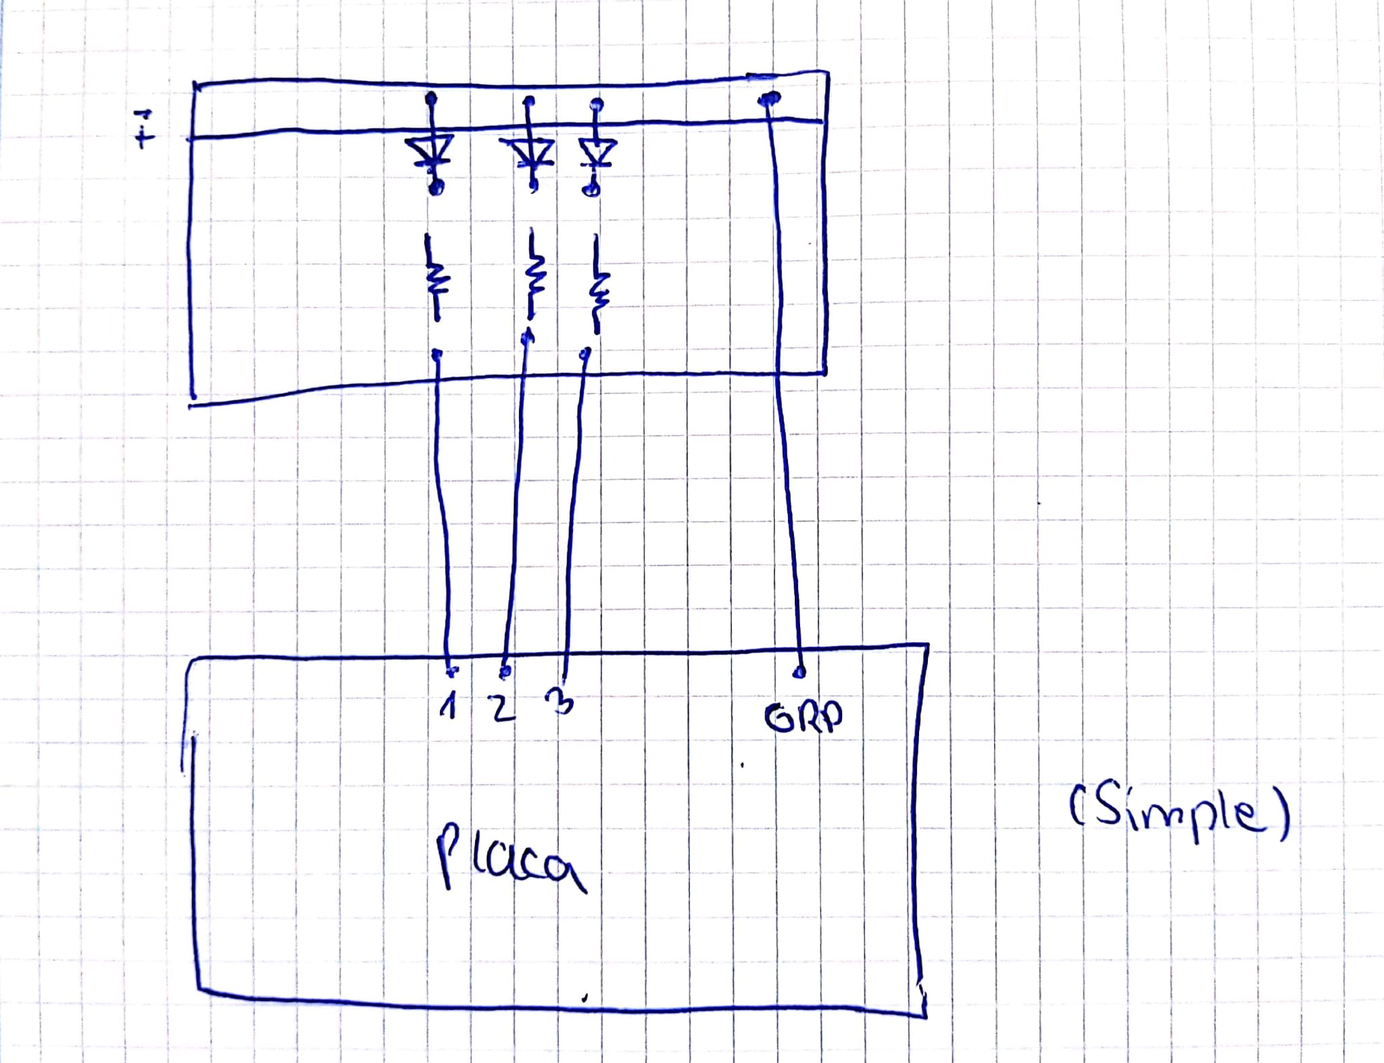

(solo la parte de los leds)

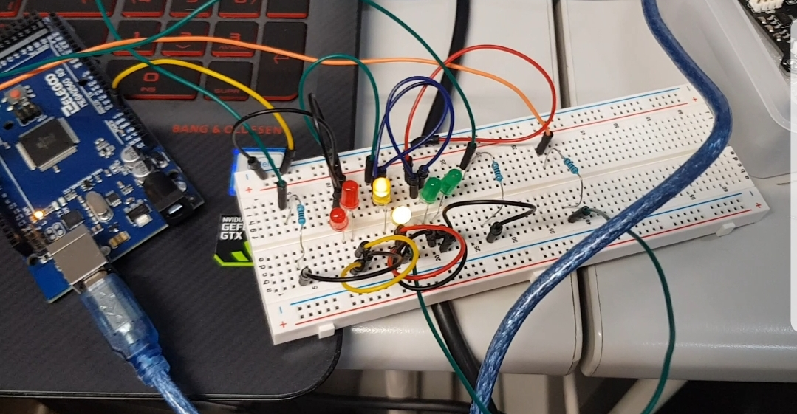

video: https://drive.google.com/open?id=1Bmvu_yvwFl6u40EXC7P7ZbQ00UBWjg6L

codigo:

void setup() {
// initialize digital pin LED_BUILTIN as an output.
pinMode(12, OUTPUT);
pinMode(10, OUTPUT);
pinMode(8, OUTPUT);
}

// the loop function runs over and over again forever
void loop() {
digitalWrite(12, HIGH); // turn the LED on (HIGH is the voltage level)
delay(3000); // wait for a second
digitalWrite(12, LOW); // turn the LED off by making the voltage LOW
for(int i=0; i<5;i++)
{
digitalWrite(10, HIGH);
delay(1000);
digitalWrite(10, LOW);
}
digitalWrite(8, HIGH);
delay(3000); // wait for a second
digitalWrite(8, LOW);
}

