Project Report

1. Project: Automatic Performance Tuner for OpenMP and Its Extensions

2. Duration: 2008.1 ~ 2008.12

3. Brief Description

Multi-cores will be widely used in high performance computer systems, as mainstream processor designs continue to integrate more cores in a single chip. PCs or laptops with general-purpose multi-cores from Intel or AMD are popular, and Cell chip from STI is being used in a wide area from world’s fastest super computer to PS3. NVIDIA is driving multi-cores of GPU for graphics and streaming workloads. In consumer electronics (CE) industry, we also expect that multi-cores will be the mainstream microprocessor architecture for devices such as mobile phones and HDTV to achieve better performance and power efficiency. And the diversity of multi-core architectures will be driven by more diverse CE devices and applications.
However, developing or reusing software for multi-core is difficult as we should consider low-level details such as memory hierarchy or data bandwidth. To obtain the potential performance of multi-core, hardware features should be carefully considered by using architectural information, experience, or profiling feedback, which results in software for a specific architecture. Unfortunately, optimized software for one H/W architecture is usually not reusable for different H/W architectures because of performance degradation. For example, if an application optimized for a dual-core CPU needs to run on quad-core CPU, it must be modified to utilize the power and cache hierarchy of the quad-core CPU.
In this project, I have designed and implemented OpenMP extensions for fine performance tuning and a method for automatic tuning of OpenMP programs. The OpenMP extensions controls performance factors such as affinity, cache blocking factor, and the number of threads. [1, 2] show that controlling these factors can significantly improve performance or reduce power, but OpenMP (or high-level programming environments) lacks these features. As these factors are highly related with HW architecture, the separation of these factors from the basic functionality of the source code (by using OpenMP pragma) allows reuse of source code easy. A question may arise how we can find optimal values for them, as the values vary on input data set and across different source code range. To answer the question, I have devised a profiling feedback mechanism integrated with our programming environment to automatically tuning parallel programs. As the searching space for finding optimal values is enormous, several algorithms are devised to shorten the search time. The prototype was implemented using gcc 4.3.

int foo() { Serial Code
#pragma omp parallel
{
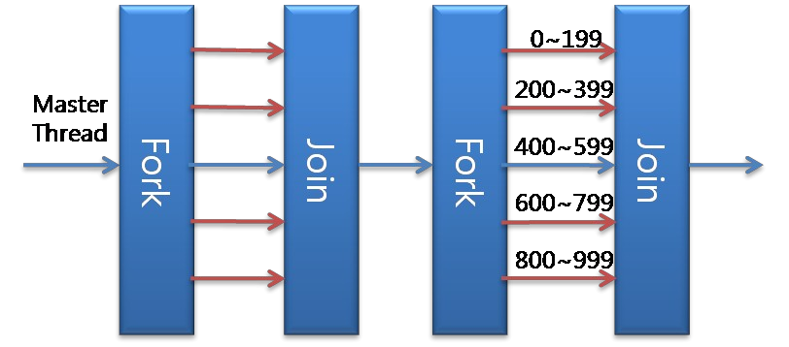

Parallel section executed by all threads
……
All threads join master thread and disband
}
Serial Code
#pragma omp parallel for
for (int i = 0; i < 1000; i++) {
c[i] = a[i] + b[i];
}
}

Figure 1: An example of OpenMP C code and its execution.

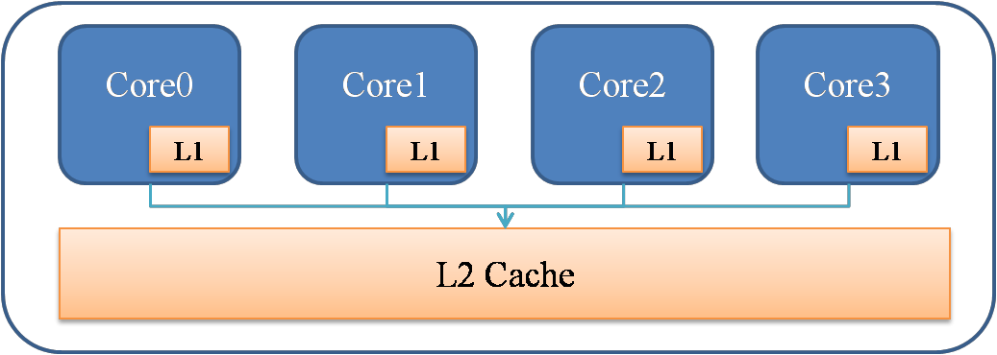

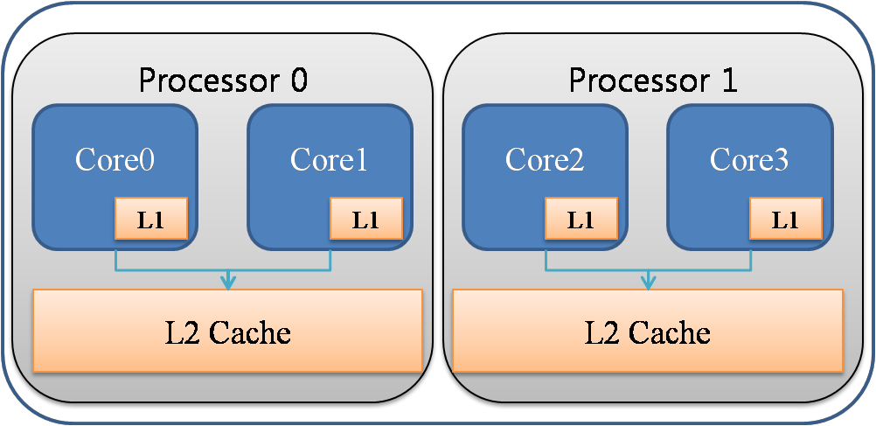

Figure 2: Architecture of Intel Core 2 Quad (Q6600 Kentsfield, left) and ARM 11 MPCore (right). As their cache size

and hierarchy are different, optimization for one processor type may not be useful to the other processor type.

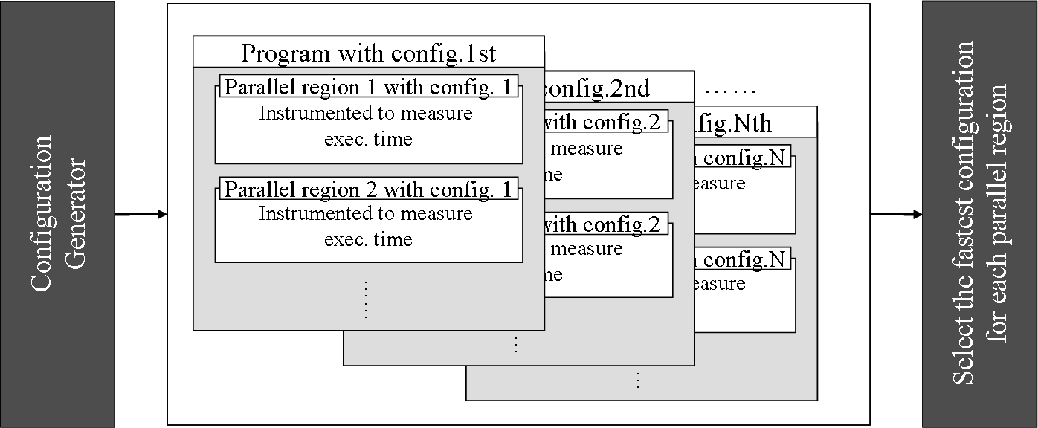

Figure 3: Automatic performance tuning. Each parallel region may have different values of performance factors, and manually finding of optimal values for all parallel regions is difficult and error prone.

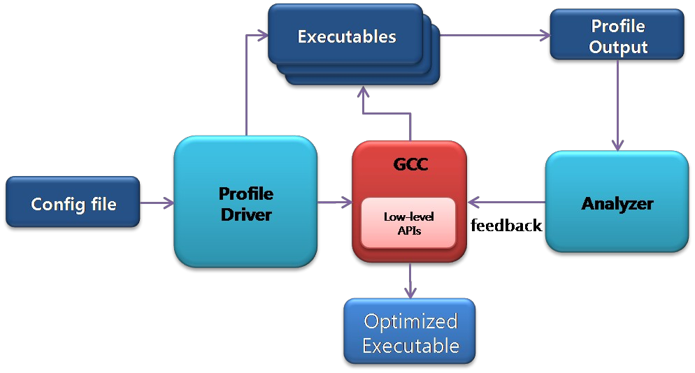

Figure 4: Automatic tuning overall architecture

4. Role

■ As the lead of the OpenMP C/C++ compiler project (a sub-lead of Multi-core S/W Platform project), I’ve designed software architecture and managed people. I’ve designed OpenMP extensions for controlling affinity, cache blocking, and number of thread, and implemented affinity. I’ve designed and implemented automatic tuning method architecture and the basic (exhaustive) searching method of optimal values.

Appendix

■ Definition & Acronyms

OpenMP: Industry standard for parallel programming, composed of language pragma and libraries.

■ References

1. M. Aater Suleman, el. Tal., “Feedback-Driven Threading: Power-Efficient High-Performance

Execution of Multi-threaded Workloads on CMPs”, In Proceedings of ASPLOS ’08, March

2008.

2. Samuel Williams, et. al., “Lattice Boltzmann Simulation Optimization on Leading Multicore

Platforms”, In Proceedings of IPDPS 2008, April 2008.

