Project Report

1. Project: Optimizing OpenMP Compiler for the Cell Architecture

2. Duration: 2006.1 ~ 2007.12

3. Brief Description

Multiprocessor-System-on-a-Chips (MPSoCs) have been widely used in today’s high performance embedded systems, such as cellular phones and MP3 players. Among them, the Cell Broadband Engine (CBE) processor is for high-end computing, targeting such application as multimedia streaming, game applications as in PlayStation 3, and other numerically intensive workloads. The CBE is a heterogeneous multi-core processor designed by Sony, Toshiba, and IBM. It is composed of 1 PowerPC Processor Element (PPE) and 8 Synergistic Processor Elements (SPE), interconnected by high-speed bus. The PPE runs OS and control tasks, and the SPE runs computation intensive tasks. The SPE has a small local memory, and the main memory is shared between the PPE and the SPEs. The SPE has SIMD unit for fast computation, and data transfer from/to main memory is carried out by explicit DMA operation (no hardware cache in the SPE for the main memory).
Developing optimized software for the CBE, however, is very difficult because of its complex architecture and multilevel heterogeneous parallelism. For easy of parallel programming, we implemented OpenMP automatic parallelizing C/C++ compiler for the CBE. OpenMP allows easily writing parallel programs just by outlining program region that can run in parallel. We also developed compiler techniques designed to exploit performance potential of the CBE, including instruction scheduling, auto-SIMD for utilizing data-level parallelism, and auto- overlay. Instead of implementing it from scratch, we used GCC open source compiler which is very popular in industry and academy. Since our first priority customer was streaming and media applications, we used mpeg2 video decoder and some proprietary video software module for improving image quality as main benchmarks. As the lead of the compiler project (a part of Multi- core S/W Platform project), I’ve designed the architecture and process, and also been involved in implementation and optimization.
As shown in the Figure 1, the GCC compiler is composed of three parts: Front-end, Middle- end, and Back-end. The Front-end reads source code and translate it into high-level machine-independent intermediate code. The Middle-end optimizes intermediate code and translates it into low-level intermediate code. Finally, the Back-end further optimizes in low-level, and then generates assembly (machine) code. My works covers all three parts from the Front-end to the Back-end.

4. Role

Lead of the OpenMP C/C++ compiler project (a sub-lead of Multi-core S/W Platform project). I’ve designed the team and software architecture, and managed people. I’ve implemented many optimizations including instruction scheduling and auto-SIMD in C language. For instruction scheduling, I’ve re- implemented software pipelining, a loop optimization of GCC, to exploit many registers in the SPE core. Also, I’ve implemented bundling so that instructions in the different pipelines of a SPE can be issued at the same time. For OpenMP optimization, I’ve designed software cache and static buffering [5] to reduce the overheads of DMA in the CBE; every access to main memory from a SPE is carried out by time- consuming DMA operation, which can be minimized by software cache and static buffering by utilizing SPE local memory as a cache for the main memory (since the SPE has no hardware cache). I’ve implemented static buffering.
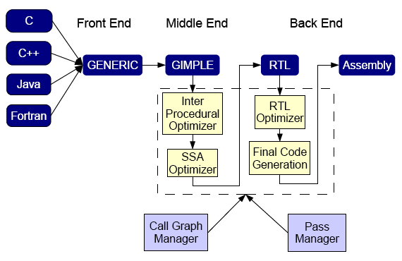

Figure 1: GCC compiler architecture. OpenMP was implemented in the Front and Middle End

(GIMPLE), and instruction scheduling was implemented in the Back End.

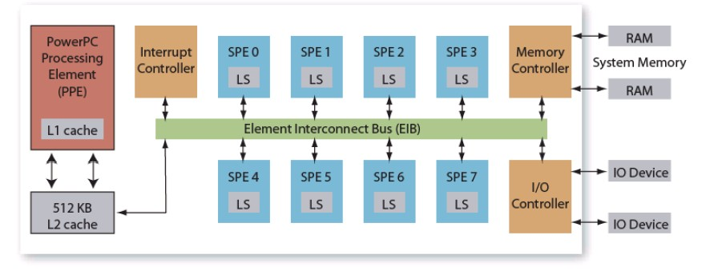

Figure 2: Cell processor architecture. A PPE performs controlling tasks and SPEs perform data-intensive tasks. The SPE has a local memory (LS) but does not have HW cache.

Appendix

■ Definition & Acronyms

GCC: GNU Compiler Collection.

OpenMP: Industry standard for parallel programming, composed of language pragma and libraries.

■ References

1. http://gcc.gnu.org

2. http://www.openmp.org

3. http://www.ibm.com/developerworks/power/cell/

4. Junggyu Park, et. al., “Compiler Optimization for the Cell Architecture”. In Proceedings of the 5th Workshop on Optimization for DSP and Embedded Systems (ODES-5), in conjunction with CGO 5, San Jose, March 2007. (http://www.ece.vill.edu/~deepu/odes/odes-5_digest.pdf)
5. T. Chen. et.al., “Optimizing the use of static buffers for DMA on a CELL chip”, In Proceedings of Workshop on

Language and Compiler for Parallel Computing (LCPC), 2006.

