Project Report

1. Project: Samsung Cellular Phones for Sprint

2. Duration: 2002.9 ~ 2004.6

3. Brief Description

Platform independence of Java makes it one of the most popular software platforms in mobile devices. J2ME, a specification for resource-constrained devices, is best suitable for Java on cellular phones and PDAs. To run a MIDlet, an application written in J2ME specification, one should have a Java Virtual Machine (JVM) and libraries in the device. As a senior software engineer in Samsung Electronics, I was involved in implementing and optimizing JVM and libraries in Samsung cellular phones for Sprint (now Sprint Nextel) including SPH-A700, A620, and A600.
For this to happen, CLDC, a small JVM and a set of basic libraries for J2ME specification, should first be implemented. Other libraries such as MIDP (for UI and basic API for games) or WMA (for wireless messaging) can be added for more features. Instead of implementing them from scratch, we have taken source code form Sun Microsystems by licensing. As shown in the Figure 1 below, CLDC and Java libraries (e.g., MIDP) are on top of native platform and operating system (in my case, REX from Qualcomm), thus some part of CLDC and libraries are written in native C language for integrating with native platform. Most of my work was to integrate J2ME platform with native platform by writing a porting (integrating) layer in C language. Integration with AMS, which manages MIDlets, was needed also (source code taken from third party). Performance optimization for faster booting, file access, and
display were carried out after that in either C or Java language.

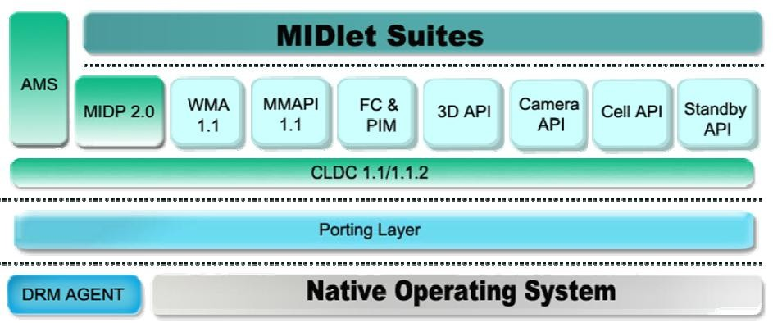
Figure 1: A typical system architecture for J2ME platform.

4. Role

■ SPH-A620, 600: Senior software Engineer for optimizing CLDC and MIDP. I have optimized RMS (Record Management System), which is a small record-based database system for MIDP, with the idea of memory DB. I also optimized 2D graphics library either by lowering Java code to native C code or by algorithm change. Java class loading, which loads Java class from flash memory to main memory, is one of the most time-consuming parts of application launching. I re-implemented it by using memory buffers to minimize time consuming flash memory access. Java garbage collection mechanism causes big overheads if a program is written to use it (by invoking explicitly) heavily; I fixed it so that garbage collection could be performed only when necessary.
■ SPH-A700: a sub-lead of the cellular phone software (the lead for Java platform), and implemented integration of CLDC/MIDP/WMS with native platform and AMS in C language.
■ Using persistent storage for storing loaded and compiled (to native code at runtime for performance) Java program was implemented and patented (refer to the attached patents).

Appendix

■ Definition & Acronyms

MIDP: Mobile Information Devices Profile. It is a profile that is designed for cellular phones and wireless PDA’s based on CLDC specifications.
J2ME: Java 2 Platform Micro Edition is a development platform for resource-constrained devices dedicated in embedded market.
CLDC: Connected Limited Devices Configuration. It has JVM and class libraries that provide a minimum amount of useful library functions for developing compact device applications.
AMS: Application management software, is a module that controls the downloading, updating, installing, listing, executing and deleting of Java applications.

■ Patents

• Patent: “System and method for shortening class loading process in Java program”.

■ Korea, 27/05/2005, P0493893

■ China, 14/02/2007, 200410003658.4

■ Refer to http://www.google.com/patents with the title as the keyword.

• Patent: “System and method for shortening compiling time of byte codes in Java program”

■ Korea, 28/07/2005, P0506522

■ Refer to http://www.google.com/patents with the title as the keyword.

