Project Report

1. Project: Object-Oriented Software Platform for Mobile Devices

2. Duration: 2004.7 ~ 2005.12

3. Brief Description

As mobile devices having more features, software platform is getting more important in that it addresses such requirements as robust, portable, reliable, customizable, extensible, and secure software. To meet these requirements, we designed OCEAN that is Object-oriented Configurable Embedded System Architecture for Next Generation (OCEAN is the successor of MOCHA, which was shipped in SGH-Z100 and 105, and many other UMTS cellular phones). OCEAN is a proprietary software platform by Samsung Electronics, designed for mobile devices, with associated application programs and programming tools. It is now named as Bada (http://www.bada.com/), and used for low-end smart phone (i.e., Samsung Wave phone). As a senior software engineer in Samsung Electronics, I was involved in designing and implementing application and component model for OCEAN.
As shown in Figure 1, OCEAN is composed of three layers: Subsystem, Framework, and Application. The Subsystem layer provides basic functionality including Core (OS), TAPI (call/SMS), GUI and event system, audio/video, and data communication support (mobile internet). Over the
Subsystem, the Framework layer provides to the Application Layer C++ class libraries which either

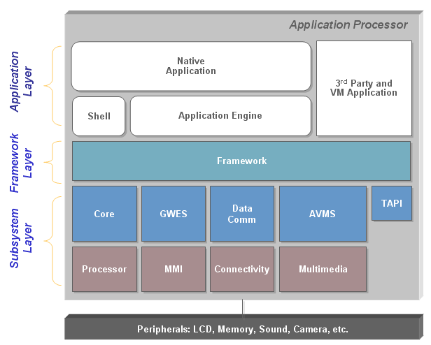

Figure 1: A typical system architecture with OCEAN platform on an application processor.

encapsulate services of the Subsystem or provide handy tools for application implementation. Finally, the Application layer resides on the top. The most important application is Shell, which installs applications and manages them at runtime. In the project, I was involved with all three layers: designing and implementing the Shell and application engine model, implementing the Component package in the Framework layer, and the Component and the Registry service in the Subsystem layer.

4. Role

A sub-lead of the project (lead for Shell, application engine, and component model). I’ve designed and implemented the Shell interface, the Component model, and the interactions between the applications and the Shell. As the Ocean platform runs on memory constrained devices, the application is needed to use small memory footprint. I’ve designed OCEAN application model to have UI and engine in a separate module to reduce memory usages; only applications running in foreground load its UI module in memory; it also increases system robustness. As the OCEAN provides configurability and extensibility (mainly for UI change of cellular phone) by plug-in model, I’ve implemented the Component and the Registry services in the Subsystem layer using C, and the Component class library in the Framework layer using C++. The Registry service manages registry information (key-value pair) in a shared memory region, so that applications in different processes can use it; registry information is needed for managing contents, components, and applications. The Component model is similar to COM from MS [1], but more lightweight by both simple threading model and small number of APIs (enough for plug-in supports), like ECOM from Symbian [2]; a component is a binary object written in any language (usually C or C++), implements one or more interfaces; a component can be used in place of the other as long as both components implement the same interface; a component should be registered by the Registry service before use; the Component model in the Subsystem provides reconfiguration and extension for the Subsystem, while the Component model in the Framework provides them for the applications; the Shell uses the Component and Registry Services to install and run applications.

Appendix

■ Definition & Acronyms

UMTS: Universal Mobile Telecommunications System (UMTS) is one of the third-generation (3G) cell phone technologies.
DRM: Digital rights management.

■ References

1. http://msdn2.microsoft.com/en-us/library/ms680573(VS.85).aspx

2. http://www3.symbian.com/faq.nsf/0/2AD55DD9F2E9A33380256F62004F9E96?OpenDocument

