Project Report

1.1. Project: Debugging Tools for Multi-core Software

1.2. Duration: 2009.1 ~ 2010.4

1.3. Brief Description

Finding the cause of errors in multi-threaded applications can be quite a challenging task. Breakpoint debuggers (such as gdb and Luaterbach T32) does not provide the effective detection of multi-thread bugs (i.e., datarace, deadlock, and atomicity) or memory bugs (i.e., memory leak, buffer overrun). To cope with this problem, Intel have developed Intel Parallel Inspector, a proactive bug finder that helps SW developers detect and perform root-cause analysis on threading and memory errors in multi-threaded applications. It can detect the following bugs:
● Memory bugs : leak detection, buffer overrun, dangling reference, uninitialized memory access, invalid memory access, misuse of malloc/free API (double free, illegal free, etc).
● Multi-thread bugs: datarace, misuse of POSIX pthreads API, deadlock, atomicity violation, diagnostic guidance (of synchronization and multi-threading).

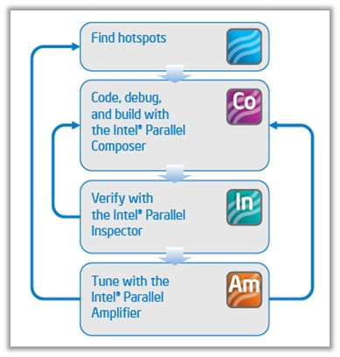

Figure 1: Intel Parallel Studio workflow. Intel Parallel Inspector is a verification tool in the Intel Parallel Studio suite. Composer is the compiler tool with libraries and a debugger, and Amplifier is performance profiling tool.
As multi-core is inevitable in embedded world, we need tools like Intel Parallel Inspector. However, such tools (including both commercial and open-source) are usually for Intel processor and there are no tools we can use for ARM processor. Thus, we started on developing ARM version of Intel Parallel Inspector. As the lead of this project (a part of Multi-core S/W Tools project), I have designed overall architecture and worked on implementing its prototype and some other modules.
Intel Parallel Inspector uses a binary instrumentation tool called Pin, which is provided by Intel. Pin allows C/C++ code to be injected into the areas of interest in a running executable. The injected code is then used to observe the behavior of the program. As Pin is not available for multi-threaded ARM application and Intel does not provide its source code, we used an open source binary instrumentation tool called Dyninst. The implementation of thread-bugs and some memory-bugs (memory leak, misuse of malloc/free API) detection tool uses Dyninst. To handle other memory bugs, we used Valgrind open source tool; Valgrind has very effective memory-bug detection tool called Memcheck, which we used for memory bug detection. Porting Dyninst and Valgrind to ARM multi-core processor is under way by my colleagues.

1.4. Role

■ As the lead of the project (a sub-lead of Multi-core S/W Tools project), I’ve designed software architecture and managed people. I’ve implemented basic datarace detector using hybrid dynamic datarace detection[3] algorithm. As instrumentation is the most time consuming part in analyzing large application using Dyninst, I’ve implemented optimized instrumentation module so that only those functions that are used at run-time be instrumented (Dyninst does not provide on-demand instrumentation as opposed to Valgrind or Pin).

Appendix

■ Definition & Acronyms

● Datarace: two concurrent threads access a shared memory location without synchronization, and at least one of them is a write access.
● Deadlock: Two concurrent threads are waiting each other to release a resource.

● Atomicity violation: concurrent threads do interfere with the execution of their atomic block.

■ References

1. http://software.intel.com/en-us/intel-parallel-studio-home/

2. http://srl.cs.berkeley.edu/~ksen/calfuzzer/

3. R. O’Callahan and J.-D. Choi. Hybrid dynamic data race detection. In ACM SIGPLAN

symposium on Principles and practice of parallel programming, pages 167–178. ACM, 2003.

