ABSTRACT

Baby care has grown in importance and difficulty for working women in recent years. Working mothers won't have enough time to watch their children even at home continuously. They either leave their infant in the hands of a baby sitter or send it to live with their grandparents. A smart cradle with an automatic baby monitoring system was created in the proposed work. The baby monitoring system measured and tracked the baby's vital signs, including temperature. The sensors and actuators are interfaced using the S.ODI board. In order to provide the infant with an atmosphere similar to an incubator, the baby monitoring system is coupled to the cradle. So that the baby will be placed in an environment akin to an incubator. The child baby is continuously monitored by a monitoring system. The mobile application will display the measured health-related parameters for the infant, such as Temperature, Humidity, and Wetness detection. The appropriate steps, such as changing temperature, turning on or off the fan, adjusting the cradle's movement, and playing music for the infant, will be taken if the recorded readings reveal any anomalies. The carer and the parents will also receive an alert message if the readings seem out of the ordinary. The prototype of a baby monitoring system makes things simpler for both carers and parents in terms of time management. This new born monitoring device has been shown to be the most accurate and cause the least amount of harm to the baby. This monitoring system uses the best security measures and is an extremely effective IOT-based system for real-time monitoring.

INTRODUCTION

Both parents working has become more typical in India in recent years. Baby monitoring will be the most challenging task for working parents in these circumstances. Even though they can provide for the baby's needs, it would be challenging for them to monitor the infant's wellbeing. Moreover, nearly one in ten infants is born preterm. Premature infants endure a great deal of suffering in their homes and after leaving incubators in medical facilities. Babies who arrive more than three weeks before their expected due date are considered premature. They frequently have health problems and higher mortality rates. Every second and occasionally, it's necessary to check on the baby's condition.

Premature babies must stay in the nursery unit or neonatal intensive care unit for a longer period of time than a new born normally (NICU). Premature neonates frequently experience PDA, low blood pressure (hypotension), and breathing difficulties because of an undeveloped respiratory system. They suffer from a weakened immune system, lose body heat, and other problems. According to surveys, 4 million kids would perish in the first month of their lives because of low birth weight. Babies can suffocate in high temperatures and humid surroundings. The health of the infant is further threatened by these situations. Parents and carers cannot always watch over a baby. In general, the incubator in hospitals safeguards and keeps an eye on the baby's condition for every parameter that needs to be watched. In contrast, there is something more baby-friendly in homes, where it is possible to keep track of the infant's health concerns and general surveillance on a minute-by-minute basis. The new born needs to have its surrounding humidity and temperature taken care of. With the Internet of Things, monitoring systems, automation, and data exchange are expanding quickly (IOT).

IOT devices are made up of wireless sensors, software and computer hardware that are all connected to and internet-providing device. With the help of its data transmitting software, it also makes it possible to transfer data and manage the sensors and any other linked devices without any human involvement, a minute-by-minute real-time monitoring is developed with the use of the Internet of Things. IOT devices use the most recent technology to mix internet- based communication and interaction with remote management and control as necessary. This is done through frameworks that have been implemented, ongoing research, and artificial intelligence. The IOT also makes it possible for the monitoring system to operate in surveillance mode, improving both environmental and health monitoring. This work includes modules for controlling the humidity, body temperature, wetness detection, sound sensor, speaker, camera for detecting the movement of infants and monitoring heartbeat parameters using the appropriate sensors. The smartphone application updates the baby's health status using the sensor readings. The framework on board development interface, or S.ODI board, contains embedded sensors. By doing this, the baby's basic circuit complexity and on board complexity are decreased. For a new born, the cradle is their first spot in the house. By taking care of this, the baby's health state is regularly updated, and health readings are controlled. This cradle aids the infant's security and comfort. The cradle's circuits are simpler, which lowers the possibility of short circuits. The cradle contains a surveillance system, and the baby's whereabouts and status are constantly tracked via a mobile application or an online web portal.

WORKING AND FLOWCHART:

Working Mechanism:

The S.ODI inter board seems to have two microcontrollers that operate in tandem with the microcontroller and Wi-Fi. It is necessary to keep and care for the necessary qualities and properties at all times. Using the proper sensors, these characteristics, such as body temperature and room temperature, are visualized. Throughout order to figure out yet if the infant is crying or not, a voice unit is fastened to the crib. This allows for the diagnosis of whether the baby is crying related to heat or perhaps a vital signs disparity. The microcontroller is going to analyze the sensory data, and the Wi-Fi component will communicate the information that has been captured. The baby's situation will indeed be taken into consideration when performing the specific steps in accordance with the sensory readings. According to the findings, the warmer placed underneath the crib offers adequate hot air for the newborn to feel at ease if the ambient temperature is elevated and the baby is crying. Along the same fashion, a handheld vent that can be adjusted in power is aligned on the upper portion of the cradle when the temperature exceeds a certain point. Likewise, the affixed sound would then perform lullabies in reference to the infant's cries, which is supposed to be constrained more by microcontroller or an output device. A actuator is utilized to operate the cradle, that either pivots when the infant cries. The cradle will indeed be governed via Wi-Fi, and a microphone will serve to recognize it.

The S.ODI's core employs a scripting platform called Wi-Fi, which displays every single instrument as well as other interaction measurements and states (Heater, Fan, and Music System). The process flow is observed when analyzing the results from either the devices connected. A camera linked to either a Raspberry Pi 0 is positioned on the cradle to record the complete infant's posture and action. This enables again for surveillance of the toddler's reclined position and daily activity through the Motion Eye-OS smartphone app. An interface that helps in camera visualization is named Motion Eye-OS. It's going to be easier for anyone to comprehend the Infant's comfort and medical issues because of the ongoing documentation and tracking, which assists in keeping the infant's condition and healthcare notice accurate.

B. FLOWCHART:

The user mobile will initially be linked to the microcontroller of the baby monitoring system. Using various sensors of the firmware, the baby's health is monitored. The microphone module detects whether the baby is crying or not, and if it is, an alert message is sent to the parent. The baby's temperature will be measured by the temperature sensor, and if it is higher than 98.6 F, a warning notification will be sent to the parent.

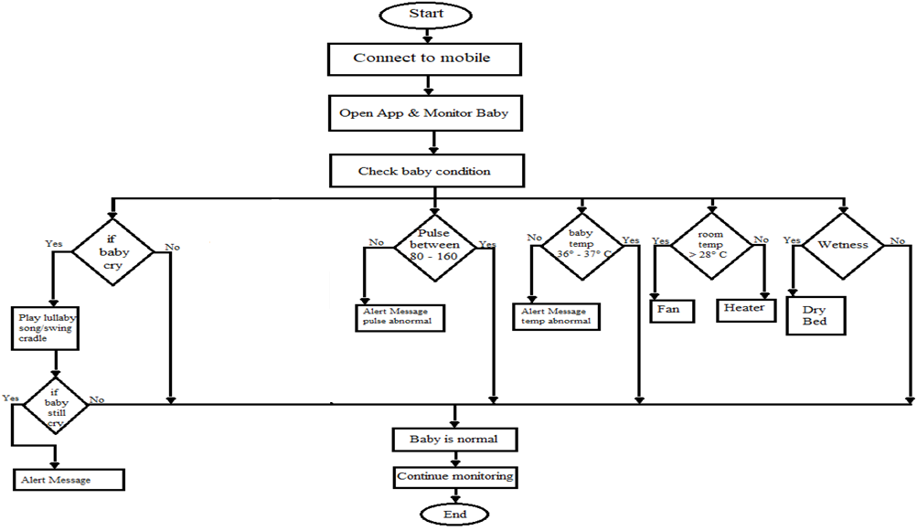

Fig. 4 Flow Chart of the Baby Monitoring System

The microcontroller will start the cooler or heater based on the temperature after the room temperature sensor has read the ambient temperature. The system will show that the baby's condition is safe and send the same message if all the sensors are functioning properly.

CONCLUSION

All relevant components, along with the webcam, mic, and temperature sensor, are incorporated with the S.ODI and WiFi Module in the developed system. The baby's body temp and also any relevant warning notifications or notices are conveyed to the care provider. A spi camera that is pre-installed with the Motion Eye- OS can be used to watch the child's posture and minute-by-minute. The required framework for baby monitoring is shown, along with the screening of important factors like health monitoring and round-the-clock baby observation.