

Simulated Network Prototype Of

SRM University , Kattankulathur ,Chennai

Prepared At ALTTC, Ghaziabad

Following Training In Advanced Networking Techniques

Guided By:-

Mr. Omendra Kumar Govind

Mr. Anand Kumar

Mr. R. Sharma

Prepared By:-

Yadhukrishna S Pai

B.Tech, CSE

4th Sem

Index

1. Concepts Applied
2. Network Structure
3. Configuration of Device’s
4. Routing Protocol’s In Network
5. Testing

Concepts Applied

* Subneting
* Virtual LAN
* Inter VLAN Routing
* Spanning Tree Protocol
* VLAN Trunking Protocol
* Serial Connection
* TCP/IP
* Static Routing
* Routing Information Protocol
* Enhanced Interior Gateway Routing Protocol
* Open Shortest Path First Protocol

Network Structure

The Plan is to make the network prototype of SRM University, Kattankulathur Campus.

There are Four Major Faculty in the university:-

1. Faculty of Engineering & Technology
2. Faculty of Management
3. Faculty of Science And Humanities
4. Faculty of Medicine

Each of the faculty will showcase different topology and protocols used .

**Faculty Of Engineering**

Divided into three Buildings namely, **University Building,**

**Tech-Park, Main Campus** .

**Design In University Building** :-

University Building Houses Next tech Lab, SRMSAT Lab, ADT Lab.

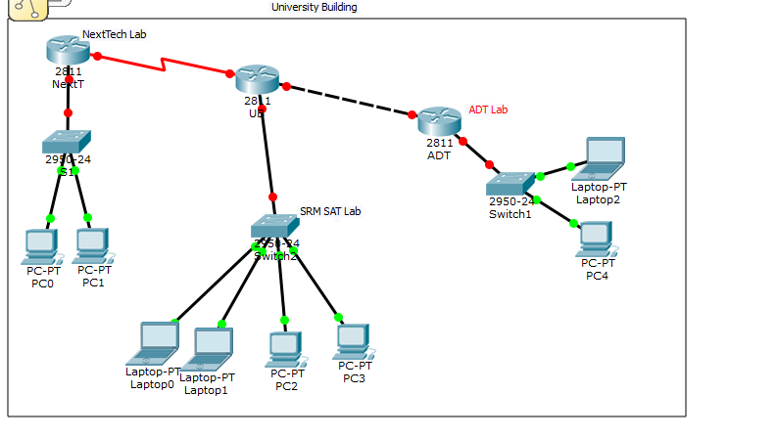

**Design Of Tech-Park** :-

Tech Park Houses Apple Lab and Nokia Lab.

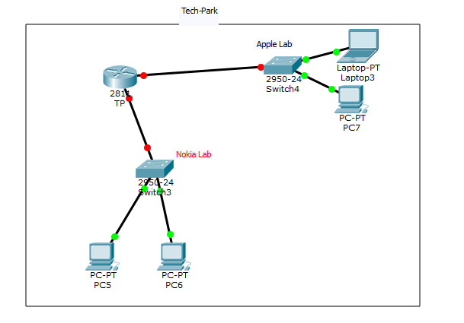

Design Of Main Campus:-

Main Campus has National Service Scheme and High Tech Block.

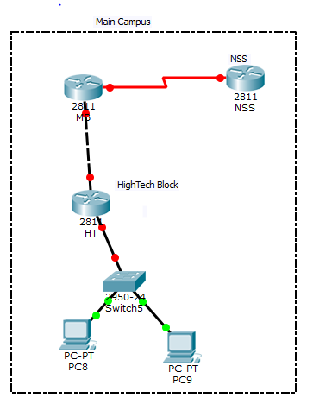

## General Configuration :

Hostname

No IP Domain-Lookup

line con 0

exec-timeout 0 0

logging synchronous

Repeat the same in

line vty 0 15

## Configuring University Building

Link in Next Tech Lab:

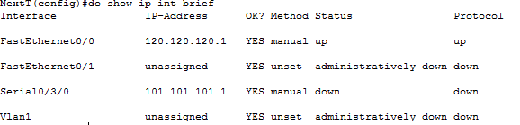

Features:

Applies the concept of Serial Connection.

Testing Network:

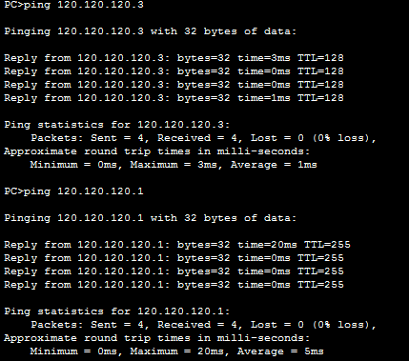

Link in ADT Lab:

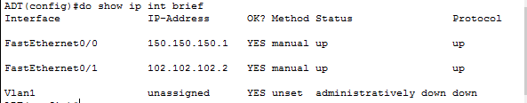

Testing Network: 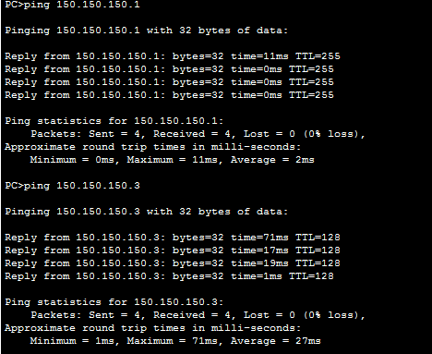

Links in SRMSAT Lab:

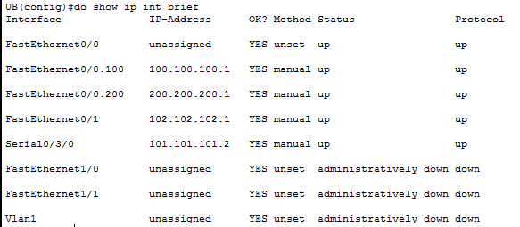

Features:

Apples the concept of Inter VLAN routing or VLAN On a Stick.

Applies Portfast feature Of Spanning Tree Protocol

Testing Network:

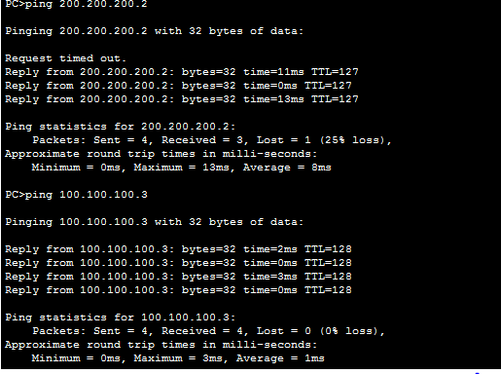

# Configuring Main Campus:

Links In High Tech Block: 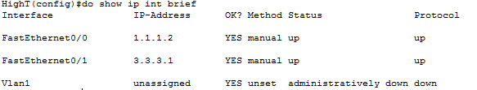

Network Test: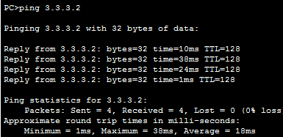

Links in NSS:

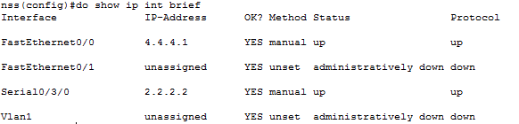

Features:

Applies Serial Connection .

Links In Main Campus:

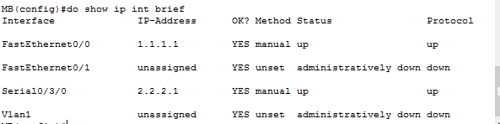

**Configuring Tech Park:**

**Links in TP:**

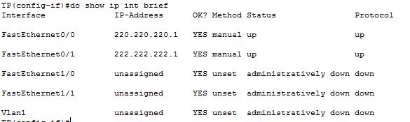

**Network test Of Apple And Nokia Lab:**

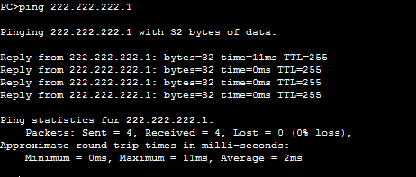

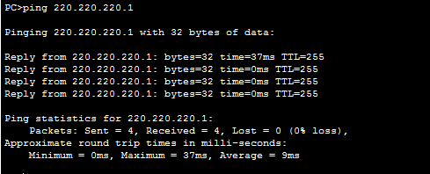**\**

**Configuring OSPF In Faculty Of Engineering :**

**University Building:**







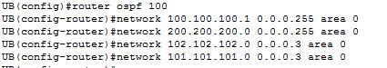









**Main Campus:**











**Tech Park:**





**Routing Table Testing:**

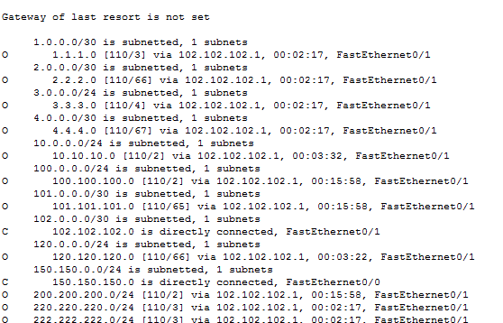

**Network Test:**

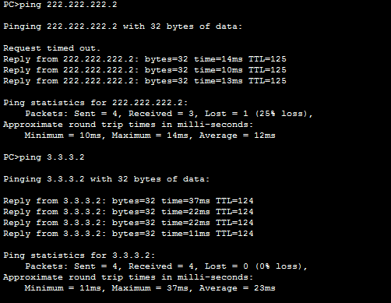

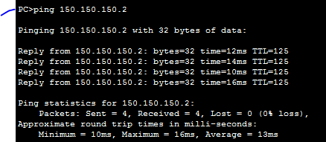

Faculty Of Management & Law

**This Department holds Main Block and A Law collage.**

**Design of Main Block:**

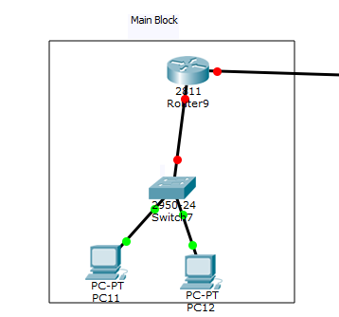

**Design of Law Collage:**

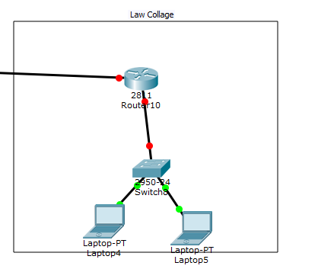

## General Configuration :

Hostname

No IP Domain-Lookup

line con 0

exec-timeout 0 0

logging synchronous

Repeat the same in

line vty 0 15

**Links in Main Block:**

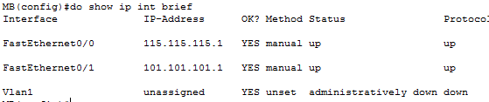

**Links in Law Collage :**

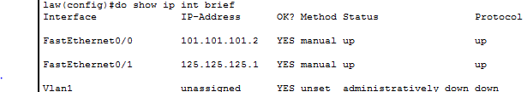

**Features Used :**

Portfast Mode in Spanning Tree Protocol

VTP Mode Server

VTP Domain Set

**Routing Protocol Used:**

We will use Static Routing as It is a small Network.





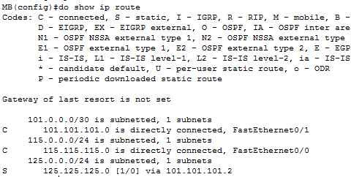

**Testing Network:**

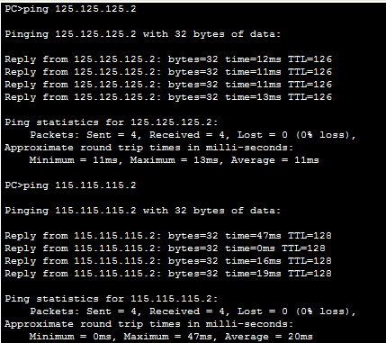

Faculty Of Science And Humanity

Two Building make the FSH ,Dept. Of Science And Dept. of Humanity.

**Design of The Network:**

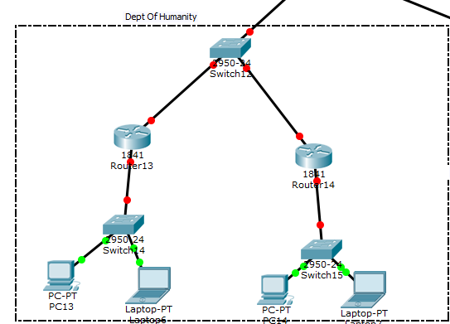

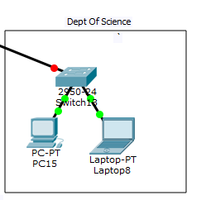

## General Configuration :

Hostname

No IP Domain-Lookup

line con 0

exec-timeout 0 0

logging synchronous

Repeat the same in

line vty 0 15

### Configuration of Network:

**Link in Humanity Router**

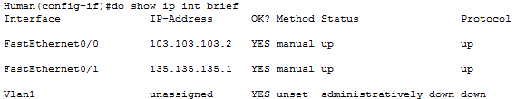

**Link in FSH Router**

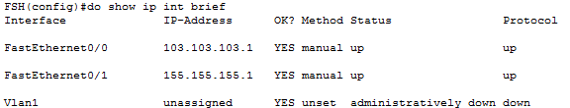

**Link in Another Humanity router:**

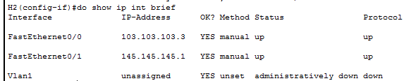

**Routing Protocols Used:**

This Network will use RIP Protocol to fill it Routing table.

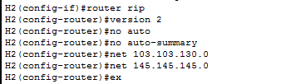





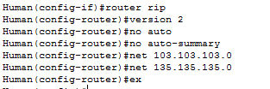

Routing Table:

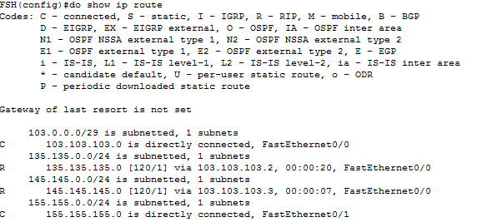

Testing Network:

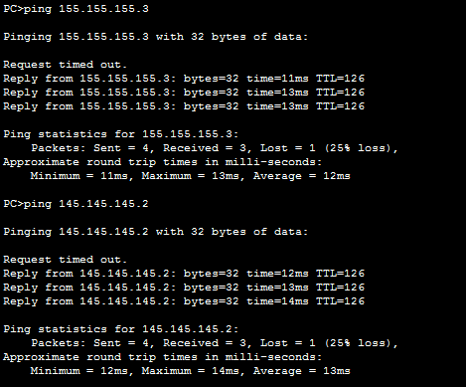

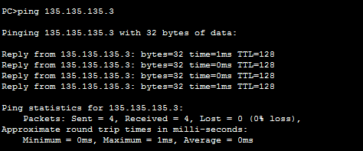

Faculty Of Medicine

The Faculty of Medicine houses 3 major buildings namely, **Dental Collage , General Hospital, Health Science.**

**Design Of The Network:**

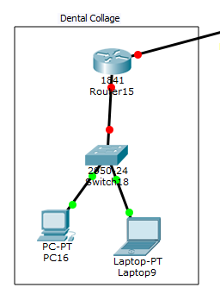

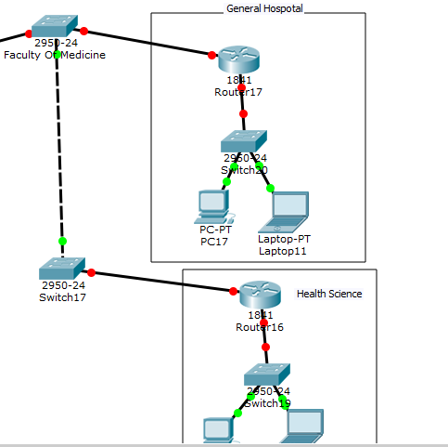

## General Configuration :

Hostname

No IP Domain-Lookup

line con 0

exec-timeout 0 0

logging synchronous

Repeat the same in

line vty 0 15

Link in Dental Hospital

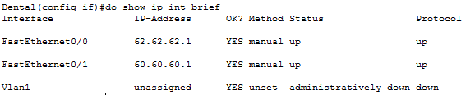

Link In Gen. Hospital

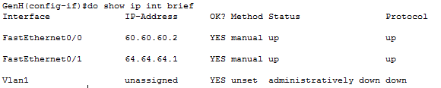

**Link in Health Science**

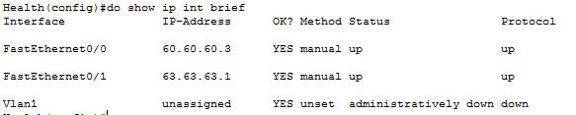

**Routing Protocols Used:**

This Topology will use EIGRP protocol to fill it routing Table.

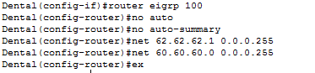

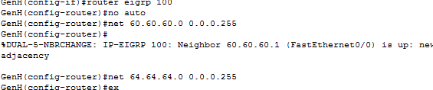

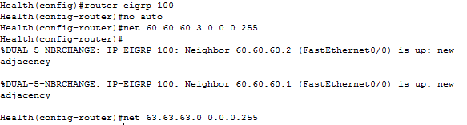

**Topology Table:**

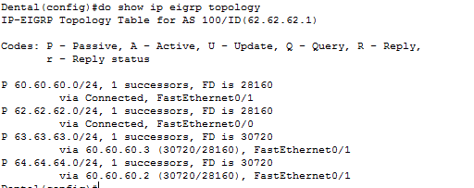

**Routing Table:**

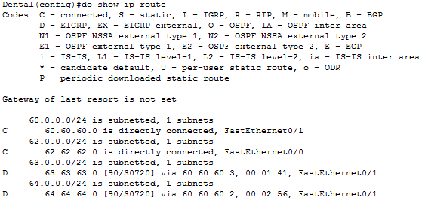

C-Directly Connected

D-Connected Via EIGRP

**Testing Network:**

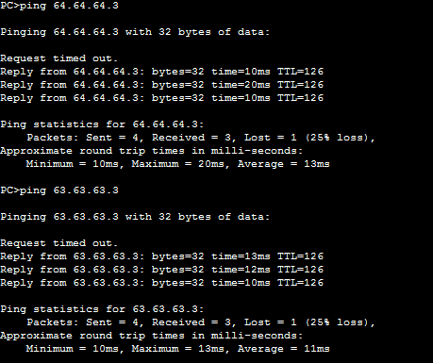

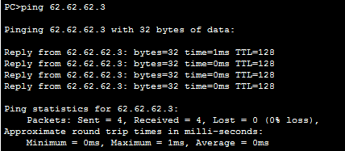

~~~~~~~~~~~~~~~~~~~~~~~~**fin**~~~~~~~~~~~~~~~~~~~~~~~~~~~