rscript2sept8.R

KatharinaBlock

Tue Sep 13 10:08:40 2016

a <- 2  
b <- -3  
siq_sq <- 0.5  
x <- runif(40)   
y <- a + b * x + rnorm (40, sd= sqrt (siq_sq))  
y

## [1] 1.015069977 -0.594219260 1.137161535 1.258971609 0.058313871  
## [6] 0.349459943 1.905237264 1.893567109 2.272331332 0.599303961  
## [11] 0.754872604 0.021540360 1.446776314 0.007382208 0.948188578  
## [16] 0.567407540 -0.045253045 0.124790408 0.713572738 0.409235349  
## [21] 0.851470067 -0.922662743 0.470441945 -0.073552242 -0.722398320  
## [26] 0.496835228 1.017047041 -0.672425606 0.336164838 -1.610953810  
## [31] 0.731099315 -0.498755444 2.152193648 1.596995595 0.372762849  
## [36] 1.430230741 -0.499294403 2.757370353 -1.874684920 1.236288681

(avgx <- mean (x))

## [1] 0.476884

plot(x,y)  
abline(a,b, col= "blue")

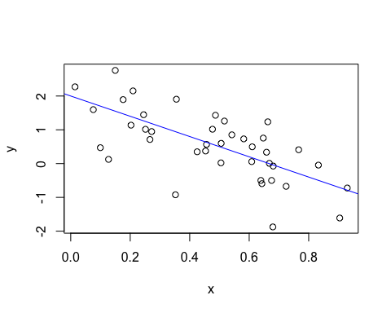

### Sept 13 class  
  
a <- 2  
b <- 7  
siq_sq <- 0.5  
n <- 400  
x <- runif(n)   
y <- a + b * x + rnorm (n, sd= sqrt (siq_sq))  
y

## [1] 1.7500548 5.2384471 1.7917159 2.2889229 2.2985837 7.2662070 6.7393731  
## [8] 2.9283556 4.1920609 3.4944744 7.2706747 7.8550601 5.5691273 2.1117263  
## [15] 7.5433173 9.0153071 3.2379801 6.4116515 2.8000910 4.8164036 8.2077237  
## [22] 7.5532787 7.0529154 5.2259255 8.0200851 5.1722525 6.9710069 2.8088483  
## [29] 7.2752254 7.2680788 1.8270626 5.3983119 6.5292036 2.0654995 6.1786435  
## [36] 3.3008068 7.3633854 3.1970664 7.6153516 7.4684438 6.4739437 7.1846193  
## [43] 7.5788418 5.2412832 2.1499445 4.7760294 4.4666209 6.2402026 9.0163069  
## [50] 8.0924997 5.1393024 4.9872563 6.7126060 6.2730115 7.2270445 6.3758703  
## [57] 5.0799543 6.1858849 6.1690515 6.8432704 9.0394571 6.0325216 4.2749521  
## [64] 4.9889176 5.1834161 6.6988668 0.8869064 8.6020485 6.9062210 2.2631253  
## [71] 5.7969363 8.0638204 6.4017723 7.3885578 6.5170563 4.8261733 3.8526194  
## [78] 2.7126161 3.0027429 4.2188623 4.8793152 6.4710345 4.9853900 9.1656512  
## [85] 6.2809745 5.9292598 3.4021013 5.0098355 4.1626331 3.6471771 6.1502243  
## [92] 3.9560717 8.5964529 3.5981399 5.2756750 1.9056745 6.0448074 3.6293282  
## [99] 2.3037704 5.0650039 4.3534815 3.0135283 6.3914343 5.9558153 7.5701370  
## [106] 4.9672131 3.5420482 7.2848790 4.4178160 7.6031181 3.9162779 3.4976053  
## [113] 3.1577944 4.8237058 6.2434867 5.7623678 5.8859426 7.2688814 5.7529932  
## [120] 6.1024588 3.0803314 8.0419800 7.5605018 6.9628799 2.7106510 4.1252971  
## [127] 6.9653332 7.3732230 3.1479366 2.0798022 7.7276616 3.6161454 5.3167472  
## [134] 7.9555126 6.7864250 6.6068065 2.6578444 3.1852166 6.8935217 5.6725450  
## [141] 9.9178117 6.0828700 3.9450874 8.7389199 5.8720053 1.4044720 3.7585661  
## [148] 5.5516774 5.8555968 4.0298554 5.3394428 4.8696688 2.3338062 2.0110371  
## [155] 2.1539296 3.8241760 4.4986294 8.6764641 8.3102295 9.4095597 5.7267686  
## [162] 5.3391955 6.4526854 1.6675611 8.7175741 6.6674437 2.8767504 5.1280059  
## [169] 9.2274457 7.1698672 9.8595493 3.2394774 8.8979500 6.7901574 5.4428399  
## [176] 6.7164737 8.4303158 1.8738415 5.4078139 5.6101800 7.1000459 4.6864798  
## [183] 4.8668872 5.9683459 4.9079850 3.2568589 5.0936757 2.8206746 3.1294175  
## [190] 2.6396647 7.9941955 9.3980710 7.4072741 6.6486497 8.7227119 4.4086778  
## [197] 3.7855737 5.1584563 7.6631744 7.4335962 6.8439343 4.0193353 8.0319812  
## [204] 5.8361334 3.6068696 6.9687575 8.5683570 3.4547599 7.4269677 4.8292436  
## [211] 5.4500229 8.5321818 6.1932046 9.1308956 2.6539041 4.0613126 6.4600947  
## [218] 5.0682243 2.3266148 3.2692517 5.0433495 7.1286643 2.4528684 8.5936207  
## [225] 9.7255444 5.1186601 5.0425028 9.3175392 8.5386295 3.4345183 5.2492302  
## [232] 7.0841295 4.9919917 8.7028359 3.0192937 8.5656485 8.5158135 5.0733991  
## [239] 8.6773966 3.5384497 7.0884120 5.3180038 7.9483017 4.0052742 2.7499477  
## [246] 7.2915168 2.7303073 5.8564664 8.0179649 5.3527278 5.1431823 4.8314326  
## [253] 9.2673357 4.6376177 7.7801171 2.7355369 7.1645756 5.3045536 3.3305784  
## [260] 4.2290624 5.1794272 5.6690286 5.9178745 8.2833230 1.4003868 7.6537645  
## [267] 6.9528401 8.4997006 6.3238193 3.2484279 4.9707868 2.8097785 5.0216048  
## [274] 9.6958928 4.5819955 6.0791545 5.5779703 7.6291693 7.8096697 5.1328461  
## [281] 2.9921215 5.1217408 5.5535845 5.0186745 4.5490850 4.2705457 9.0962612  
## [288] 7.6215313 3.4334366 7.7829494 4.6685658 2.4544414 2.0604518 7.9877882  
## [295] 3.6620530 6.9163480 5.6016747 5.0822110 3.8071131 1.8350159 5.9007089  
## [302] 5.1098254 5.4629632 1.8403570 4.8018476 1.9783438 6.5490549 2.0581572  
## [309] 7.3944787 1.4474056 8.6773708 3.7312392 3.0642162 2.9766341 5.6483729  
## [316] 3.4596795 6.4061743 5.9424986 4.2783930 5.1673923 4.7594754 7.3572805  
## [323] 8.1427773 4.6176794 4.0682704 4.9675570 5.6238895 8.4991559 4.0676304  
## [330] 6.5729508 8.0007058 3.2644529 2.2218119 4.9478746 8.1779421 3.3865476  
## [337] 2.4743680 4.3099371 5.9601599 4.8480699 8.8739435 7.7932339 6.9118868  
## [344] 2.7291366 7.1201465 2.8133052 5.3169725 5.2692884 5.1608569 4.8861158  
## [351] 3.5526867 4.5883843 8.2097196 7.8482079 7.4770846 3.8719499 5.7817858  
## [358] 6.3243926 3.4228020 2.1543236 3.8168341 6.2426741 2.1800180 6.5850686  
## [365] 3.3701345 1.0980968 8.2689310 2.5799224 5.1274288 4.9971017 8.0550037  
## [372] 3.1048863 9.2202797 9.7603943 5.4760117 6.5008484 4.7336244 9.7286571  
## [379] 2.9279159 4.3448450 2.7588145 2.2214253 7.7203665 6.8535643 2.7207628  
## [386] 7.4882444 7.0718691 4.2333416 8.5206632 8.9351924 3.0477097 5.1402727  
## [393] 5.3855395 7.3717190 7.3461355 7.5899564 5.1514717 5.2683436 2.7286472  
## [400] 6.9163191

(avgx <- mean (x))

## [1] 0.5016794

## this will write a textfile out of this variable  
## all files will be written into the project directory  
write(avgx, file = "avgx.txt")  
  
plot(x,y)  
abline(a,b, col= "blue", lwd =2)

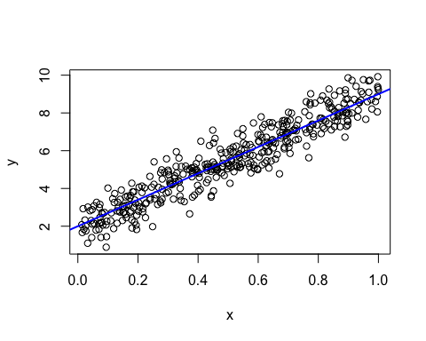

### this saves the graph as a pdf  
dev.print(pdf, "toy-line.pdf")

## quartz_off_screen   
## 2