**Binary counter**

**Each labs worth 10 points**

**All lab work must be initiated during the lab hour and be completed during the lab hour.  
Only when additional time is required, the student may show the lab instructor his uncompleted work during the lab, then complete the lab work in the following day for 2 points off.**

1. Using the following state diagram, design the sequential circuit with T FlipFlop.

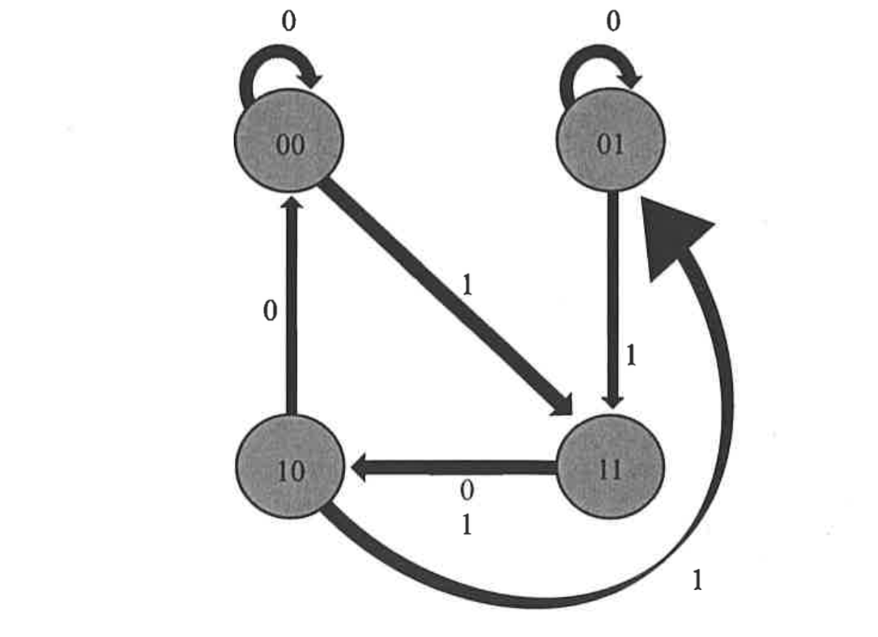

|  |  |  |  |  |  |  |
| --- | --- | --- | --- | --- | --- | --- |
| x | A(t) | B(t) | A(t+1) | B(t+1) | Ta | Tb |
| 0 | 0 | 0 | 0 | 0 | 0 | 0 |
| 0 | 0 | 1 | 0 | 1 | 0 | 0 |
| 0 | 1 | 0 | 0 | 0 | 1 | 0 |
| 0 | 1 | 1 | 1 | 0 | 0 | 1 |
| 1 | 0 | 0 | 1 | 1 | 1 | 1 |
| 1 | 0 | 1 | 1 | 1 | 1 | 0 |
| 1 | 1 | 0 | 0 | 1 | 1 | 1 |
| 1 | 1 | 1 | 1 | 0 | 0 | 1 |
|  |  |  |  |  |  |  |

Ta = xA’ + AB’

|  |  |  |  |  |
| --- | --- | --- | --- | --- |
| x | AB |  |  |  |
|  | 00 | 01 | 11 | 10 |
| 0 | 0 | 0 | 0 | 1 |
| 1 | 1 | 1 | 0 | 1 |

Tb = xB’ + AB

|  |  |  |  |  |
| --- | --- | --- | --- | --- |
| x | AB |  |  |  |
|  | 00 | 01 | 11 | 10 |
| 0 | 0 | 0 | 1 | 0 |
| 1 | 1 | 0 | 1 | 1 |