Hospital Quality and Insurance Base Rate Analysis
Objective: Determine whether hospitals with higher quality recognition receive higher insurance base rates for inpatient spine surgery DRGs.

Data integration
Hospitals in base-rate dataset: 346
CMS source hospitals: 5424
CMS matches by CCN: 136
CMS fallback name matches: 90
CMS ratings available: 156
Blue Distinction accepted: 30
Blue Distinction manual review: 35

Statistical results
Analysis | Estimate | P value | N | Interpretation
Hospital-level Welch t-test | 2805 | 0.05113 | 195 | Mean difference: Blue Distinction minus non-Blue Distinction
Mann-Whitney U test | 2862 | 0.02896 | 195 | Nonparametric comparison of hospital average base rates
DRG-adjusted log-linear regression | 21.16 | 0.03541 | 2133 | Percent difference associated with Blue Distinction
CMS Spearman correlation | 0.2398 | 0.003923 | 143 | Association between CMS stars and average base rate
CMS log-linear regression | 15.85 | 0.0001074 | 143 | Percent difference per additional CMS star

Average Base Rate Histogram
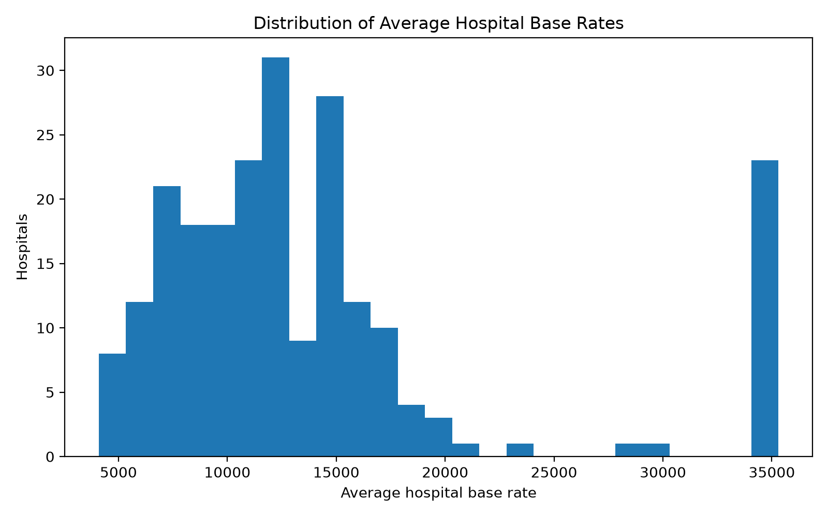

Blue Distinction Boxplot
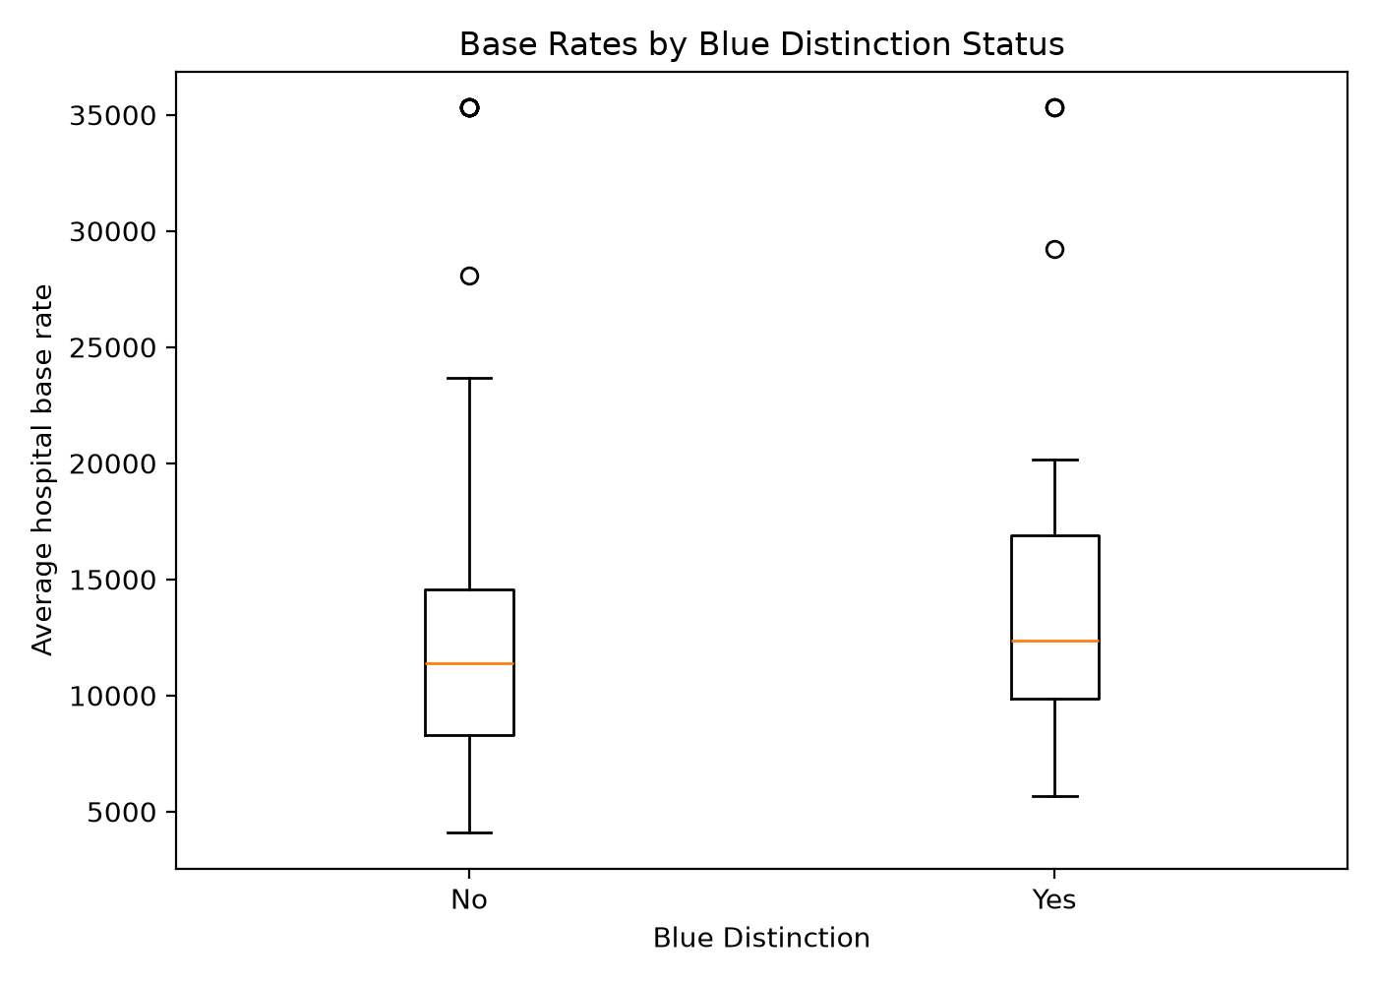

Cms Rating Scatterplot
