Analytical study of dislocation scattering in sputtered MgZnO/ZnO heterostructure for HFET application

Domain
Pawan Kumar∗, Md Arif Khan, and Shaibal Mukherjee

Hybrid Nanodevice Research Group, Electrical Engineering, Indian Institute of Technology Indore, Madhya Pradesh 453552, India.

*Corresponding author: phd1701202002@iiti.ac.in
ABSTRACT
Here, the role of dislocation scattering (DS) in electron mobility (µ) of sputtering-grown MgZnO/ZnO (MZO) heterostructure is performed by analytical modelling. Prior reports on DS mobility (µ_{DS}) exist for molecular beam epitaxy (MBE)-grown MZO epitaxial heterostructure [1]. However, an extensive study of µ_{DS} in sputtering-grown MZO is not found in prior literature. In this work, for the first time in the literature, analytical parameters are derived from experimental dual ion beam sputtering (DIBS) [2] and radio frequency sputtering [3]-grown MZO heterostructure. The value of µ_{DS} is calculated for varying Mg compositions in the barrier layer and for different barrier layer thickness. Fig. 1(a) shows the variation in electron mobility in MZO heterostructure with varying barrier layer thickness (t_{b}) at constant Mg composition (x = 0.3), T = 300 K, dislocation density (N_{DS} ≈ 10¹⁴ cm⁻²). It is observed that the trend of µ_{DS} changes from positively increasing to slightly decreasing with t_{b}, for considering (i) constant N_{DS} with t_{b}, and (ii) increasing N_{DS} with t_{b}, respectively. This is due to the generation of more interfacial dislocation due to an enhanced sheet induced charge density, that leads to stronger scattering, and hence, reducing the electron mobility [4]. Fig. 1(b) shows the variation of electron mobility with varying x in barrier layer at constant t_{b} (30 nm), and temperature (300 K). The µ_{DS} values increase with an increase in Mg composition in the barrier layer, which can be attributed to an enhanced polarization charge difference at the interface that suppress the grain boundary potential which, in turn, increases the electron mobility [5]. In Fig.1(a) and (b), a close agreement in the trends of simulated µ_{DS} and experimental mobility (µ_{net}) suggests that dislocation scattering is one of the dominant scattering components in sputtering grown MZO heterostructure. The presented study is significant for achieving high 2-dimensional electron gas (2DEG) mobility by optimizing the growth parameters to attain low dislocation density for low-cost ZnO-based HFETs..
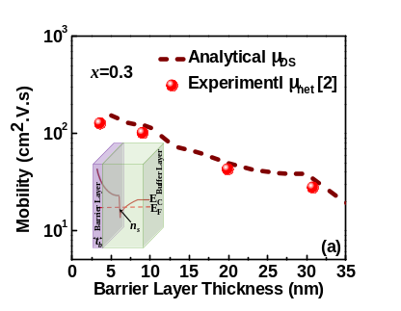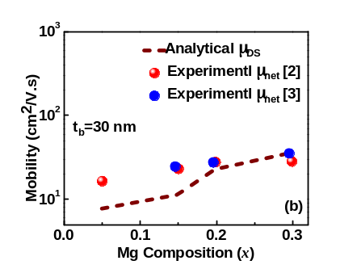
Fig. 1(a) Comparison of µ_{net} with µ_{DS} with changing barrier layer thickness. Inset shows the schematic of the heterostructure with 2DEG wave function. (b) Effect of µ_{DS} on µ_{net} with increasing x in the barrier layer.
References

[1] Q. Li et al., Semicond. Sci. Technol., vol. 29, pp. 115001 (2014).
[2] R. Singh et al., J. Phys. D: Appl. Phys., vol. 51, pp. 13LT02 (2018).
[3] H.-A. Chin et al., J. Appl. Phys., vol. 108, pp. 054503 (2010).
[4] B. Liu et al., Phys. Lett. A, vol. 376, pp. 1067-1071 (2012).
[5] C.-I. Huang et al., IEEE Trans. Electron Devices, vol. 57, pp. 696-703 (2010).
Acknowledgment
Authors acknowledge DST-SERB, MeitY for providing fellowship to pursue research work and Young Faculty Research Fellowship (YFRF) under Visvesvaraya PhD Scheme for Electronics and IT.

