Introduction to the use of the Poison keyboard

(Version 2.0, 20191215)

Table of Contents

1. Application Screens 3

1.1. Main Screen 3

1.2. Setup screen 4

1.3. Key Configuration screen 6

2. Layers 7

2.1. Key module Layer configuration. 7

2.2. Temporary access Layer while key is held. 7

2.3. Dedicated physical key used to switch & persists to Layer and Persist Layer. 8

2.4. Send Key value on key press / Switch to Layer on long key press. 10

2.5. The transparent  and the empty  keys 11

2.6. Comprehensive application instance 11

3. Macros 12

3.1. Single Shot Mode 13

3.2. Dual Sections Mode 16

3.3. Manual Continuous Loop Mode 18

3.4. Auto Continuous Loop Mode 19

3.5. Shortcut mode 20

# Application Screens

Basic screen information and ribbon introduction

## Main Screen

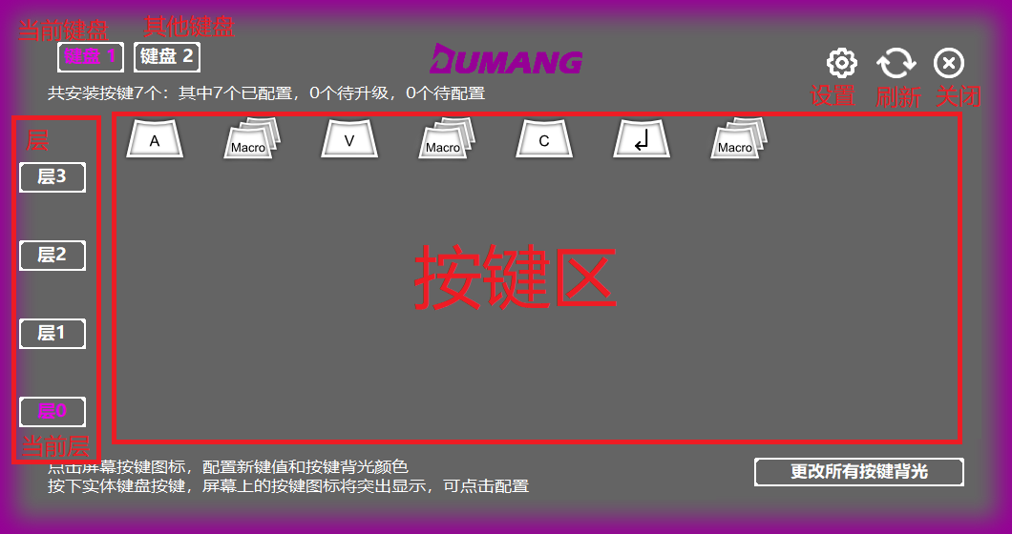

When the software is updated, there is a red dot on the settings icon 

When you hover over a key, the corresponding physical key flashes a white light to prompt the user

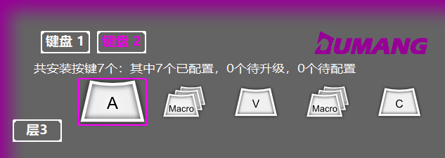

When you press a key on the physical keyboard, the corresponding icon on the drive software interface zooms in

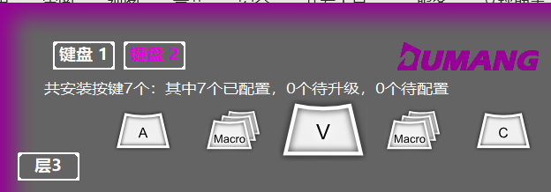

## Setup screen

When there are no updates

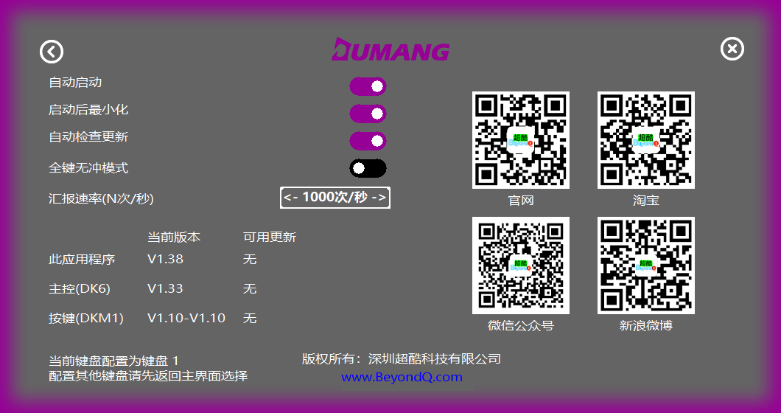  
When there are updates

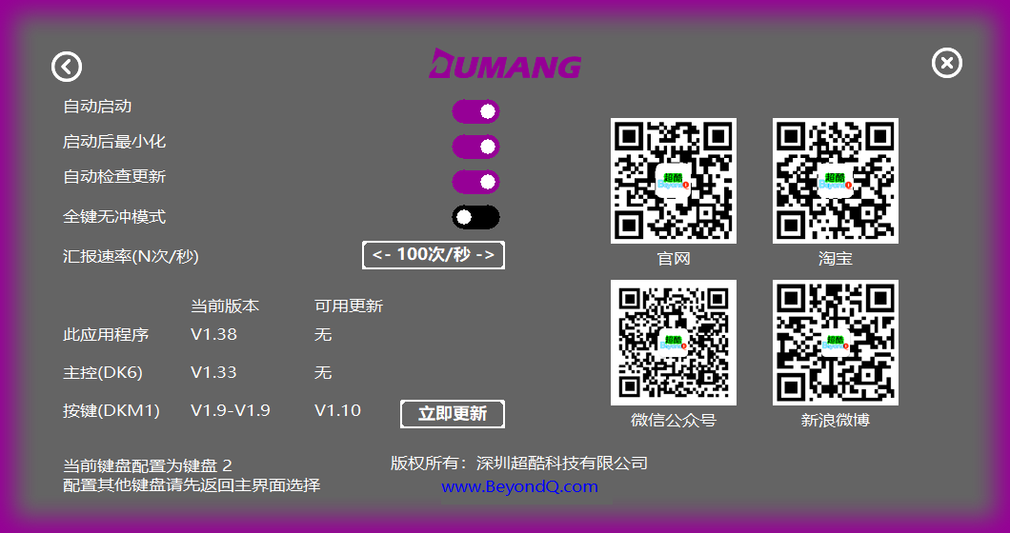

Click the Automatic Updates button to update the firmware

## Key Configuration screen

Click the key module in the main interface, you can enter the key value configuration interface, on the key value you want to configure the left mouse button, you can complete the configuration, and automatically return to the main interface

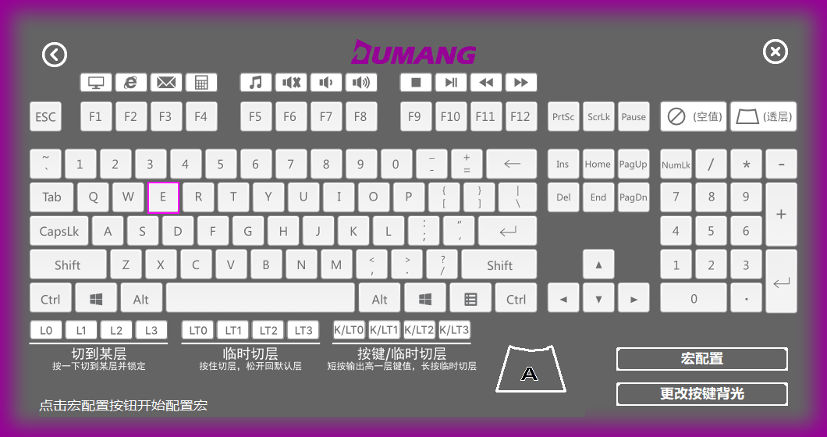

Click the Configure Macro button again to record, edit, and save macros (you can save them directly to the key module or to a file)

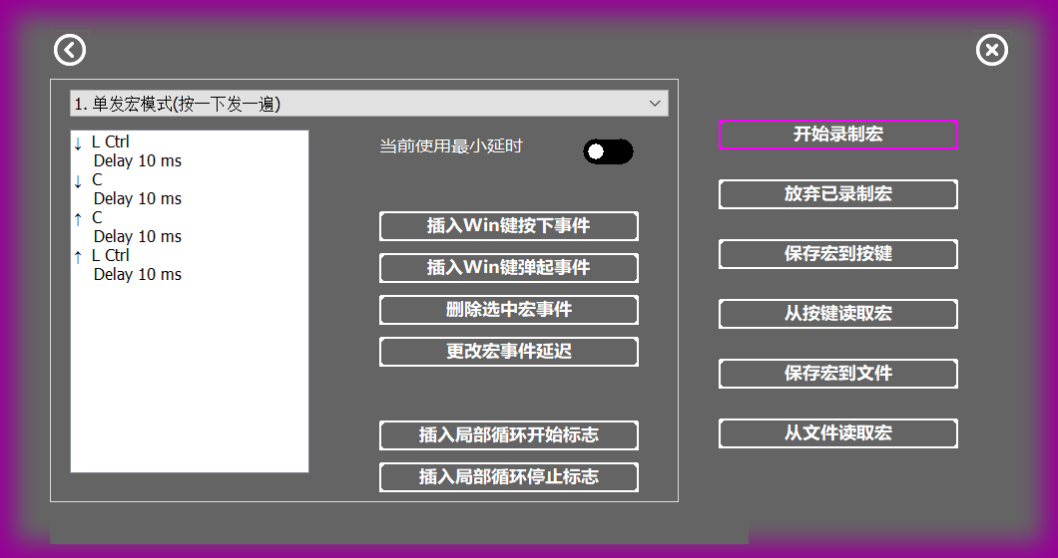

# Layers

The Poison keyboard supports 4-layer key values, i.e., each key can be configured with 4 different key values, in conjunction with Layer keys, to facilitate the expansion of keyboard functionality.

The Poison keyboard supports 3 methods to access a Layer:

* Lx - Switch to Layer on key press.
* LTx - Temporary access Layer while key is held.
* K/LTx - Send Key value on key press / Switch Layer on long key press.

One of these layers can be configured as a macro operation.

Color of each layer of ledge (at the bottom plate Logo):

Layer 0: White

Layer 1: Red

Layer 2: Green

Layer 3: Blue

## Key module Layer configuration.

Click the Layer 0 button and configure the key value for Layer 0

Click the Layer 1 button and configure the key value for Layer 1

Click the Layer 2 button and configure the key values for Layer 2

Click the Layer 3 button and configure the key value for Layer 3

## Temporary access Layer while key is held.

Scenario: A customer wants to generate the key outputs of 1, 2, 3...9, 0 values, aka *ten digits,* and key outputs of F1-F10 to be generated via the physical keys ASDFGHJKL;.

|  |  |  |  |  |  |  |  |  |  |  |
| --- | --- | --- | --- | --- | --- | --- | --- | --- | --- | --- |
| Layer 2 | F1 | F2 | F3 | F4 | F5 | F6 | F7 | F8 | F9 | F10 |
| Layer 1 | 1 | 2 | 3 | 4 | 5 | 6 | 7 | 8 | 9 | 0 |
| Layer 0 | A | S | D | F | G | H | I | K | L | ; |

The number of physical keys required is 10 plus 2, i.e., 10 character keys, 2 Layer keys, as compared to the original 30 keys, the number of keys is greatly reduced

Configuration: Configure an LT1 (0-Layer key-value matching LT1) and an LT2 (0-Layer key-value matching LT2).

Configure according to the table above:

Layer 0 is A, Layer1 is 1 and Layer 2 is .

Layer 0 is S, Layer1 is 2, And Layer 2 is .

Usage:

Pressing A at the default level 0, outputs A, Pressing S outputs S, ...

Pressing *LT1* plus A outputs 1, pressing *LT1* plus S outputs 2, ...

Pressing *LT2* plus A outputs , pressing *LT1* plus S outputs , ...

## Dedicated physical key used to switch & persists to Layer and Persist Layer.

Definition: A single physical key is used to switch to a Layer N when the key is long pressed but outputs a value when pressed.

* Example 1: Using a physical key to switch between Layers.

Configure a circular Layer button where pressing 0 switches to Layer 1, pressing 0 again switches to Layer 2, pressing 0 again switches to Layer 3, and pressing 0 again switches back to Layer 0.

The layer 0 key value is configured as *L1*, the layer 1 key value is configured as L2, the layer 2 key value is configured as L3, and the layer 3 key value is configured as L0.

* Example 2: Dedicated Layers per User.

A single public keyboard is shared between 4 people, but all four have different needs for keyboard layout

Ala: Traditional column

|  |  |  |  |  |  |
| --- | --- | --- | --- | --- | --- |
| ~ | 1 | 2 | 3 | 4 | ... |
| Tab | Q | W | E | R | ... |
| Caps | A | S | D | F | ... |
| Shift | Z | X | C | V | ... |
| Ctrl | Win | Alt | Space | | ... |

Bill: Win and Ctrl swap locations

|  |  |  |  |  |  |
| --- | --- | --- | --- | --- | --- |
| ~ | 1 | 2 | 3 | 4 | ... |
| Tab | Q | W | E | R | ... |
| Caps | A | S | D | F | ... |
| Shift | Z | X | C | V | ... |
| **Win** | **Ctrl** | Old | Space | | ... |

Chris: Caps exchanges with Ctrl

|  |  |  |  |  |  |
| --- | --- | --- | --- | --- | --- |
| ~ | 1 | 2 | 3 | 4 | ... |
| Tab | Q | W | E | R | ... |
| **Ctrl** | A | S | D | F | ... |
| Shift | A | X | C | V | ... |
| **Caps** | Win | Old | Space | | ... |

Damon: Shift, Ctrl, Caps are all positioned

|  |  |  |  |  |  |
| --- | --- | --- | --- | --- | --- |
| ~ | 1 | 2 | 3 | 4 | ... |
| Tab | Q | W | E | R | ... |
| Shift | A | S | D | F | ... |
| Ctrl | Z | X | C | V | ... |
| Caps | Win | Alt | Space | | ... |

Configure the keyboard to each layer as described above, using

* Ala is assigned to Layer 0
* Bill is assigned to Layer1
* Chris is assigned Layer 2
* Damon is assigned Layer 3

As in Example 1, configure a circular Layer key that switches to their corresponding layer when each user uses it.

* Example 3: Creating a dedicated Number pad Layer.

Configure some of the letter keys to numeric keyboard mode

Layer 0 is the letter key

|  |  |  |  |
| --- | --- | --- | --- |
| Q | W | E | R |
| A | S | D | F |
| Z | X | C | V |
| Ctrl | Alt | Space |  |

Layer 1 is configured as numeric keyboard mode

|  |  |  |  |
| --- | --- | --- | --- |
| 7 | 8 | 9 | - |
| 4 | 5 | 6 | + |
| 1 | 2 | 3 | = |
|  | 0 | . |  |

## Send Key value on key press / Switch to Layer on long key press.

Definition: Pressing the outputs value of a space, however long pressing switches to Layer n.

Setup:

Key Module 1 configuration:

Layer 0 with K/LT1, 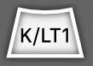

Layer 1 with space bar 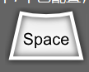

Key Module 2 configuration:

Layer 0 is key A.

Layer 1 is key .

Usage:

When the default layer is 0,

Pressing Key Module 2 outputs the value A.

Pressing Key Module 1 outputs a space as the value.

Long pressing Key Module 1 switches the keyboard to Layer 1,

Long pressing Key Module 2 outputs the value F1.

## The transparent and the empty keys

* Scenario 1: Pressing Aoutputs A, regardless of which layer

Method 1: The key module is configured as value A on each Layer.

Method 2: The key module is configured on Layer 0 to output A. On Layers 1, 2, and 3, the key module is configured as the transparent key  (default value).

Usage: The key module outputs the value A if the current layer is Layer 2 and A is pressed.

* Scenario 2: Key A outputs A at Layer 0 and does not output any values in Layer 1, 2, & 3.

Method: The key module is configured as A for Layer1. On Layers 1, 2, and 3, the key module is configured as the empty value .

Usage: When the current layer is 0, pressing A will output A as the value. When the current layer is 1, 2, or 3, pressing A, will not product an output.

## Comprehensive application instance

* Scenario

# Macros

The Poison keyboard supports macro recording, editing, saving and other operations

The Poison keyboard supports five different macro modes

1. Single Shot Mode: Press the key to start sending, and only once, and support local looping.
2. Dual Sections Mode: A "wait button bounce flag" needs to be inserted in the middle to split the macro into two parts. Press the key to send the first half of the macro, and do not send the second half of the macro until the key bounce is detected.
3. Manual Continuous Loop Mode: When pressing and holding down a key, the keyboard will continue to loop the macro until the key is released.
4. Auto Continuous Loop Mode: When a key is pressed released, the keyboard will start to loop the macro. Pressing and releasing the key again will stop the loop.
5. Key Combination Mode: A special case of two macros that makes it easy for users to perform operations like Ctrl-Alt-Shift-S.

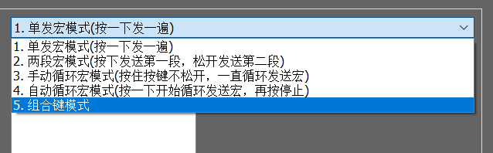

The following examples describe various user scenarios and how to use them.

## Single Shot Mode

This is the simplest mode and the macro you recorded will be sent again. When the macro interface is open, it is in this mode by default.

* Scenario 1: The customer needs to "copy, paste" with one click.

1. Select single-shot macro mode

Click the STOP RECORDING MACRO button

1. Follow the normal operation in turn by ctrl-c, ctrl -v
2. Click Stop Recording Macros

Saving the recorded macro with the Save Macro To Key button, takes effect immediately. You can also save the recorded macro as a file with the Save Macro to File button, so that you can Read Macro From File and save them to the key module later.

Note: Saving to a file means saving to a computer, when you press a key, the macro does not take effect, you must save the macro to the key before the macro can take effect.

* Scenario 2: Press A, then press the 50 times in a row, and finally press .

1. Select single-shot macro mode
2. Record the macro, press A, once, and then press .
3. When the macro is finished recording, click Stop Recording Macro to finish as shown.

1. Then click on and then click Insert Local Loop Start Flag to enter the number of cycles as prompted, click OK, then click "" When you're done, you can see that the lower arrows are wrapped up by Marco Loop Start(xx) and Marco Loop End

Saving the recorded macro with the Save Macro To Key button, takes effect immediately. You can also save the recorded macro as a file with the Save Macro to File button, so that you can Read Macro From File and save them to the key module later.

Note: Saving to a file means saving to a computer, when you press a key, the macro does not take effect, you must save the macro to the key before the macro can take effect.

## Dual Sections Mode

* Scenario: An operation needs to issue A, B, when the key is pressed, and no more key messages are sent until the keys are released, but 6 more when the keys are released.

In Drive, tap a button, and then click macro configuration,

1. Select Two macro modes.

Click START RECORDING MACRO and press the A, B, 6 keys, and then click the Stop Recording Macro button as shown below:

Select the first bounce button, in the image above, for the "6" button, and then click the Insert waiting for the button to bounce the flag button.

The operation is done as follows:

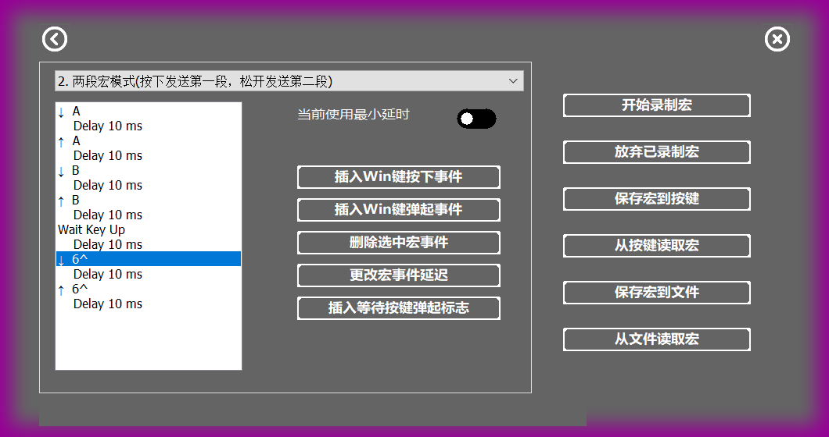

Saving the recorded macro with the Save Macro To Key button, takes effect immediately. You can also save the recorded macro as a file with the Save Macro to File button, so that you can Read Macro From File and save them to the key module later.

Note: Saving to a file means saving to a computer, when you press a key, the macro does not take effect, you must save the macro to the key before the macro can take effect.

## Manual Continuous Loop Mode

* Scenario: Hold down a key and keep sending the values 1, 2, 3.

1. Select 3. Manual Continuous Loop Mode to manually loop the send macro mode.
2. Click Start Recording Macro.
3. Press, 1, 2, 3, and click Stop Recording Macro.

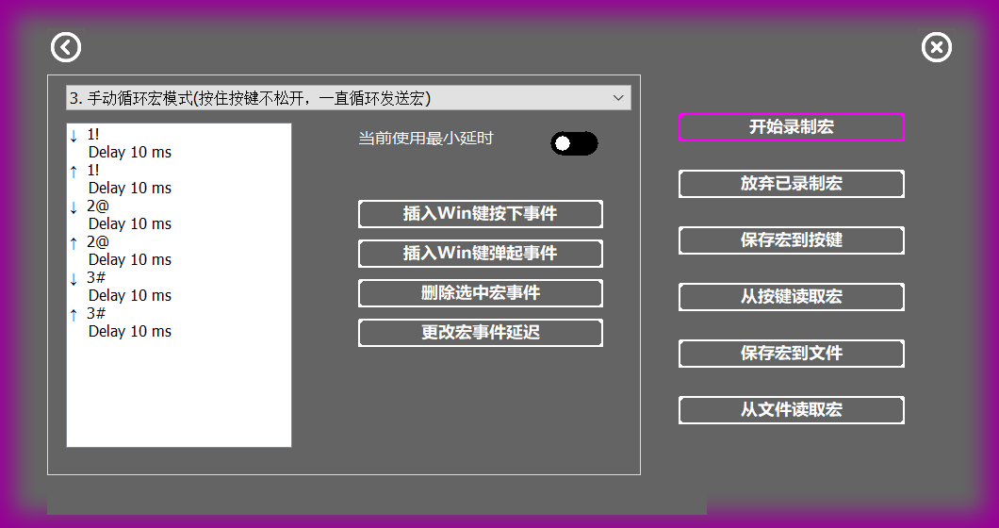

Saving the recorded macro with the Save Macro To Key button, takes effect immediately. You can also save the recorded macro as a file with the Save Macro to File button, so that you can Read Macro From File and save them to the key module later.

Note: Saving to a file means saving to a computer, when you press a key, the macro does not take effect, you must save the macro to the key before the macro can take effect.

## Auto Continuous Loop Mode

* Scenario: Press a key, keep sending a, b, c, and then press when you need to stop

1. Select 4. Auto Continuous Loop Mode
2. Click Start Recording Macro
3. Press, a, b, c, and click Stop Recording Macro.

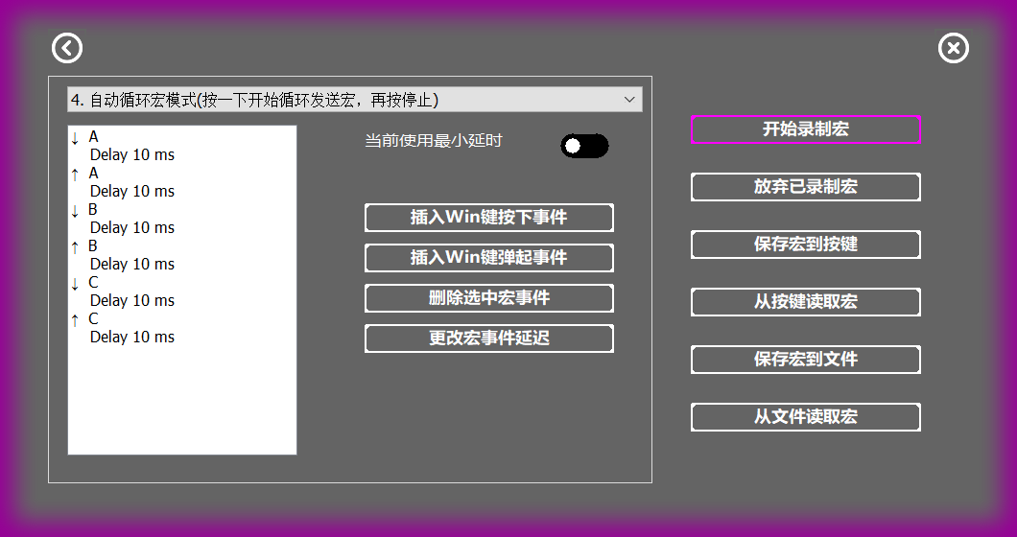

Saving the recorded macro with the Save Macro To Key button, takes effect immediately. You can also save the recorded macro as a file with the Save Macro to File button, so that you can Read Macro From File and save them to the key module later.

Note: Saving to a file means saving to a computer, when you press a key, the macro does not take effect, you must save the macro to the key before the macro can take effect.

## Shortcut mode

* Scenario: A shortcut is , , , S, and the operation is very inconvenient, and the customer wants to simplify the operation.

1. Select 5. Key Combination Mode.
2. Click Start Recording Macro.
3. Press, , , , or both, and , and you can do both, and then click Stop Recording Macro.

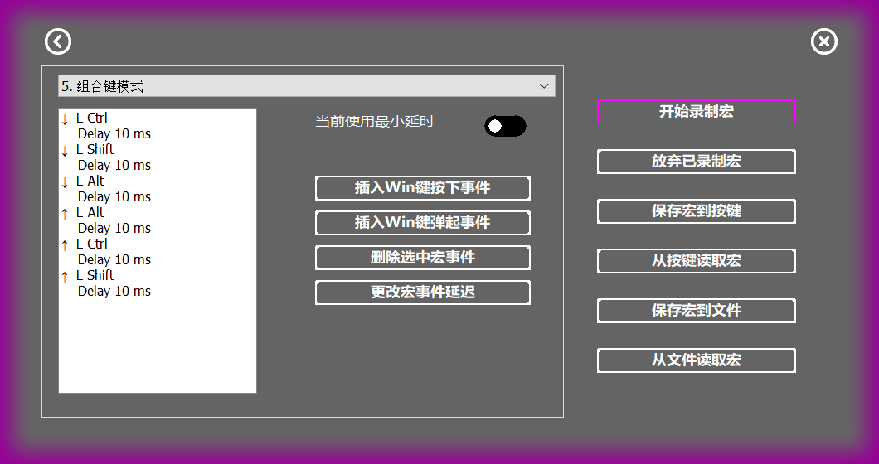

Saving the recorded macro with the Save Macro To Key button, takes effect immediately. You can also save the recorded macro as a file with the Save Macro to File button, so that you can Read Macro From File and save them to the key module later.

Note: Saving to a file means saving to a computer, when you press a key, the macro does not take effect, you must save the macro to the key before the macro can take effect.